# Alumni Newsletter for Spring semester, 2014

*Published May 15, 2014*

# Community Service

   The members of Rho Beta chapter are big on community service. This year our major events were babysitting dogs for the Ohio pawpaw festival, cleaning up Athens during beautification day, and serving food to the needy on behalf of Good Works Inc., an Athens based charity.

    The pawpaw festival is a festival centered around the pawpaw tree (an Ohio native plant), extended from Friday, September 13th to Sunday, September 15th, during which Rho Beta manned the ‘Paws at the Pawpaw’ event, and were responsible for caring for the dogs whose owners wished to explore areas outside of the Paws at the PawPaw event. It was an amazing time for everyone who went, after all, who wouldn’t want to spend a weekend puppy sitting a bunch of cute dogs?

    Athens beautification day (B-day) occurs April 14th of every year, and serves the purpose of not only cleaning up Athens, but also strengthening the bond between the town and the university, something Rho Beta Chapter is proud to be a part of. During this year’s B-day, we completed our project with haste, and as has become a tradition in this chapter, we completely ignored the scavenger hunt aspect of the cleanup (50 points for scraping up road kill? Count me in). Athens B-day still remains our most attended community service event, with a majority of active members attending, due in no small part to the offers of free food, and the fact that the impact on the community is immediately apparent.

    Somewhere between sitting dogs and cleaning up Athens, we found time to help provide food for the homeless. Good Works Inc. is a charity dedicated to help the homeless in Athens, and the greater southeastern Ohio area. In addition to running a homeless shelter, Good Works also puts on annual walks and dinners that serve to benefit the homeless. One such dinner was staffed by the Rho Beta chapter. The event lasted approximately two hours, during which members of Rho Beta provided food for well over a hundred people. After the event finished we were provided with food as well. The food wasn’t exactly five star cuisine, but certainly filled you up, which is what really matters.

The entire chapter would like to give a huge thanks to our community service chair, **Claire Hall**, and to everyone who attended the community service events.

# Fundraising

Our Annual trip to Cedar Point went almost as expected, once our fundraising chair **Amy Pierce** managed to convince enough people to spend a weekend in Cleveland working rides. Policy at Cedar Point has changed in our favor as far as the jobs provided. We are no longer allowed to work sweeps or operations, meaning we are given far more important and meaningful jobs, such as measuring children with a stick. That said, everyone managed to follow Ride Pride policy, and we received our full pay and bonus, which amounted to over $3000 in revenue for the chapter.

(it is also worth mentioning that Casey Davis is now convinced that if he drops out of engineering, he wants a job where he gets to make children scream)

# Professionalism

Our former professional development chair **Eric May** arranged for a leadership series to be arranged, but unfortunately shortly after its introduction it has to be postponed due to a number of scheduling conflicts, however it is likely that it will be continued during the 2014-2015 year.

**Joshua Novak**, our current professional development chair has arranged a few movements toward professional development in the interim, including True Colors, executive meetings on establishing professionalism within chapter, and an initiative to get actives to dress in business professional on Wednesdays.

On chapter professionalism, attendance in chapter has been at a record high, due in no small part to the chapter’s recent population explosion. Meanwhile attendance percentage is also the highest it has been in years, due to a combination of incentives, and people taking an interest in the discussions and decisions that have happened in chapter as of late.

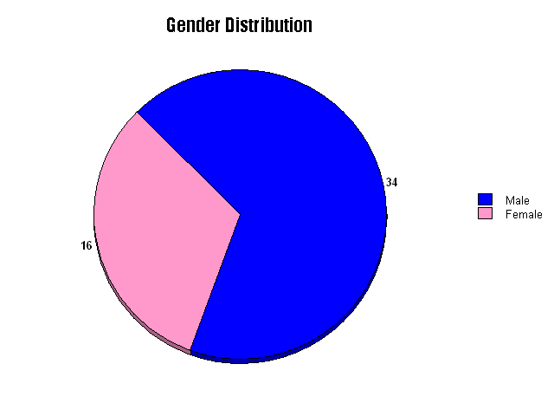

# Demographics

Currently Theta Tau has 54 members, 32% of which are women. This puts us at 150% of the expected average for the engineering college. In previous years we have seen numbers as high as 50%/50% M/F, but the Rho Beta chapter is still far from an all-boys club.

On student year demographics, we see another interesting characteristic of Rho Beta. We currently only have two graduating seniors, but next year we will have 19 seniors. Assuming all of those seniors graduate, we will lose over a third of our membership, and nearly every person in every leadership role. This is a very similar situation to the last school year, where we lost 12 of our 34 members to graduation.

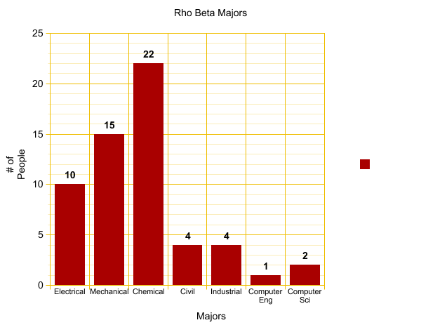 Breaking down the fraternity by major, we are currently dominated by Chemical and Mechanical Engineers, with more Chemical Engineers than Electrical Engineers, Computer Engineering/Science, Civil Engineers, and Industrial Engineers combined. When notified of this fact, our regent had this to say: “Good. Mechanicals suck. Honestly, Mechanicals are just worse Chemicals”.

# Road trip and Interfraternal Visits

As is standard, this year we went on two road trips, Tennessee in the fall, and Pittsburgh in the spring. Also of note, we were visited by Marshall Colony during the Marshall vs. Ohio University football game, during which we bonded closely with our green and white clad brothers. Plans are currently in the works to arrange for us to visit Marshall Colony during next year’s game.

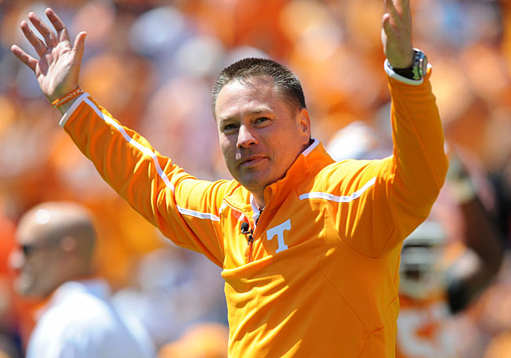In the fall we took four cars down to Tennessee to meet our brothers from Chi Gamma, and give our pledges one last hurrah before joining us as brothers. Southern hospitality was in no short supply in Tennessee as the entire two day period was filled with events, from a party the night we arrived, followed by breakfast in the morning, then a tour through Knoxville, a pre-game cookout, and a football party to cap things off. I will say however, for those who haven’t been to Knoxville, Tennessee fans make OSU fans look like OU fans. I think at one point, one of our brothers said something along the lines of “I would have sex with Jones [The Tennessee head coach] in the middle of that stadium if it means winning the game”. The Tennessee fans are… dedicated, to say the least.

This spring, we descended on our regent’s home town of Pittsburgh, for yet another round of mingling with brothers. While I wasn’t able to attend the Nu Delta visit personally, it went exceedingly well, and I made sure to thank them for their hospitality, especially since they managed to pull together living arrangements last minute (they don’t have a house and a few people who initially agreed to be hosts bailed out on them). Nu Delta has expressed interest in visiting our chapter in the future, a visit which we have promised to accommodate.