Retail Sales Performance Analysis
Power BI Dashboard Project
Prepared by: Rushikesh Patil
Role: Data Analyst / Business Intelligence
Tools Used: Power BI, DAX, Power Query, Excel

Executive Summary
This report presents an end-to-end Retail Sales Performance Analysis using Power BI. The objective was to transform raw transactional data into executive-level insights supporting data-driven decisions across sales, marketing, and customer strategy.
Project Objective & Dataset Overview
The primary objective of this project is to analyze retail sales performance and uncover key insights related to revenue trends, customer behavior, and product category performance. The analysis aims to support data-driven decision-making by providing a comprehensive view of sales, transactions, and customer demographics.
The dataset consists of transactional retail data containing features such as transaction date, product category, quantity sold, unit price, customer ID, gender, and age. The project focuses on cleaning the data, analyzing trends, and creating interactive visualizations to better understand business performance and customer purchasing patterns.
Tools & Methodology
Tools Used
- Power BI – For building interactive dashboards, KPI cards, and drill-through visualizations
- Power Query – For data cleaning and transformation
- DAX – For creating calculated measures such as total revenue, transactions, and quantity sold
- Microsoft Excel – For initial data review and validation
Methodology
- Data Cleaning – Validated transactional data, created calculated measures, and structured fields for analysis
- Exploratory Data Analysis – Analyzed revenue trends, product category performance, and customer demographics
- Dashboard Development – Designed an interactive Power BI dashboard with KPIs, slicers, filters, and drill-through functionality to enable detailed business insights

Business Objectives
- Measure overall retail performance using KPIs
- Identify revenue and transaction trends
- Analyze customer demographics and behavior
- Evaluate product category performance
- Enable interactive analysis using filters and drill-through

Data Preparation & Cleaning
The dataset was validated for accuracy and completeness. Calculated measures were created for revenue, transactions, and quantity sold. Customers were segmented into age groups to support demographic analysis.

Key Performance Indicators
- Total Revenue
- Total Transactions
- Quantity Sold
- Customer Count

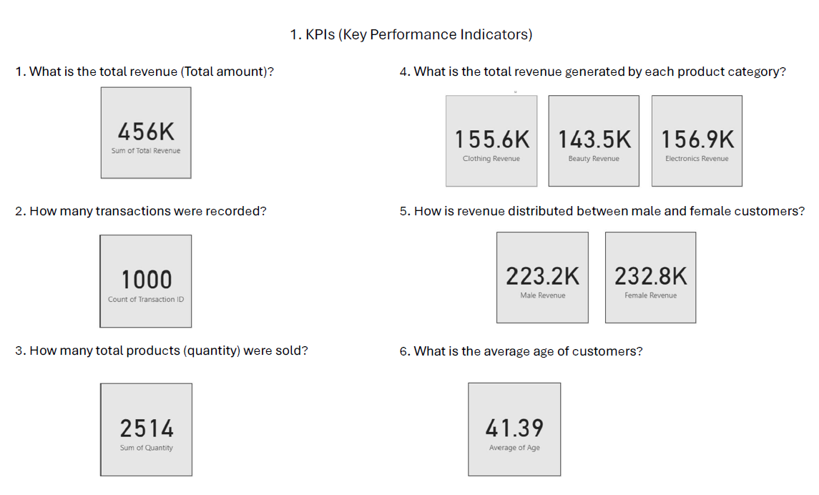 Sales & Revenue Analysis
Monthly analysis revealed seasonal fluctuations in revenue. A strong relationship was observed between transaction volume and revenue, indicating key high-performance periods.
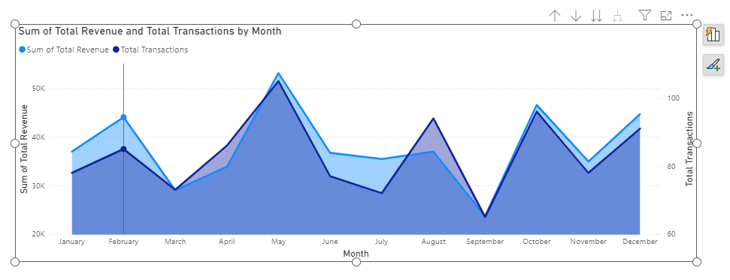

Product Category Performance
Electronics and Clothing emerged as strong contributors to revenue, supporting targeted inventory and marketing strategies.
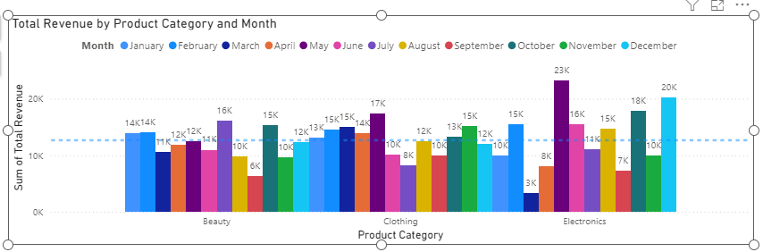

Customer Insights
Revenue distribution between genders was balanced. Adult and senior customers contributed the majority of revenue, indicating strong purchasing power.
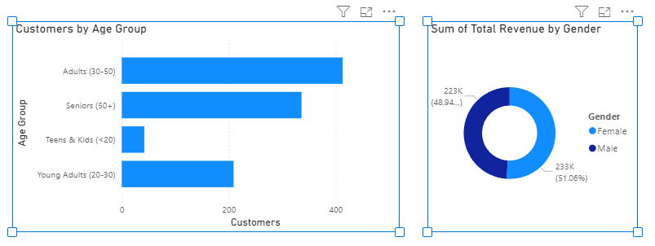

Top Customer Analysis
The top 10 customers contributed a significant portion of total revenue, highlighting the importance of retention and loyalty strategies.
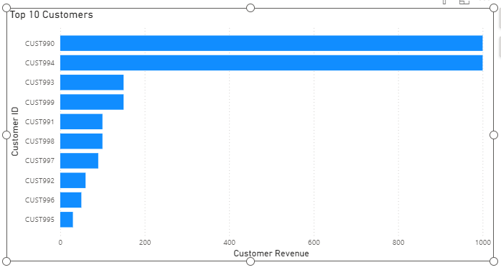
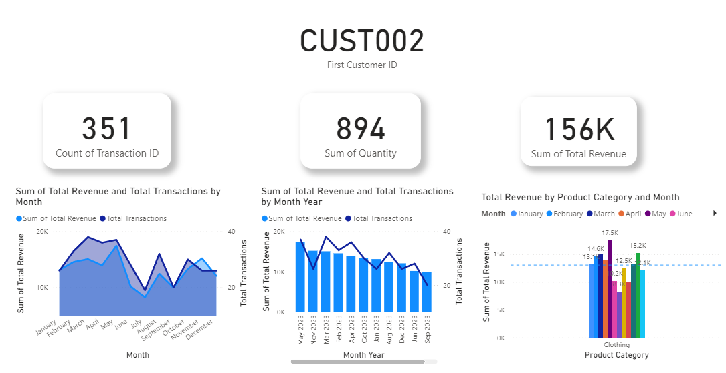

Dashboard Interactivity
The dashboard includes date slicers, product and customer filters, and drill-through capabilities to analyze individual customer transaction histories.
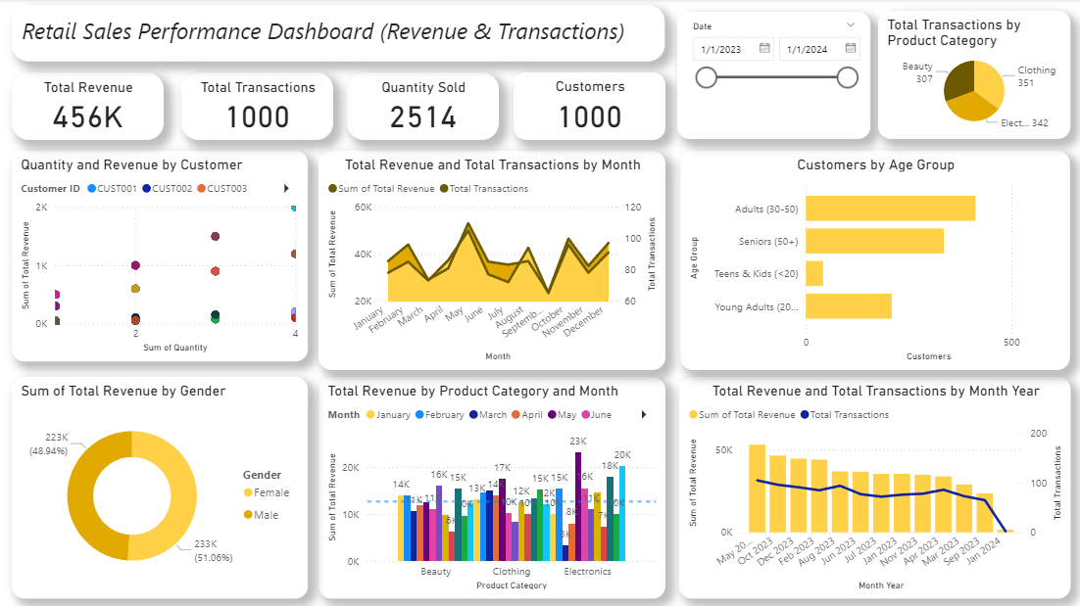

Key Recommendations
- Retain high-value customers
- Optimize promotions for high-performing categories
- Leverage seasonal sales trends
- Use segmentation for personalized marketing

Conclusion
This project demonstrates the effective use of Power BI to deliver actionable business insights through clean data modeling, visualization, and executive storytelling.

