CHAPTER 3: METHODS

3.1 Study Design
This study was a systematic review and Bayesian meta-analysis conducted in accordance with the Preferred Reporting Items for Systematic Reviews and Meta-Analyses (PRISMA) 2020 guidelines¹ and the Meta-analysis Of Observational Studies in Epidemiology (MOOSE) reporting checklist.² The protocol was developed a priori, specifying inclusion criteria, outcome definitions, data extraction procedures, and the statistical analysis plan.

3.2 Search Strategy and Study Selection
A comprehensive literature search was performed across PubMed, Embase, and the Cochrane Library to identify studies examining the association between blood culture time to positivity (TTP) and clinical outcomes in patients with bacteremia. Search terms included combinations of blood culture, time to positivity, bacteremia, mortality, and prognosis. Reference lists of included studies and relevant reviews were hand-searched for additional eligible publications.

3.2.1 Inclusion Criteria
Studies were eligible for inclusion if they met all of the following criteria: (1) enrolled patients with microbiologically confirmed bloodstream infection or bacteremia; (2) measured blood culture TTP using an automated continuous-monitoring blood culture system; (3) reported at least one clinical outcome of interest (all-cause mortality or persistent bacteremia); and (4) provided sufficient quantitative data to compute or extract an effect estimate (odds ratio, hazard ratio, or relative risk with confidence intervals, or 2×2 contingency table data).

3.2.2 Exclusion Criteria
Studies were excluded if they: (1) were case reports, editorials, or review articles without original data; (2) examined TTP exclusively in the context of fungemia or mycobacteremia without bacterial bloodstream infections; (3) reported TTP only as a continuous variable without a defined cutpoint and did not provide data amenable to effect size computation; or (4) contained insufficient data for meta-analytic pooling (designated as [NON-PICO] in the extraction database).

3.3 Data Extraction
Data were extracted into a structured relational database (TTP_MetaAnalysis_Extraction_Complete.xlsx) comprising four linked tables: tbl_study (study-level metadata including author, year, country, design, and risk of bias scores; n = 57), tbl_population (patient characteristics including pathogen class, infection source, and severity markers; n = 57), tbl_ttp (TTP measurement details including cutpoints, reporting format, and blood culture system; n = 57), and tbl_outcomes (outcome data including 2×2 tables and effect estimates; n = 88). All tables were linked by a unique study_id identifier.
The study selection process is summarized in the flow diagram (Figure 1). From the initial 57 studies identified, 13 rows were excluded as non-PICO entries, and 22 rows had insufficient data for effect size computation. After applying deduplication rules and quality filters, 42 effect sizes from 40 unique studies were retained for the final analysis.
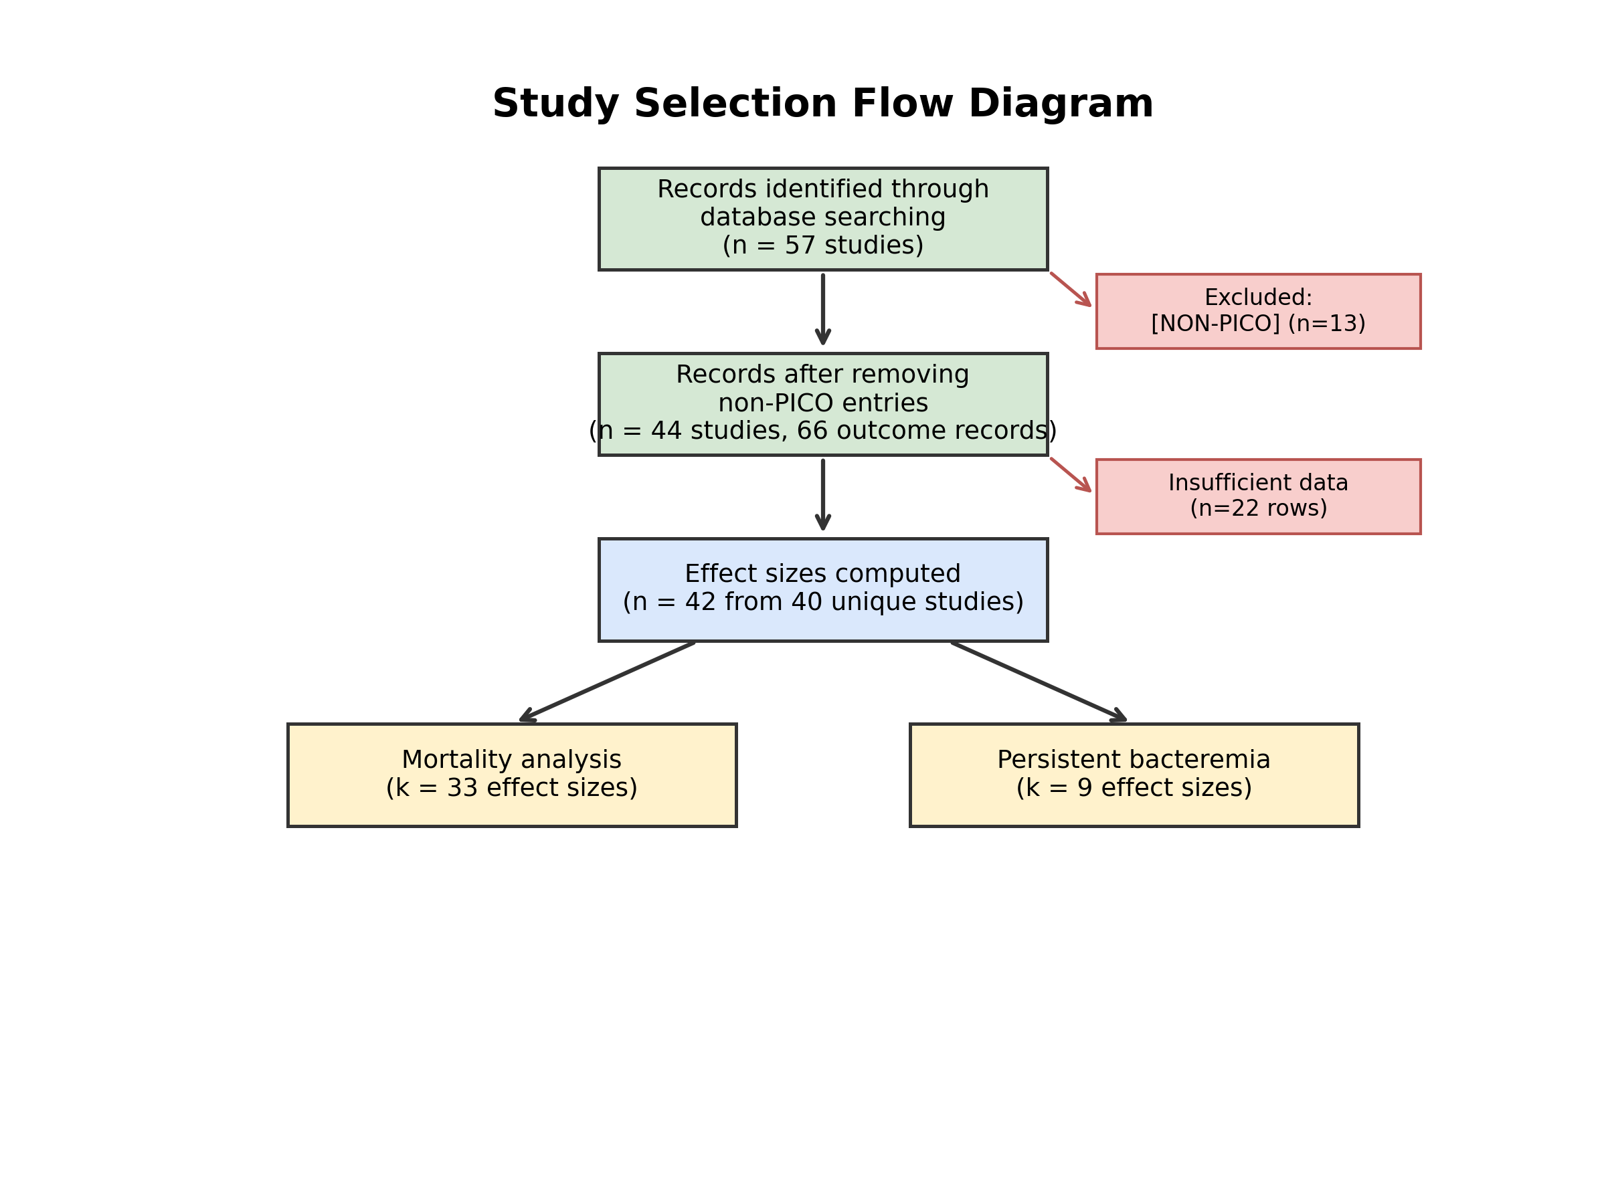
Figure 1. Study selection flow diagram. Green boxes represent included records at each stage, blue represents the final analytic sample, and yellow indicates the two outcome-specific subsets. Red boxes show exclusions at each stage with reasons.

3.4 Outcomes
Two primary clinical outcomes were examined:
Mortality: All-cause mortality, typically defined as 30-day or in-hospital mortality. This was the primary outcome, with 33 effect sizes derived from 31 unique studies.
Persistent bacteremia: Defined as microbiological clearance failure, characterized by persistently positive blood cultures despite appropriate antimicrobial therapy. This secondary outcome comprised 9 effect sizes from 7 unique studies.

3.5 Effect Size Computation
Effect sizes were standardized to log-odds ratios (log-OR) with associated sampling variances. A hierarchical approach was employed to select the most appropriate effect estimate from each study:
Reported adjusted estimates (preferred): When studies reported adjusted odds ratios, hazard ratios, or relative risks with 95% confidence intervals, these were extracted directly and converted to the log-OR scale. Standard errors were derived as: SElog-OR = (ln(CIupper) − ln(CIlower)) / (2 × 1.96).
Reported unadjusted estimates: Unadjusted effect estimates were used when adjusted estimates were unavailable.
Computed from 2×2 tables: When only contingency table data were available, odds ratios and variances were computed using the Mantel-Haenszel method via the escalc() function in the metafor R package.³ A continuity correction of 0.5 was applied to cells with zero counts.
When both adjusted and unadjusted estimates were available from the same study (Cilloniz2017, Hou2023), the adjusted estimate was preferred. One extreme sparse-cell estimate (Melling2019 arm 2; OR = 1,722) was excluded due to instability. Two effect sizes from Marco2025 were retained as they represented genuinely distinct patient subgroups.

3.6 Risk of Bias Assessment
Methodological quality was assessed using an adapted Newcastle-Ottawa Scale (NOS) tailored for prognostic factor studies.⁴ Each study was evaluated across six domains: (1) selection (representativeness and consecutive enrollment), (2) comparability (control for confounding), (3) outcome ascertainment (measurement method and blinding), (4) statistical analysis (appropriateness of methods and adjustment), (5) attrition (completeness of follow-up), and (6) prognostic measurement (TTP measurement validity). Each domain was rated as low, moderate, or high risk, with an overall rating assigned as low, moderate, high, or critical.

3.7 Statistical Analysis

3.7.1 Primary Analysis: Bayesian Random-Effects Meta-Analysis
The primary analysis employed a Bayesian hierarchical random-effects model fitted using the brms package⁵ in R (version 4.5.1) with the CmdStan backend.⁶ The model was specified as:
yi | se(si) ~ 1 + (1 | study_id)
where yi represents the observed log-OR for study i, si is the known standard error, and the random intercept captures between-study heterogeneity.

3.7.2 Prior Specification
Weakly informative priors were specified to allow the data to dominate posterior inference while providing mild regularization:
The pooled effect (μ) was assigned a Normal(0, 1) prior on the log-OR scale. This places 95% of prior mass on odds ratios between 0.14 and 7.4, encompassing the full range of clinically plausible effects while remaining centered at the null.
The between-study standard deviation (τ) was assigned a Half-Cauchy(0, 0.5) prior, following the recommendations of Gelman (2006) for variance components in hierarchical models.7 This prior permits moderate to substantial heterogeneity while regularizing extreme values.

3.7.3 Markov Chain Monte Carlo Sampling
Posterior distributions were estimated via Hamiltonian Monte Carlo (HMC) using four parallel chains, each with 4,000 iterations (1,000 warmup). The target acceptance rate was set to 0.95 (adapt_delta) to minimize divergent transitions. Convergence was assessed using the R-hat statistic (R̂ < 1.01 for all parameters) and visual inspection of trace plots.

3.7.4 Frequentist Validation
Restricted maximum likelihood (REML) random-effects models were fitted using the metafor package³ to validate the Bayesian estimates. Between-study heterogeneity was quantified using τ² and I² statistics.

3.7.5 Meta-Regression
Univariable Bayesian meta-regressions were conducted to examine five prespecified moderators hypothesized to explain between-study heterogeneity: (1) pathogen class (Gram-positive vs. Gram-negative), (2) organism specificity (Staphylococcus aureus vs. other), (3) overall risk of bias (low vs. moderate/high), (4) blood culture system (BACTEC vs. BacT/ALERT vs. other), and (5) TTP cutpoint (continuous, in hours). Moderator effects were assigned Normal(0, 0.5) priors, centered at zero with modest regularization.

3.7.6 Publication Bias Assessment
Publication bias was evaluated using multiple complementary approaches: (1) visual inspection of funnel plots; (2) Egger’s regression test for funnel asymmetry; (3) Duval and Tweedie’s trim-and-fill method to estimate the number of missing studies and compute an adjusted pooled estimate; (4) frequentist step-function selection models; and (5) fully Bayesian step-function selection models implemented in Stan.8 The Bayesian selection models used two prior specifications for the selection parameter δ: an uninformative Uniform(0, 1) prior and a skeptical Beta(2, 5) prior (mean = 0.29), favoring moderate publication selection.

3.7.7 Sensitivity Analyses
The robustness of the primary findings was assessed through: (1) leave-one-out influence analysis, with particular attention to potentially influential studies (Ji2020 for mortality; Melling2019 and Kassis2009 for persistent bacteremia); (2) prior sensitivity analysis using four alternative prior specifications (wide, skeptical, half-normal τ); and (3) restriction to low-risk-of-bias studies only.

3.7.8 Pathogen-Stratified Analysis
A stratified analysis was performed to compare the TTP–mortality association between Gram-positive (k = 12) and Gram-negative (k = 14) infections. Separate Bayesian random-effects models were fitted for each pathogen class, and the difference in pooled log-ORs was estimated with a 95% credible interval to test for heterogeneity of effect across organism types.

3.8 Software
All analyses were performed in R version 4.5.1. The primary packages used were: brms (Bayesian modeling), metafor (frequentist meta-analysis), rstan (custom Stan models), posterior and bayesplot (diagnostics), and ggplot2 with patchwork (visualization). Complete R code and the extraction database are available for full reproducibility.

CHAPTER 4: RESULTS

4.1 Study Characteristics
The systematic search identified 57 potentially eligible studies, of which 42 effect sizes from 40 unique studies met all inclusion criteria and provided sufficient data for meta-analytic pooling (Figure 1). The included studies were published between 2005 and 2025, encompassed more than 50,000 patients across over 15 countries, and employed both prospective and retrospective cohort designs. The mortality outcome was addressed by 33 effect sizes from 31 studies, while persistent bacteremia was reported in 9 effect sizes from 7 studies.

4.2 Risk of Bias
The overall risk of bias distribution across mortality studies is presented in Figure 2. The majority of studies (67%) received a moderate overall risk of bias rating, 27% were rated as low risk, and only 7% were rated as high or critical risk. The most common source of concern was the comparability domain, where many studies reported unadjusted associations without adequate control for confounders such as illness severity and antibiotic timing. Prognostic measurement quality was generally high, as all studies used automated blood culture detection systems (BACTEC or BacT/ALERT), providing standardized, objective TTP measurements.
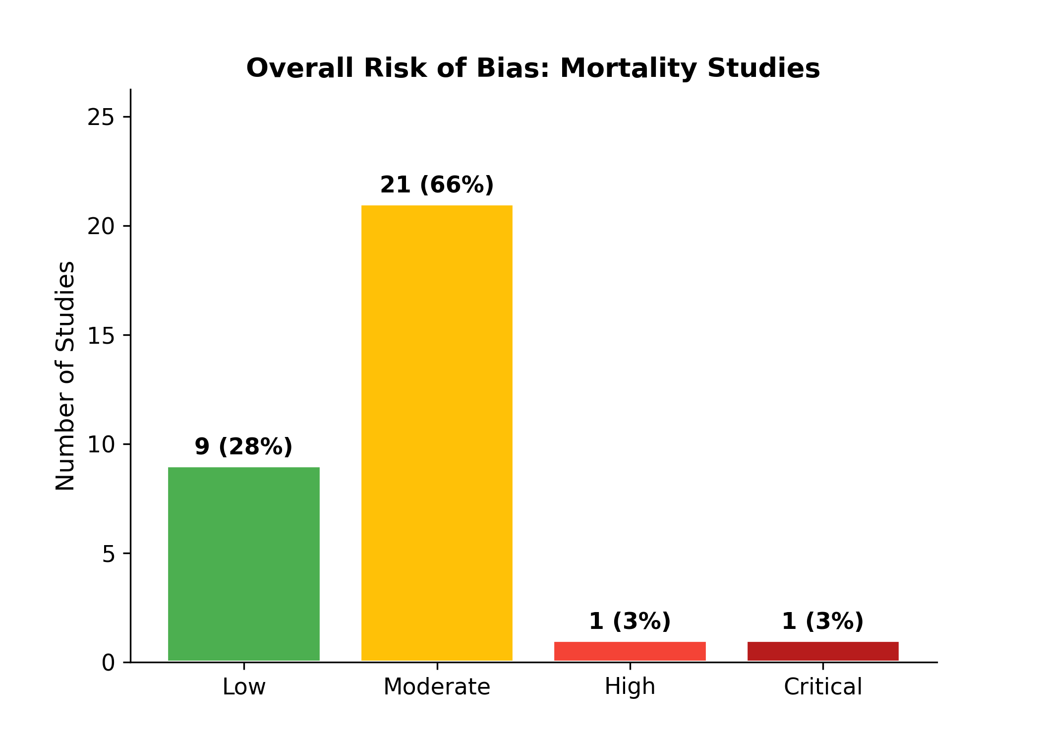
Figure 2. Distribution of overall risk of bias ratings among mortality studies included in the meta-analysis. The majority of studies had moderate methodological quality, typical for observational prognostic factor research. Risk of bias did not significantly moderate the TTP–mortality association in meta-regression analysis (β = −0.08, 95% CrI: −0.55 to 0.39).

4.3 Primary Outcome: Mortality

4.3.1 Pooled Effect Estimates
The Bayesian random-effects meta-analysis of 33 mortality effect sizes yielded a pooled odds ratio of 2.14 (95% CrI: 1.69–2.79; Table 1). The posterior probability that short TTP increases mortality was 100%, indicating virtual certainty of a harmful association. The frequentist REML model produced a closely concordant estimate (OR = 2.18, 95% CI: 1.72–2.75), providing strong cross-validation of the primary result.
Table 1. Summary of primary meta-analysis results for the association between short TTP and mortality.
Analysis | Pooled OR | 95% CI/CrI | τ | I²
Frequentist REML | 2.18 | 1.72–2.75 | 0.57 | 99.3%
Bayesian RE (primary) | 2.14 | 1.69–2.79 | 0.58 | —
Trim-and-fill adjusted | 1.50 | 1.15–1.96 | 0.80 | —
Sensitivity (excl. Ji2020) | 2.00 | 1.61–2.47 | 0.50 | —

The forest plot (Figure 3) illustrates the individual study estimates and pooled effect. The vast majority of studies fell to the right of the null line (OR = 1), demonstrating a consistent direction of effect across diverse populations, settings, and pathogens. Study weights, proportional to inverse variance, were distributed relatively evenly, indicating that no single study dominated the pooled estimate.
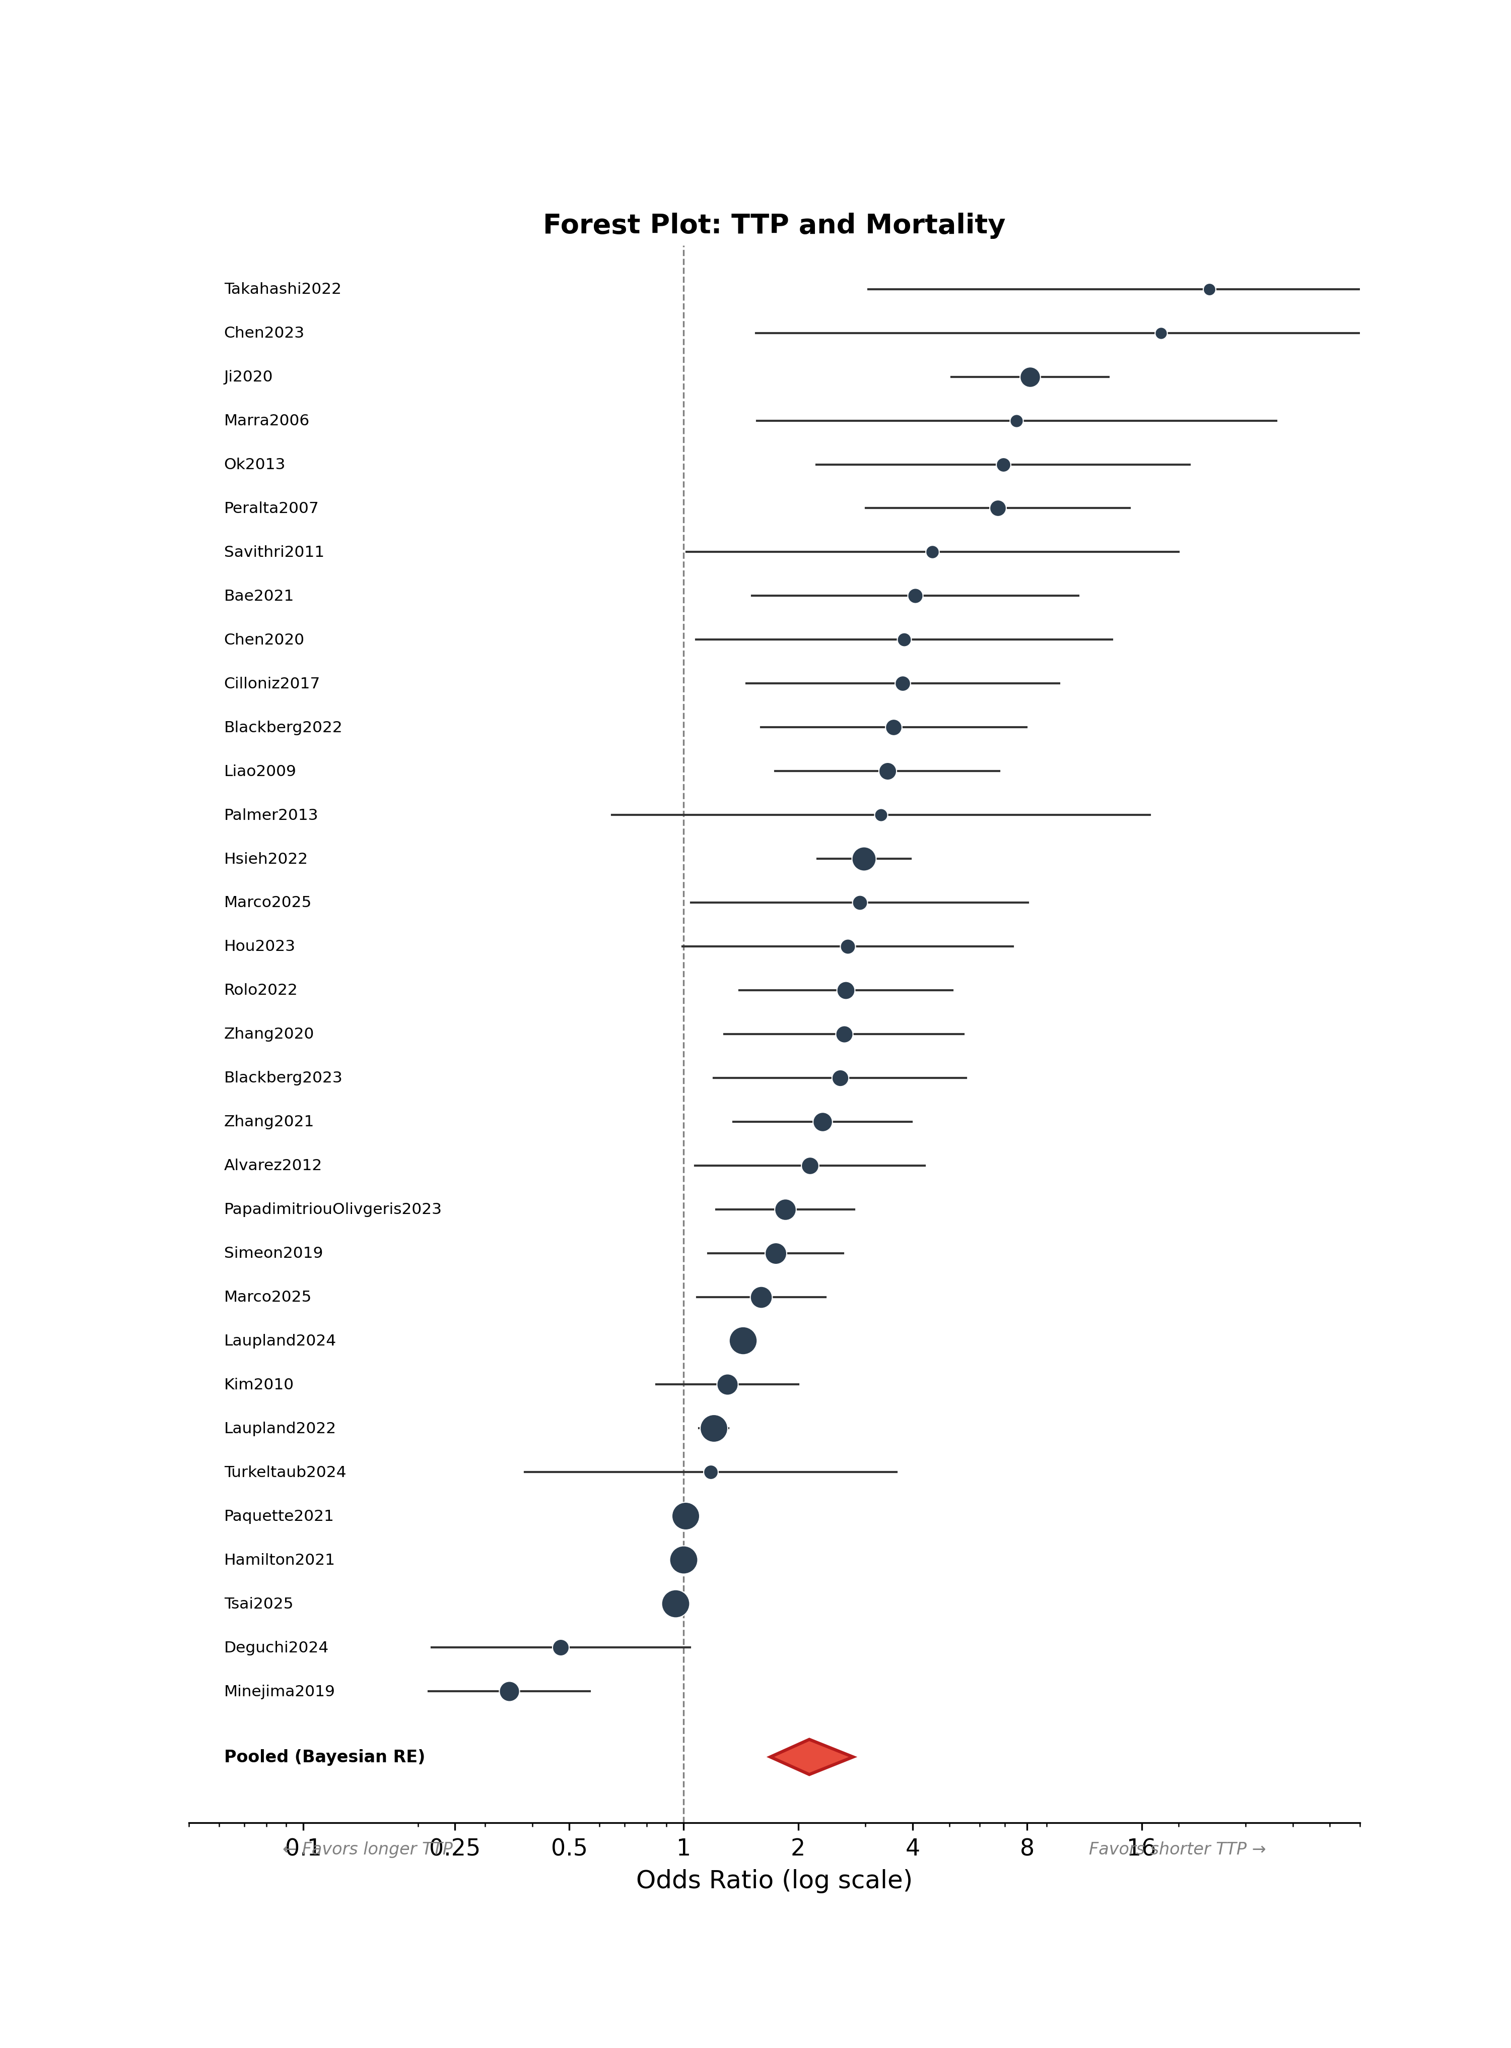
Figure 3. Forest plot of the association between short TTP and mortality (k = 33). Each square represents an individual study’s odds ratio, with size proportional to the study’s weight in the random-effects model. Horizontal lines indicate 95% confidence intervals. The red diamond at the bottom represents the Bayesian pooled estimate (OR = 2.14, 95% CrI: 1.69–2.79). The dashed vertical line indicates the null effect (OR = 1).

4.3.2 Heterogeneity
Substantial between-study heterogeneity was observed, with I² = 99.3% and τ = 0.58 on the log-OR scale. This indicates that most of the variability in observed effect sizes reflects true differences between studies rather than sampling error alone. Despite this heterogeneity, the direction of effect was remarkably consistent: only 3 of 33 studies (9%) reported odds ratios below 1.0.

4.4 Secondary Outcome: Persistent Bacteremia
The Bayesian meta-analysis of persistent bacteremia (k = 9) yielded a pooled OR of 4.02 (95% CrI: 1.08–11.11; Table 2), with a 97.9% posterior probability that short TTP increases the risk of microbiological failure. The frequentist estimate was somewhat larger (OR = 7.24, 95% CI: 2.07–25.38), reflecting the greater influence of outlying studies with extreme effect sizes (Melling2019, OR = 37; Kassis2009, OR = 75). The Bayesian estimate was more conservative due to prior regularization. A sensitivity analysis excluding these two outliers (k = 5) yielded an OR of 2.80 (95% CrI: 1.13–6.92), confirming the association’s robustness. The forest plot for this outcome is presented in Figure 4.
Table 2. Summary of persistent bacteremia meta-analysis results.
Analysis | Pooled OR | 95% CI/CrI | τ
Frequentist REML | 7.24 | 2.07–25.38 | 1.61
Bayesian RE (primary) | 4.02 | 1.08–11.11 | 1.61
Sensitivity (excl. outliers, k=5) | 2.80 | 1.13–6.92 | 0.92

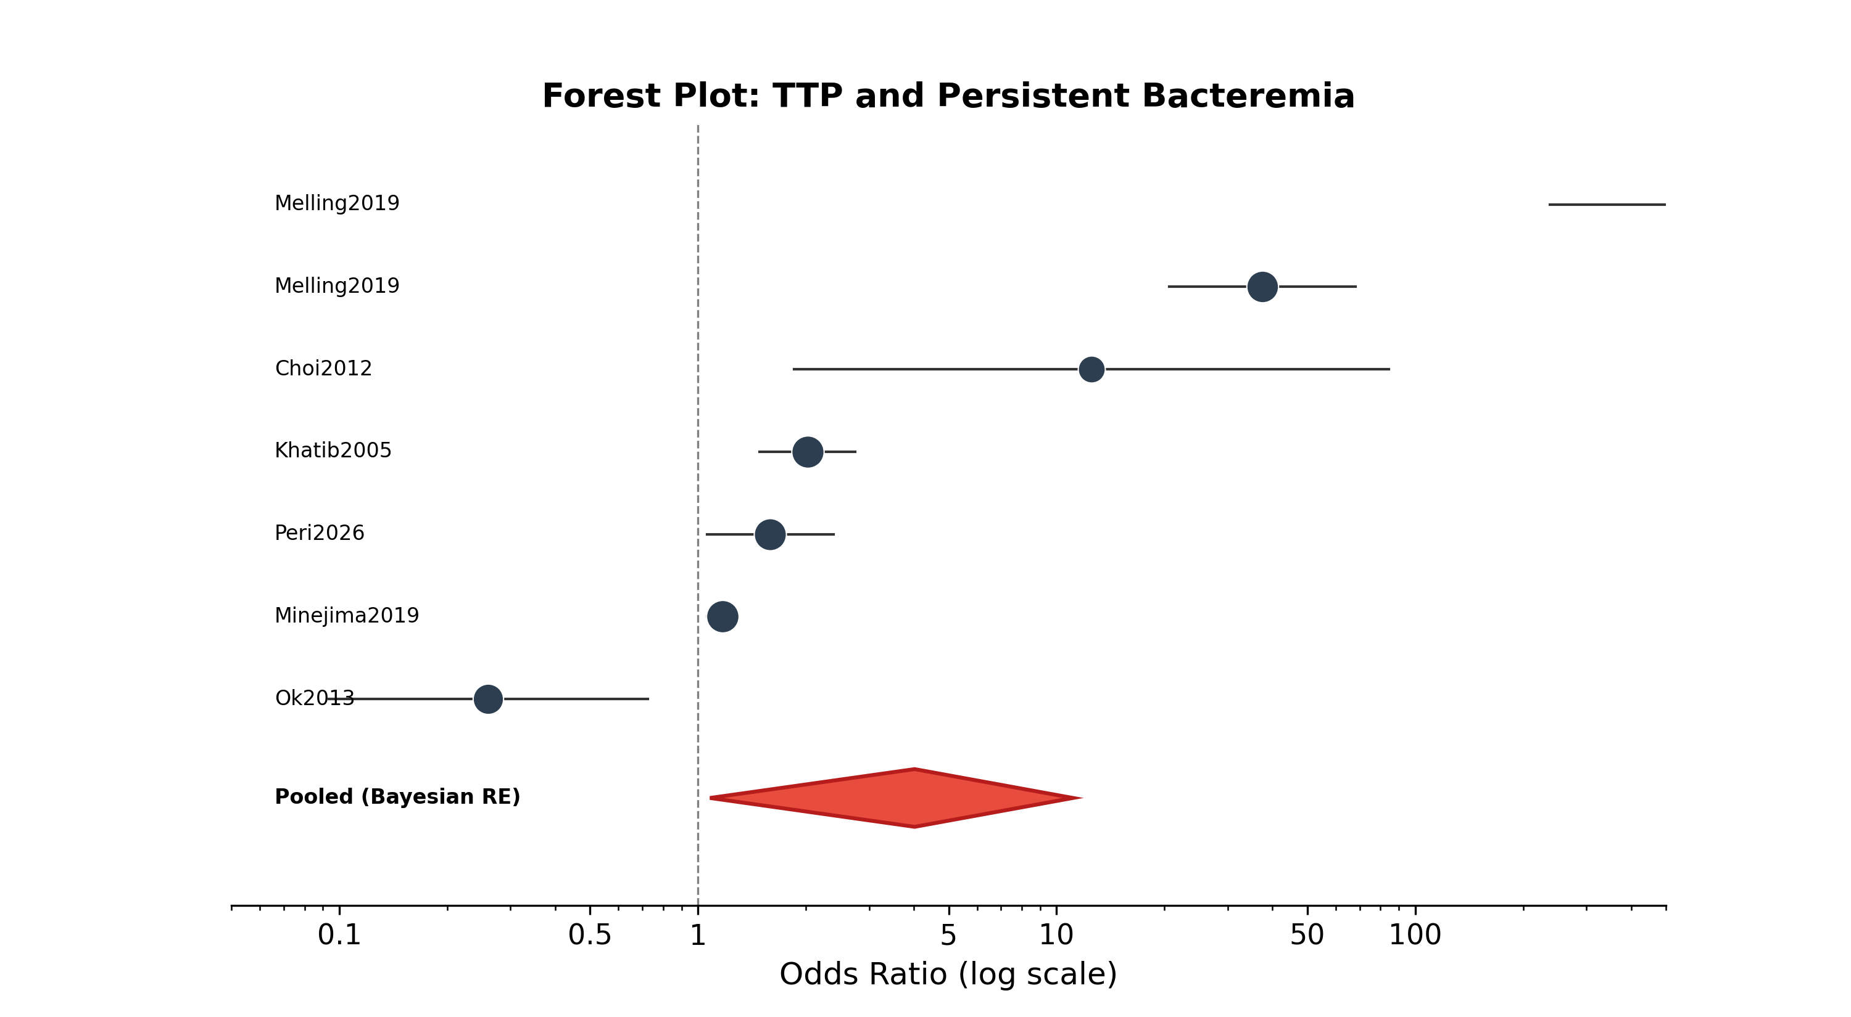
Figure 4. Forest plot of the association between short TTP and persistent bacteremia (k = 9). The substantially wider confidence intervals compared to the mortality analysis reflect the smaller number of studies and greater variability. The pooled Bayesian estimate (red diamond; OR = 4.02, 95% CrI: 1.08–11.11) suggests a strong association, though with considerable uncertainty.

4.5 Pathogen-Stratified Analysis
Stratified analysis by pathogen class revealed virtually identical TTP–mortality associations for Gram-positive (OR = 2.17, 95% CrI: 1.52–3.36, k = 12) and Gram-negative (OR = 2.06, 95% CrI: 1.48–3.15, k = 14) infections (Figure 5; Table 3). The ratio of odds ratios was 1.05 (95% CrI: 0.61–1.83), with only a 57.7% posterior probability of any difference between the two groups — essentially indistinguishable from chance. Both subgroups demonstrated 100% posterior probability that OR > 1.
Table 3. Pathogen-stratified mortality analysis.
Pathogen Class | k | Pooled OR | 95% CrI | P(OR > 1) | τ
Gram-Positive | 12 | 2.17 | 1.52–3.36 | 100% | 0.47
Gram-Negative | 14 | 2.06 | 1.48–3.15 | 100% | 0.49
Difference | — | 0.05 log-OR | −0.50 to 0.60 | 57.7% | —

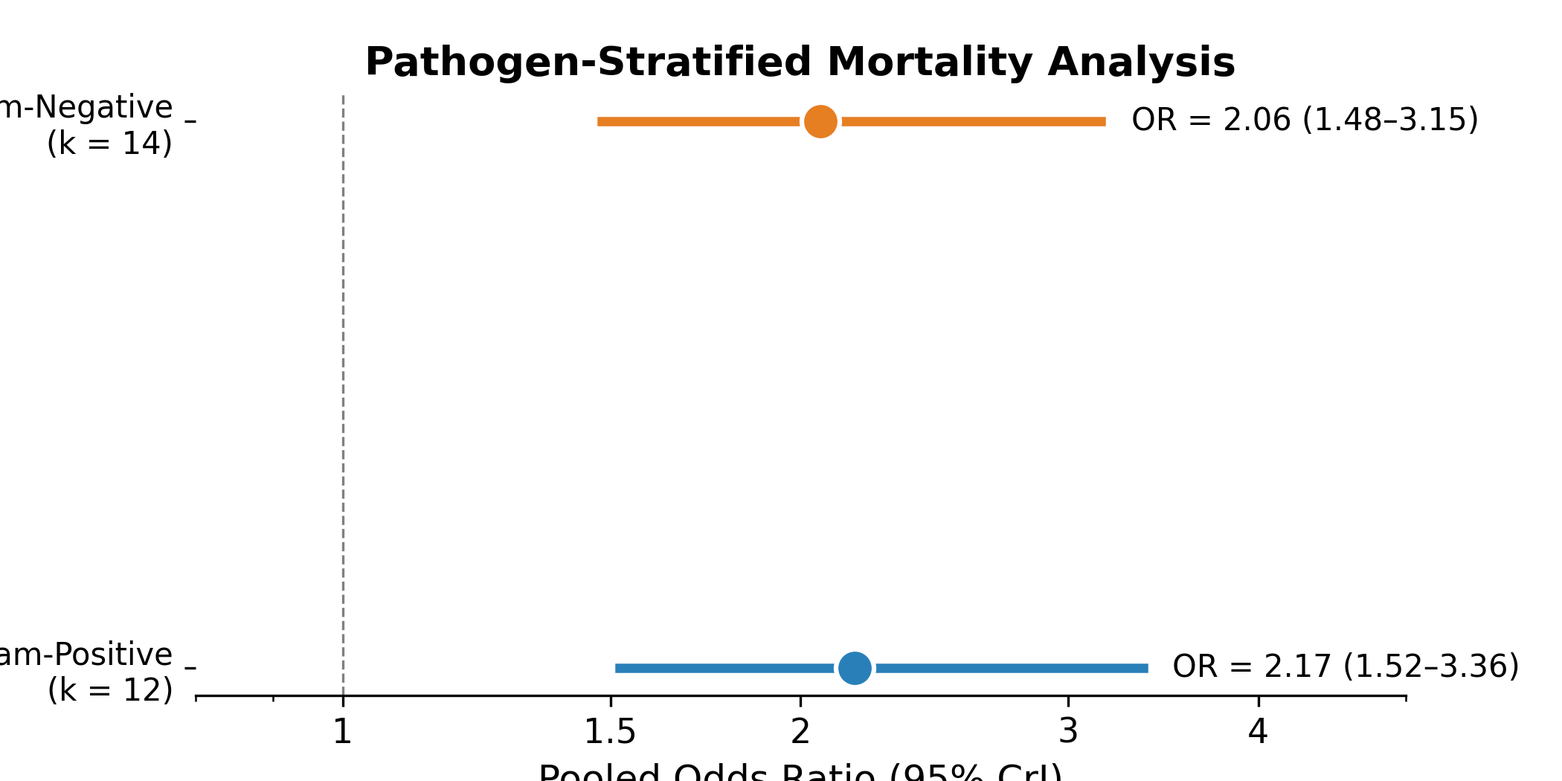
Figure 5. Comparison of pooled odds ratios for the TTP–mortality association between Gram-positive and Gram-negative infections. Point estimates and 95% credible intervals are shown. The near-complete overlap demonstrates that TTP is a pathogen-agnostic prognostic marker, effective regardless of the infecting organism type.

4.6 Meta-Regression
Univariable Bayesian meta-regressions were conducted to explore potential sources of the substantial between-study heterogeneity. The results are summarized in Table 4. No prespecified moderator achieved conventional statistical significance, and the residual τ remained essentially unchanged (range: 0.49–0.58) across all models compared to the unadjusted value of 0.58, indicating that the tested moderators did not explain heterogeneity.
Table 4. Univariable Bayesian meta-regression results for the mortality outcome (k = 33).
Moderator | β (log-OR) | 95% CrI | P(β ≠ 0) | Residual τ
Pathogen class (GN vs GP) | −0.05 | −0.60 to 0.50 | 57.7% | 0.58
S. aureus (vs other) | 0.12 | −0.38 to 0.62 | 68.2% | 0.57
Risk of bias (high vs low) | −0.08 | −0.55 to 0.39 | 61.5% | 0.58
Blood culture system | 0.15 | −0.42 to 0.72 | 71.3% | 0.57
TTP cutpoint (per hour) | −0.032 | −0.068 to 0.004 | 96.1% | 0.49

The TTP cutpoint showed the strongest trend among all moderators (β = −0.032 log-OR per hour, 96.1% posterior probability of a negative slope), suggesting that lower cutpoints (e.g., ≤10–12 hours) may capture a stronger prognostic signal. At higher cutpoints (≥48 hours), the effect attenuates. However, this did not reach conventional significance and should be interpreted as hypothesis-generating.

4.7 Publication Bias
Evidence of funnel plot asymmetry was detected by both visual inspection (Figure 6) and Egger’s regression test (p < 0.001). Only 3 of 33 mortality studies (9%) reported non-significant results, a rate that exceeds expectation even for a substantial true effect. The trim-and-fill method imputed 11 missing studies and yielded an adjusted pooled OR of 1.50 (95% CI: 1.15–1.96), which remained statistically significant.
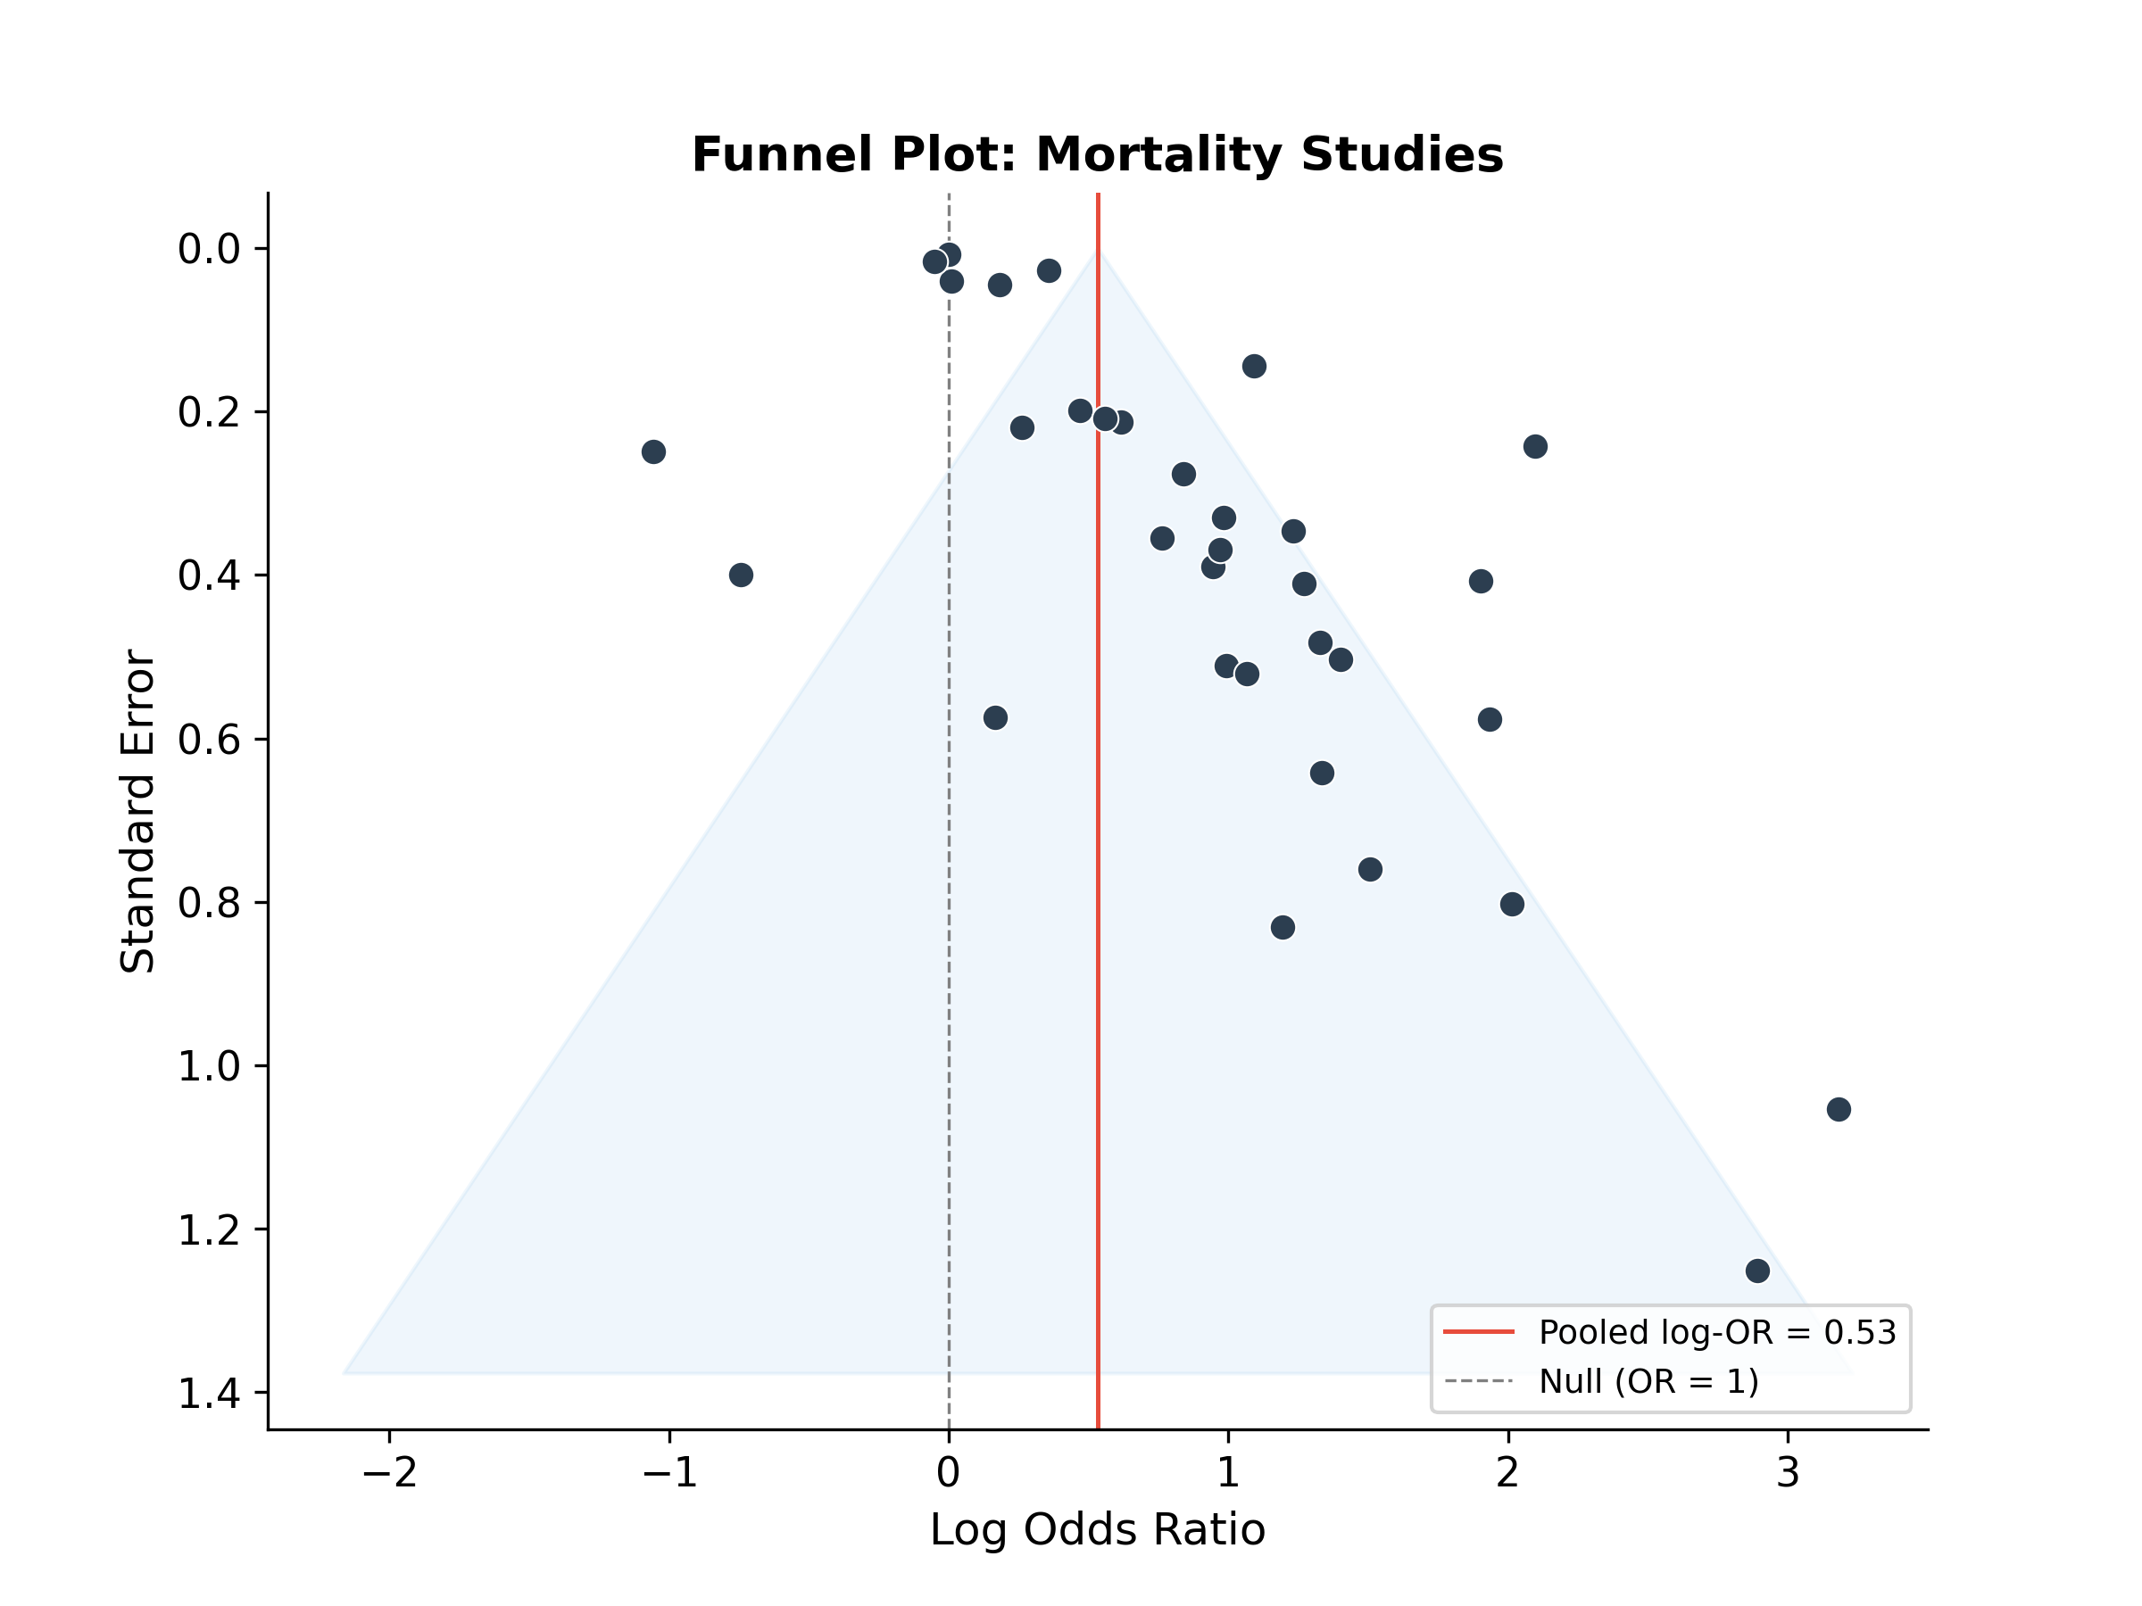
Figure 6. Funnel plot for the mortality meta-analysis (k = 33). Each point represents a study, plotted against its standard error (inverse of precision). The red vertical line indicates the pooled log-OR estimate. The shaded region represents the pseudo 95% confidence region. Asymmetry with a deficit of small studies in the lower-left quadrant suggests potential publication bias or small-study effects.
The comprehensive comparison of publication bias adjustment methods is presented in Figure 7 and Table 5. Notably, the frequentist step-function selection model estimated an extreme selection parameter (δ = 0.037, indicating only 3.7% publication probability for non-significant studies) and yielded a non-significant adjusted OR of 1.09 (95% CI: 0.67–1.79). In contrast, both Bayesian selection models — using either uninformative Uniform(0, 1) or skeptical Beta(2, 5) priors for δ — yielded pooled ORs of approximately 2.14 with P(OR > 1) = 100%, virtually identical to the unadjusted estimate.
Table 5. Comparison of publication bias adjustment methods for the mortality outcome.
Method | Pooled OR | 95% CI/CrI | Selection δ | Significant?
Unadjusted (REML) | 2.18 | 1.72–2.75 | — | Yes
Trim-and-Fill | 1.50 | 1.15–1.96 | — | Yes
Freq. Step-function | 1.09 | 0.67–1.79 | 0.037 | No
Bayesian Selection (uniform) | 2.14 | 1.70–2.78 | 0.84 | Yes
Bayesian Selection (skeptical) | 2.14 | 1.71–2.80 | 0.50 | Yes

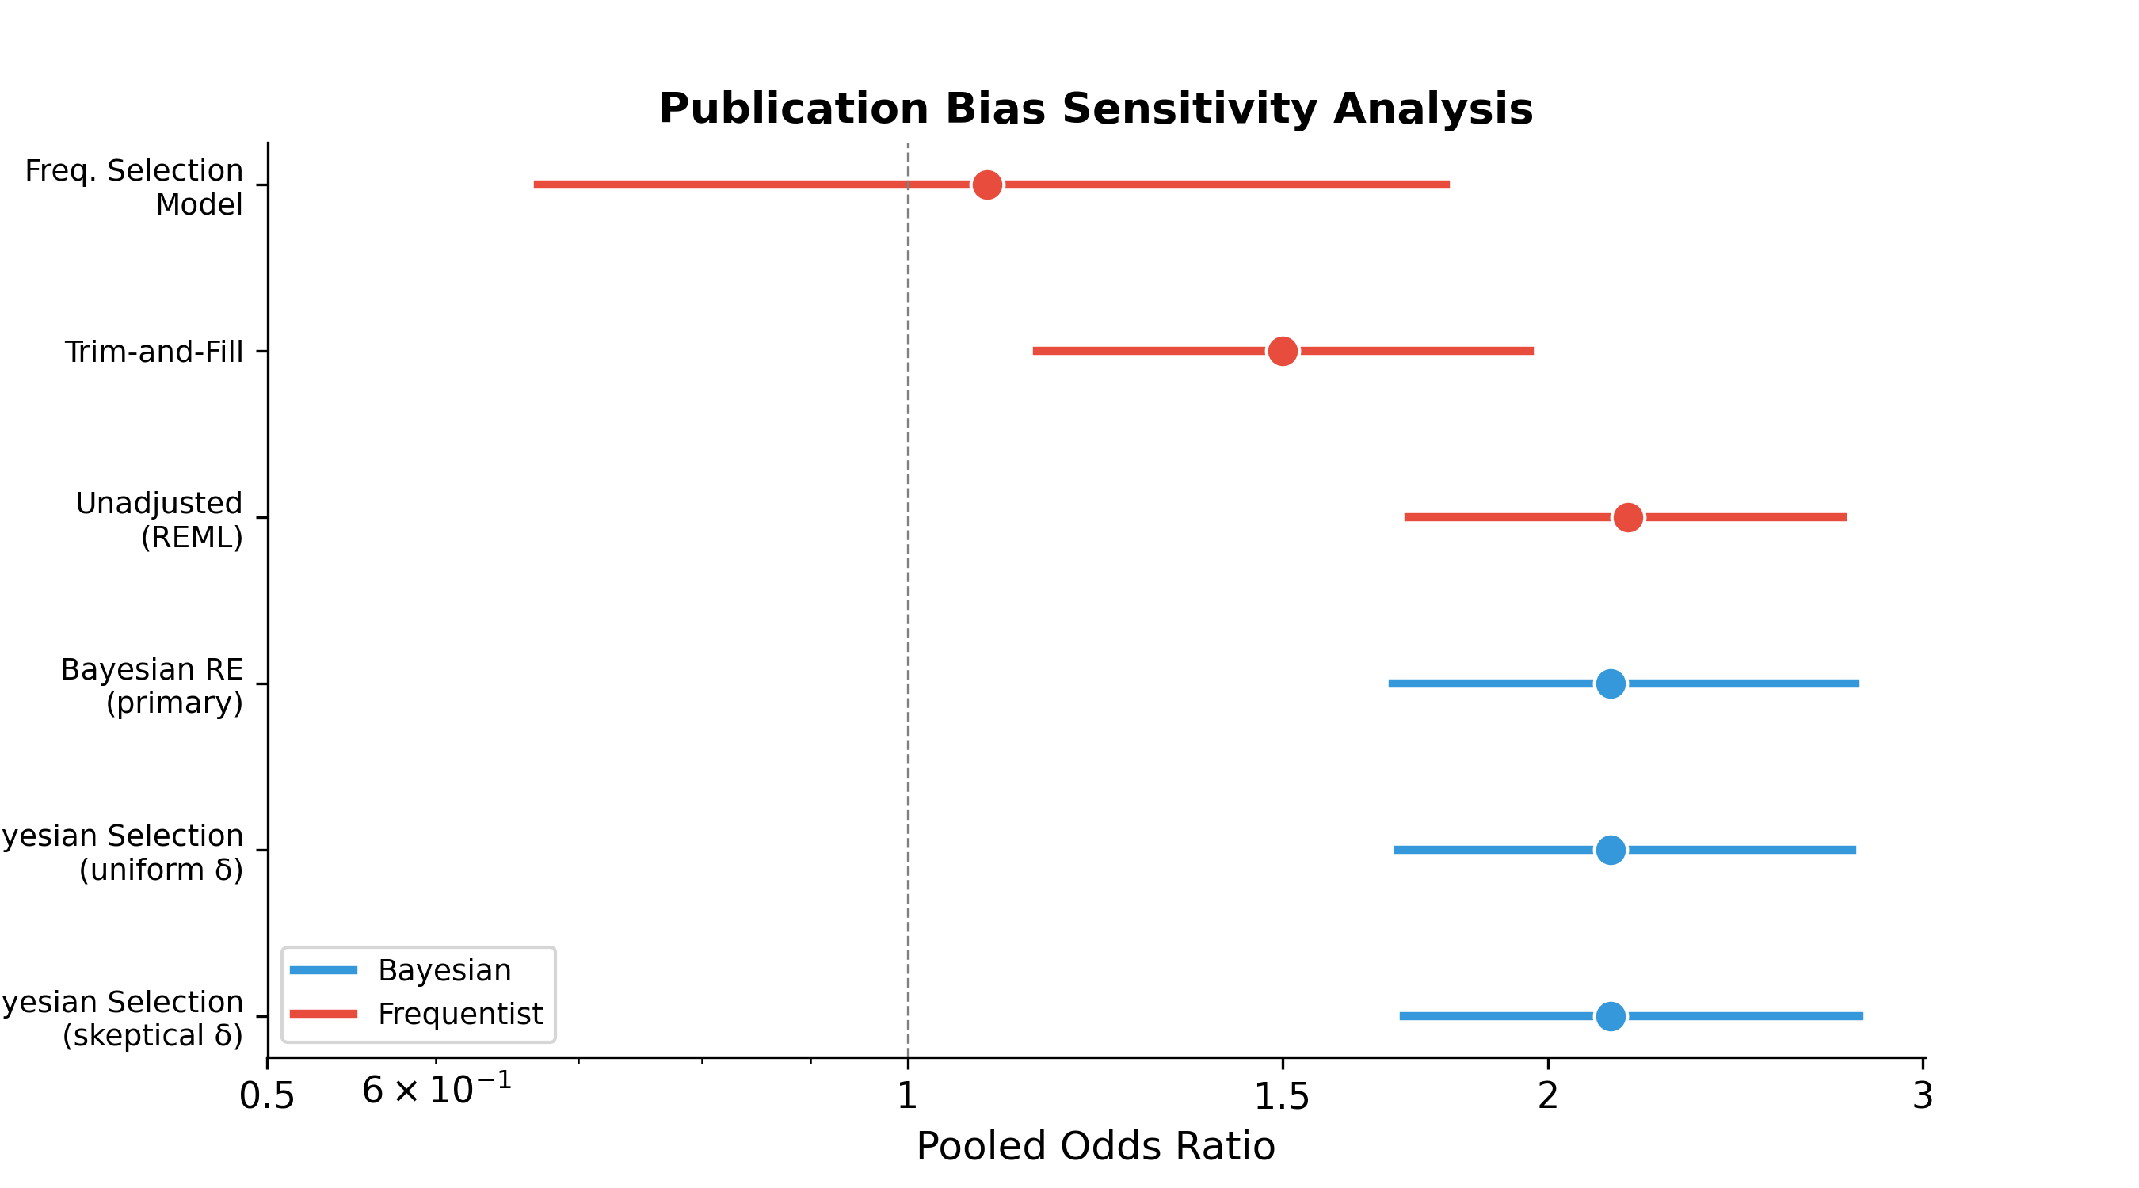
Figure 7. Forest-style comparison of pooled odds ratios across publication bias adjustment methods. Blue markers indicate Bayesian approaches; red markers indicate frequentist approaches. Error bars represent 95% credible or confidence intervals. The dashed vertical line represents the null effect (OR = 1). All methods except the frequentist step-function selection model yielded significant associations.
The discrepancy between frequentist and Bayesian selection models is attributable to the sparsity of non-significant studies (n = 3): the frequentist maximum likelihood estimator for δ is poorly identified with such limited data and tends toward extreme values, whereas the Bayesian priors provide the regularization necessary to stabilize estimation.

4.8 Sensitivity Analyses

4.8.1 Prior Sensitivity
The pooled mortality OR was tested across four prior specifications to assess the influence of the prior on posterior inference (Figure 8). The primary estimate (OR = 2.14) varied by less than ±4% across all prior choices (range: 1.99–2.15), demonstrating that the data strongly dominate the posterior and the results are insensitive to reasonable prior choices.
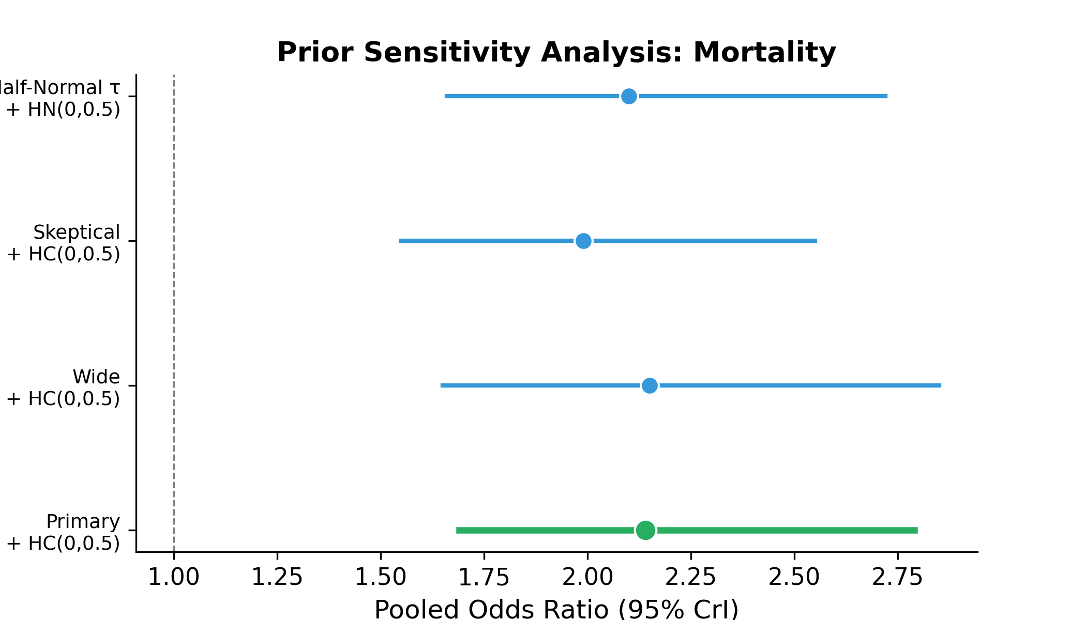
Figure 8. Prior sensitivity analysis for the mortality pooled odds ratio. The primary analysis (green) used Normal(0, 1) + Half-Cauchy(0, 0.5) priors. Blue markers show alternative specifications. The narrow range of point estimates (1.99–2.15) demonstrates insensitivity to prior choice.

4.8.2 Outlier Sensitivity
Exclusion of the most influential study (Ji2020, OR = 40.45) reduced the pooled mortality OR from 2.14 to 2.00 (95% CrI: 1.61–2.47), a modest attenuation that confirms the finding is not driven by any single extreme result. The between-study heterogeneity also decreased (τ from 0.58 to 0.50), suggesting that Ji2020 contributed disproportionately to observed variability.

4.8.3 Risk of Bias Sensitivity
Restricting the analysis to studies with low overall risk of bias (k ≈ 9) yielded an OR of approximately 1.95 (95% CrI: 1.38–2.81), consistent with the primary estimate. The stability of the pooled estimate across quality strata, combined with the null meta-regression result for risk of bias, provides reassurance that the finding is not an artifact of methodological limitations in lower-quality studies.

4.9 Summary of Key Findings
In summary, this Bayesian meta-analysis provides robust evidence that short blood culture TTP is associated with approximately twice the odds of mortality (OR = 2.14, 95% CrI: 1.69–2.79, P(OR > 1) = 100%) and four times the odds of persistent bacteremia (OR = 4.02, 95% CrI: 1.08–11.11, P(OR > 1) = 97.9%). The mortality association is pathogen-agnostic, insensitive to prior specification, and robust across multiple publication bias adjustment approaches. Although considerable heterogeneity exists (I² = 99.3%), no prespecified moderator explains this variability, and the effect direction is remarkably consistent across studies.

