**EVERY SECTION LABELED BLUE WAS ADDED**

1. STUDENT NAME

Gino Russo

2. URL to STUDENT WEB SITE

https://cis-linux2.temple.edu/tomcat10/sp25_3308_tuo45914/index.html

3. user_role TABLE DESIGN

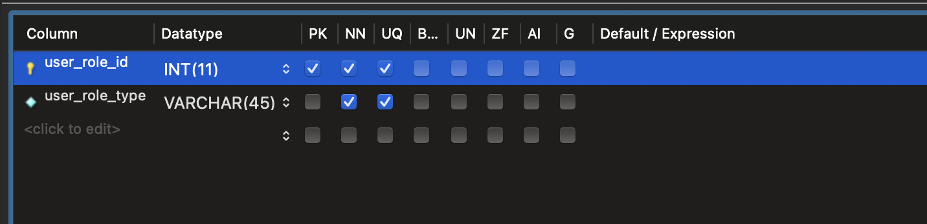

4. web_user TABLE DESIGN and FOREIGN KEY

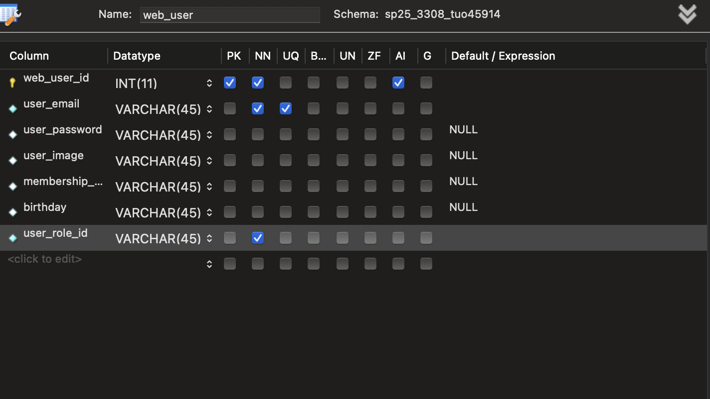

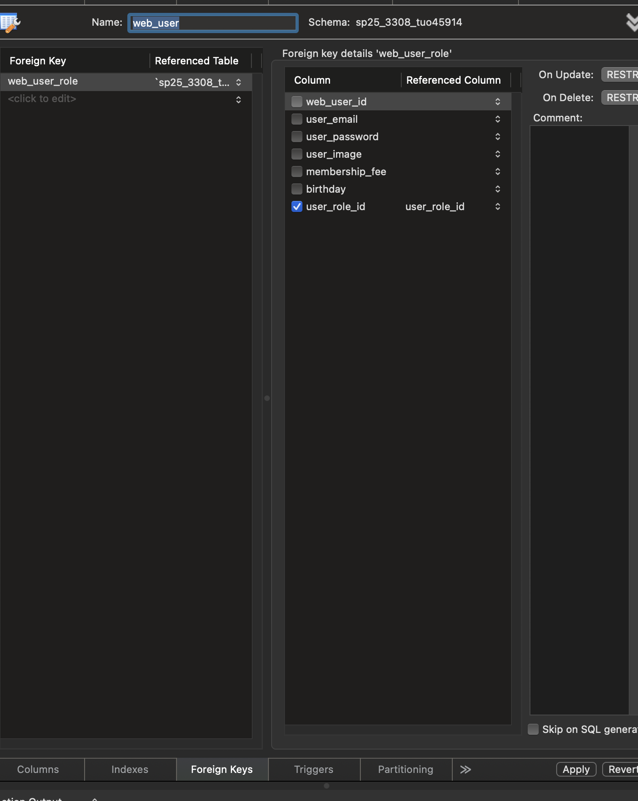

5. “OTHER” TABLE DESIGN and FOREIGN KEY

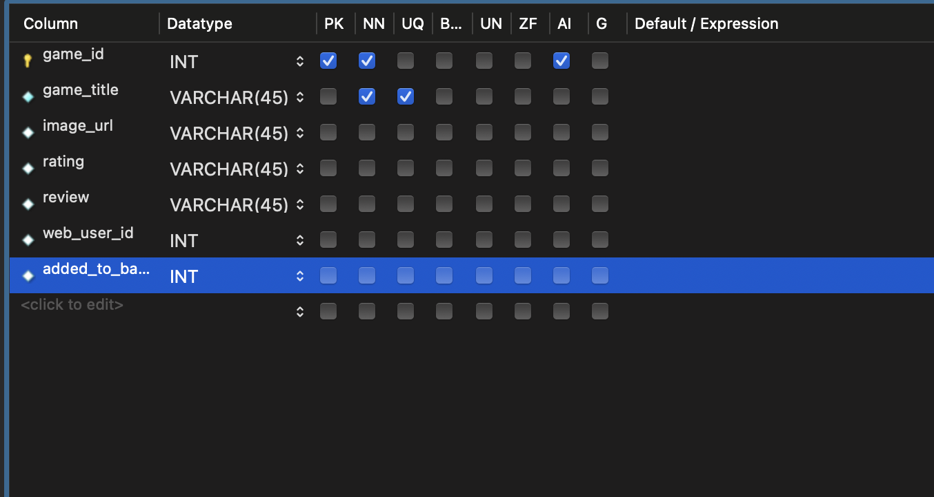

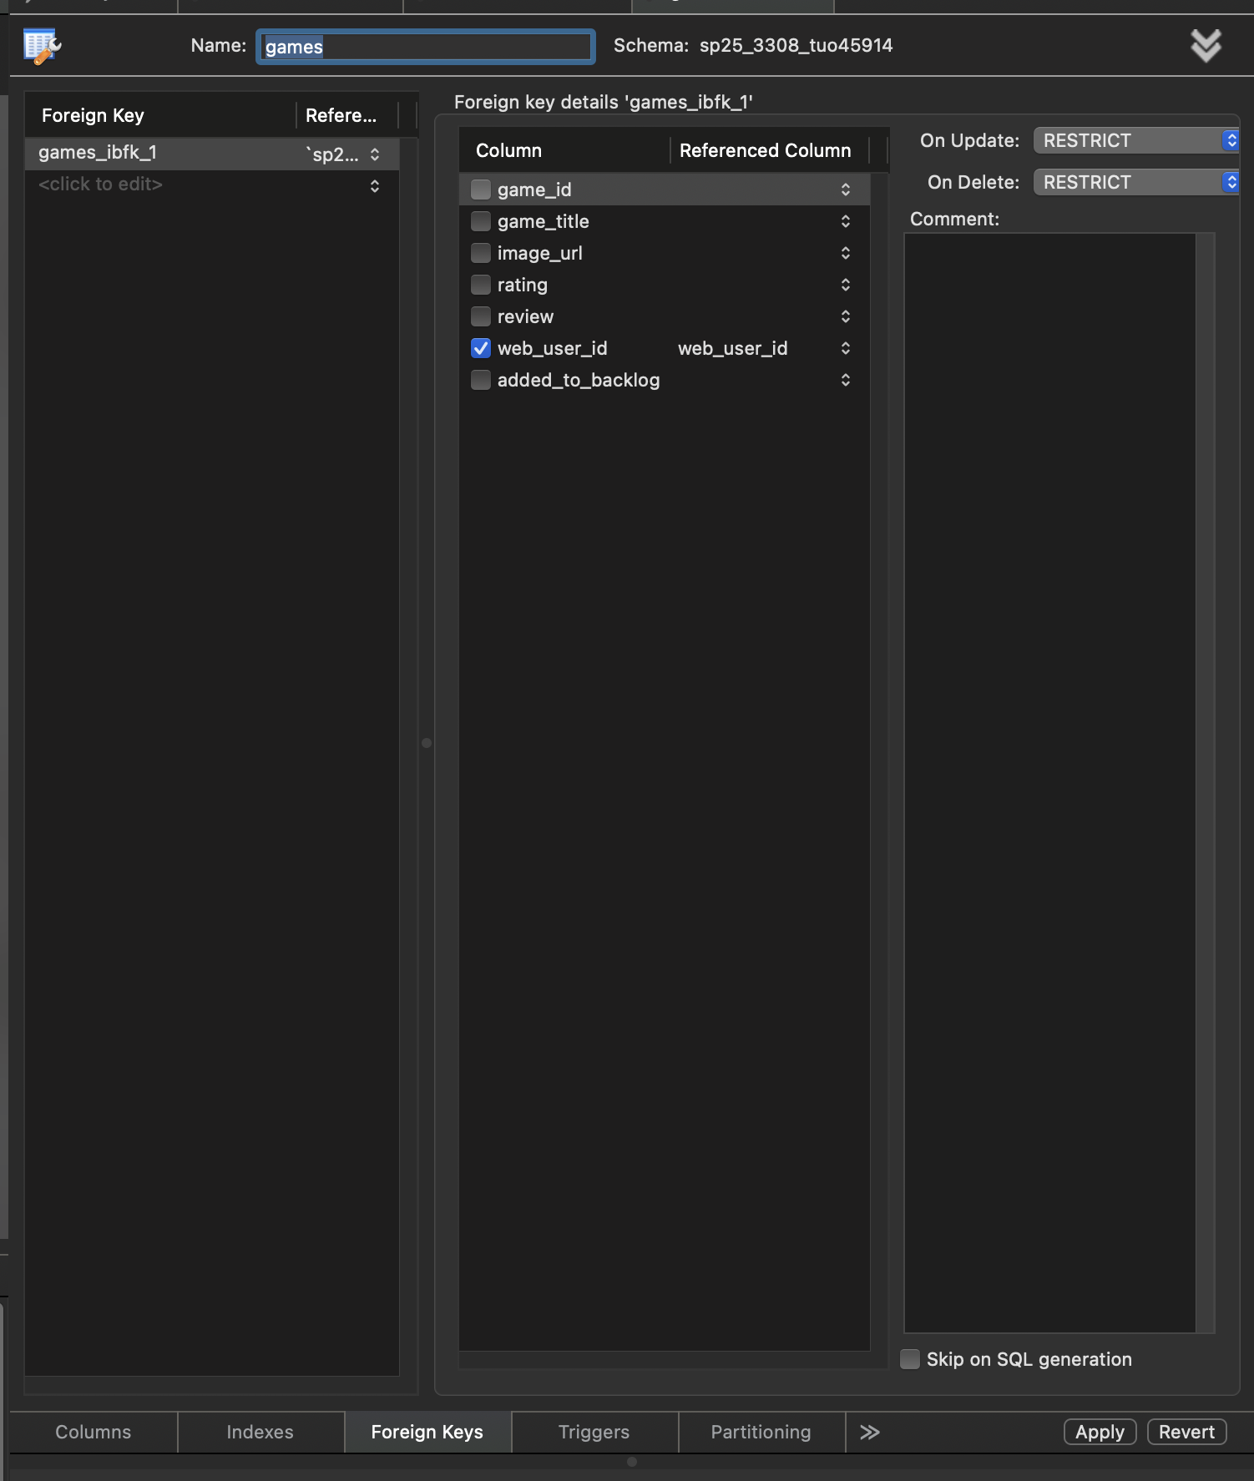

6. DATA ENTRY ERRORS

a) Error: Duplicate user_role PK

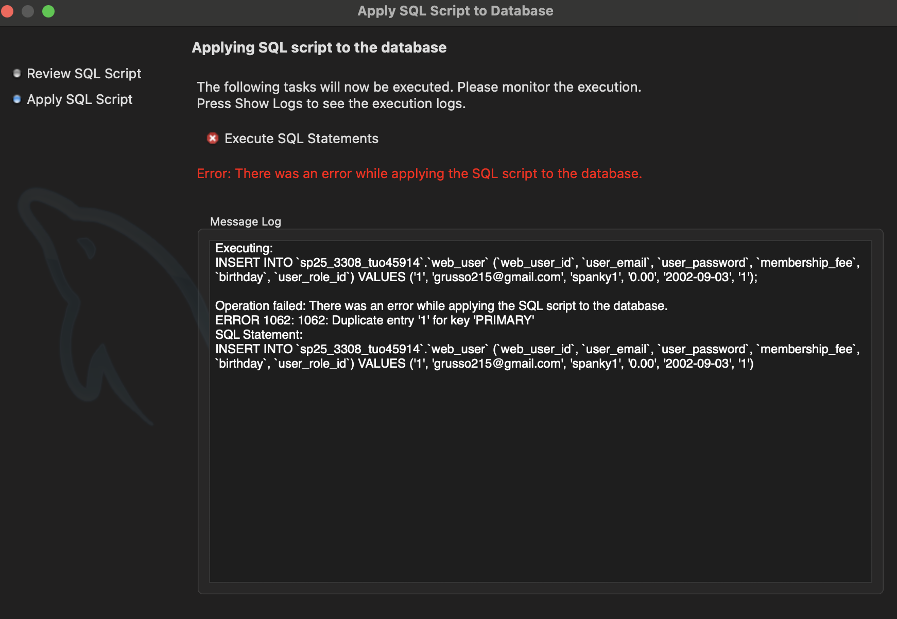

b) Error: Invalid user_role FK in web_user record

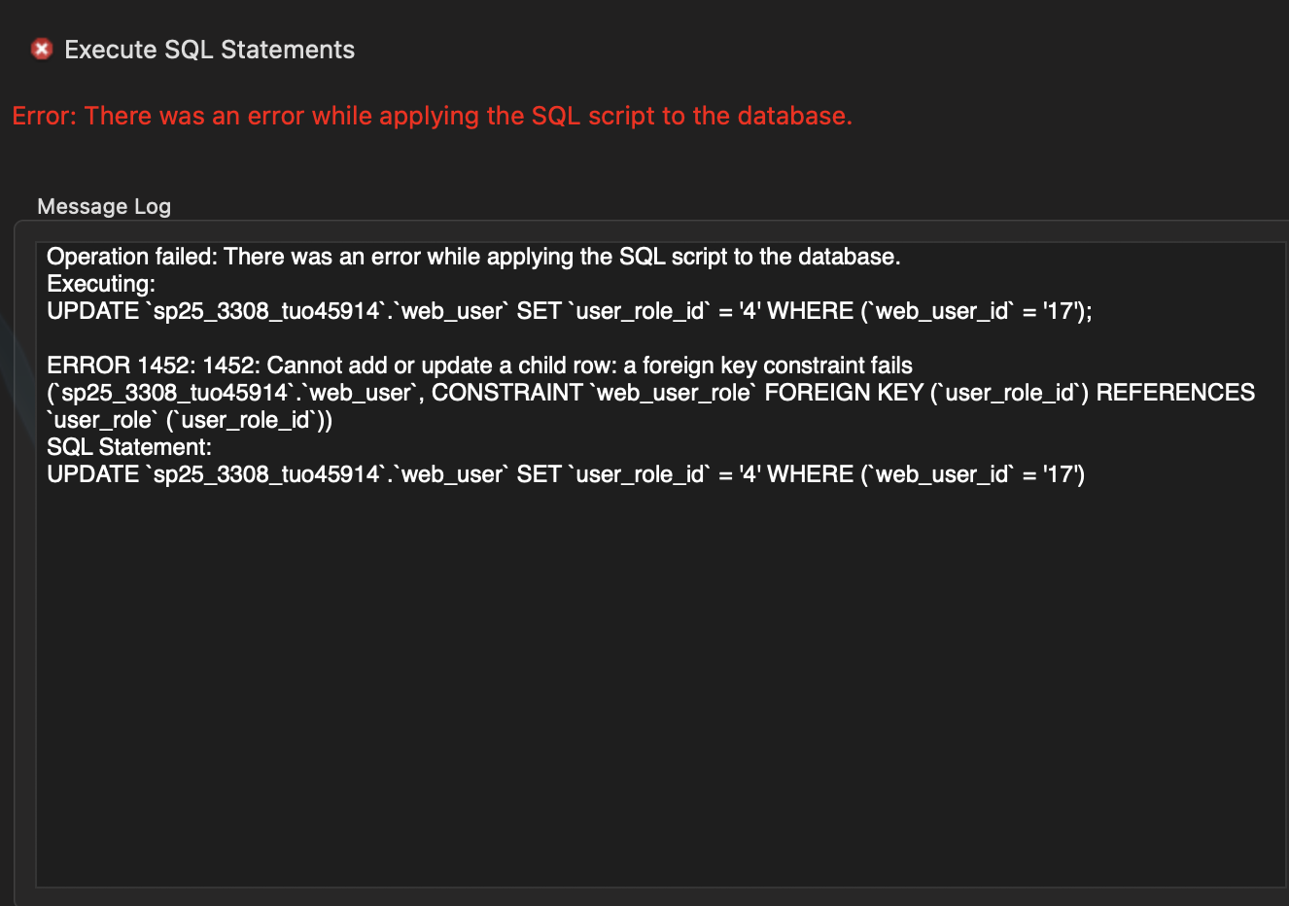

c) Error: Cannot delete a user_role record that’s referenced by a web _user record

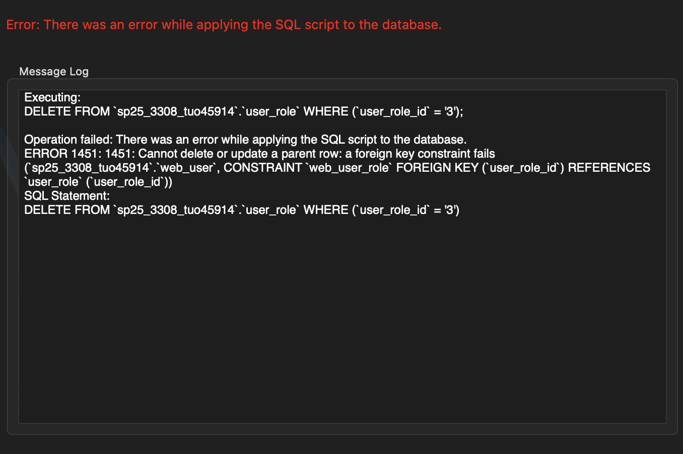

d) Invalid web_user FK in “other” record

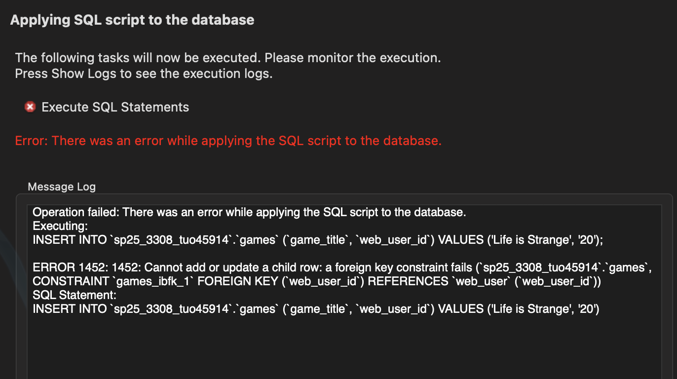

e) Error trying to delete a web_user record that’s referenced by an “other” record

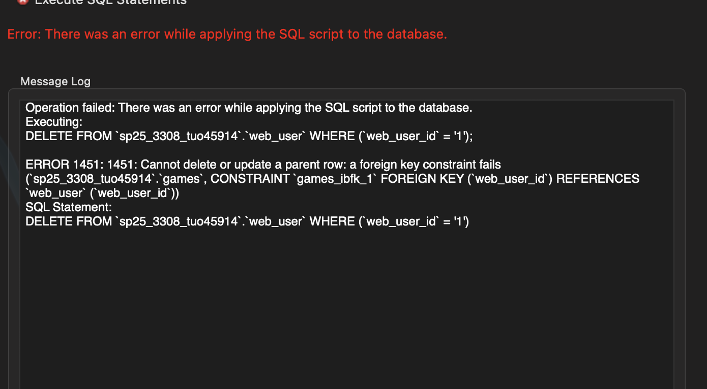

7. SELECT STATEMENTS

a) USER_ROLE: all rows, all columns, sorted by user_role_id.

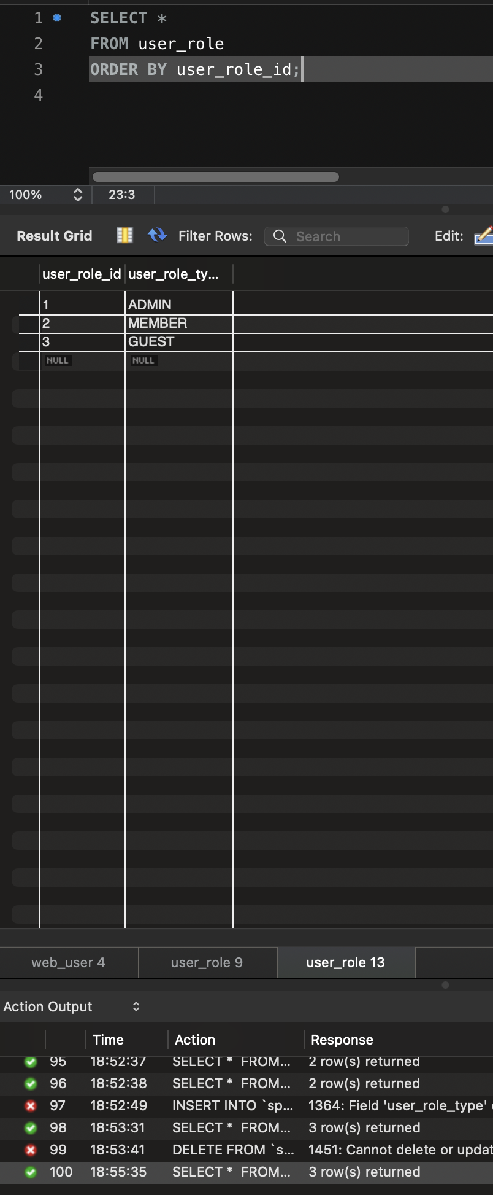

b) WEB_USER: all rows, all columns, sorted by web_user_id.

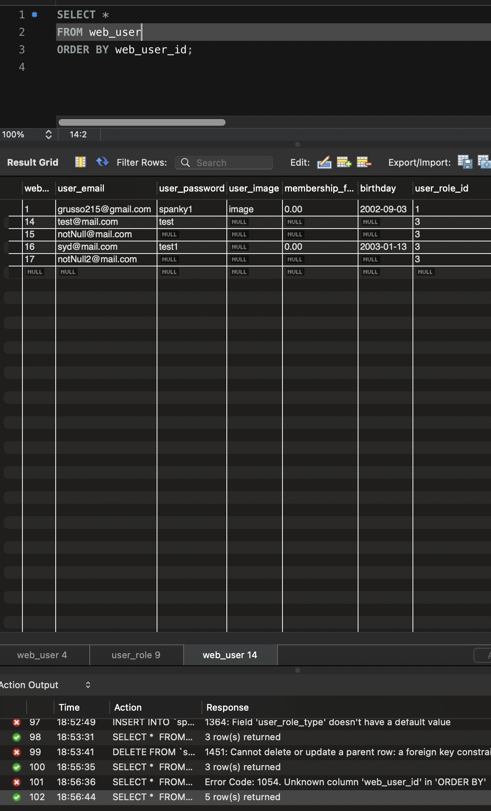

c) WEB_USER JOINED WITH USER_ROLE: all rows, certain columns, sorted.

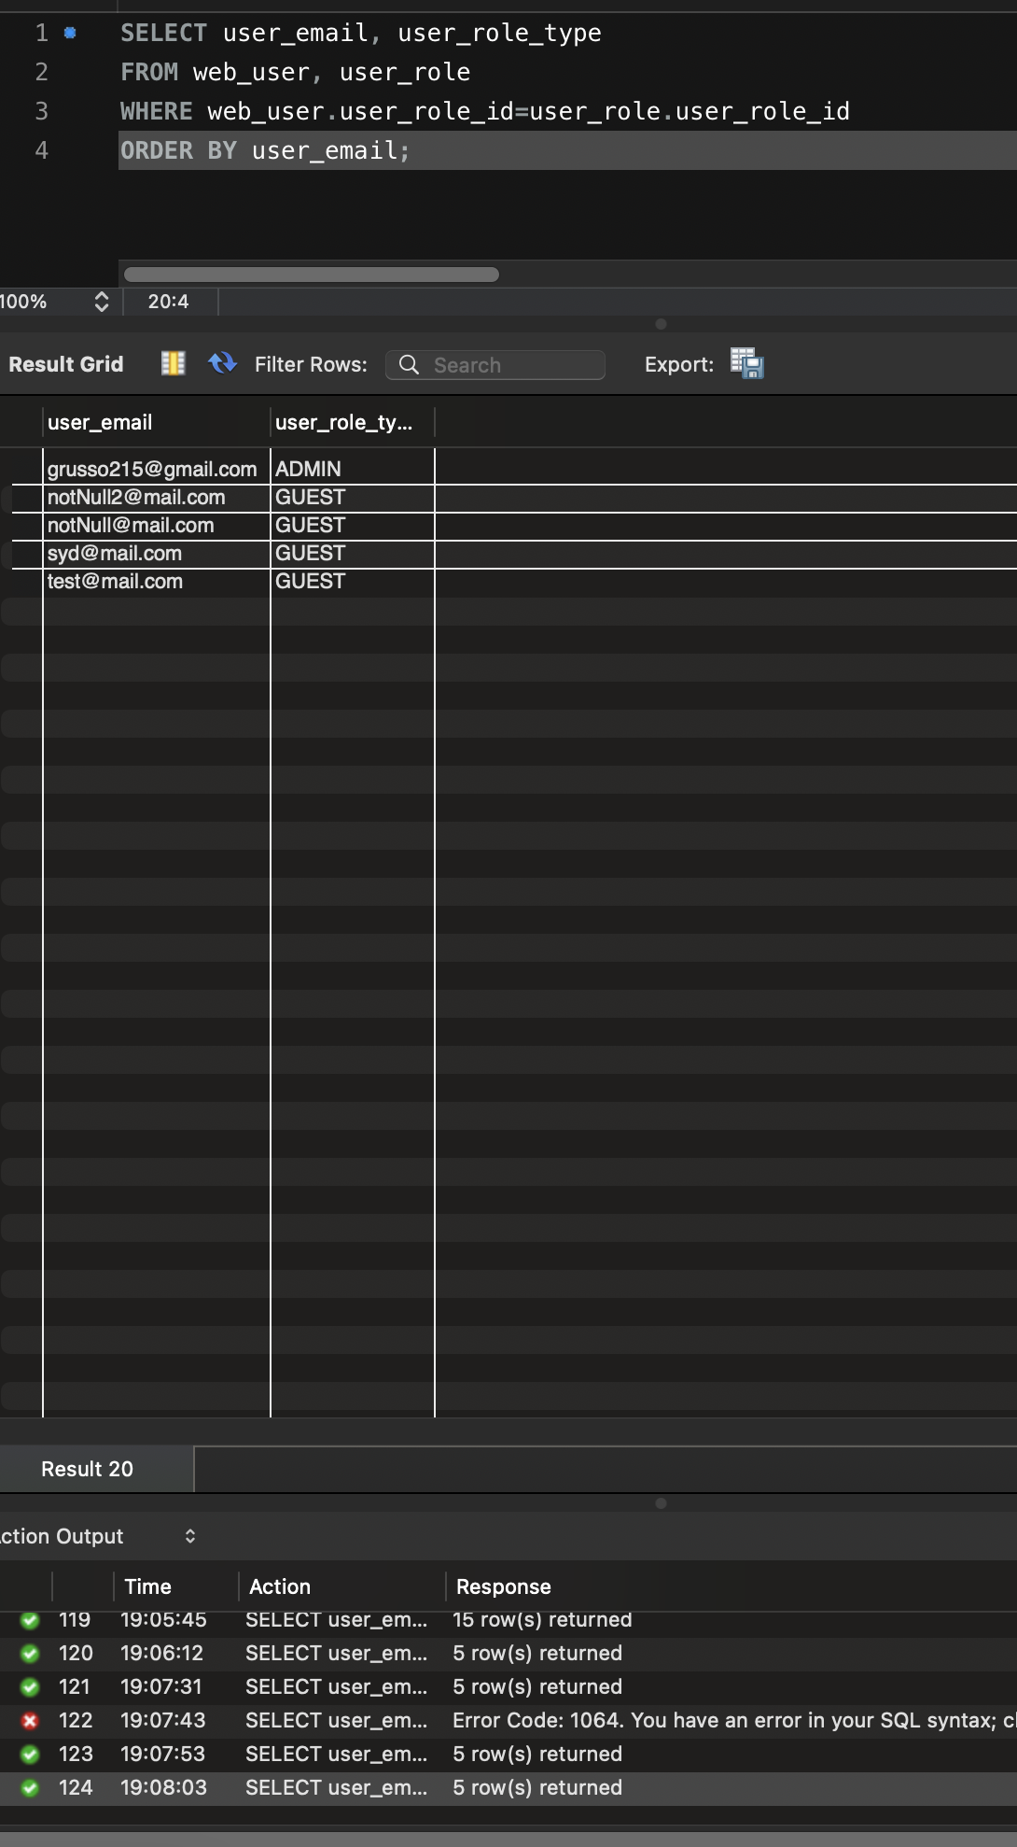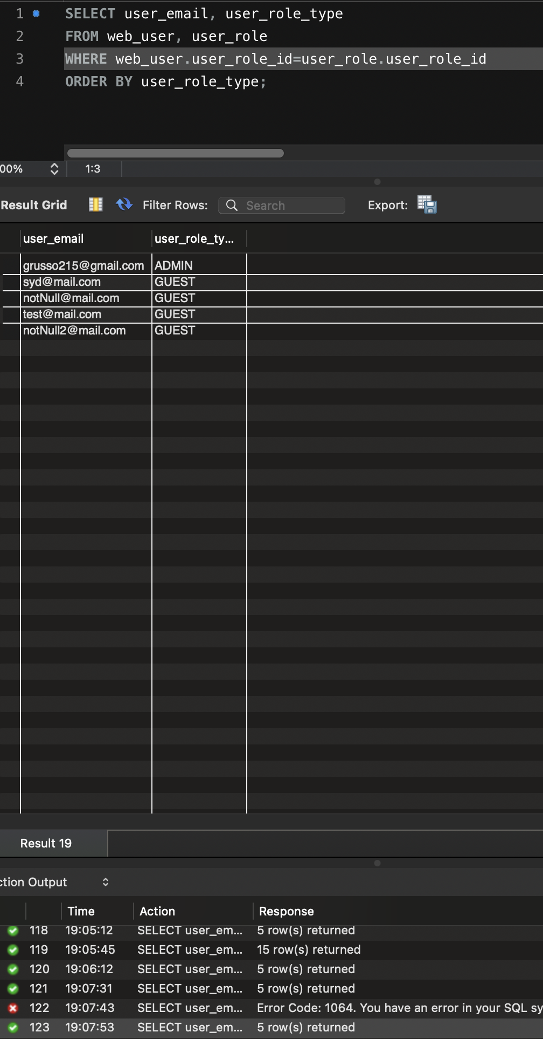

f) “OTHER”: all rows, all columns, sorted by the id of your “other” table.

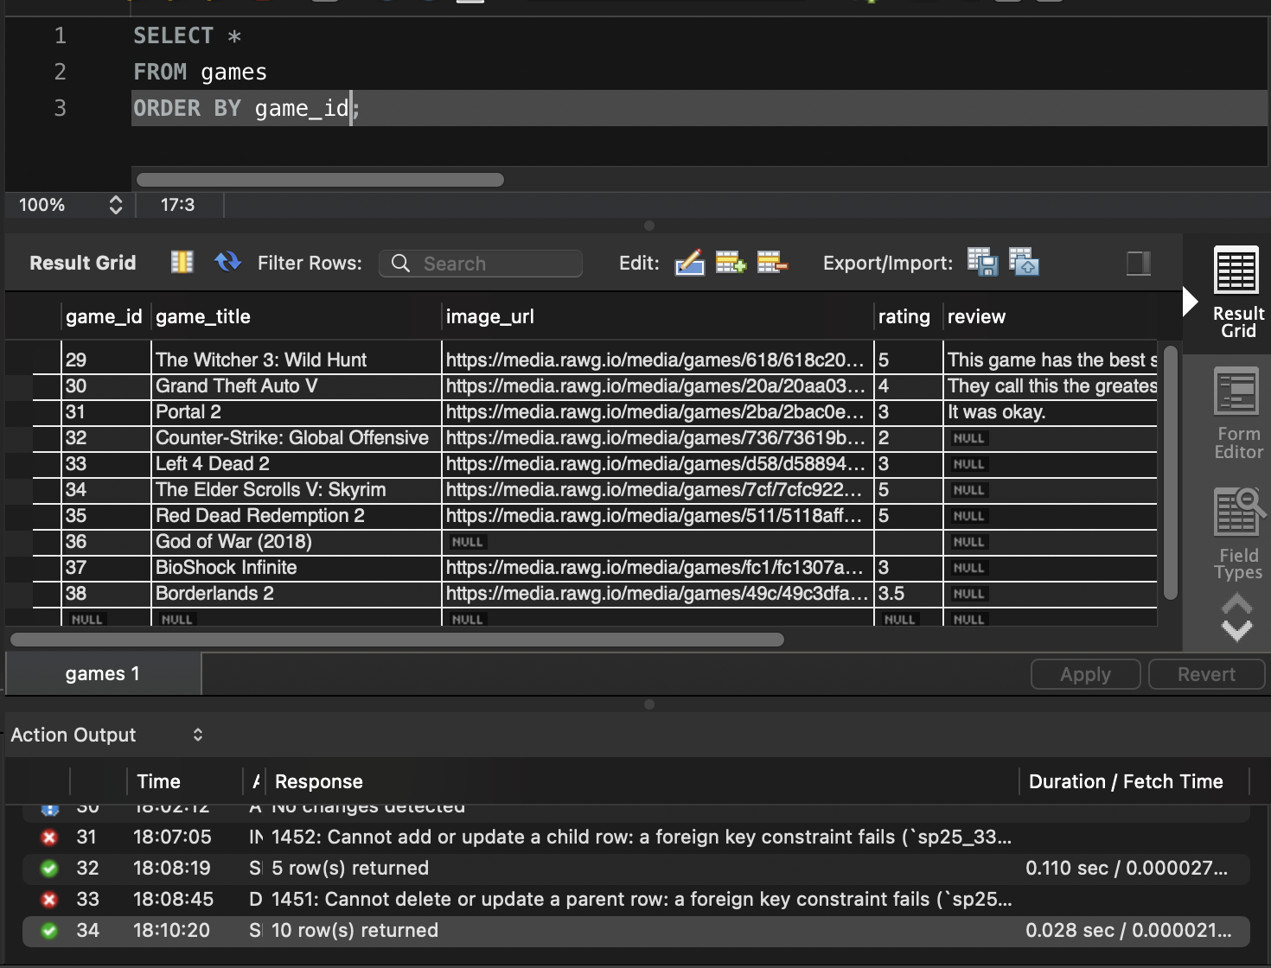

g) “OTHER” JOINED WITH WEB_USER all rows, certain columns, sorted.

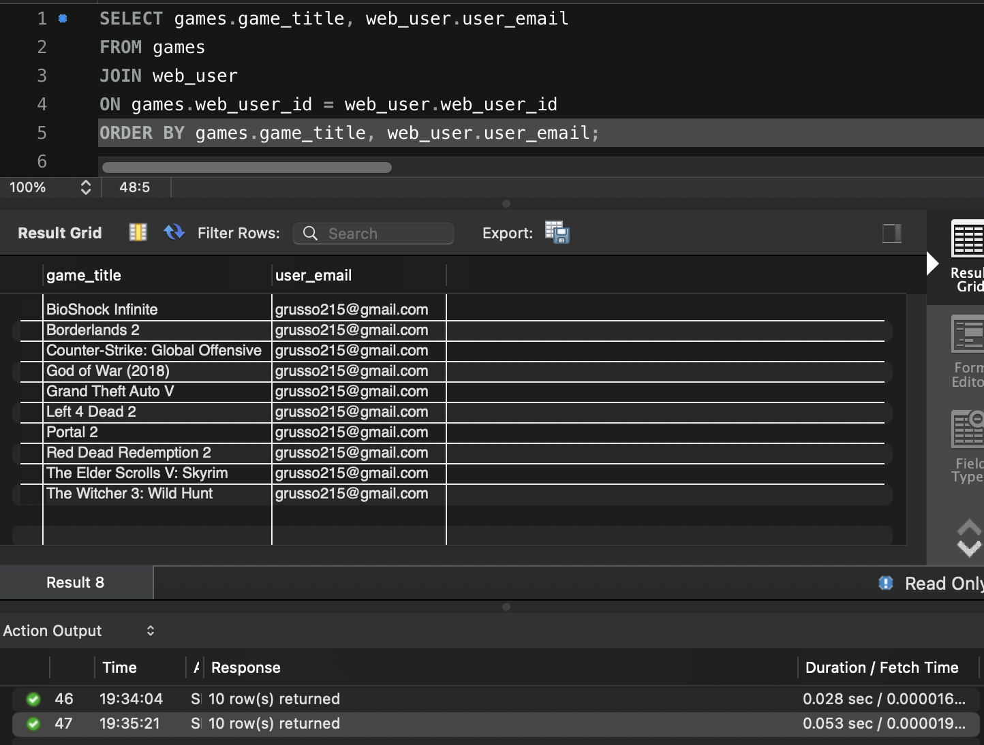

h) “OTHER” JOINED WITH WEB_USER some rows, certain columns, sorted.

