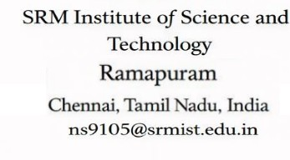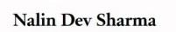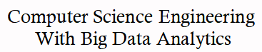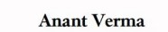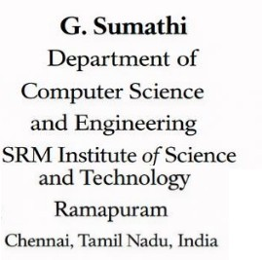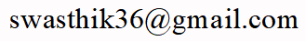

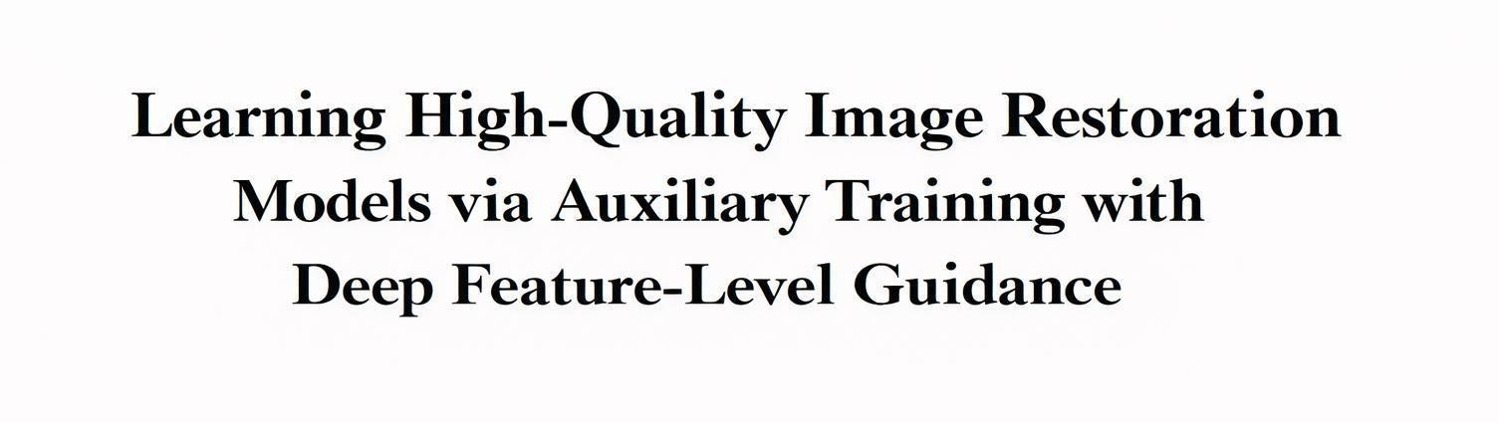
Abstract—It is also worth noting that many neural network designs have been developed for image restoration, mainly focusing on lifting accuracy while maintaining data speed — at least for now. Here's the deal: however, comparatively little attention has been given to boosting training strategies — if that makes sense. Now, this paper introduces Deep-Feature Extra Guidance (DFAG), a novel training method designed to enhance the accuracy of image Restoration models without increasing inference time or altering their designs. DFAG integrates auxiliary losses at Each multi-scale level during training, which helps stabilize deep feature learning and improves overall feature quality. All DFAG modules operate only during the training phase And are removed during inference, ensuring that no extra data cost is incurred. We evaluate DFAG on Various multi-scale encoder-decoder- based image restoration Models and observe consistent performance improvements across multiple tasks, including real image denoising, Gaussian denoising, motion deblurring, JPEG artifact reduction, and super-resolution. Without requiring architectural modifications, these results prove that DFAG is an effective strategy for boosting image restoration performance.

Keywords-JPEG artifact removal, image deblurring, image denoising, image restoration, super-resolution.

INTRODUCTION
Image restoration is a basic issue in the computer vision That intents to restore high quality images on the basis of
Reduced observations. Any form of degradation, Including noise, blur, compression artifact, and resolution loss, May have a severe bad effect on the image quality And the use of the image downstream, including the medical imaging, autonomous systems, remote sensing, and digital photography. Of art drastically improve using deep learning-based, in the last ten years, image restoration problems have seen the state methods. Specifically, convolutional neural networks (CNNs) and Encoder-decoder networks have been found to be Powerful at learning complicated mapping of degraded images to clean ones. Problems, including denoising, deblurring, artifact removal, and super-resolution, these models can capture hierarchical properties, which contextual information on multi-scale levels, allowing them to be useful on a wide range of restoration.

The major area of research in recent times has been Based on bettering network designs, in order to Accomplish better restoration results at the cost of not Sacrificing the data output. Such methods As multi-scale feature extraction, attention, residual Learning, and transformer-based modules are well-studied to improve the representational strength of the restoration networks.Despite The fact that the architectural innovations have generated significant improvements, it Is common that they are accompanied with increased Model complexity, increased memory needs, or Increased inference times.

In the field In Efficient, thanks to practice (mainly in real time or resource limited scenarios), it's key to. Inference without compromising high restoration quality.

Although a lot of emphasis has been placed on an architectural design, relatively little has been done to Enhance the training strategies of these networks! It of deep models, the method of training is very key in defining the quality of learned features, which the overall speed.
Arguably, why does this matter? Here's the deal: badly trained training may create unsteady feature training, slow or sub-top representations — if that makes sense. In particular in deep multi-scale networks where data is required to flow through several layers and scales. Granted, without complicating inferences are a valuable — oddly — direction, in research, thus, effective training strategies which are capable of increasing feature learning.

In an attempt to overcome this problem, this paper presents Deep-Feature Auxiliary Guidance (DFAG), a new training methodology aimed at enhancing the acquisition of deep features in multi-scale image restoration networks. DFAG was built on the following essential concept: additional Loses are added to the training process on multiple scales to provide the network with larger guidance at the Intermediate feature levels. The learning process is stabilizzed by the method. And promotes the network to generate better intermediate representations, and eventually, the overall speed of the restoration — or so it seems. This the DFAG (in practice) modules are only activated when training! Granted, when making predictions so that the architecture of, it are fully deactivated. Arguably, it are fully deactivated when making bets so that the setup of. It are fully deactivated when making (notably) bets so that the setup of. the model And computational overheads do Not change during deployment.

We test the suggested DFAG strategy on a series of Encoder-decoder based image restoration models on various restoration tasks. In such, the test findings show that there are consistent results fixes. As real image denoising, Gaussian denoising, motion deblurring, JPEG artifact reduction, and image Super-resolution. The usefulness is revealed of by these findings. the DFAG as a lightweight training enhancement method that can be effectively used to enhance the performance of restorations without adding extra inference overheads or architecture changes. The multi-scale supervision Mechanism strengthens deep feature learning and stabilizes gradient propagation during training. The auxiliary Guidance provided at different levels helps the model capture both Fine textures and global image structures more well. For practical image restoration apps as a result, the framework achieves improved PSNR, SSIM, and perceptual quality, making it suitable.
- KEY CONTRIBUTIONS

Proposed Training Strategy (DFAG)
To enhance the learning ability of the already trained multi-scale encoder-decoder image restoration models, we present Deep-Feature Auxiliary Guidance (DFAG), A simple (importantly) but suitable training approach! This deeper, which more stable and informative representations and still maintain the original network, dFAG provokes intermediate-level supervision in the training process, allowing the network to learn. Notably, the proposed modules are abandoned at the training stage, and they're removed when making inferences, which does not add any extra computational cost to the deployment. The proposed modules are abandoned at the training stage — and they're removed when making inferences — which doesn't add any extra data cost to the deployment. The implications are clear.

Training-Level Improvement Without Architectural Modification :
Our method, in contrast to many other available Methods that enhance the speed by changing the network designs or trying to define more complex models, works on the training process itself. DFAG Can be incorporated into the existing multi-scale encoder- decoder models without causing any structural redesigning of these frameworks, thus being flexible And light weight to add on to restore the results of these multi-scale restorations..

Analysis of Limitations in Conventional Training Methods:
We conduct a detailed analysis of usual training strategies used in multi-scale image restoration Networks and highlight their limitations, mainly in terms of insufficient intermediate supervision and unstable deep feature learning. Based on this analysis, we Prove how DFAG addresses these issues by providing multi- scale auxiliary guidance that stabilizes feature learning and improves form quality across different network depths.

Improved Feature Learning Through Multi- Scale Supervision
We perform a critical examination of the old training ways applicable in multi-scale image collapse structures and outline its drawbacks, Mainly inadequate interior guidance and wobbly profound attribute acquisition. Based on such an analysis, We show how DFAG alleviates such problems with multi- scale extra guidance that stabilizes feature learning and enhances representation quality in Multi-network depths.

Extensive Experimental Validation Across Tasks and Models.
We prove the usefulness of DFAG by extensive experiments on a variety of image restoration tasks like Real image denoising, Gaussian denoising, motion deblurring, reduction of the JPEG compression artifact, and image super-resolution. Indicate that the commonalities of is finded by these experimental. performance enhancement occur With the implementation of DFAG to the other multi-scale encoder-deceler structures.

Generalizable and Practical Framework.
The suggested DFAG framework is very flexible and may be used as an addon to a broad spectrum of already existing image restoration networks. Since it does not involve an extra inference cost and requires few adjustments when training it, it can be used in a real- world setting to offer a viable and scalable solution in improving the restoration performance of the system.

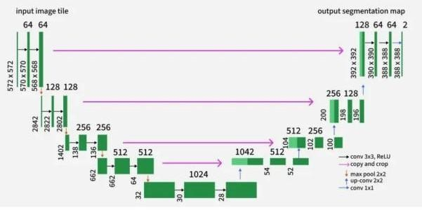
Figure 1. Multi-scale U-Net encoder-decoder architecture

RELATED WORKS
- Image Restoration : EImage Restoration is desired to achieve the high-quality image recovery Arguably, by removing noisy background, blur, compression artifacts or loss of image resolution in deteriorated observations. Or the usual image restoration schemes (importantly) had heavy dependency on manual priors, as well as fixing-based ones. Now, the total variation (TV) regularization method by Rudin et al. [1], the sparse coding method by Elad and Aharon [2], and Funny enough, the total variation (TV) regularization method by Rudin et al. [1], the sparse coding method by Elad and Aharon [2], and The non-local filter method as used in BM3D by Dabov Et al. [3] were all quite successful methods in the field of denoising and restoration. These algorithms usually bore heavy statistical hypotheses Of natural images and on fixing processes.
CNNs have risen to be the state-of-the-art in image restoration with the fastest development of deep learning. Methods are denoised by one of the first images.
That used deep learning was DnCNN Introduced by Zhang et al. [4] that showed that deep CNNs could Be trained to make residual mappings between distorted and clean images. In a similar fashion, the Intro of SRCNN by Dong et al. [5] was a major breakthrough in single-image super-resolution since it showed that CNNs could directly be trained to learn end-to-end mappings to image-enhancement problems.
Based on these initial achievements numerous designs have been created to enhance the results of restorations. The use of encoder- decoder networks such as U-Net by Ronneberger et al.
- Gained much popularity as it enabled general context and fine-grained local myatesa To capture spatial form by use of skip connections and multi- scale feature-detection. Later publications have even improved these architectures through the addition of residual learning, dense connections and multi-stage refinement architectures.
Recent work on image restoration has made more usage of attention mechanisms and transformer architectures. Models that enable channels. It spatial attention mechanisms like those suggested in RCAN (Residual Channel Attention Network) by. Zhang et al.
- Also enable models to focus on and highlight informative features selectively. On transformers like, it was Models who based. SwinIR Suggested by Liang et al. [8] use self-attention to include long-range relationships and global contextual data. Together, diffusion-based models have proven in image restoration operations to be promising as well Because of their powerful generative ability [9].
Multi-scale feature processing is another area of major focus in modern restoration models In which the info is extracted and processed At various scales. Multi-scale designs make Arguably, networks capture global structures in addition to local details. Although the approaches outlined concentrate more on architectural innovations, our work will be of a other view of. Hopefully. These are e. g, hierarchical encoder-decoder models. enhancing the training Strategy itself. And feature learning, in particular, the suggested Deep-Feature Auxiliary Guidance ( DFAG) increases the stability of trainings via auxiliary Supervision without altering the underlying model form and Or adding complexity to the inferences.

- Auxiliary Guidance: Extra supervision is an efficient technique that has been adopted a long time ago in enhancing the training of Deep neural networks. The first and the most effective one is GoogLeNet (Inception Network) [10] by Szegedy

Et al. which adds extra classifiers to intermediate networks to ease the vanishing gradient issue and enhance the performance of training very deep Networks. In training, these extra branches offered more supervision signals. to enable more discriminative Features to be learnt by intermediate layers.
Later works have shown that extra losses may serve as a regularization mechanism and that it can be used to guide intermediate representations and stabilize gradient flow in the network. Lee et al. [11] created the idea of deeply supervised networks to have the use of supervision signals in more than one depth of the network to enhance the learning of features, besides accelerating the convergence. The strategy has been effectively implemented in different fields such as Image sorting, semantic segmentation and medical image analysis.
Auxiliary losses are typically employed in guiding the learning of features at intermediate network stages in computer vision activities like semantic segmentation. Indicatively, architectures such as PSPNet [12] add the additional supervision component of assisting optimization and allowing the network to learn useful intermediate representations. In the same way, the auxiliary guidance has been studied in generative Models and diffusion models to increase training stability.
Though the advantage of extra supervision has been proved in most of the vision tasks, its usage in image restoration networks, especially in multi-scale Encoder-decoder networks, is relatively understudied. In the intermediate supervision strategy, the image restoration models usually have deep hierarchical structure, which the feature refinement process takes place on different scales, and thus are a good candidate.
Driven by this finding, our help is Deep- Features Auxiliary Guidance (DFAG) where auxiliary losses on multiscales Are introduced into the training process. Compared to the previous methods in which The main emphasis is placed on the architectural enhancements, DFAG targets the quality of feature learning and training stability but preserves the original model structure and computational efficiency in the DFAG targets the quality of feature learning and training stability but preserves the original model form and data output in the inference.

PROPOSED SYSTEM

The proposed system introduces a novel training strategy called Deep-Feature Extra Guidance (DFAG) to enhance the performance of multi-scale Encoder-decoder-based image restoration model without modifying their setup or increasing data cost during inference.
Old image restoration networks usually Apply supervision only at the final output layer using A single loss function. While this approach Simplifies training, it often leads to two major problems: vanishing gradients in deeper encoder layers and ambiguity in sub-task allocation between decoder and up-sampling modules. As a result, deep feature representations become unstable, saturated, or poorly optimized, ultimately limiting restoration performance. To address these limitations, the proposed system incorporates auxiliary supervision At multiple intermediate scale levels during training, so strengthening gradient flow and lifting feature learning across the entire network.
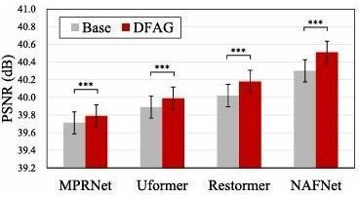

Figure 2. Quantitative comparison of PSNR

The backbone remains a standard multi-scale Encoder- decoder setup, such as U-Net or transformer- based variants commonly used in image restoration tasks.

The encoder progressively extracts hierarchical features through down-sampling operations, capturing both local textures and global contextual information. Then, the decoder reconstructs the high-quality image by progressively up-sampling, which refining these features, with skip connections linking corresponding encoder and decoder levels to preserve spatial details. Importantly, the architecture itself remains unchanged DFAG modifies only the training process.During Training, extra guidance modules are attached to the output of each decoder level before The up-sampling operation.

Each extra module consists of a lightweight 3×3 convolution layer that converts intermediate feature

Maps into residual image predictions with the same number of channels as the ground truth image. Since who intermediate feature maps exist at lower, it was. resolutions, The corresponding ground truth residual image is Down-sampled using average pooling to match the spatial dimensions of each scale level. An L1 loss is Then computed between the predicted residual and The down-sampled ground truth residual. To intermediate layers, creating shorter, these auxiliary losses provide direct supervision gradient paths and effectively Mitigating the vanishing gradient problem that typically affects deep encoder layers.

The overall training objective of the proposed system Is defined as a mix of the primary restoration Loss and multiple auxiliary losses, or mainly, the total Loss is formulated as the sum of the main loss applied at The final output and a weighted sum of extra losses applied at each intermediate scale. A balancing parameter controls contributing auxiliary supervision to ensure stable fixing, or by Distributing supervision across multiple scales, the system ensures that deep feature representations Receive sufficient gradient updates, leading to more stable learning and improved semantic consistency in Low-resolution feature regions.

To lifting gradient flow, the proposed system also clarifies the functional roles of decoder and up-sampling modules. In conventional training, flexible up-sampling techniques such as pixel shuffle may unintentionally assume feature extraction responsibilities, causing grid-like artifacts and unstable feature representations. By supervising decoder outputs directly before up-sampling, DFAG encourages Decoders to focus solely on feature extraction while allowing up-sampling modules to concentrate strictly On resolution enhancement. This clearer sub-task Allocation results in smoother feature transitions and reduced artifact generation.

To further enhance performance, the proposed system employs a multi-stage training strategy. In the first Stage, the model is trained using both the main loss And extra losses to stabilize deep feature learning.
In the second stage, all extra modules are removed, and the model is fine-tuned using only the primary restoration loss.

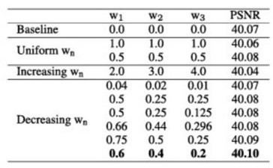

Figure 3. Ablation study of different weight configurations

Since the auxiliary components are used Exclusively during training and completely removed during inference, the proposed system introduces no extra data overhead, memory cost, Or structural modification at deployment time.
Overall, the proposed DFAG-based system Provides a simple yet highly effective training lift framework for image restoration models. It Improves gradient spread, stabilizes deep feature learning, reduces artifacts, and consistently boosts restoration accuracy across tasks such as Real image denoising, Gaussian denoising, motion deblurring, JPEG artifact reduction, and Super-resolution. Most, these fixes are achieved without altering the original setup or increasing inference complexity, making the proposed system practical, scalable, and easily adaptable to existing State-of-the-art restoration networks.
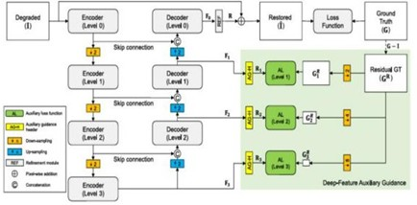

Figure 4. Overall process of DFAG.

SYSTEM IMPLEMENTATION

The proposed system for learning high-quality image restoration models is designed around a deep neural architecture enhanced through auxiliary training with deep feature-level guidance. The core objective of the framework is to improve perceptual and structural quality of restored images by integrating semantic supervision during the training phase. The system consists of a primary restoration network responsible For reconstructing degraded images and an auxiliary feature guidance mechanism that operates exclusively during training. The primary network follows a deep convolutional architecture composed of stacked convolutional layers, residual blocks, and non-linear activation functions to effectively learn hierarchical feature representations. This network accepts degraded images affected by noise, blur, compression artifacts, Or resolution loss and produces restored outputs that aim To approximate the original high- quality images.

To strengthen the learning process, an auxiliary Network is incorporated to provide feature-level supervision. Arguably, this extra component extracts high- level representations from both the restored output and the matching ground truth image. This these features capture (importantly) semantic info such as texture patterns, structural edges! But is it really that simple? It contextual bonds that are. Not fully represented through pixel-level comparison alone. Through the restoration network to generate a reconstructed image is passed by during the forward propagation stage, the degraded image.

Both the reconstructed image and the ground truth image are then fed into the auxiliary feature extractor. The extracted deep features are compared to compute a perceptual loss, which encourages the restoration network to generate outputs that are not only numerically accurate but also visually meaningful.

The overall training objective is formulated as a weighted combination of multiple loss functions. A pixel-level reconstruction loss, typically L1 loss, Ensures fidelity (importantly) between restored and ground truth images! It is also worth noting that now, here's the deal: it edge preservation and structural consistency, a feature-level perceptual loss minimizes the difference between deep representations of restored. Which reference images — or in some setups. Extra structural similarity loss may be included to enhance.
Why does this matter? Of each supervision signal, the total drop function balances these components using adjustable weighting factors, allowing controlled influence — in a way. In practice, granted, fixing
Is performed using the Adam optimizer with a carefully selected learning rate schedule to ensure stable meet.

The training process utilizes data augmentation techniques such as cropping, rotation, and horizontal flipping to improve model generalization! The data demands efficiently, the system is implemented using modern deep learning models, which trained on GPU-based hardware to handle. Importantly, the auxiliary branch is removed during inference, ensuring that the final model remains lightweight and suitable for real-time deployment. Importantly, the extra branch is removed during inference, ensuring that the final model remains lightweight and suitable for real-time deployment.
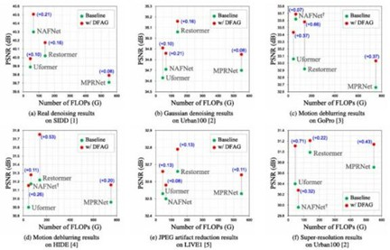

Figure 5. PSNR vs. FLOPs comparison

RESULT

The test review of the proposed framework proves clear upgrades over usual image restoration models trained solely with pixel-based supervision. Quantitative results across benchmark datasets indicate higher PSNR values, reflecting improved reconstruction accuracy. Structural Similarity Index (SSIM) scores also Show consistent lift, suggesting better preservation of spatial structures and image On this point, textures. Funny enough, to ground truth images, as for texture and — at least in part — fine detail. Also, perceptual similarity assessments reveal that the proposed method produces outputs are visually closer.
Qualitative analysis further supports these findings..

Unlike traditional methoDs that often sacrifice high- frequency details to minimize pixel error, The feature-guided training strategy enables the network to recover subtle visual elements such as hair strands, object contours, and fine background textures. Also, color consistency and natural appearance are noticeably improved. The integration of deep feature-level supervision allows the model to understand contextual and semantic information, leading to outputs that are perceptually more realistic. Despite these improvements, the inference complexity remains unchanged due to the removal of the auxiliary Guidance module after training, maintaining output without compromising quality.

CONCLUSION
This study presents a full image restoration framework that leverages auxiliary training with deep feature-level guidance to enhance restoration quality. Through deep aspect comparison, by integrating semantic info during training, the proposed method Addresses limitations associated with standard pixel-only loss boosting. That combining is proved by the results. Arguably, pixel-level and perceptual supervision leads to (importantly) large upgrades in both objective metrics and subjective visual quality! It the framework well balances reconstruction fidelity, which perceptual realism while maintaining data output at inference time. Why does this matter? If you ask me, it perceptual realism — oddly — while maintaining computational speed at inference time.
The findings confirm that auxiliary guidance is a Powerful strategy for enhancing deep learning-based restoration models and can be extended to various low-level vision tasks.

FUTURE DEVELOPMENT
Future research directions (importantly) can further expand and refine this framework. It is also worth noting that now, here's the deal: strength, blending transformer- based designs may improve the modeling of long-range dependencies — which global contextual bonds within images. Or adaptive loss weighting strategies could dynamically adjust supervision based on degradation severity or — if that makes sense. Image content. Training with
real-world degradation datasets instead of synthetic distortions would improve robustness in Practical applications. Additionally, model compression Techniques such as pruning and knowledge distillation could Enable deployment on resource-constrained devices such as smartphones and embedded systems. Integrating adversarial learning mechanisms may further enhance perceptual realism by encouraging The generation of sharper and more natural textures.

REFERENCES
- Rudin, Osher, and Fatemi, Nonlinear total Variation based Noise removal steps, 1992.
- Elad and Aharon, Image denoising via Sparse and redundant representations over learned dictionaries, 2006.
- Dabov Et al, Image denoising by sparse 3D transform- domain collaborative filtering (BM3D), 2007.
- Zhang et al, Beyond a Gaussian denoiser: Residual learning of deep CNN for image denoising (DnCNN), 2017.
- Dong et al, Image Super-Resolution Using Deep Convolutional Networks (SRCNN), 2014.
- Ronneberger Et al, U-Net: Convolutional Networks for Biomedical Image Segmentation, 2015.
- Zhang et al, RCAN: Image Super-Resolution Using Very Deep Residual Channel Attention Networks, 2018.
- Liang et al, SwinIR: Image Restoration Using Swin Transformer, 2021.
- Ho et al, Denoising Diffusion Probabilistic Models, 2020.
- Szegedy et al, Going Deeper with Convolutions (GoogLeNet), 2015.
- Lee et al, Deeply-Supervised Nets, 2015.
- Zhao et al, Pyramid Scene Parsing Network (PSPNet), 2017
[13]A. Abdelhamed, S. Lin, and M. S. Brown, ''A high- quality denoising dataset for smartphone cameras,'' in Proc. IEEE/CVF Conf. Comput. Vis. Pattern Recognit, Jun. 2018,
pp. 1692–1700.
[14]J. Huang, A. Ahuja, ''Single image super-resolution from transformed self-exemplars,'' in Proc.
[15]S. Nah, T. H. Kim, and K. M. Lee, ''Deep multi-scale convolutional neural network for dynamic Scene deblurring,'' in Proc. IEEE Conf. Comput. Vis. Pattern Recognit. (CVPR), Jul. 2017, pp. 257-265.
[16]Z. Shen, W. T. Xu, and
L. Shao, ''Humanaware Motion deblurring,'' in Proc. ICCV,
Oct. 2019, pp. 5571–5580.
[17]H. Sheikh. (2005), or live Image Quality Assessment Database Release 2. [Online]. Available: http://live.ece.utexas.edu/research/quality
[18]J. Su, B. Xu, and H. Yin, ''A survey of deep learning approaches to image restoration,'' Neurocomputing, vol. 487,
Pp. 46-65, May 2022.
[19]M. Banham and A. Katsaggelos, ''Digital image restoration,'' IEEE Signal Process. Mag., vol. 14, no. 2, Pp. 24-41, Feb. 1997.
[20]C. Tian, L. Fei, W. Zheng, Y. Xu, W. Zuo, and C.-W. Denoising: An overview, '' Neural, lin, ''Deep learning on image Netw, vol. 131, pp. 251-275, Nov. 2020.

