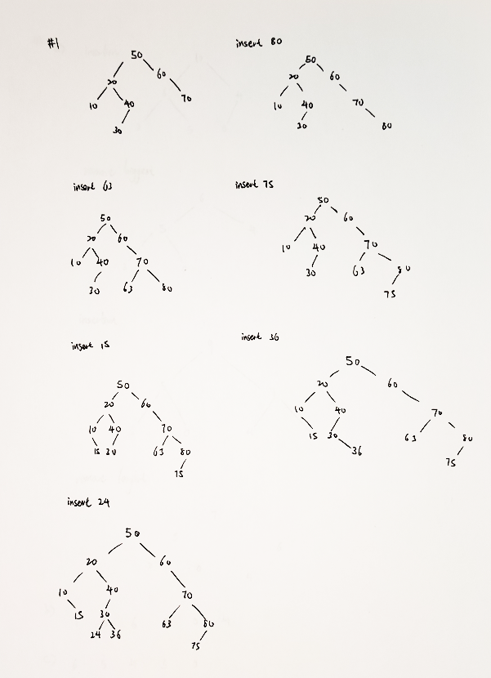

//2 a)

struct Node {

    int value;

    Node\* parent;

    Node\* left;

    Node\* right;

};

//2 b)

Node \* insert(int Parameter, Node \* Current)

if Current is null pointer,

    set Current to a new node with given Parameter

    root now points to this new node,

    set left and right to null;

    return Current;

if Parameter > Current,

    right of Current = insert(Parameter, right of current node)

else if Parameter < current

    left of Current = insert(Parameter, left of current node)

else

    no need to insert

return Current;

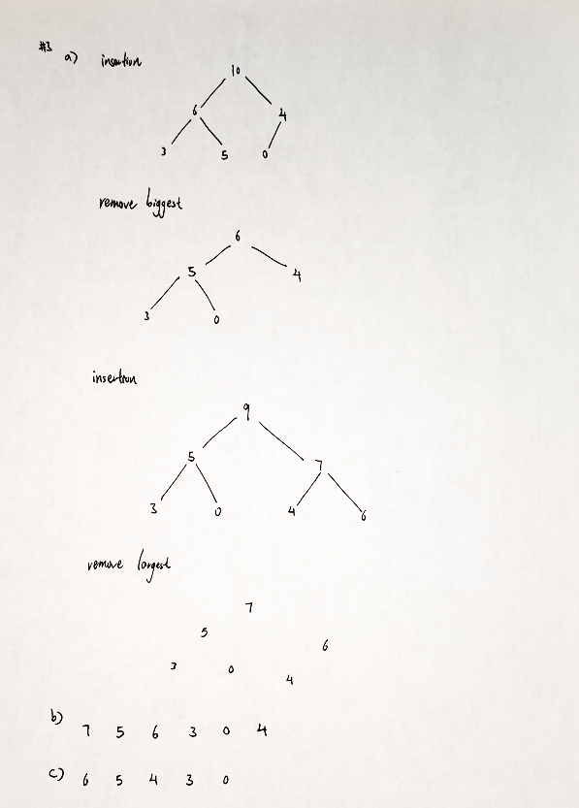

//4

a. O(C+S)

b. O(logC + S)

c. O(logC + log S)

d. O(logS)

e. O(1)

f. O(logC + S)

g. O(S logS)

h. O(C logS)