House will have features like bedroom square feet and more
data are required to be vector and normal distribution but usually they are not always normally or not in vector distributed
types of data
* continuous data
* categorical like gender birth country
* ordinal: order no actual distance mentionded
* boolean
* date time

exercise 1
# Import pandas
import pandas as pd

# Import so_survey_csv into so_survey_df
so_survey_df = pd.read_csv(so_survey_csv)

# Print the first five rows of the DataFrame
print(so_survey_df.head())

# Print the data type of each column
print("\nColumn Data Types:")
print(so_survey_df.dtypes)

Pandas
Pandas is one the most popular packages used to work with tabular data in Python. It is generally imported using the alias pd and can be used to load a CSV (or other delimited files) using read_csv().
You will be working with a modified subset of the Stackoverflow survey response data in the first three chapters of this course. This dataset records the details, and preferences of thousands of users of the StackOverflow website.

Selecting specific data types
Often a dataset will contain columns with several different data types (like the one you are working with). The majority of machine learning models require you to have a consistent data type across features. Similarly, most feature engineering techniques are applicable to only one type of data at a time. For these reasons among others, you will often want to be able to access just the columns of certain types when working with a DataFrame.
The DataFrame (so_survey_df) from the previous exercise is available in your workspace.
# Create subset of only the numeric columns
so_numeric_df = so_survey_df.select_dtypes(include=['int','float'])

# Print the column names contained in so_survey_df_num
print(so_numeric_df.columns)

Dealing with Categorical Variables

We know that device can only work with categorical variables not something like red green blue so we encode them in number or booleans
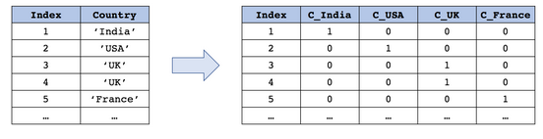
categorizing the countries with ordered numbers may seem good approach but as countries aare not ordered so force ordering the country such way will grreatly penalize the model. Better approach can be the boolean one where value represents that the thing given is picked or not. Does work without inffering any order

Types of encoding
1. One hot Encoding:
* n caregories into n features
* prefix for readablility

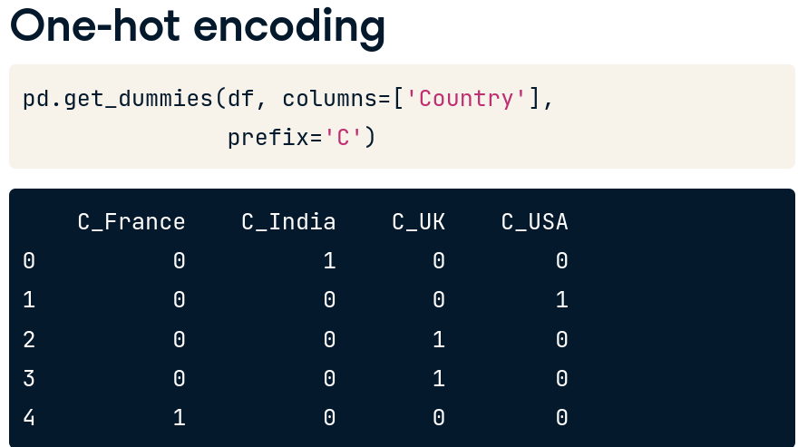
2. Dummy Encoding

* n category n-1 features ommiting first category
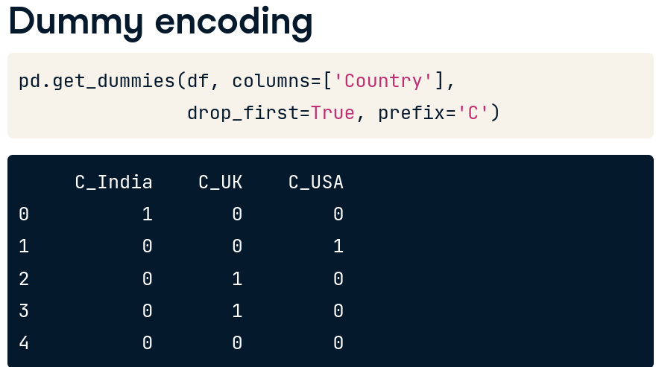

one hot encoding can be representing all but duplication due to collinearity of data may arise which Dummy encoding mitigates where pandas support one hot as default. Example of redundancy and reducing it
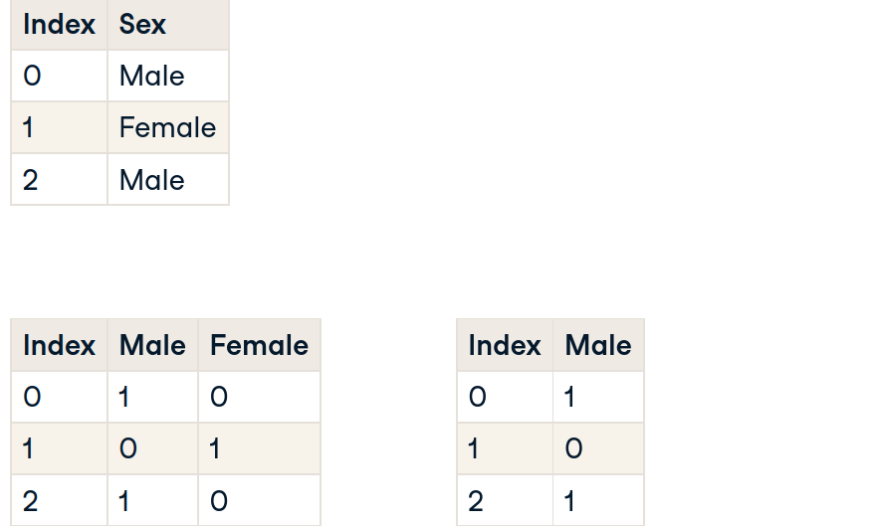

Both will result huge number of columns

so we need to limit them by creating columnd for most column value
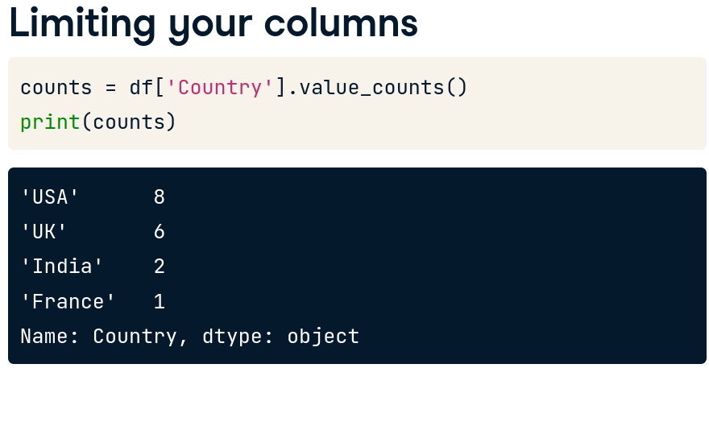

then create mask on value that occurred less frequently and label them as others as below
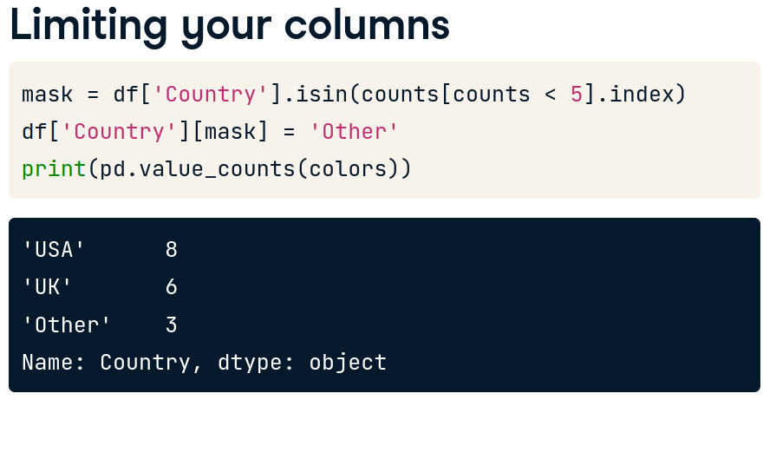

exercise:
# Convert the Country column to a one hot encoded Data Frame
one_hot_encoded = get_dummies(df, columns=['Country'], prefix='OH')

# Print the columns names
print(one_hot_encoded.columns)

Exercise 2:
# Create dummy variables for the Country column
dummy = pd.get_dummies(so_survey_df, columns=["Country"], drop_first=True, prefix='DM')

# Print the columns names
print(dummy.columns)

dealing with uncommon categories:
# Create a series out of the Country column
countries = so_survey_df['Country']

# Get the counts of each category
country_counts = countries.value_counts()

# Create a mask for only categories that occur less than 10 times
mask = countries.isin(country_counts[country_counts < 10].index)

# Label all other categories as Other
so_survey_df['Country'][mask] = 'Other'

# Print the updated category counts
print(pd.value_counts(countries))

Numeric variables
Even when a dataset contains only numeric features — such as age, price, counts, or spatial coordinates — there's still room to improve their usefulness through thoughtful feature engineering. Raw numbers often lack context, and transforming them can reveal deeper patterns.

📊 Magnitude vs. Direction
Numeric features can be treated in several ways depending on what matters most:
- Magnitude: The size or intensity of a value.
- Direction: The orientation or relative position of a value (especially in spatial data).
Sometimes, magnitude is more important than frequency or repetition. Other times, direction or location adds critical context.

🧪 Example: Restaurant Safety Ratings
Imagine a dataset tracking restaurant safety violations. You might have a numeric feature like:
- major_violations_count
Now consider two restaurants:
- One has 10 violations in a single inspection.
- Another has 2 violations across 5 inspections.
Even though both have 10 violations total, the first restaurant poses a higher immediate risk. So instead of just counting violations, you might engineer features like:
- is_high_risk: Flag restaurants with violations above a threshold.
- violations_per_inspection: Normalize by number of inspections.
- log_violations: Reduce skew from extreme values.
- distance_from_cleanest: Use spatial coordinates to measure proximity to top-rated restaurants.

🧭 Spatial Features: Direction Matters
For features like latitude and longitude, raw coordinates aren't always helpful. You might extract:
- distance_to_city_center
- north_south_position or east_west_position
- cluster_id: Group restaurants by location using clustering algorithms
These derived features can help models understand location-based patterns more effectively.
Restuarants may have no major violations many may have one or more we will be crating new bianry column whether restaurant had done any violation ornot
binarixing them

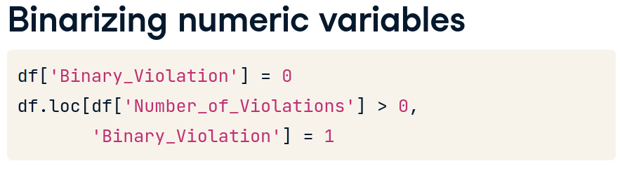

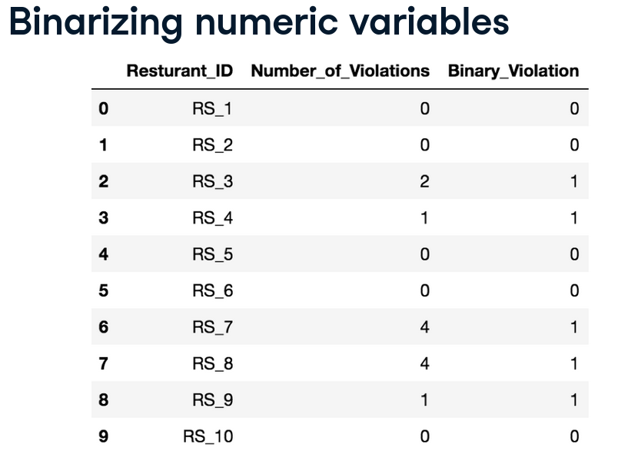

Binning
Binning is the process of converting continuous numerical data into discrete categories or intervals (called "bins"). It helps simplify data, reduce noise, and make patterns easier to detect.
Why binning?
- Makes models more robust to outliers
- Helps with visualization
- Useful for decision trees and rule-based models
- Can improve interpretability

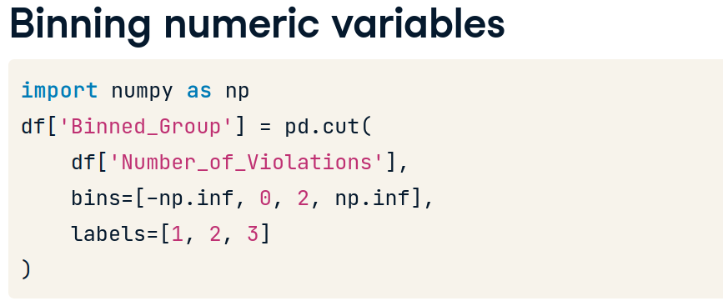

Binning the data

# Create the Paid_Job column filled with zeros
so_survey_df['Paid_Job'] = 0

# Replace all the Paid_Job values where ConvertedSalary is > 0
so_survey_df.loc[so_survey_df['ConvertedSalary'] > 0, 'Paid_Job'] = 1

# Print the first five rows of the columns
print(so_survey_df[['Paid_Job', 'ConvertedSalary']].head())

# Import numpy
import numpy as np

# Specify the boundaries of the bins
bins = [-np.inf, 10000, 50000, 100000, 150000, np.inf]

# Bin labels
labels = ['Very low', 'Low', 'Medium', 'High', 'Very high']

# Bin the continuous variable ConvertedSalary using these boundaries
so_survey_df['boundary_binned'] = pd.cut(so_survey_df['ConvertedSalary'],
bins=bins, labels=labels)

# Print the first 5 rows of the boundary_binned column
print(so_survey_df[['boundary_binned', 'ConvertedSalary']].head())

Gaps in data
data rarely come in no gaps perfectly formatted perfect way thats unfortunate may have noise emmisions collection errors unsuccessful collection of data paper surveys not being collected properly. Intentionally ommiting
use data.info() to see the full data info and isnull() to get all the null values for that data
