MLOps

1: What is MLOps?

Definition
- MLOps = Machine Learning Operations
- It’s a set of practices to design, deploy, and maintain machine learning systems in production.
- Focus: Continuous, reliable, and efficient ML lifecycle management.

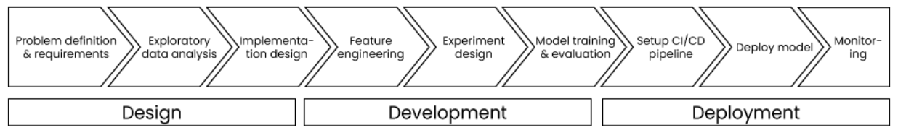
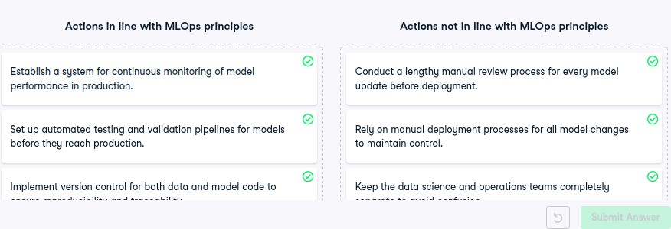
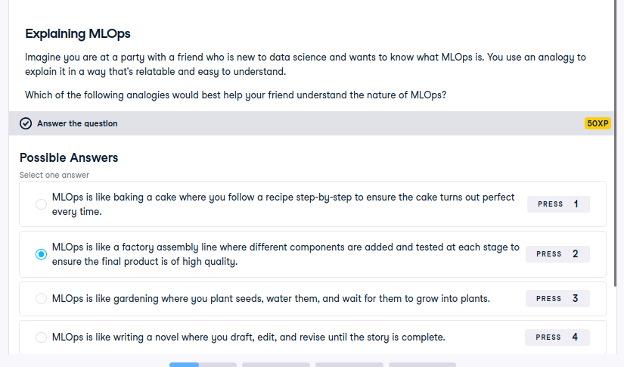

“In Production” means:
- ML systems integrated into business processes (not just local experiments).
- Goal: Ensure models function effectively in real-world environments.

ML Lifecycle
- Covers design -> development -> deployment -> maintenance of ML models.

- MLOps governs the entire lifecycle, not just model training.

Origin of MLOps
- Derived from DevOps (Development Operations).
- DevOps = practices/tools to develop and deploy software continuously and reliably.
- Traditionally:
  - Developers wrote code.
  - Operations handled deployment & maintenance.
-> This separation caused inefficiency.
- MLOps extends DevOps by integrating:
  - Data Scientists (model creators)
  - ML Engineers (deploy & monitor models)
- Aim: Unified workflow -> seamless collaboration -> efficient model deployment & monitoring.

Why MLOps?

1. Real-world ML systems are complex:
- Involve many components:
  - High-quality data
  - Feature engineering
  - Model training & evaluation
  - Deployment & monitoring
- Continuous monitoring ensures accuracy, reliability, and adaptability over time.

2. Benefits of MLOps:
- Bridges gap between ML and Operations teams.
- Enables automation of deployment -> fewer manual errors.
- Faster model delivery to production.
- Enables performance monitoring to maintain reliability.
- Overall: Ensures all moving parts integrate seamlessly.
summary:
MLOps = Continuous integration + Continuous delivery (CI/CD) principles applied to ML systems -> bringing data, models, and operations together for reliability and scalability.

MLOps Lifecycle

Overview
- The Machine Learning Lifecycle = foundation of MLOps.
- It transforms ML ideas -> production-ready models.
- Structure = 3 key phases:
Design -> Development -> Deployment
- Process is iterative (looping back as feedback and data evolve).

Why Learn the ML Lifecycle?
- Acts as a blueprint to structure ML projects.
- Clarifies:
  - Key phases
  - Roles and responsibilities
  - Tools for each step
- Enables optimization, scalability, and collaboration.

1. Design Phase
Goal: Understand problem & define project scope.
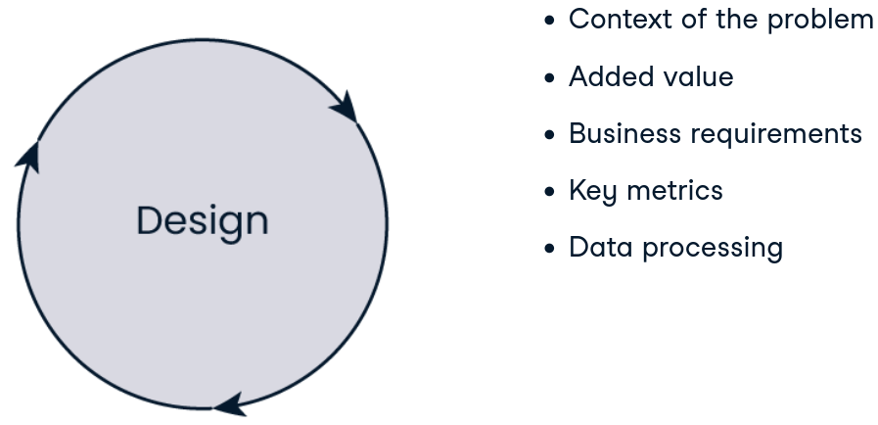

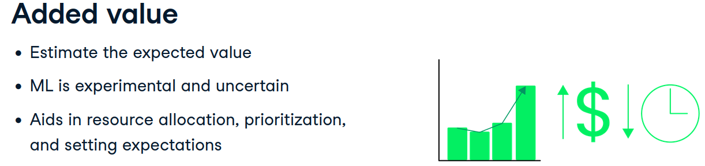
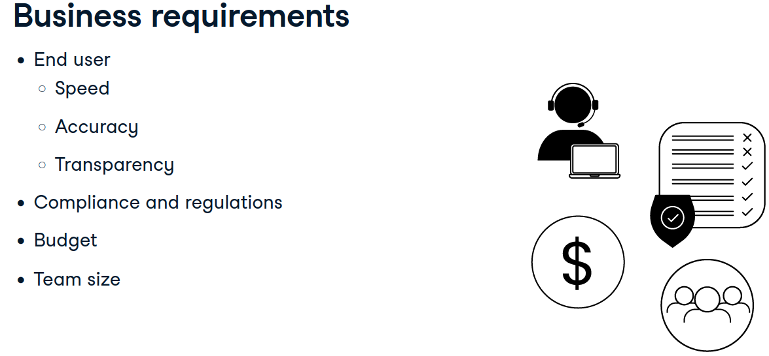
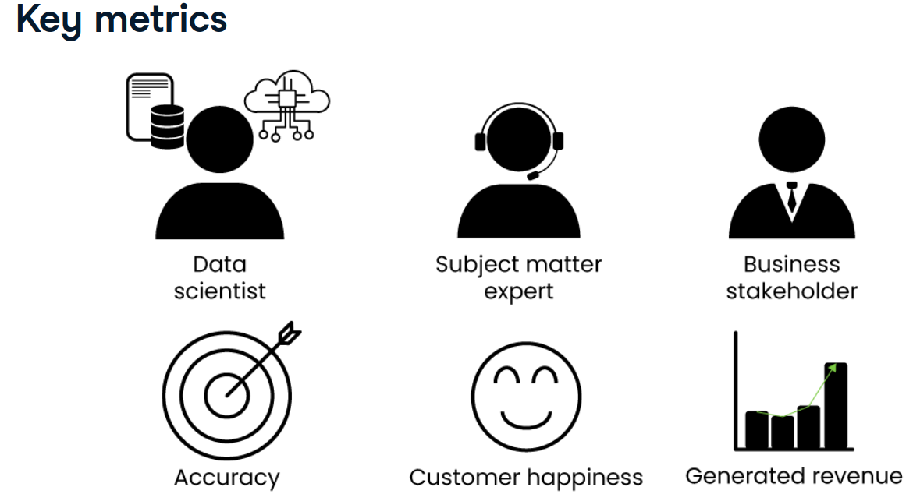
Steps:
- Clarify context and business value of the problem.
- Collect business requirements (what does success look like?).
- Define key metrics to track progress.
- Assess data quality & preprocessing needs.
- Engage stakeholders early to ensure feasibility.
Outcome:
A clear, data-driven project plan aligned with business goals.

2. Development Phase
Goal: Build, train, and evaluate models.
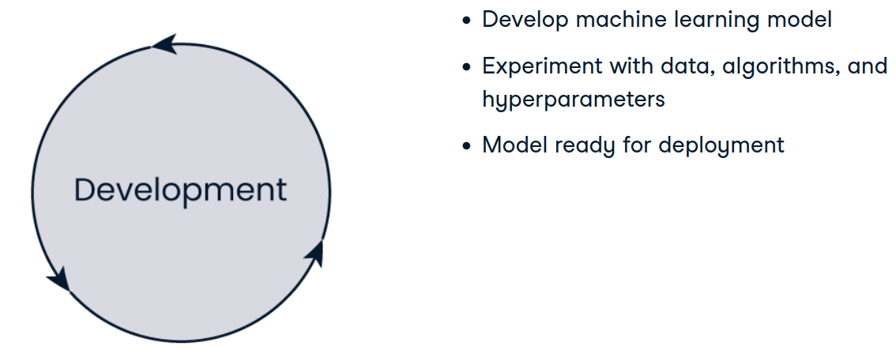
Steps:
- Experiment with:
  - Different data samples
  - Algorithms
  - Hyperparameters
- Train multiple models -> evaluate each using defined metrics.
- Iterate continuously to improve results.
Outcome:
A well-tuned model ready for real-world deployment.

3. Deployment Phase
Goal: Integrate the model into business processes.
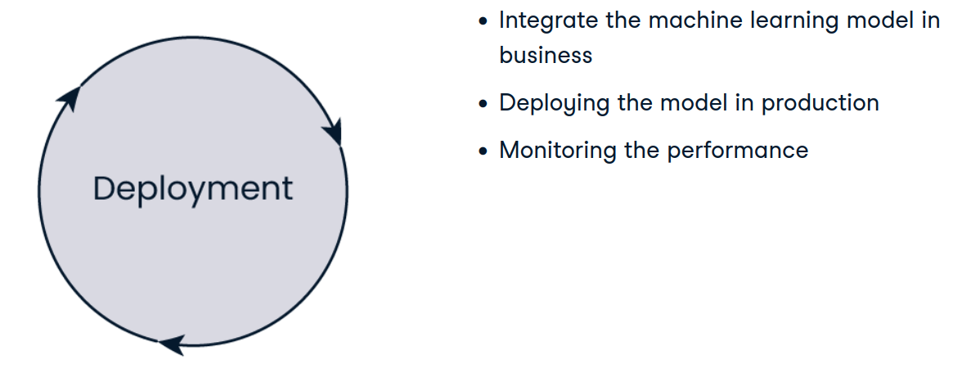
Steps:
- Wrap model into a microservice for accessibility & scalability.
- Integrate with existing systems.
- Establish monitoring pipelines to detect:
  - Performance degradation
  - Data drift
  - Prediction errors
Continuous monitoring ensures:
- Long-term accuracy
- Reliability
- Business value retention
Outcome:
Operationalized model delivering measurable impact.

Lifecycle Recap
- Constant evaluation:
  - Is the project viable?
  - Is it delivering value?
- MLOps = not just model building -> building end-to-end ML systems that sustain business outcomes.

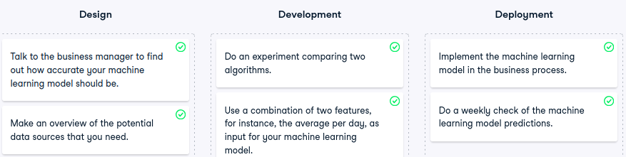

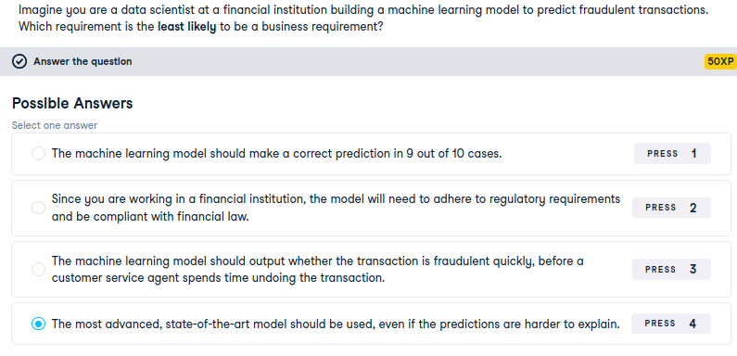

3: Roles in MLOps

🔹 Lifecycle Roles Overview
Every ML project requires both:
- Business Roles -> define objectives, interpret results.
- Technical Roles -> handle data, modeling, and deployment.

Business Roles

1. Business Stakeholder / Product Owner
- Responsibilities:
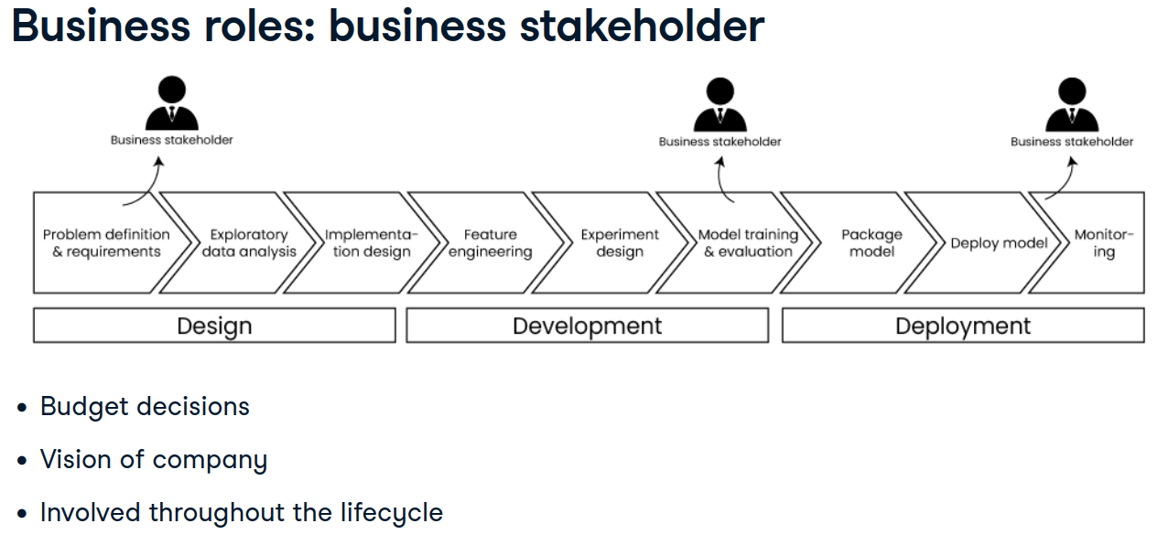
  - Budget decisions
  - Ensuring alignment with company vision
  - Oversee progress across all phases:
    - Define business requirements (Design)
    - Review experimental results (Development)
    - Verify final outcomes (Deployment)

2. Subject Matter Expert (SME)

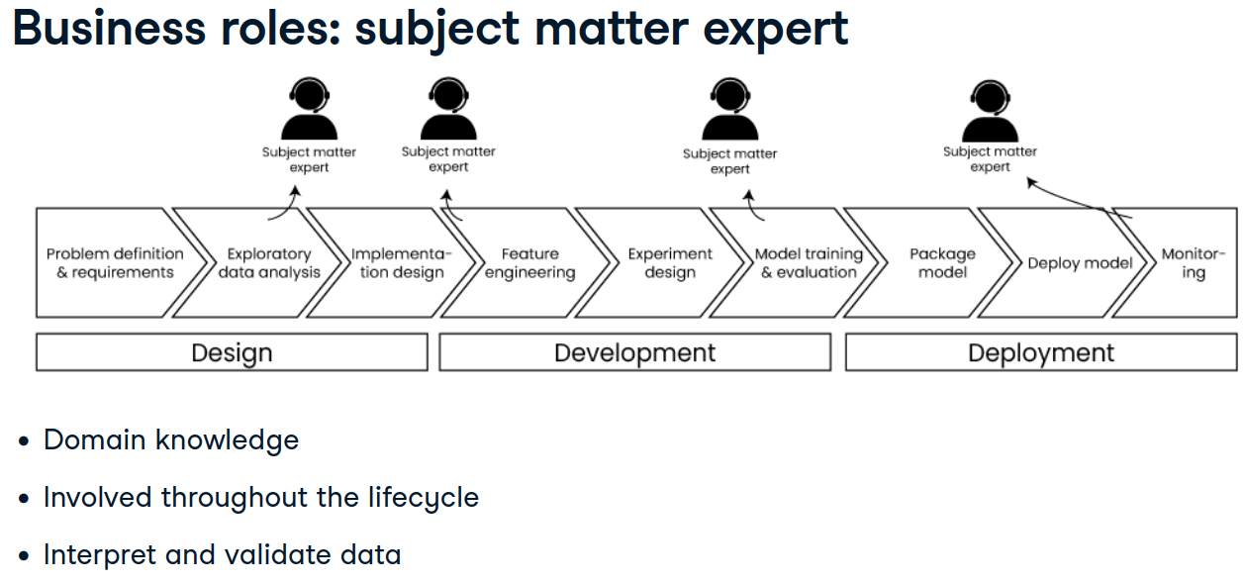
- Responsibilities:
  - Provide domain knowledge about the problem.
  - Help interpret data & results.
  - Involved throughout all phases for context validation.

Technical Roles

1. Data Scientist
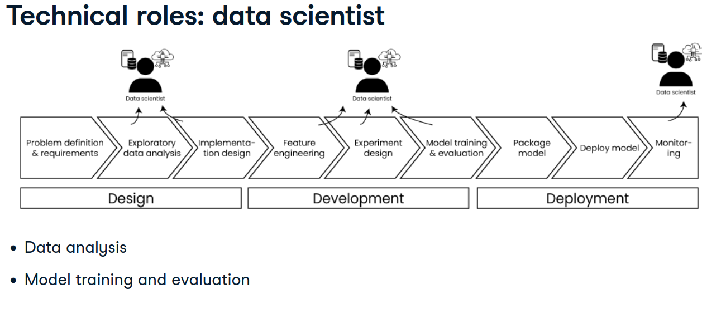
- Responsibilities:
  - Data analysis
  - Feature engineering
  - Model training, tuning, evaluation
  - Post-deployment model monitoring
- Phase focus: Development

2. Data Engineer
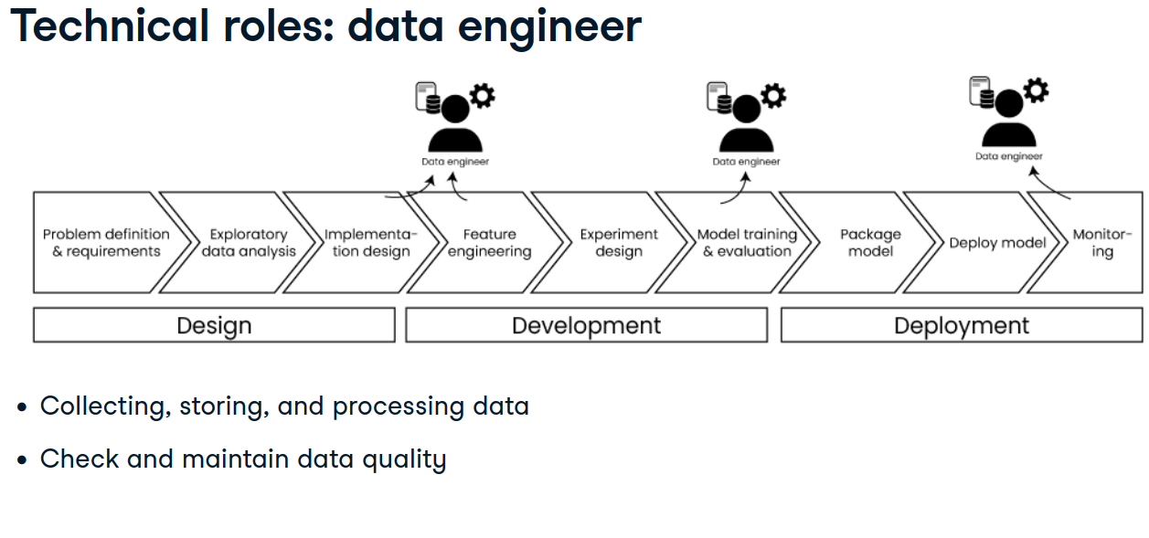
- Responsibilities:
  - Collect, clean, and store data
  - Ensure data quality & testing
  - Manage pipelines for data ingestion & transformation
- Phase focus: Design -> Development -> Production

3. ML Engineer
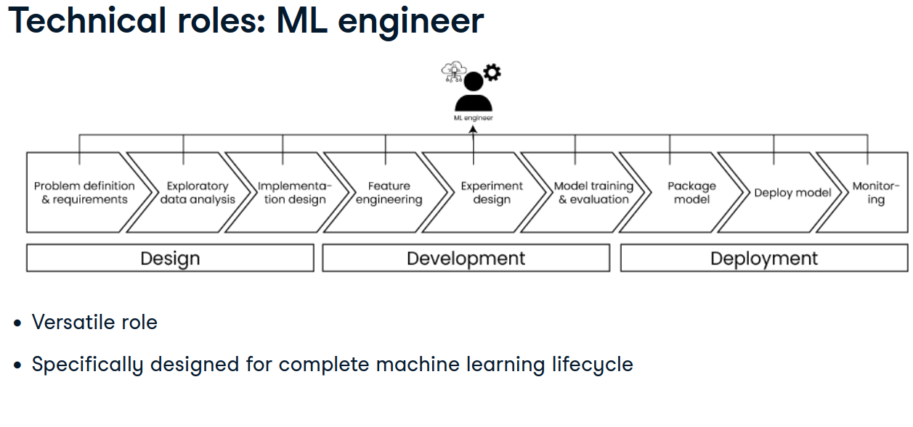
- Responsibilities:
  - Bridge between data science and operations
  - Oversee full lifecycle:
    - Data extraction
    - Model development
    - Deployment
  - Build scalable pipelines and APIs
- Phase focus: All phases (cross-functional)

Additional Roles
- Data Analysts
- Developers / Software Engineers
- Backend Engineers
Note:
In startups -> roles overlap (generalists).
In enterprises -> roles specialize (division of labor).
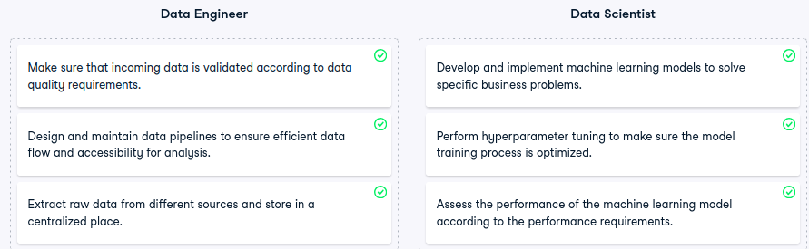
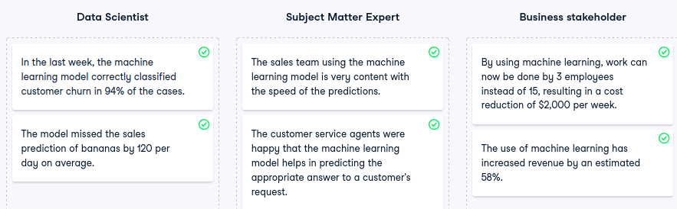

4: Data Quality and Ingestion

🔹 Data Collection in Design Phase
- Gathering and validating data occurs during Design.
- Objective: ensure high-quality, relevant, and accessible data.

What is Data Quality?
- Measure of how well data serves its intended purpose.
- Determines how reliable a model will be.
- High data quality -> high model performance.

Four Key Dimensions of Data Quality
Dimension | Description | Example
Accuracy | Data correctly represents reality | Customer’s recorded age = 32, not 18
Completeness | No missing or incomplete entries | All customers have last names
Consistency | Definitions remain uniform across systems | “Active customer” definition same across departments
Timeliness | Data is up-to-date and available when needed | Daily sync ≠ real-time data

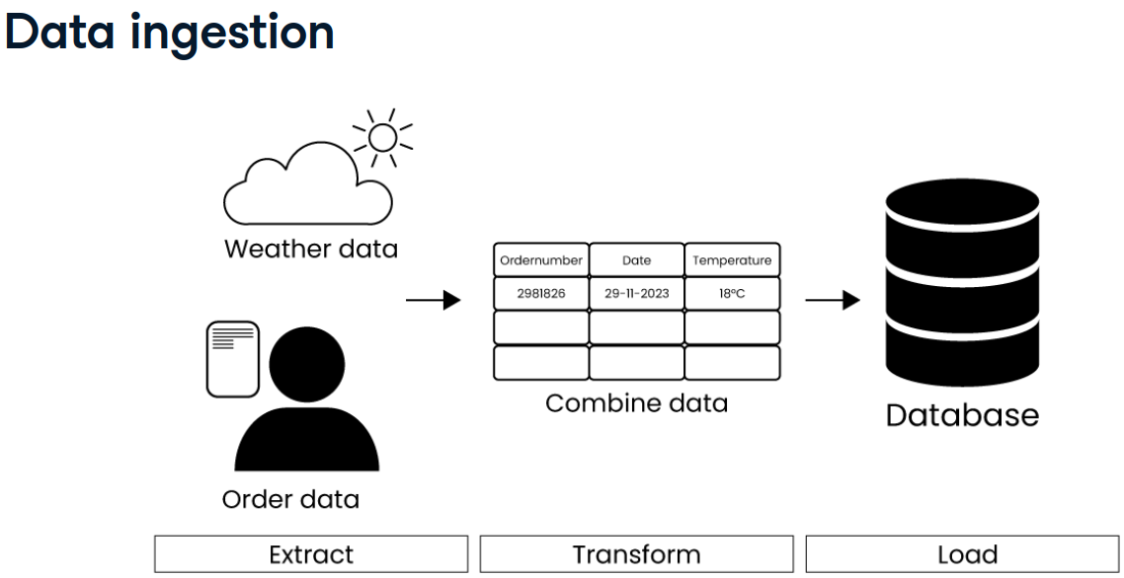

Feature | ETL (Extract, Transform, Load) | ELT (Extract, Load, Transform)
Workflow Order | Data is transformed before loading into the destination system | Data is loaded first, then transformed within the destination
Transformation Location | Performed in a staging area or ETL tool | Performed inside the target data warehouse
Best For | Traditional data warehouses (e.g., on-premise systems) | Modern cloud-based data platforms (e.g., BigQuery, Snowflake)
Performance | Limited by external transformation tools | Leverages scalable compute power of cloud warehouses
Data Volume Handling | Suited for smaller or structured datasets | Optimized for large-scale, semi-structured or unstructured data
Latency | Higher latency due to pre-load transformation | Lower latency with faster data ingestion
Tool Examples | Informatica, Talend, Apache Nifi | dbt, Spark SQL, native SQL in cloud warehouses
Security & Compliance | Easier to enforce before data enters warehouse | Requires robust governance inside the warehouse
Flexibility | Less flexible for schema evolution | More adaptable to changing data structures

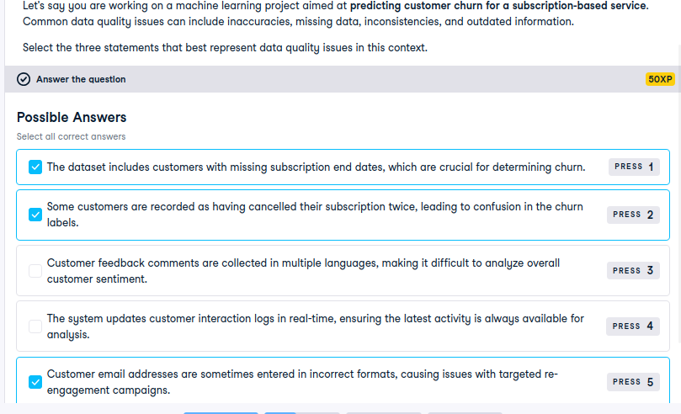

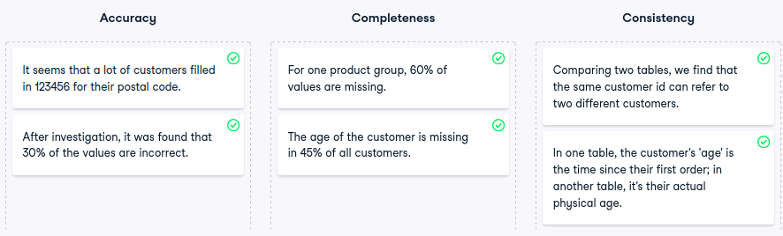

Feature engineering
After the design phase, feature engineering is the next step in the machine learning development process.
Feature engineering is the process of selecting, manipulating, and transforming raw data into features. A feature is a variable, such as a column in a table. How we create features from the data is an important part of machine learning development. We can use the features as they appear in the raw data, but we can also build our own. Let's look at an example.

4. Customer data
In this example dataset, we have a set of customers and some information about their orders. The number of orders and total expenditure of each customer are two different features. To build a new feature, we could calculate the average expenditure per customer.
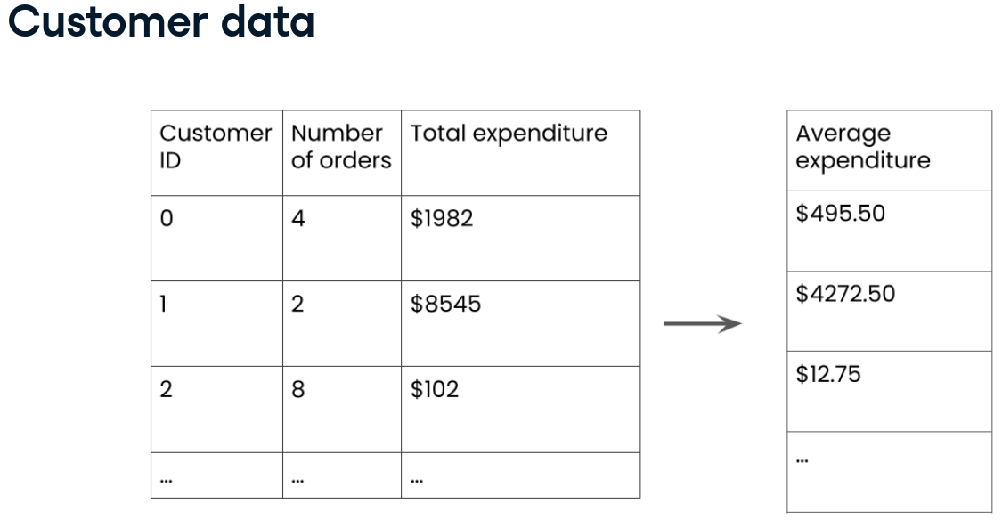

In this way, we have engineered a new feature. Apart from the order data in this example, there is often much more data available in actual machine learning projects, and thus a lot of possibilities to engineer features.

6. Feature engineering
The goal of feature engineering is to enhance model performance by identifying the most informative features. Rather than increasing the number of features indiscriminately, it's about selecting the most relevant ones. Tools and techniques like
- feature selection,
- a feature store,
- and data version control,
help automate and structure the feature engineering process.

1. Feature selection
- Leveraging domain-specific knowledge is essential for creating and selecting features that are both relevant and impactful.
- This expertise helps ensure that the features used in the model are not only statistically significant but also meaningful in the context of the problem.
- Additionally, we can examine correlations to identify and eliminate redundant features.
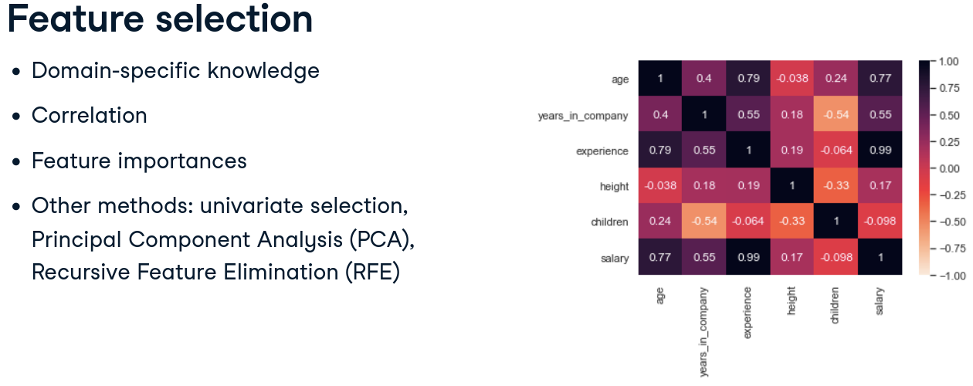
- We can also evaluate feature importance to understand which features significantly influence the model’s predictions.
- Other techniques such as univariate selection, Principal Component Analysis (PCA), and Recursive Feature Elimination (RFE) can further refine the feature set, enhancing model performance by focusing on the most valuable features.
For mor einfo visit: https://www.datacamp.com/tutorial/tutorial-datails-on-correlation

8. The feature store
- A feature store is a centralized repository for features, allowing data scientists to discover, define, and reuse features across projects.
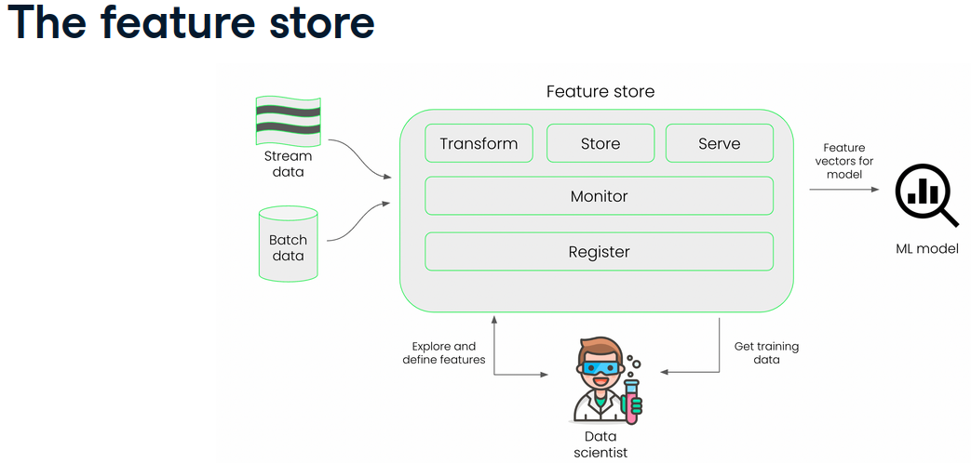
- Feature stores are essential in large teams where multiple projects need consistent and reusable features.
- However, they're not always necessary. If features are already in an optimal format or if projects are less complex, a feature store may not add significant value.

9. Data version control
- Data version control is a tool that can be useful for tracking dataset changes and maintaining consistency throughout the machine learning lifecycle.
- It works in similar fashion as Git, which is a tool that allows us to track changes in code over time. Data version control helps to track versions of datasets such that we could easily find and rollback to earlier versions.
https://www.datacamp.com/courses/cicd-for-machine-learning

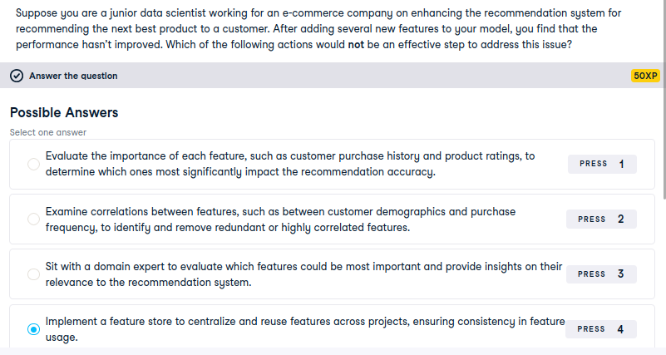
Implementing a feature store is useful for managing features across projects but does not address immediate concerns with feature relevance or model accuracy.

Scenairo
Your friend, Alex, is a data scientist working on a machine learning project. He’s facing challenges with feature engineering and is unsure about the best approach to improve his model’s performance. You want to provide him with advice on how to proceed effectively.
Here are the four options Alex is considering:
Use as many features as possible: Alex is thinking of incorporating every feature available in his dataset, believing that more features will lead to better model performance.
Experiment with a combination of feature selection tools: Alex plans to apply various feature selection techniques, such as univariate selection, Principal Component Analysis (PCA), and Recursive Feature Elimination (RFE), to refine his feature set.
Consult a domain expert: Alex is considering reaching out to a domain expert who can provide insights into which features are most relevant and impactful for his specific problem.
Manually create features based on gut feeling: Alex is considering creating new features based on his intuition or gut feeling about what might be important, without a systematic approach.
Appropriately sort the best to worst way

sorted with order of effectiveness

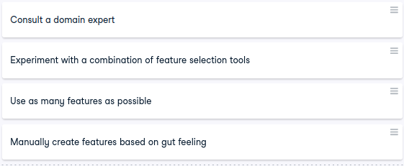

Experiment Tracking in Machine Learning
- Experiment tracking is a foundational concept in MLOps, enabling reproducibility, collaboration, and transparency across the ML lifecycle.
- Machine learning experiments involve training and evaluating multiple models to identify the best-performing configuration for a given task.
- Each experiment may vary across multiple dimensions:
  - Model architecture (e.g., linear regression vs. deep neural networks)
  - Hyperparameters (e.g., number of layers, learning rate)
  - Dataset versions (e.g., original vs. augmented)
  - Training scripts and code versions
  - Environment configurations (e.g., Python/R versions, library dependencies)
- Tracking these variations is essential for:
  - Comparing model performance across runs
  - Reproducing successful experiments
  - Collaborating effectively with team members
  - Reporting findings to stakeholders with full traceability
- Tracking methods depend on development maturity:
  - Manual logging: spreadsheets (e.g., Excel) with rows for each experiment; simple but labor-intensive
  - Custom platforms: in-house solutions tailored to specific workflows; flexible but costly to build and maintain
  - Modern tools: automated experiment tracking platforms (e.g., MLflow, DVC, Weights & Biases); efficient and scalable with a learning curve
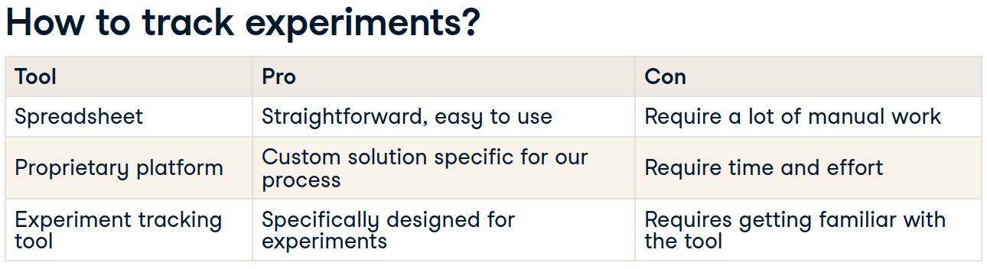
Illustrative Example: Image Classification
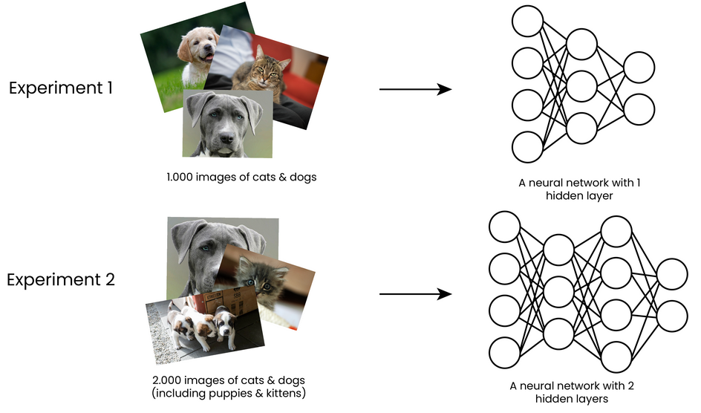
- First experiment: neural network with one hidden layer, trained on 1,000 images of cats and dogs
- Second experiment: dataset expanded to 2,000 images including puppies and kittens, model upgraded to two hidden layers

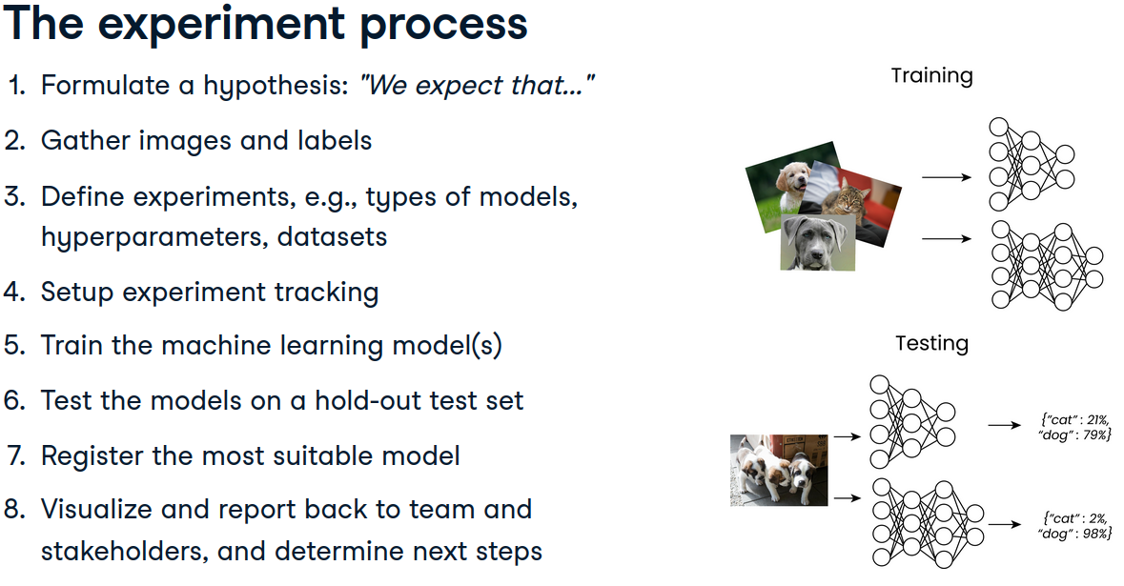

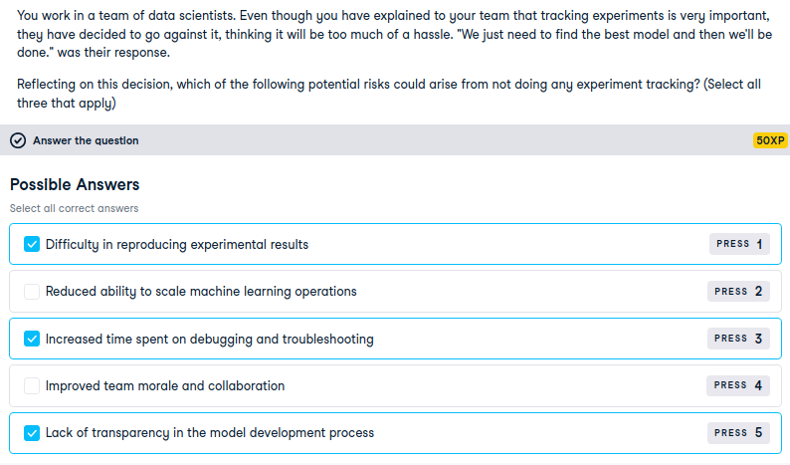

By skipping experiment tracking, the team risks losing visibility into:
- Which model configurations were tried
- What data versions were used
- Which hyperparameters led to which results
- How reproducible or explainable the final model is

Correct Risks That Arise from Not Tracking Experiments
These are the valid consequences of ignoring experiment tracking:
- Difficulty in reproducing experimental results Without logs, it's nearly impossible to recreate a successful model or debug failures.
- Reduced ability to scale machine learning operations Scaling requires automation, versioning, and traceability none of which are possible without tracking.
- Increased time spent on debugging and troubleshooting If something breaks or underperforms, you’ll waste time retracing steps manually.
- Lack of transparency in the model development process Stakeholders and auditors won’t be able to verify how decisions were made or which models were tested.

Machine Learning Model for Deployment
- Deployment is the final phase of the machine learning lifecycle, where the trained model is transitioned from development to production to generate real-world predictions and impact.
- During development, data scientists train models using historical or labeled data in a controlled environment typically a local machine or a cloud-based virtual workspace.
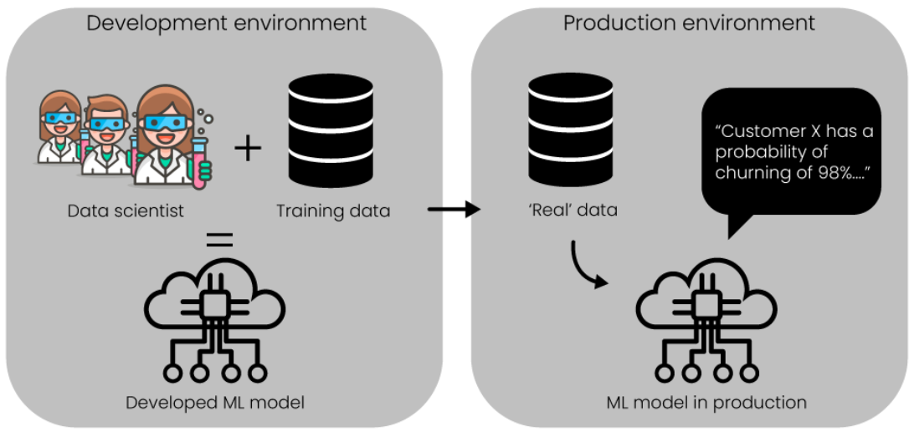
- The production environment is where the model operates on live, incoming data. It must be stable, scalable, and integrated with business systems to deliver actionable outputs.
- Deployment is complex due to differences in runtime environments:
  - Development and production may use different OS, Python versions, or library dependencies.
  - These discrepancies can cause code failures or inconsistent model behavior.
- Analogy: Different runtime environments are like different kitchens. A recipe may yield different results depending on the tools, appliances, or chefs involved even if the instructions are the same.
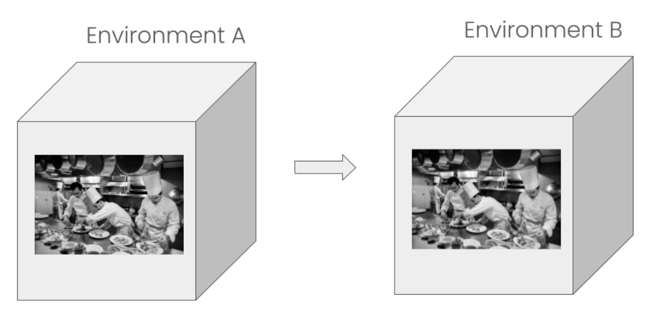
- To ensure consistency across environments, containers are used:
  - A container packages the model along with its dependencies, configurations, and runtime settings.
  - It acts like a portable kitchen setup that guarantees the same output regardless of where it's executed.
- Benefits of containers:
  - Maintainability: Easier to manage and update without affecting other systems.
  - Portability: Build once, run anywhere across machines, clouds, or teams.
  - Speed: Fast startup since only the necessary components are included.

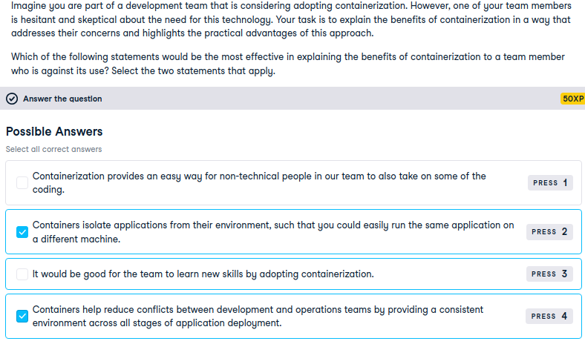

Machine Learning Deployment Architecture
- Once runtime environments are stabilized, the next focus is on deployment architecture how the ML model integrates into the broader application ecosystem.
- Traditional applications often use a monolithic architecture, where all services (e.g., payment, cart, inventory) run as a single, unified application on one instance.
- In contrast, microservices architecture breaks the application into smaller, independently deployable services. Each service handles a specific function and can be updated or scaled separately.
- Monolithic drawbacks:
  - If one service fails, the entire application may crash.
  - Services are tightly coupled, making scaling and maintenance difficult.
  - Complexity increases as the application grows.
- Microservices benefits:
  - Isolated failures only the affected service goes down.
  - Easier to scale specific components.
  - More flexible for large, modular applications.
- However, for small applications, microservices can be overkill:
  - Each service requires separate compute resources.
  - Maintenance overhead increases with service count.
- In ML deployment, it is standard practice to deploy the model as a microservice:
  - This enables inferencing making predictions on new, unseen data.
  - Example: input is customer data, output is churn probability.
- Inferencing refers to the process of feeding new input into a deployed model to generate predictions. It’s the operational phase of ML where business impact is realized.
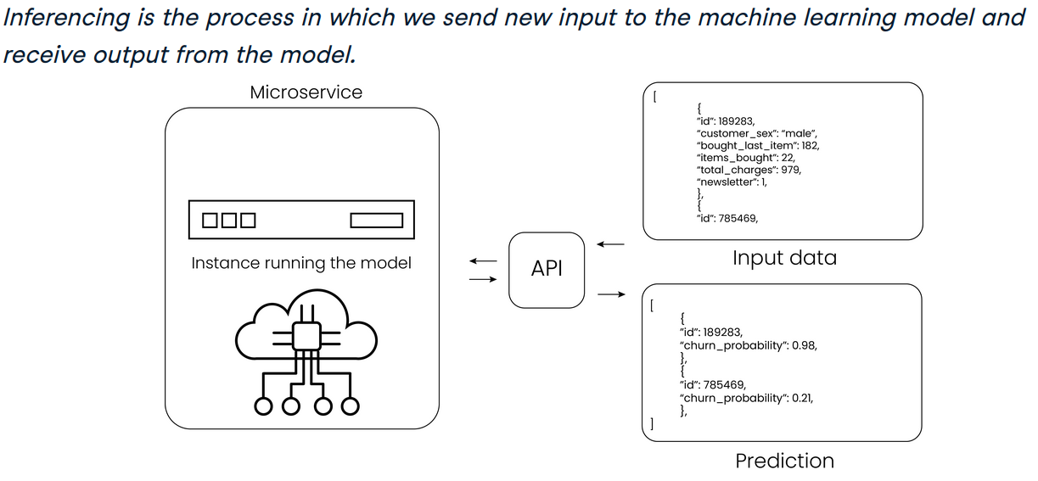
- To enable communication between microservices, an Application Programming Interface (API) is used:
  - An API defines structured input/output formats for service interaction.
  - Analogy: a restaurant menu input is the order, kitchen (ML model) prepares the dish, and the service delivers it.
  - Without an API, services lack a standardized way to communicate, leading to integration failures.
API and data IO flow
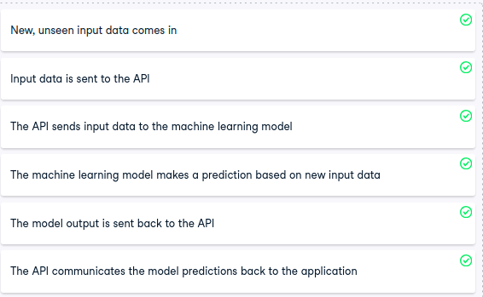

CI/CD Pipeline and Deployment Strategies in Machine Learning
- The CI/CD pipeline is a structured automation framework used during the deployment phase to ensure code quality, reproducibility, and safe release of machine learning models.
- The CI/CD pipeline enables automation by having automated build-and-test steps with each incremental code change.
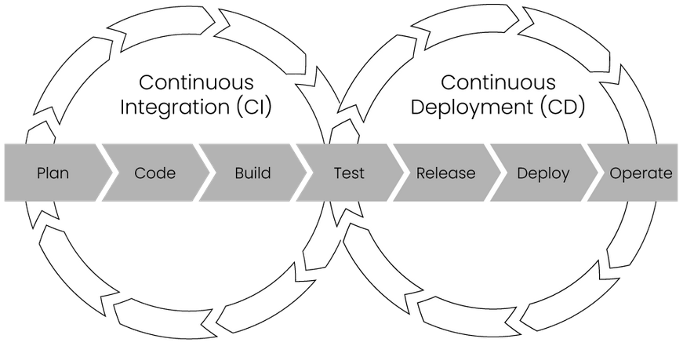
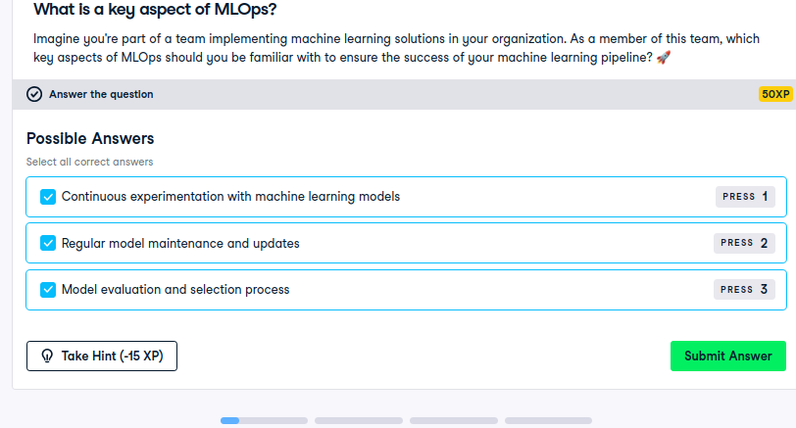
- Analogy: CI/CD is like a checklist for launching a new recipe in a restaurant ach change is tested and validated before being served to customers.
- Continuous Integration (CI):
  - Code changes are integrated frequently and automatically tested upon commit and merge.
  - Ensures early detection of bugs and maintains code stability.
  - Comparable to testing a new recipe before adding it to the menu.
- Continuous Deployment (CD):
  - Automates the release of validated code from CI into production.
  - Once tested, the model is deployed and made available to users.
  - Similar to publishing a new dish on the menu and briefing the service team.
- Once a model is ready, deployment strategies determine how the new model replaces the old one in production.
Deployment Strategy Types
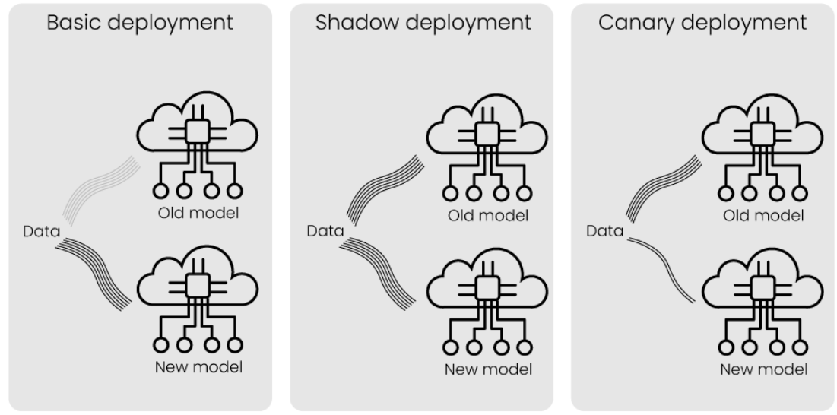
- Basic Deployment:
  - Direct replacement of the old model with the new one.
  - All incoming data is routed to the new model.
  - Easiest to implement, minimal resource usage.
  - High risk if the new model fails no fallback.
- Shadow Deployment:
  - New data is sent to both old and new models.
  - Only the old model’s output is used in production.
  - New model’s output is monitored for validation.
  - No production risk, but higher resource usage due to dual execution.
- Canary Deployment:
  - New model is used for a small subset of incoming data.
  - Allows real-time testing with limited exposure.
  - Moderate implementation complexity.
  - Lower resource usage than shadow deployment.
  - Slight risk if the new model underperforms, but impact is contained.
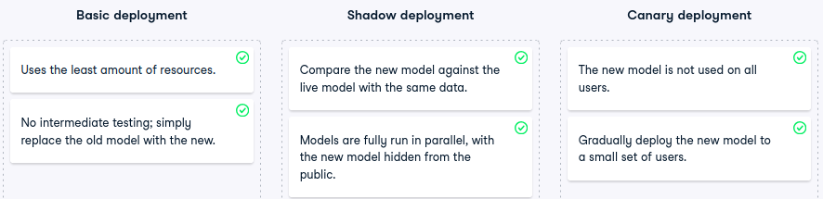

Automation and Scaling in the Machine Learning Lifecycle
- Automation and scaling are essential in MLOps to accelerate iteration, ensure reproducibility, and handle large data volumes efficiently.
- The ML lifecycle is inherently experimental frequent back-and-forth between design, development, and deployment phases is common. Automation helps repeat experiments reliably and quickly.
- Scaling is necessary due to the large datasets and growing prediction demands typical in ML applications. Together, automation and scaling make ML systems robust and production-ready.
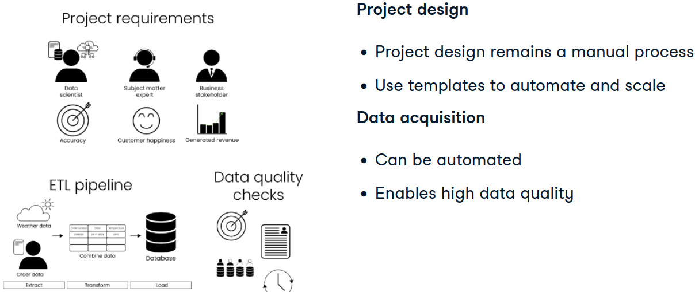
Design Phase
- Most critical phase sets the foundation for success in development and deployment.
- Requires clear objectives, high-quality data, and cross-functional alignment.
- While largely manual, the design phase can be templated to standardize business goals, added value, and key metrics bringing structure in line with MLOps principles.
- Automation is possible for:
  - Data acquisition
  - Data quality checks
  - These improve model reliability and readiness for production.
Development Phase
- Feature store usage automates feature reuse, saving time and reducing redundancy across experiments.
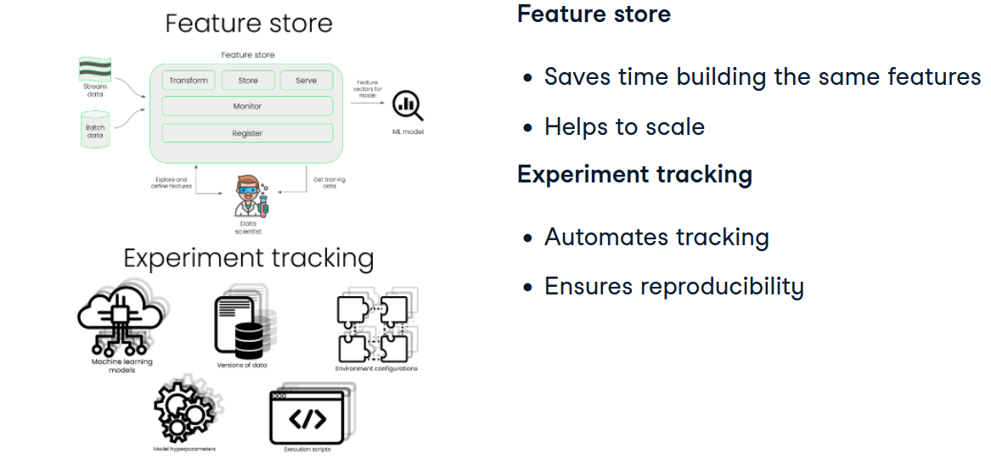
- Experiment tracking automates logging of configurations, metrics, and outcomes.
  - Ensures reproducibility
  - Facilitates model evaluation against design-phase metrics
  - Enables traceability of model decisions
Deployment Phase
- Containerization mitigates runtime environment inconsistencies.
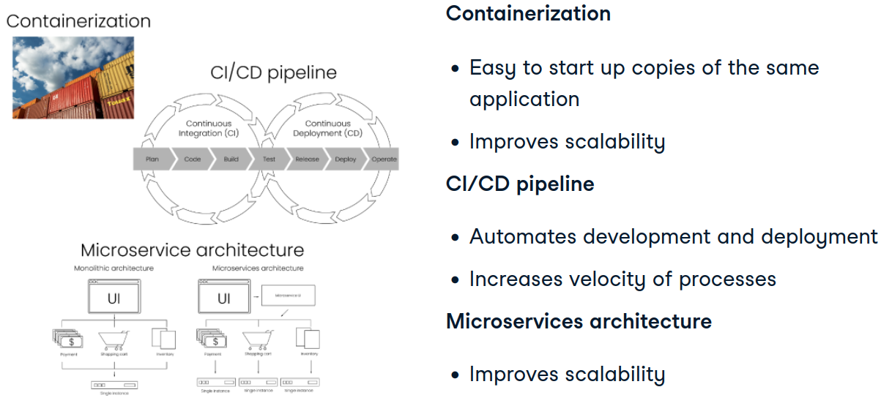
  - Containers encapsulate dependencies and runtime settings.
  - Enable horizontal scaling multiple instances can be spun up to handle increased load (e.g., predicting churn for thousands of users simultaneously).
- CI/CD pipelines automate:
  - Code integration
  - Testing
  - Deployment
  - Support collaborative development and fast iteration cycles
- Microservices architecture supports scaling by:
  - Allowing independent development and deployment of services
  - Isolating failures
  - Enabling modular growth without disrupting existing systems
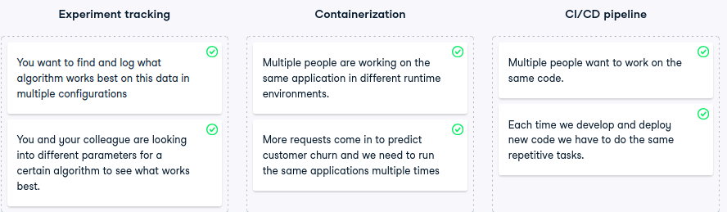

Monitoring Machine Learning Models in Production
- Monitoring is the final and ongoing phase of the deployment lifecycle. Once a model is live, it must be continuously observed to ensure it performs reliably on new, unseen data.
- Monitoring ensures the model behaves as expected and continues to deliver accurate, stable predictions under real-world conditions.
Types of Monitoring
- Statistical Monitoring:
  - Focuses on input data and model outputs.
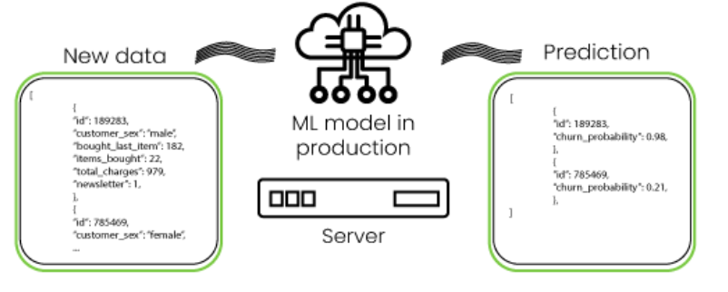
  - Example: tracking predicted probabilities of customer churn.
  - Detects shifts in data distribution or prediction quality.
- Computational Monitoring:
  - Focuses on system-level metrics.
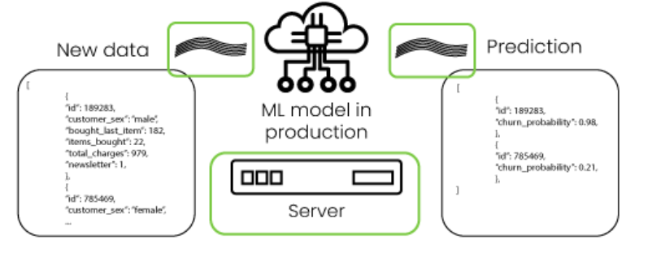
  - Includes request volume, network usage, and server resource consumption.
  - Ensures infrastructure stability and responsiveness.
Analogy for Clarity
- Think of a kitchen:
  - Computational monitoring = checking appliances, gas, electricity, and staff activity everything unrelated to food quality.
  - Statistical monitoring = inspecting ingredient quality and dish taste directly tied to the food output.
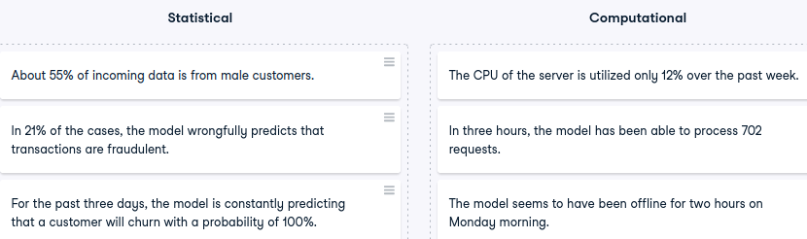
Feedback Loop
- Over time, actual outcomes (e.g., whether a customer churned) become available this is the ground truth.
- Comparing model predictions to ground truth reveals:
  - Accuracy trends
  - Model degradation
  - Biases or failure patterns (e.g., errors for specific customer groups)
- This comparison forms the feedback loop, which is essential for:
  - Diagnosing model errors
  - Triggering retraining
  - Improving future model versions
Best Practice
- Monitor both statistical and computational metrics in tandem.
- This dual approach helps detect both prediction issues and infrastructure bottlenecks, enabling timely mitigation and model reliability.

Retraining Machine Learning Models
- Retraining is a critical post-deployment activity that ensures models remain accurate and relevant as data evolves over time.
- Data is dynamic changes in the real world affect the patterns and distributions that models rely on. Retraining helps the model adapt to these changes by learning from fresh data.
Types of Drift
- Data Drift:
  - Refers to changes in the input data distribution.
  - Example: customer demographics shift new age groups or regions appear.
  - May or may not affect model performance depending on how sensitive the model is to these changes.
- Concept Drift:
  - Refers to changes in the relationship between input data and the target variable.
  - Example: same customer profile now leads to non-churn instead of churn.
  - This shift breaks the learned patterns and can degrade model accuracy significantly.
Retraining Frequency
- Depends on multiple factors:
  - Business environment: fast-changing domains (e.g., finance, retail) may require frequent updates.
  - Expert insight: domain experts can anticipate shifts and recommend retraining schedules.
  - Cost of retraining: complex models require more compute and time, influencing retraining feasibility.
  - Performance thresholds: if accuracy drops below a required level (e.g., 90%), retraining is triggered.
  - Model degradation rate: how quickly performance deteriorates over time.
Retraining Strategies
- Separate Models:
  - Train a new model using only new data.
  - Maintain the old model for reference or fallback.
- Combined Data:
  - Merge old and new data to train a unified model.
  - Choice depends on domain sensitivity, cost constraints, and performance goals.
Automatic Retraining
- In mature ML setups, retraining can be automated:
  - Triggered by data volume thresholds or drift detection.
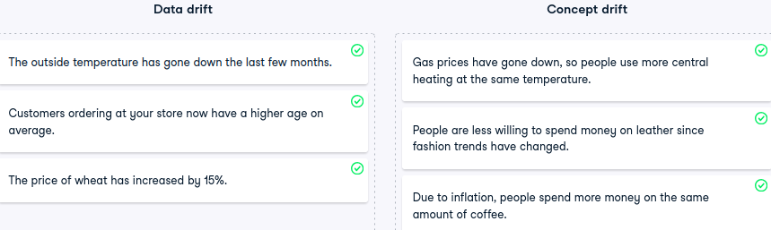
  - Example: if average customer age shifts significantly, retraining is initiated.
Levels of MLOps Maturity
- MLOps maturity reflects how well a business automates, collaborates, and monitors its machine learning lifecycle especially in development and deployment phases.
- A higher maturity level doesn’t always mean “better,” but it does highlight opportunities for improvement and scalability.
- The design phase remains largely manual due to its reliance on human judgment and cross-functional input, though templates can help streamline it.
Three Levels of MLOps Maturity
- Level 1: Manual Processes
  - No automation across the lifecycle data ingestion, model training, and deployment are all manual.
  - Teams work in silos with minimal collaboration.
  - No traceability features, experiments, and model performance are not tracked.
  - Common starting point for companies new to machine learning.
  - High time and effort required; error recovery is slow and costly.
- Level 2: Automated Development
  - Development phase includes automation via feature stores and automated training.
  - CI pipelines are used, but deployment remains manual.
  - Collaboration between ML and operations teams begins to emerge.
  - Traceability improves models can be reproduced and evaluated during development.
  - Post-deployment monitoring is minimal but present.
- Level 3: Automated Development and Deployment
  - Full automation across development and deployment using CI/CD pipelines.
  - Strong collaboration across all roles in the ML pipeline.
  - Production models are actively monitored.
  - Retraining can be automatically triggered based on performance or drift detection.

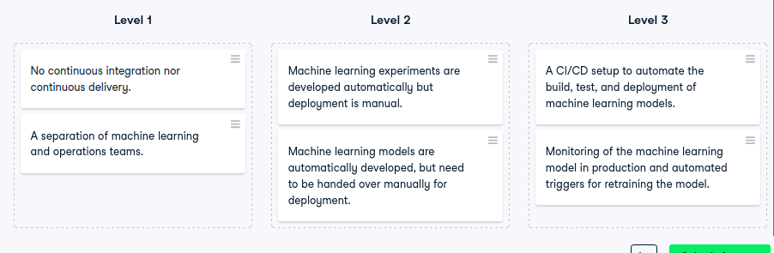
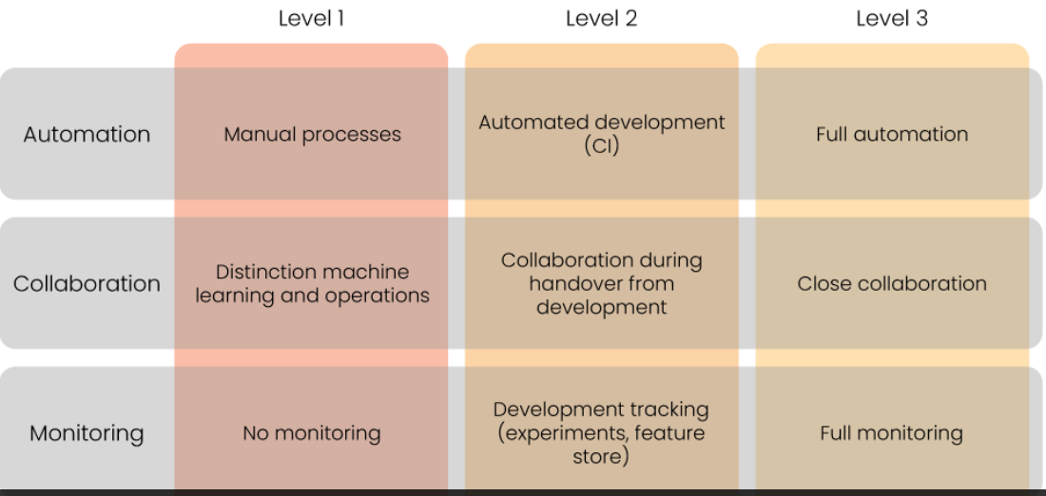

MLOps Tools Across the Machine Learning Lifecycle
- MLOps has led to the development of specialized tools that enhance automation, reliability, and scalability across ML workflows. MaMLOps Tools Across the Machine Learning Lifecycle
- MLOps has led to the development of specialized tools that enhance automation, reliability, and scalability across ML workflows. Many are open-source and modular, allowing teams to tailor their stack.
Feature Store Tools
- Feast:
  - Open-source and self-managed.
  - Offers flexibility but requires manual setup and maintenance.
- Hopsworks:
  - Open-source and part of the broader Hopsworks platform.
  - Best suited when other Hopsworks components are already in use.
Experiment Tracking Tools
- MLflow:
  - Focused on ML development lifecycle.
  - Tracks parameters, metrics, and artifacts.
- ClearML:
  - Covers both development and deployment.
  - Offers experiment tracking and orchestration.
- Weights & Biases (W&B):
  - Specializes in visualizing experiment results.
  - Strong dashboarding and collaboration features.
Containerization Tools
- Docker:
  - Most widely used tool for packaging applications with dependencies.
  - Ensures consistent runtime across environments.
- Kubernetes:
  - Orchestrates and scales containerized applications.
  - Enables automated deployment and load balancing.
- Cloud-native options:
  - AWS, Azure, and Google Cloud offer integrated container services for ML workloads.
CI/CD Pipeline Tools
- Jenkins:
  - Open-source CI/CD automation server.
  - Highly customizable with plugins.
- GitLab:
  - Proprietary platform with built-in CI/CD and version control.
  - Supports collaborative development via project repositories.
Monitoring Tools
- Fiddler:
  - Focuses on model performance monitoring.
  - Tracks prediction accuracy and drift.
- Great Expectations:
  - Focuses on data quality monitoring.
  - Validates schema, missing values, and distribution shifts.
End-to-End MLOps Platforms
- AWS SageMaker
- Azure Machine Learning
- Google Cloud AI Platform
  - Each provides integrated tools for:
    - Data exploration
    - Feature engineering
    - Model training
    - Deployment
    - Monitoring
  - Ideal for teams seeking unified lifecycle management with cloud scalability.
- ny are open-source and modular, allowing teams to tailor their stack.


