What Is Artificial Intelligence?
Artificial Intelligence (AI) refers to technologies that enable machines to perform tasks typically requiring human intelligence such as perception, reasoning, and decision-making.

Why Explainability Matters
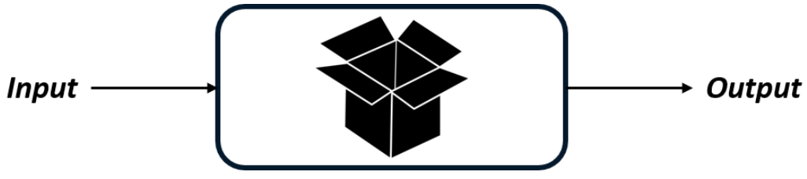
AI models, especially those based on machine learning, often behave like black boxes:
- We observe inputs and outputs.
- But the internal decision logic remains hidden.
This opacity raises concerns about trust, fairness, and accountability.
Explainable AI (XAI) addresses this by making model behavior interpretable and transparent.

Trade-off: Explainability vs. Accuracy
AI models lie on a spectrum:
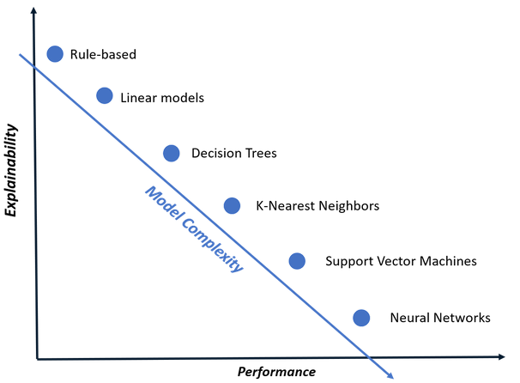
Model Type | Explainability | Accuracy
Simple models (e.g., Decision Trees) | High | Lower
Complex models (e.g., Neural Networks) | Low | Higher
Complex models capture intricate patterns but are harder to interpret.

Decision Trees vs. Neural Networks
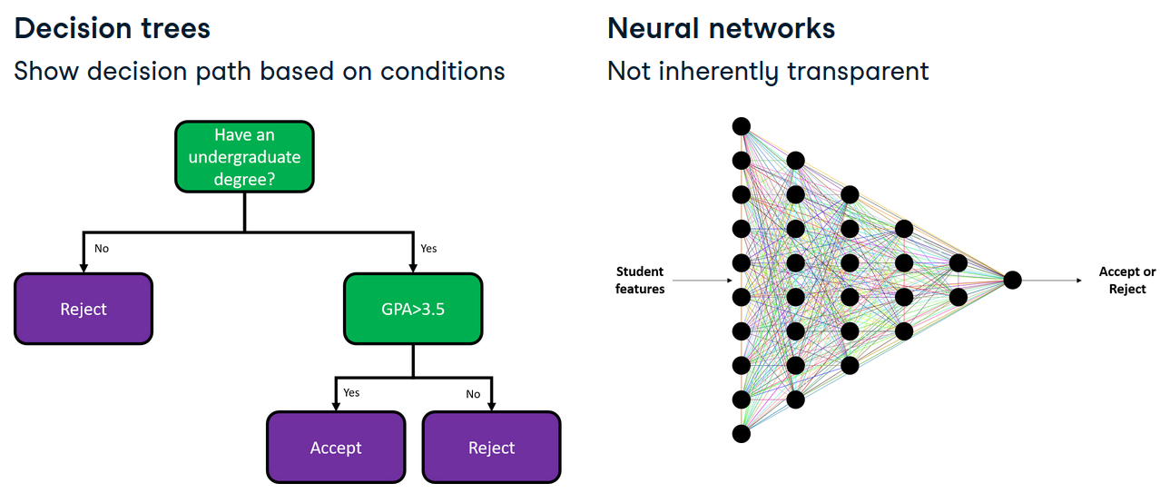

Decision Trees
- Represent decisions as a flow of conditions.
- Easy to trace and explain.
- Example: Predicting graduate school admission based on GPA and GRE scores.

Neural Networks
- Composed of multiple layers and neurons.
- Capable of modeling complex relationships.
- Lack inherent transparency in decision-making.

Comparison Summary
Feature | Decision Tree | Neural Network
Structure | Hierarchical rules | Layered neurons
Interpretability | High | Low
Performance (in example) | Lower accuracy | Higher accuracy

Student Admission Prediction Example
Dataset includes:
- GRE and TOEFL scores
- University rating
- SOP and LOR grades
- CGPA
Models used:
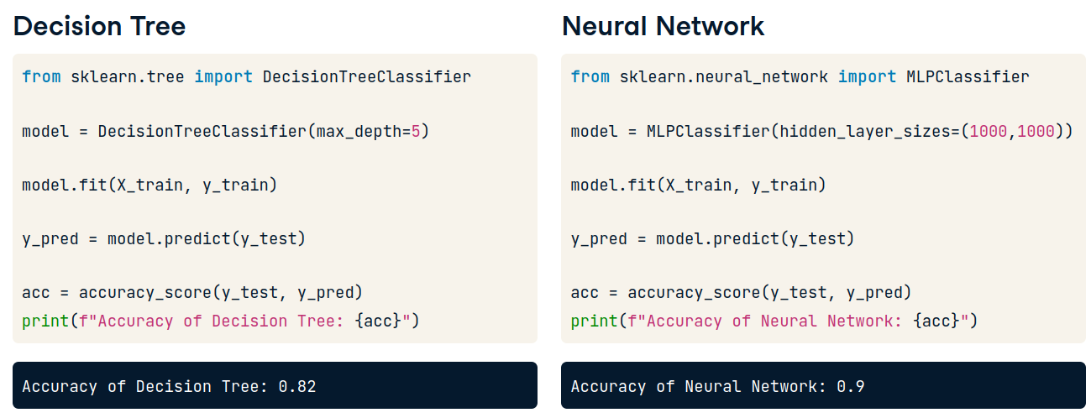
- DecisionTreeClassifier with max_depth=5
- MLPClassifier with hidden_layer_sizes=(1000, 1000)
Outcome:
- Neural network (MLPClassifier) outperforms the decision tree in accuracy.
- However, only the decision tree offers interpretable rules.

Extracting Decision Tree Rules
Using sklearn.tree.export_text, we can extract decision logic:
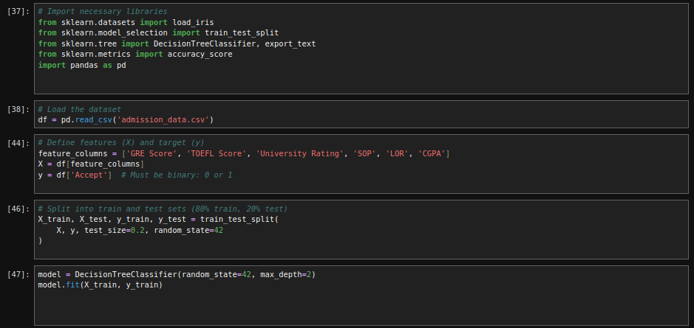

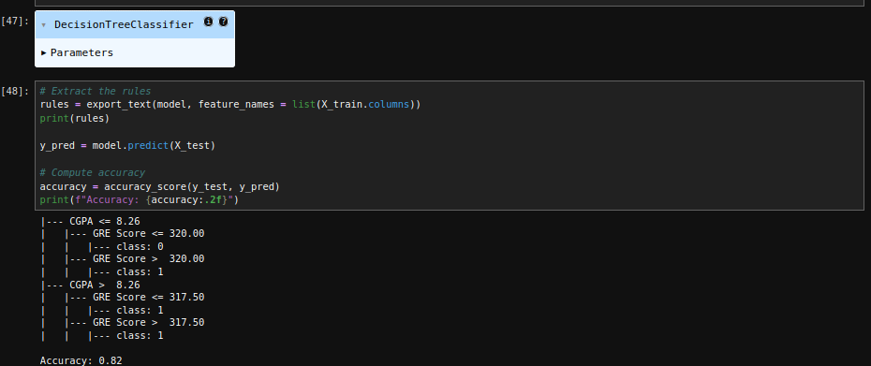
- If CGPA ≤ 8.34 and GRE ≤ 320.5 -> Reject
- If GRE > 320.5 -> Accept
Such rule-based explanations are not available for neural networks.

Model-Specific vs. Model-Agnostic Explainability

Model-Specific Techniques
- Tailored to specific model types.
- Example: Rule extraction for decision trees.

Model-Agnostic Techniques
- Applicable to any model.
- Example: SHAP and LIME for explaining neural networks.
Analogy:
- Model-specific = custom key for a lock
- Model-agnostic = master key for multiple locks

What’s Next in the Course
Topics to be covered:
- Local vs. global explainability
- Model-specific and model-agnostic methods
- Explainability metrics
- Unsupervised model explainability
- Generative AI explainability
Libraries used:
- sklearn
- SHAP
- LIME

explainibility for Decision tree
model = DecisionTreeClassifier(random_state=42, max_depth=2)
model.fit(X_train, y_train)

# Extract the rules
rules = export_text(model, feature_names = list(X_train.columns))
print(rules)

y_pred = model.predict(X_test)

# Compute accuracy
accuracy = accuracy_score(y_test, y_pred)
print(f"Accuracy: {accuracy:.2f}")

without explainability Multilayer perceptron networks

model = MLPClassifier(hidden_layer_sizes=(36, 12), random_state=42, max_iter=5000)
# Train the MLPClassifier
model.fit(X_train, y_train)

# Derive the predictions on the test set
y_pred = model.predict(X_test)

# Compute the test accuracy
accuracy = accuracy_score(y_test, y_pred)
print(f"Accuracy: {accuracy:.2f}")

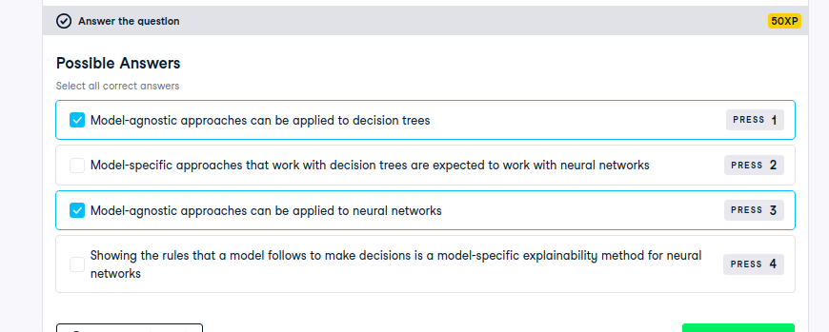

Explainability in Linear Models
We begin our exploration of model-specific explainability with linear models, widely used in both regression and classification tasks.

Types of Linear Models
- Linear Regression: Predicts continuous outcomes. Example: Estimating a mobile phone’s price based on storage capacity.
- Logistic Regression: Used for binary classification. Example: Detecting fraudulent transactions based on amount and time.

Why Are Linear Models Explainable?
Linear models predict outcomes using a linear combination of input features. In two dimensions:
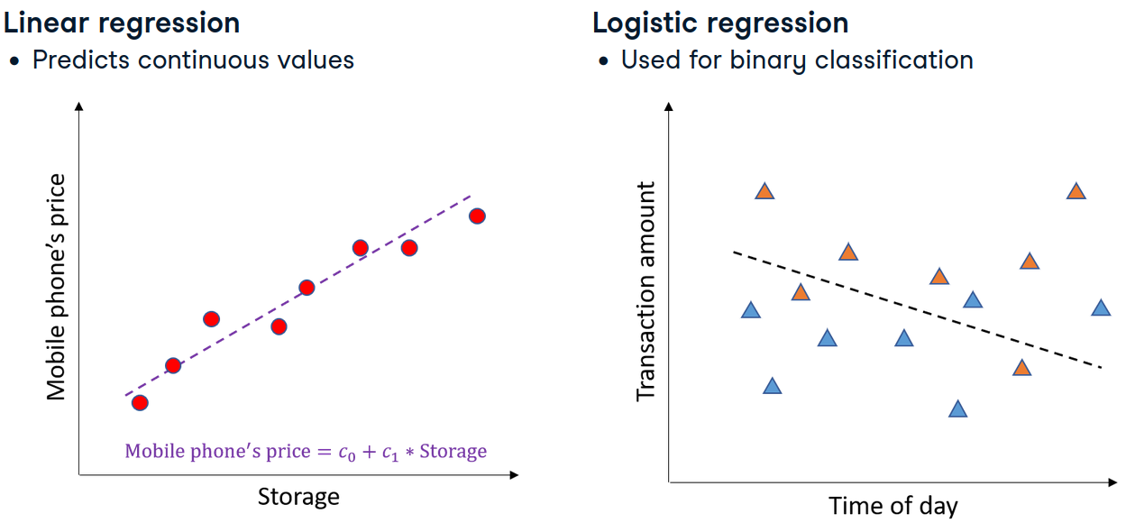
- Linear Regression fits a line that minimizes prediction error.
- Logistic Regression fits a line (or hyperplane) that separates two classes.
Each feature is assigned a coefficient that quantifies its contribution to the prediction.

Understanding Coefficients
- Magnitude:
  - A larger absolute value indicates greater influence on the prediction.
  - Example: If storage has a coefficient of 5 and camera count has 2, storage is more influential.
- Sign:
  - Positive coefficients increase the predicted value.
  - Negative coefficients decrease it.
  - Coefficients of -5 and 5 have equal strength but opposite effects.
- Normalization:
  - Essential for fair comparison of coefficients.
  - Without normalization, features on different scales (e.g., GigaByte vs. count) distort interpretability.

Example: Mobile Phone Price Prediction
- Features: Storage capacity (e.g., 128–1024 GB), Number of camera lenses (1–4)
- Without normalization, storage dominates due to its larger numeric scale.
- Normalization ensures both features contribute comparably to the model.

Case Study: Graduate Admissions Dataset
- Features: GRE, TOEFL, University Rating, SOP, LOR, CGPA
- Labels:
  - y_reg: Chance of acceptance (regression)
  - y_cls: Acceptance/rejection (classification)

Model Training Workflow
- Normalize features using MinMaxScaler.fit_transform().
- Train:
  - LinearRegression on y_reg
  - LogisticRegression on y_cls

Accessing Coefficients
- Use .coef_ attribute:
  - Linear regression -> 1D array
  - Logistic regression -> 2D array (extract first row for binary classification)

Visualizing Coefficients
- Use matplotlib.pyplot.bar to plot feature importance.
- X-axis: X_train.columns
- Y-axis: Corresponding coefficients
- For logistic regression, use model.coef_[0]
Key Insight:
- CGPA emerges as the most influential feature in predicting graduate admissions, aligning with domain expectations.

build and explain a linear regression model that estimates insurance charges based on features like age, BMI, and smoking status by analyzing the model's coefficients to determine the impact of each feature on the predictions.

# Standardize the training data
scaler = MinMaxScaler()
X_train_scaled = scaler.fit_transform(X_train)
model = LinearRegression()

# Fit the model
model.fit(X_train_scaled, y_train)

# Derive coefficients
coefficients = model.coef_
feature_names = X_train.columns

# Plot coefficients
plt.bar(feature_names, coefficients)
plt.show()
analyze the model to determine the relevant factors influencing smoking status, helping the company assess risk more accurately and tailor insurance policies accordingly.
scaler = MinMaxScaler()
X_train_scaled = scaler.fit_transform(X_train)

model = LogisticRegression()
model.fit(X_train_scaled, y_train)

# Derive coefficients
coefficients = model.coef_[0]
feature_names = X_train.columns

# Plot coefficients
plt.bar(feature_names,coefficients)
plt.show()

Explainability in Tree-Based Models
After understanding linear models, we now explore tree-based models specifically decision trees and random forests which offer distinct mechanisms for decision-making and interpretability.

Decision Trees
- Serve as the foundational structure for many tree-based models.
- Applicable to both regression and classification tasks.
- Use a hierarchical, tree-like structure where each node represents a decision based on a feature.
- Naturally interpretable: each path from root to leaf reveals the decision logic.

Random Forests
- Composed of multiple decision trees.
- Used for both regression and classification.
- Aggregate predictions from all trees to produce final output.

Interpretability Challenge
- Individual trees can be inspected, but doing so across hundreds or thousands becomes impractical.
- Instead, we use feature importance scores to assess which features most influence predictions instead of learnedcoeff like in linear models.

Comparison with Linear Models
Aspect | Linear Models | Tree-Based Models
Importance Mechanism | Coefficients | Reduction in prediction uncertainty
Interpretability | Direct (via coefficients) | Indirect (via importance scores)
Scalability of Explanation | High | Lower (especially for ensembles)

Case Study: Graduate Admissions Dataset
- Goal: Predict student admission using features like GRE, TOEFL, CGPA, SOP, LOR, and university rating.
- Data:
  - Features -> X_train
  - Labels -> y_train

Model Training Workflow
- Import models:
  - DecisionTreeClassifier from sklearn.tree
  - RandomForestClassifier from sklearn.ensemble
Initialize and train:
tree_model.fit(X_train, y_train)
forest_model.fit(X_train, y_train)

Extract feature importances:
tree_model.feature_importances_
forest_model.feature_importances_

Visualizing Feature Importance
- Use matplotlib.pyplot.barh to create horizontal bar plots.
- X-axis: Importance scores
- Y-axis: Feature names from X_train.columns

Key Insight
- CGPA and test scores consistently emerge as the most influential features.
- This aligns with domain expectations, reinforcing model validity.

Heart disease model explanation

decision tree classifier to identify patients at risk of heart disease using the heart disease dataset. Now you need to explain the model by analyzing feature importance to determine the key factors for predicting heart disease, enabling more targeted healthcare interventions.

model = DecisionTreeClassifier(random_state=42)
model.fit(X_train, y_train)

# Derive feature importances
feature_importances = model.feature_importances_
feature_names = X_train.columns

# Plot the feature importances
plt.barh(feature_names, feature_importances)
plt.show()

For Random Forest
model = RandomForestClassifier(random_state=42)
model.fit(X_train, y_train)

# Derive feature importances
feature_importances = model.feature_importances_
feature_names = X_train.columns

# Plot the feature importances
plt.barh(feature_names, feature_importances)
plt.show()

Conceptual Analogy
Imagine a band:
- Each musician contributes to the song.
- Shuffle one musician’s notes -> assess impact on song quality.
- If the song degrades, that instrument is important.
This mirrors permutation importance:
- Shuffle one feature’s values.
- Measure change in model performance.
- Larger drop -> higher feature importance.

What Is Permutation Importance?
- A model-agnostic technique to assess feature importance.
- Applicable to any model, including neural networks.
- Measures how shuffling a feature affects prediction accuracy.

How It Works
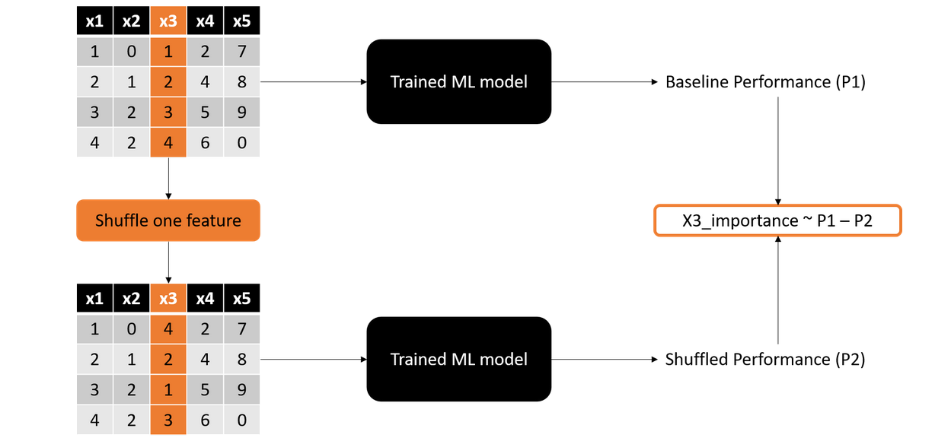
- Train a model on dataset with features x_1, x_2, ..., x_5.
- Compute baseline performance (e.g., accuracy).
- Shuffle one feature at a time.
- Recompute performance.
- Importance ∝ drop in performance.
Drop in Accuracy | Feature Importance
Large | High
Small | Low

Case Study: Graduate Admissions Dataset
- Features: GRE, TOEFL, CGPA, SOP, LOR, University Rating
- Labels: Admission outcome
- Model: MLPClassifier with two hidden layers of 10 neurons each

Implementation Steps
- Train the neural network:
model = MLPClassifier(hidden_layer_sizes=(10, 10))
model.fit(X_train, y_train)

Import andapply permutation importance

from sklearn.inspection import permutation_importance

result = permutation_importance(
model,
X_train,
y_train,
n_repeats=30,
random_state=42,
scoring='accuracy'
)

Average inportances

importances = result.importances_mean

Visualizing Feature Importance
- Use matplotlib.pyplot.bar to plot:
  - X-axis: X_train.columns
  - Y-axis: result.importances_mean

Key Insight
- CGPA and test scores emerge as most influential.
- Confirms domain expectations and model validity.

Comparison with Model-Specific Methods
Method | Model Type | Mechanism | Applicability
Coefficients | Logistic Regression | Direct weight assignment | Model-specific
Permutation Importance | Any model | Performance degradation | Model-agnostic

Both methods highlight CGPA and test scores as key predictors, but permutation importance offers broader applicability across model types.

Coefficients vs. permutation importance
compare the patterns identified by permutation importance with the model coefficients from a logistic regression trained on the heart disease dataset. A helper function plot_importances() is called at the end of the script to plot importances on the same plot.

from sklearn.inspection import permutation_importance

# Extract and store model coefficients
coefficients = model.coef_[0]

# Compute permutation importance on the test set
perm_importance = permutation_importance(
model, X, y,
n_repeats=20,
random_state=1,
scoring='accuracy'
)

# Compute the average permutation importance
avg_perm_importance = perm_importance.importances_mean
plot_importances(coefficients, avg_perm_importance)

SHAP Explainability
We now explore SHAP (SHapley Additive exPlanations), a model-agnostic technique rooted in game theory that attributes model predictions to individual input features.

What Is SHAP?
- SHAP is based on Shapley values, a concept from cooperative game theory.
- It fairly distributes a model’s prediction (the “payout”) among input features (the “players”) based on their contribution.

Analogy
Imagine a band sharing profits from a hit song:
- Each musician’s contribution is assessed.
- Profits are split proportionally to their impact.
- SHAP does the same for features in a prediction.

SHAP Explainers
SHAP provides two categories of explainers:
- Model-agnostic explainers: Work with any model.
- Model-specific explainers: Optimized for certain model types.
In this module, we focus on:
- TreeExplainer: Efficient and accurate for tree-based models like decision trees and random forests.

Case Study: Graduate Admissions Dataset
Models:
- RandomForestRegressor: Predicts probability of admission.
- RandomForestClassifier: Predicts binary acceptance.
Features are stored in the dataframe X.

Deriving SHAP Values
- Import SHAP and initialize explainers:
import shap
explainer = shap.TreeExplainer(model)
Compute shap values
shap_values = explainer.shap_values(X)

Understanding SHAP Output

For Regression
- shap_values is a matrix of shape (n_samples, n_features).
- Each value indicates how much a feature increased or decreased the prediction for a sample.

For Classification
- Output has shape (n_classes, n_samples, n_features).
- For binary classification, use shap_values[1] to explain the positive class.

Aggregating Feature Importance
To compute global feature importance:
Take the mean of absolute SHAP values across all samples:
import numpy as np
importance = np.abs(shap_values).mean(axis=0)

Visualize barplot
import matplotlib.pyplot as plt
plt.bar(X.columns, importance)

Key Insight
- CGPA and test scores consistently emerge as the most influential features.
- SHAP explanations align with those from permutation importance and model-specific methods, reinforcing trust in the model.

SHAP Kernel Explainer Overview
The SHAP Kernel Explainer is a model-agnostic method for interpreting predictions. Unlike the Tree Explainer, which is optimized for tree-based models, the Kernel Explainer can be applied to any machine learning model including KNNs, neural networks, and even tree models. It uses the same SHAP value principles but is slower due to lack of model-specific optimizations. When available, type-specific explainers are preferred, but the Kernel Explainer remains universally applicable.

Use Case: Heart Disease Classification
We apply the Kernel Explainer to a neural network model mlp_clf trained to classify heart disease risk. Input features include:
- Chest pain type
- Heart rate

Use Case: Insurance Charges Regression
We also apply the Kernel Explainer to a neural network model mlp_reg trained to predict insurance charges. Input features include:
- Smoking status
- Age

Creating Kernel Explainers
To set up SHAP Kernel Explainers:
1. Import SHAP
import shap
2. Define the explainer Use shap.KernelExplainer with:
- The model’s prediction function (predict or predict_proba)
- A representative summary of the dataset
3. Model-specific prediction functions
- For regression: mlp_reg.predict
- For classification: mlp_clf.predict_proba
4. Efficient dataset summarization
- Instead of using the full dataset, use:
shap.kmeans(data, 10)
This clusters the data and uses centroids as representative samples.
- Compute SHAP values
explainer.shap_values(X)
in code
Classification
import shap
explainer = shap.KernelExplainer(mlp_clf.predict_proba, shap.kmeans(X,10))
shap_cls_value = explainer.shap_values(X)
mean_clf = np.abs(shap_cls_value[:,:,1]).mean(axis=0)
plt.bar(X.columns,mean_clf)

Regression
import shap
explainer = shap.KernelExplainer(mlp_reg.predict_proba, shap.kmeans(X,10))
shap_cls_value = explainer.shap_values(X)
mean_reg = np.abs(shap_reg_value).mean(axis=0)
plt.bar(X.columns,mean_reg)

Feature Importance Analysis
To derive feature importance:
- Aggregate SHAP values using mean absolute value across samples.
- For classification, select the appropriate class index (e.g., index 1).
- Plot the results to visualize feature impact.
Findings:
- Insurance Charges: Age and smoking status are most influential.
- Heart Disease: Chest pain type and thalassemia are key drivers.
These insights align with domain expectations in healthcare and insurance.

Comparison with Model-Specific Approaches
When compared to linear and logistic regression coefficients:
- Feature importance patterns remain consistent.
- Computation methods and values differ.
- Kernel Explainer offers broader applicability across model types.
Key Advantage: Model-agnostic explainers like Kernel Explainer are essential for interpreting complex models (e.g., neural networks), supporting transparency and reliability in AI systems.

Given your familiarity with the admissions dataset, you will employ SHAP's Kernel Explainer to explain an MLPRegressor trained on this data. This method will allow you to critically assess how different features impact the model's predictions and verify these insights against your existing understanding of the dataset.

import shap

# Create a SHAP Kernel Explainer
explainer = shap.KernelExplainer(model.predict, shap.kmeans(X,10))

# Calculate SHAP values
shap_values = explainer.shap_values(X)

# Calculate mean absolute SHAP values
mean_abs_shap = np.abs(shap_values.mean(axis=0))

plt.bar(X.columns, mean_abs_shap)
plt.title('Mean Absolute SHAP Values for MLPRegressor')
plt.xticks(rotation=45)
plt.show()

Neural networks can be very accurate, but understanding their decisions can be challenging due to complexity. Now, you'll leverage the SHAP Kernel Explainer to interpret an MLPClassifier trained on the adult income dataset. You will explore which of the three features—age, education, or hours worked per week—is most important for predicting income according to this model.

import shap

# Create a SHAP Kernel Explainer
explainer = shap.KernelExplainer(model.predict_proba,shap.kmeans(X,10))

# Calculate SHAP values
shap_values = explainer.shap_values(X)

# Calculate mean absolute SHAP values
mean_abs_shap = np.abs(shap_values.mean(axis=0))

plt.bar(X.columns, mean_abs_shap)
plt.title('Mean Absolute SHAP Values for MLPClassifier')
plt.xticks(rotation=45)
plt.show()

Visualizing SHAP Explainability
SHAP provides powerful visualization tools to interpret model predictions. These plots help uncover how features influence outcomes, both globally and locally.

Dataset and Model Setup
We use a Random Forest Regressor trained on the insurance dataset to predict medical charges. Since it's a tree-based model, we apply shap.TreeExplainer to compute SHAP values.

Feature Importance Plot
Feature importance plots aggregate SHAP values across all samples to show each feature’s overall contribution.

Steps:
- Use shap.summary_plot(shap_values, X, plot_type='bar')
- This generates a bar chart ranking features by mean absolute SHAP value.

Insights:
- Smoker is the most influential predictor of insurance charges.
- Gender has minimal impact.
This aligns with domain expectations in healthcare pricing.
For College Admissions
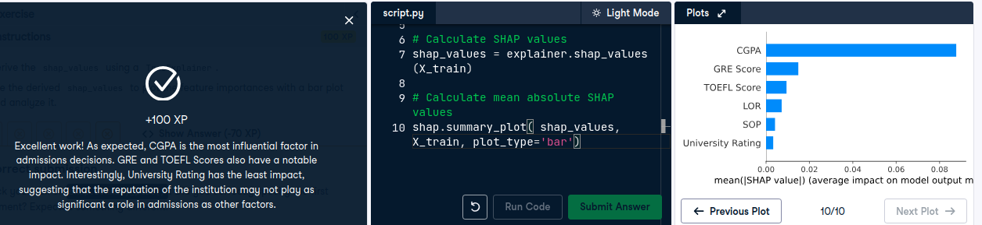

Beeswarm Plot
Beeswarm plots offer a granular view of SHAP value distributions across samples, showing both magnitude and direction of feature impact.

Key Characteristics:
- Each dot represents a SHAP value for a feature-sample pair.
- Color-coded:
  - Red = high feature value
  - Blue = low feature value
- SHAP value sign:
  - Positive = increases prediction
  - Negative = decreases prediction

Example:
- Red dots for smoker with positive SHAP values -> higher charges.
- Blue dots for non-smoker with negative SHAP values -> lower charges.

Plotting:

shap.summary_plot(shap_values, X, plot_type='dot')
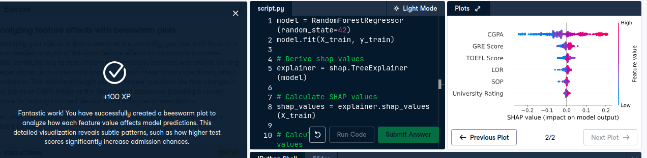

Partial Dependence Plot
Partial dependence plots (PDPs) show how a single feature affects predictions across its range, holding other features constant.

How It Works:
- For each sample, vary the target feature (e.g., age) across its range.
- Predict outcomes while keeping other features fixed.
- Average predictions for each value of the target feature.

Plotting:
shap.partial_dependence_plot(
"age", model.predict, X
)

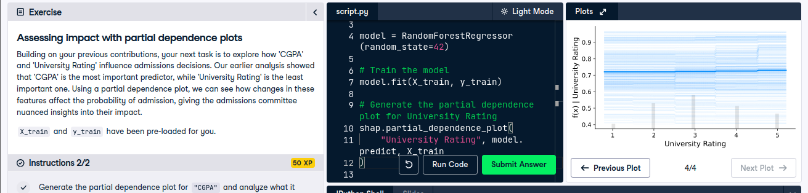
least impacctigng model

Interpretation:
- Dark blue line: average prediction trend higher age -> higher charges.
- Light lines: individual sample effects.
- Gray bars: distribution of age values in the dataset denser regions imply more confident predictions.

Local Explainability with SHAP
Local explainability focuses on understanding why a model made a specific prediction for an individual instance, rather than analyzing overall model behavior. This is crucial in sensitive domains like healthcare and finance, where transparency at the individual level builds trust and accountability.

Global vs. Local Explainability
- Global Explainability: Explains the model’s overall behavior by identifying the most influential features across the dataset.
- Local Explainability: Explains the model’s decision for a single data point. Analogy:
  - Global = professor discussing class-wide exam trends
  - Local = professor explaining one student’s grade
Both perspectives are essential for building fair and interpretable AI systems.

Use Case: Heart Disease Prediction with KNN
We apply SHAP to a KNN classifier trained on the heart disease dataset to generate local explanations.

Workflow for Local SHAP Explanation
- Create Kernel Explainer

explainer = shap.KernelExplainer(knn_model.predict_proba, shap.kmeans(X_train, 10).data)
- Select a Test Instance

test_instance = X_test.iloc[0]
- Compute SHAP Values for the Instance

shap_values = explainer.shap_values(test_instance)
  - For binary classification, shap_values is a list of two arrays (class 0 and class 1).
  - Each array has shape (n_features,).

SHAP Waterfall Plot
Waterfall plots visualize how each feature contributes to the prediction for a specific instance.

Components:
- Baseline Value: Average model prediction across all samples (explainer.expected_value[1] for class 1).
- Feature Contributions: Each feature either pushes the prediction higher or lower.
- Example:
  - age and resting_blood_pressure -> increase heart disease risk
  - resting_ecg_results -> decrease risk

Plotting:

shap.waterfall_plot(
shap.Explanation(
values=shap_values[1],
base_values=explainer.expected_value[1],
data=test_instance,
feature_names=X.columns
)
)

Comparing Multiple Instances
By generating waterfall plots for several test samples, we can:
- Observe how feature impact varies across individuals.
- Identify consistent vs. case-specific drivers of prediction.
- Ensure model decisions are interpretable and justifiable.

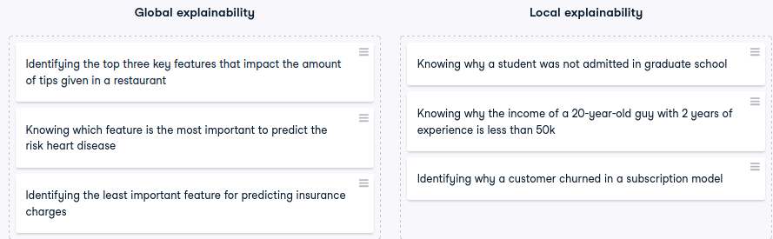

Local Explainability with LIME
LIME is a tool designed to provide local explainability for machine learning models. It focuses on explaining individual predictions rather than global model behavior.

What is LIME?
LIME stands for Local Interpretable Model-agnostic Explanations. It explains predictions of complex models by approximating them locally with interpretable models. Key characteristics:
- Local: Focuses on a single instance at a time.
- Interpretable: Uses simple models (like linear models) for explanation.
- Model-agnostic: Works with any black-box model.

Types of LIME Explainers
LIME offers different explainers tailored to data types:
- LIME Tabular Explainer – for structured/tabular data.
- LIME Text Explainer – for textual data.
- LIME Image Explainer – for image data.
Each explainer perturbs the input instance and observes how the model’s prediction changes. These perturbations are used to train a local surrogate model that mimics the behavior of the original model around that instance.

Case Study: Graduate Admissions Dataset
Two models are trained on the admissions dataset:
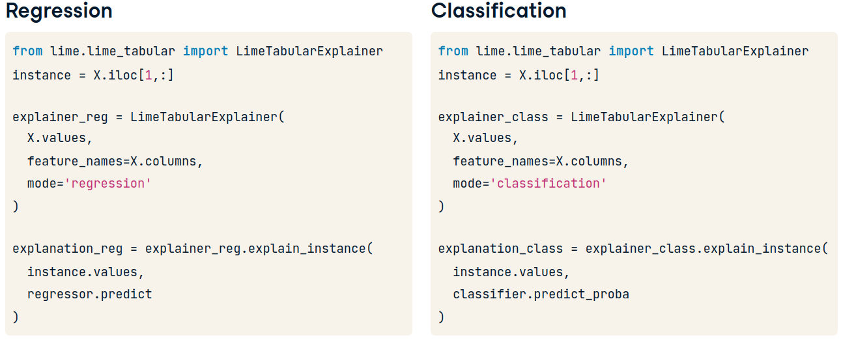
- A regressor that predicts the likelihood of admission.
- A classifier that predicts whether a student will be admitted.
Although both models are used for comparison, in practice, one would be chosen based on the problem context. The features are stored in a dataframe X.

Steps to Create a Tabular Explainer
- Import the explainer:

from lime.lime_tabular import LimeTabularExplainer
- Select an instance to explain (same for both models).
- Initialize the explainer:

explainer = LimeTabularExplainer(
training_data=X.values,
feature_names=X.columns,
mode='regression' or 'classification'
)
- Generate explanation:

explanation = explainer.explain_instance(
data_row=instance.values,
predict_fn=model.predict or model.predict_proba
)
from lime.lime_tabular import LimeTabularExplainer

sample_data_point = X.iloc[2, :]

# Create the explainer
explainer = LimeTabularExplainer(
training_data=X.values,
feature_names=sample_data_point,
mode='regression'
)

# Generate the explanation
exp = explainer.explain_instance(
data_row=sample_data_point.values,
predict_fn=model.predict
)

# Display the explanation
exp.as_pyplot_figure()
plt.show()

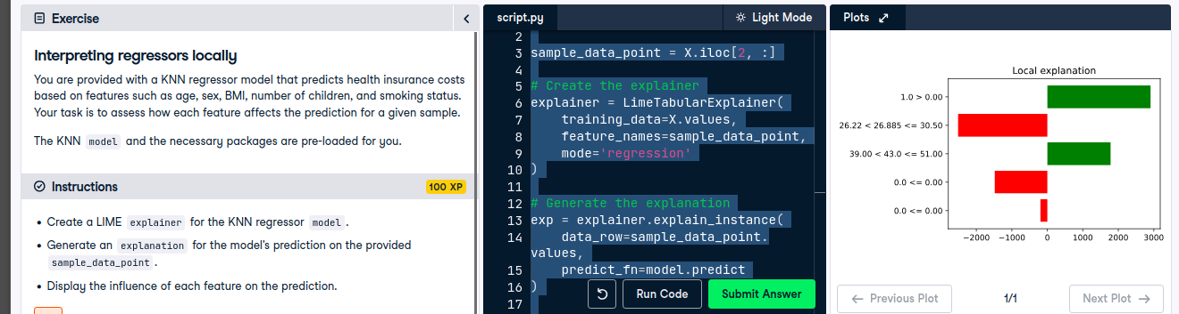
from lime.lime_tabular import LimeTabularExplainer

sample_data_point = X.iloc[2, :]

# Create the explainer
explainer = LimeTabularExplainer(
training_data=X.values,
feature_names=sample_data_point,
mode='classification'
)

# Generate the explanation
exp = explainer.explain_instance(
data_row=sample_data_point.values,
predict_fn=model.predict_proba
)

# Display the explanation
exp.as_pyplot_figure()
plt.show()

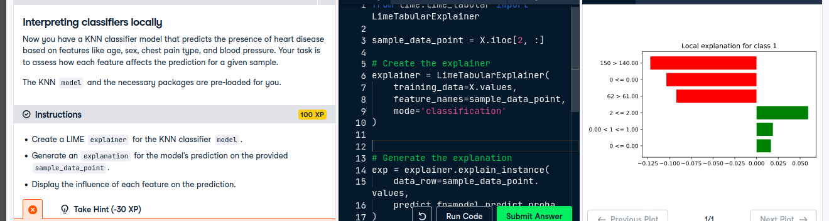

Text and Image Explainability with LIME
LIME is not limited to tabular data it also supports text and image models, helping us interpret predictions from black-box systems in NLP and computer vision.

Text-Based Models and Explainability
Text-based models process written language to perform tasks like sentiment analysis, where the model predicts whether a review is positive or negative. These models are often opaque, making it hard to understand why a prediction was made.
To address this, we use:

LimeTextExplainer
- Designed specifically for text classification tasks.
- Reveals how individual words influence the model’s prediction.

Steps to Use LIME for Text
- Import the explainer:
from lime.lime_text import LimeTextExplainer
- Define the text instance:
text_instance = "The movie was great but the ending was poor."
- Create the explainer:
explainer = LimeTextExplainer()
- Define a prediction function that returns class probabilities:
def model_predict(texts):
return model.predict_proba(texts)
- Generate explanation:
exp = explainer.explain_instance(text_instance, model_predict)
- Visualize:
exp.as_pyplot_figure()
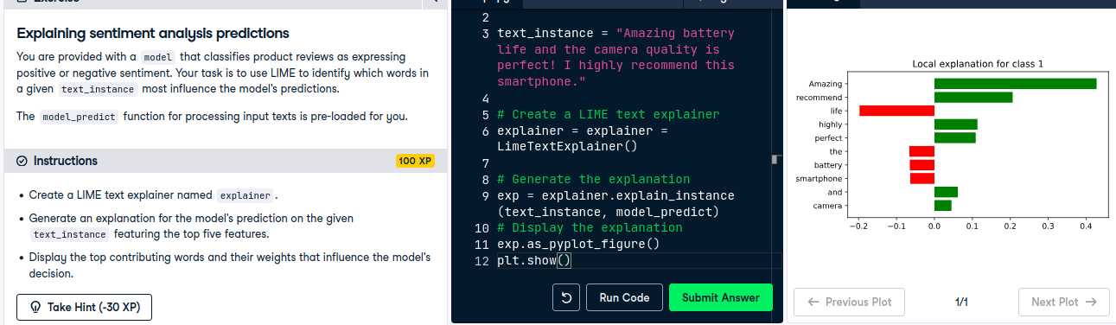
Words like "great" and "poor" will show strong positive or negative contributions, helping interpret sentiment decisions.

Image-Based Models and Explainability
Image models interpret visual inputs, such as classifying food images. These models are even more complex and harder to interpret.
To explain them, we use:

LimeImageExplainer
- Highlights regions of the image that most influence the prediction.
- No prior knowledge of image processing is needed.

Steps to Use LIME for Images
- Import the explainer:
from lime.lime_image import LimeImageExplainer
- Create the explainer:
explainer = LimeImageExplainer()
- Define the prediction function:
def model_predict(images):
return model.predict(images)
- Generate explanation:
explanation = explainer.explain_instance(
image_instance,
model_predict,
top_labels=1,
hide_color=0,
num_samples=1000
)
- Visualize important regions:
from skimage.segmentation import mark_boundaries
temp, mask = explanation.get_image_and_mask(
label=explanation.top_labels[0],
hide_rest=True
)
plt.imshow(mark_boundaries(temp, mask))
plt.title("LIME Explanation - Image")
plt.axis('off')
plt.show()
The important regions (e.g., the ice cream) remain visible, while less relevant areas are blacked outconfirming the model is focusing on the right features.

Visualizing the Explanation

explanation.as_pyplot_figure()
Insights from both models:
- Positive influence: Higher GRE and TOEFL scores.
- Negative influence: Lower SOP, University Rating, and CGPA.
Model choice depends on the specific use case.

SHAP vs. LIME
While SHAP provides consistent global and local explanations, LIME emphasizes local conditions how features affect a specific prediction. This granularity enhances transparency and trust, especially in high-stakes AI applications.

Consistency
Measures whether explanations remain stable when the model is trained on different data subsets.

How to Measure:
- Split the dataset into two parts: X1, y1 and X2, y2.
- Train two models: model1 on X1, y1, and model2 on X2, y2.
- Use SHAP to compute feature importances for both models.
- Calculate the cosine similarity between the two importance vectors.

Interpretation:
- Close to 1 -> Highly consistent explanations
- Near 0 -> No consistent pattern
- Close to -1 -> Opposite explanations (potential model instability)
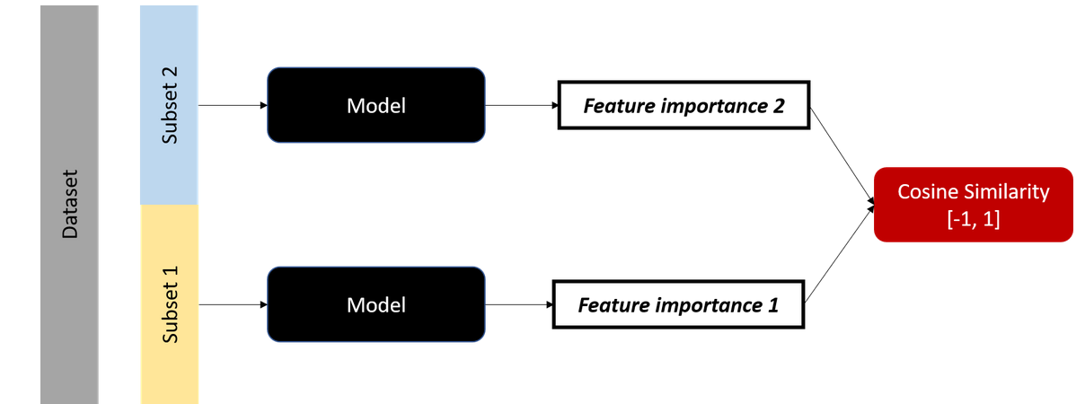
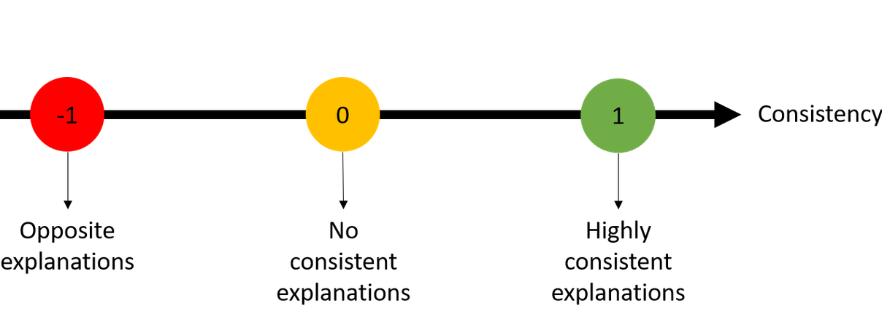

Example:

from sklearn.metrics.pairwise import cosine_similarity

explainer1 = shap.TreeExplainer(model1)
explainer2 = shap.TreeExplainer(model2)
shap_values1 = explainer1.shap_values(X1)
shap_values2=explainer2.shap_values(X2)

importance1 = np.mean(np.abs(shap_values1.values), axis=0)
importance2 = np.mean(np.abs(shap_values2.values), axis=0)

consistency_score = cosine_similarity([importance1], [importance2])[0][0]
print("Consistency:", consistency_score)
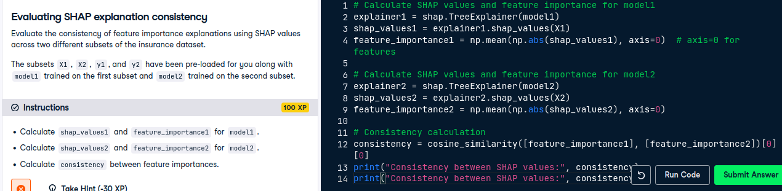

Faithfulness
Definition: Measures whether the features identified as important actually influence the model’s prediction when altered.

How to Measure:
- Select a sample and get its original prediction.
- Use SHAP or LIME to identify important features.
- Modify one or more of those features.
- Measure the change in prediction score.

Interpretation:
- Large change -> High faithfulness (feature truly impacts prediction)
- Small change -> Low faithfulness (feature may not be influential)
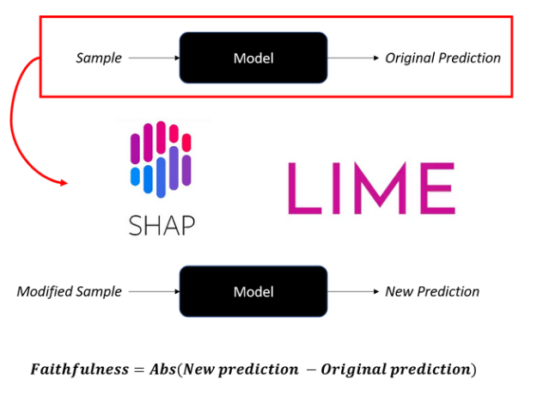

Example:
original_prob = model.predict_proba(instance)[0][1] # e.g., 0.43
modified_instance = instance.copy()
modified_instance['GRE Score'] = 310
new_prob = model.predict_proba(modified_instance)[0][1] # e.g., 0.77

faithfulness_score = abs(new_prob - original_prob) # e.g., 0.34
print("Faithfulness:", faithfulness_score)

Why These Metrics Matter
- Consistency ensures explanations are stable across data splits.
- Faithfulness confirms that explanations reflect true model behavior.
- Together, they help validate the reliability of interpretability tools like SHAP and LIME.

Explainability in Unsupervised Models: Clustering
Clustering algorithms like K-means group similar data points without labels. To interpret clustering behavior, we ask:
- Which features improve cluster quality?
- Which features influence cluster assignments?

Metric 1: Silhouette Score (Cluster Quality)
Definition: Measures how well-separated clusters are.
- Range: -1 to 1
- Close to 1 -> well-separated clusters
- Close to -1 -> poor clustering or misassignments
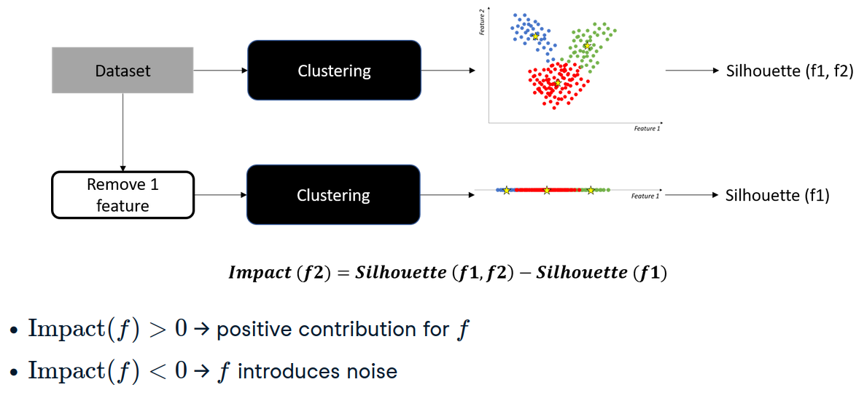

Feature Impact on Cluster Quality
from sklearn.cluster import KMeans
from sklearn.metrics import silhouette_score
import numpy as np

# Original clustering
kmeans = KMeans(n_clusters=2, random_state=42)
original_labels = kmeans.fit_predict(X)
original_score = silhouette_score(X, original_labels)

# Feature impact loop
feature_impacts = []
for i in range(X.shape[1]):
X_reduced = np.delete(X, i, axis=1)
kmeans_reduced = KMeans(n_clusters=2, random_state=42)
reduced_labels = kmeans_reduced.fit_predict(X_reduced)
reduced_score = silhouette_score(X_reduced, reduced_labels)
impact = original_score - reduced_score
feature_impacts.append(impact)

print("Silhouette-based feature impacts:", feature_impacts)
- Positive impact -> feature improves clustering
- Negative impact -> feature adds noise

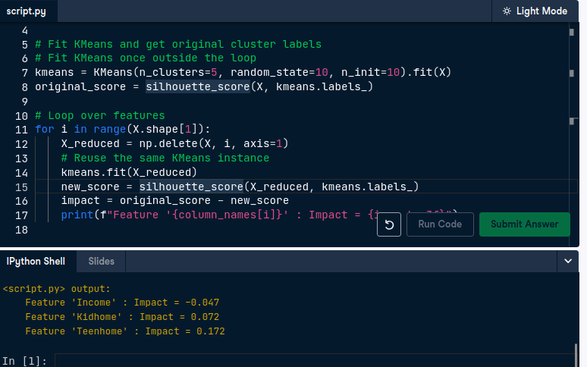
Metric 2: Adjusted Rand Index (Cluster Assignment Sensitivity)
Definition: Measures similarity between two clusterings.
- Range: 0 to 1
- Close to 1 -> identical cluster assignments
- Close to 0 -> different assignments

Feature Importance for Cluster Assignments
from sklearn.metrics import adjusted_rand_score

# Original clustering
kmeans = KMeans(n_clusters=2, random_state=42)
original_clusters = kmeans.fit_predict(X)

# Feature importance loop
assignment_impacts = []
for i in range(X.shape[1]):
X_reduced = np.delete(X, i, axis=1)
reduced_clusters = KMeans(n_clusters=2, random_state=42).fit_predict(X_reduced)
ari = adjusted_rand_score(original_clusters, reduced_clusters)
importance = 1 - ari
assignment_impacts.append(importance)

print("ARI-based feature importance:", assignment_impacts)
- Higher 1 - ARI -> feature strongly affects cluster assignments
- Lower 1 - ARI -> feature has little impact

Example: Student Performance Dataset
Features: age, health, absences, G1, G2, G3
- Cluster quality: age, health, absences improve separation
- Cluster assignment: health, G2, G3 drive cluster decisions

Chat-Based Generative AI Models
These models differ from traditional ones by generating text word-by-word. Given a prompt, they predict each next word based on prior context and a vast internal knowledge base. The challenge lies in explaining the reasoning behind their responses.

Chain-of-Thought Prompting
A powerful method for interpretability is the Chain-of-Thought (CoT) prompt. This prompt explicitly asks the model to explain its reasoning step-by-step. The model then outlines intermediate steps before arriving at its final answer, helping us trace its logic.

Example: Creating a Chain-of-Thought Prompt
To illustrate CoT prompting, consider a scenario where ChatGPT calculates the number of apples left in a shop after several transactions.
- The prompt includes the initial count, apples sold, and apples received.
- A function get_response handles interaction with ChatGPT
- The model responds with a breakdown:
  - Starts with initial count
  - Subtracts sold apples
  - Adds received apples
  - Outputs the final count
This step-by-step explanation reveals how the model processes each transaction logically.
# Complete the chain-of-thought prompt
prompt = "In a basket, there are twice as many apples as oranges and three times as many oranges as bananas. If there are 6 bananas in the basket, how many fruits are there in total? show your reasonnig step by step"

response = get_response(prompt)
print(response)

Self-Consistency
Self-consistency is another technique to evaluate model confidence. It involves generating multiple responses to the same prompt and analyzing how consistent the answers are.

Self-Consistency in Text Classification
This method is especially useful for classification tasks. For example:
- Prompt the model to classify a review as 'positive' or 'negative'.
- Generate multiple responses (e.g., five).
- Aggregate the results to compute confidence scores.

Example: Confidence Calculation
If 4 out of 5 responses are 'positive', the confidence score is:
- Positive: 0.8
- Negative: 0.2

Creating Self-Consistency Prompts
To implement this:
- Write a prompt asking for sentiment classification (reply only with 'positive' or 'negative').
- Use a loop to generate multiple responses.
- Convert each response to lowercase and store in a list.
- Calculate proportions of each category to determine confidence.

prompt = """Classify the following review as positive or negative.
You should reply with either "positive" or "negative", nothing else.
Review: 'The coffee was excellent, but the service left much to be desired.'"""

responses = []
for i in range(5):
sentiment = get_response(prompt)
# Append the response to the responses list
responses.append(sentiment.lower())

# Compute the confidence for each sentiment
confidence = {
'positive': responses.count('positive')/len(responses),
'negative': responses.count('negative')/len(responses)
}

print(confidence)

