**Fall 2020 – Application Programming in Java**

**Lab Assignment # 2**

**Topics covered: control structures in Java**

**Last Date of Submission: 18/10/2020**

**(Body Mass-Index (BMI) Calculator with BMI interpreter)**

| **Measurement Units** | **Formula and Calculation** |
| --- | --- |
| **Kilograms and meters** | Formula: weight (kg) / [height (m)]2  With the metric system, the formula for BMI is weight in kilograms divided by height in meters squared.  Example: Weight = 68 kg, Height = 1.65 mts Calculation: 68 ÷ (1.65)2 = 24.98 |
| **Pounds and inches** | Formula: weight (lb) / [height (in)]2 x 703  Calculate BMI by dividing weight in pounds (lbs) by height in inches (in) squared and multiplying by a conversion factor of 703.  Example: Weight = 150 lbs, Height = 5’5″ (65″) Calculation: [150 ÷ (65)2] x 703 = 24.96 |

**BMI interpretation:**  
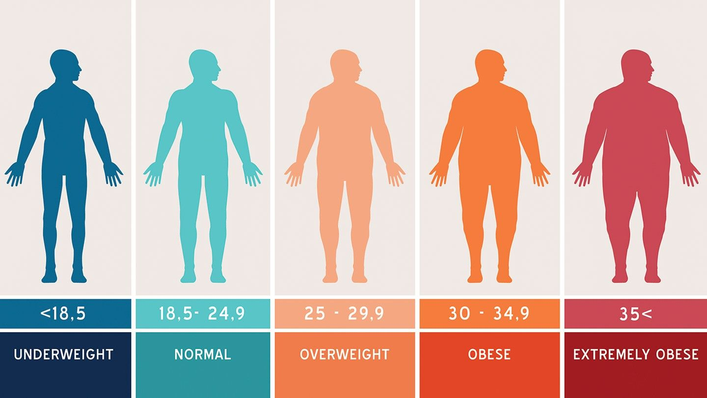

Write java program to take height and weight of n number of persons (e.g. sentinel control loop should be used.), calculate BMI and print BMI with interpretation of BMI.

Special Instructions-

1. You can modify last assignment (Lab Assignment – 01).
2. Program should be well commented.
3. Program should be easy to use.
4. Input should be either Kilograms and Meters or Pounds and Inches.
5. Height and Weight should be validate(> 0).
6. After calculating BMI, as per result BMI interpretation should be display.