In the Java programming language, all source code is first written in plain text files ending with the .java extension. Those source files are then compiled into .class files by the javac compiler. A .class file does not contain code that is native to your processor; it instead contains *bytecodes* — the machine language of the Java Virtual Machine[1](https://docs.oracle.com/javase/tutorial/getStarted/intro/definition.html#FOOT) (Java VM). The java launcher tool then runs your application with an instance of the Java Virtual Machine.

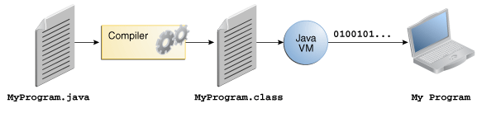

An overview of the software development process.

Because the Java VM is available on many different operating systems, the same .class files are capable of running on Microsoft Windows, the Solaris™ Operating System (Solaris OS), Linux, or Mac OS. Some virtual machines, such as the [Java SE HotSpot at a Glance](http://www.oracle.com/technetwork/java/javase/tech/index-jsp-136373.html), perform additional steps at runtime to give your application a performance boost. This includes various tasks such as finding performance bottlenecks and recompiling (to native code) frequently used sections of code.

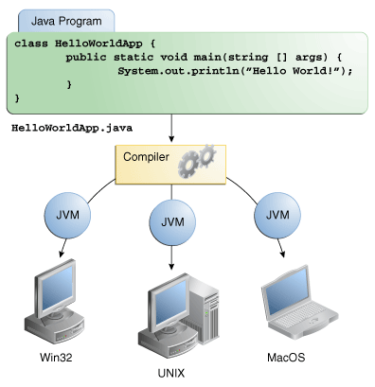

Through the Java VM, the same application is capable of running on multiple platforms.

Reference : <https://docs.oracle.com/javase/tutorial/getStarted/intro/definition.html>