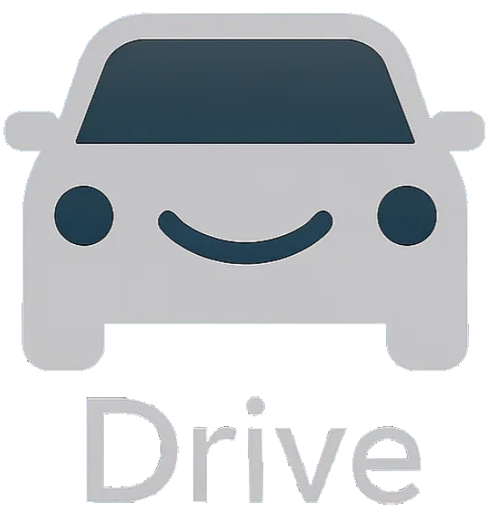

DriveShare Medium-Fidelity Prototype & Testing Report

1. Low-Fidelity to Medium-Fidelity Conversion
When transitioning from our low-fidelity to medium-fidelity prototype, our primary goal was to refine visual hierarchy, enhance usability, and integrate user feedback from earlier rounds of testing. The low-fidelity prototype mainly validated the concept and task flow, while the medium-fidelity version introduced consistent visual structure, color-coded elements, iconography, and clearer spatial relationships between search, map, and booking features.
Key updates included:
- Improved navigation clarity: We restructured the layout to include a persistent bottom navigation bar, allowing users to easily return to their dashboard or switch between searching and listing features.
- Enhanced booking flow: The low-fi version required multiple manual steps to confirm a reservation; the new design consolidates this into a single “Rent Driveway” confirmation page, reducing friction.
- Added contextual imagery: Driveway previews and icons were added to provide a more realistic user experience.
- Visual consistency: Typography, spacing, and alignment were standardized using Figma’s design system tools, improving readability and cohesion.
- Safety emphasis: Based on earlier qualitative findings, placeholder verification and review icons were added to suggest safety and trustworthiness between renters and homeowners.
Overall, the medium-fidelity design maintained the simplicity of the original but improved visual polish and interaction feedback for smoother task completion.

2. Interactive Prototype Overview
The medium-fidelity prototype was built in Figma and designed for mobile use. It demonstrates a complete renter-side flow for students searching for, reserving, and confirming a driveway spot. The prototype includes:
- Home/Search Screen: Users can enter their current location, share GPS data, or view recently rented spots.
- Map View: Displays available driveways with dynamic pins that reveal pricing and ratings when tapped.
- Filter & Availability Controls: Users can set date, time, and distance radius filters to refine search results.
- Driveway Preview Screen: Shows price per hour, photo, and a short description before confirmation.
- Booking Confirmation Flow: Includes date/time selection and a “Confirm” button leading to a summary page.
- Final Screen: Displays a navigation route and key details of the reserved spot.
The prototype is fully interactive across all these major flows, with button states, transitions, and interactions connecting each screen logically. Although homeowner-side functions are not yet interactive, the renter experience is complete and representative of core app functionality.

3. Testing & Feedback Integration
We conducted user testing with three participants representing our primary user groups: two student commuters and one homeowner. Each participant was guided through a “think-aloud” process while completing common tasks (searching, booking, and confirming parking).

Participant 1 – Mona Menghani (Student)
Mona found the search feature intuitive and appreciated the ability to share her location for convenience. She emphasized the usefulness of selecting specific days but noted the absence of an option to extend time at the last minute. She suggested adding buffer time between reservations to avoid overlap. Additionally, she wanted to see longer-term rental options, such as weekly or monthly bookings, and appreciated the “favorites” feature for recurring spots.
Her feedback highlighted the importance of flexibility and predictability for student commuters. Based on her input, we plan to integrate a “Extend Time” option post-booking and explore a longer-term subscription model for frequent users.

Participant 2 – Tyler Jennings (Student)
Tyler’s test scenario involved finding parking for a concert in the city. He praised the clean interface and ease of navigation, especially the time and price display. However, he recommended that the map zoom level start wider, allowing users to see more available spots at once. He also suggested adding driveway photos earlier in the flow, before the price confirmation, and including a messaging option to contact homeowners directly.
We implemented the photo placement change in the prototype and plan to introduce an in-app messaging system in future iterations. Tyler also suggested surge pricing for high-demand times—a feature we noted for scalability and monetization considerations.

Participant 3 – Cody Meyers (Homeowner)
Cody tested the “list your driveway” flow. He liked the straightforward setup and hourly pricing options but suggested adding recommended pricing based on neighborhood data to help homeowners set competitive rates. He also wanted descriptions or tooltips explaining what qualifies as “security lighting” or other driveway features. Cody appreciated the verified listings concept and suggested an option for multiple photos and weekly/monthly scheduling to simplify listing maintenance.
His feedback reinforced the need for better onboarding support for new listers. We plan to integrate smart recommendations and optional tooltips in future prototypes to address this.

4. Insights & Refinements
Through our testing sessions, several consistent themes emerged:
- Predictability & Flexibility Matter Most: Users valued the ability to manage time effectively, extending sessions or booking ahead of time was key.
- Visual Trust Cues Increase Confidence: Driveway images, safety verification, and rating displays were repeatedly mentioned as comfort factors.
- Simplicity Is Appreciated: All testers found the app easy to navigate, reinforcing our decision to maintain a minimal, uncluttered layout.
- Contextual Assistance Needed: Users wanted subtle guidance, such as pricing suggestions, definitions, and visual indicators, to make informed decisions quickly.
Based on these insights, our refinement goals for the next iteration are:
- Add buffer and extension time options post-booking.
- Incorporate an in-app messaging system for renter–owner communication.
- Introduce safety verification indicators modeled after trusted platforms like Uber.
- Allow multiple images per driveway and visual prompts for feature explanations.
- Implement smart pricing suggestions using location-based averages.
These actionable insights directly align with the rubric’s emphasis on connecting testing outcomes to user needs. Each refinement was derived from specific feedback and will shape the high-fidelity design phase.

5. Conclusion
The DriveShare medium-fidelity prototype successfully validated our app’s renter flow, interaction logic, and core usability. Testing confirmed that users appreciate the clarity of the interface and concept but desire enhanced flexibility, communication, and verification features. Our next steps involve implementing these refinements and expanding interactivity for the homeowner-side experience.
DriveShare continues to evolve as a community-based parking platform that connects students seeking affordable, reliable parking with homeowners offering underused spaces, creating a win–win ecosystem of convenience, safety, and affordability.

