**Report**

*Homework Assignment Project 2*

1.1 Nearest-Neighbor Interpolation

After getting sizes of image a new zero matrix is created based on new size which is multiplying initial coordinates by the input scale factor

7 x_new = round(scale_factor*(rows-1));

8 y_new = round(scale_factor*(cols-1));

9 M = zeros(x_new,y_new);

Then, we go through our M matrix and fill with values from initial image

12 for r = 0:x_new

13 for c = 0:y_new

14 M(r+1,c+1) = img(1+round(r./scale_factor),1+round(c./scale_factor));

15 end

16 end

As an output we have the following figure:

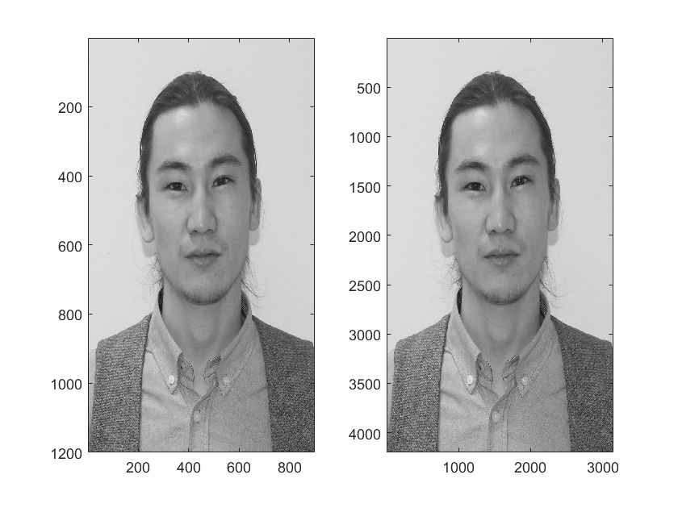

1.2 Histogram equalization

We have a mystery image which we need to equalize by global histogram and local histogram. For global equalization I used histeq(img) function. For local equalization I used block processing operation called blockproc (img,[40 40],fun) where fun is block processing function which applies to the block 40x40 in img. The results are following:

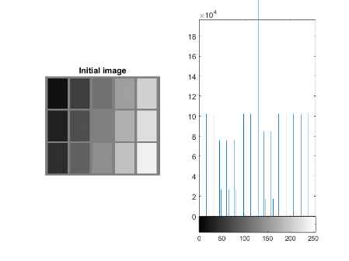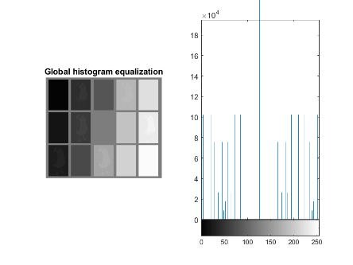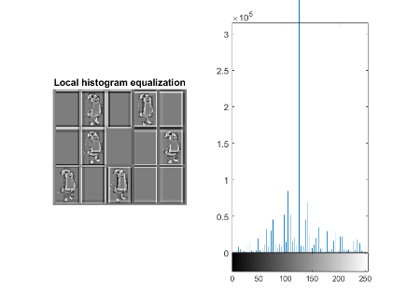

It is observed that local histogram equalization is better because it has less pixel to work with, that is why equalization is more expressed.

2.1 Floyd-Steinberg dithering

We need to implement dithering which creates a 2-level image from 256-level image that looks very similar to the initial image. It can be done by applying special algorithm based on adding quantization error with specific coefficients. The result of Lena is the following:

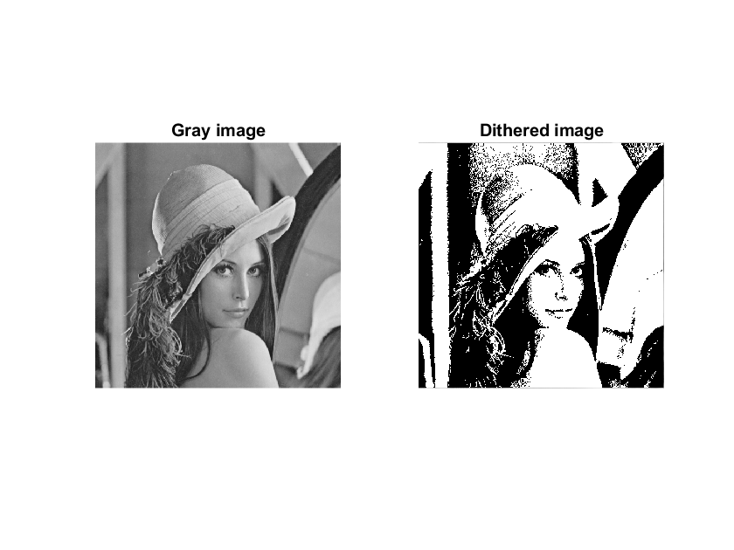

It seems that it has a big threshold. When the linear gradient is applied, we have the following:

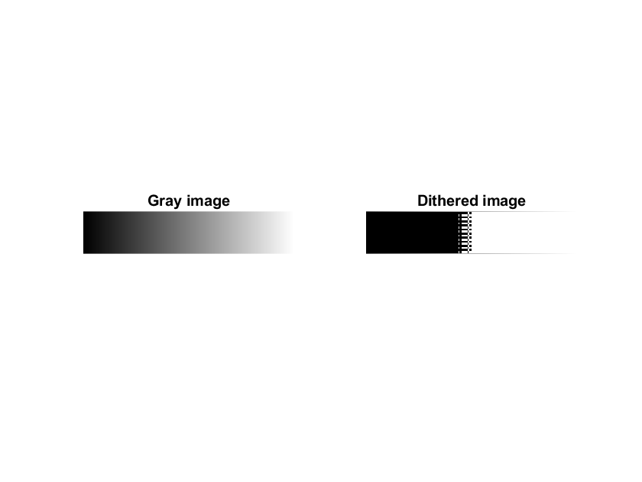

If we apply the function dither(gray_img), we can see better result:

