SIS
Classification using Perceptron and Multilayer Perceptron (MLP)

Student Name: | Khalimov Rustam
Group: | Friday 16:00-17:00
Date: | 25.02.2026

1. Objectives
- Understand the architecture of single-layer Perceptron and Multilayer Perceptron (MLP)
- Learn to calculate the number of trainable parameters in neural networks
- Compare classification performance of Perceptron vs MLP on non-linearly separable data
- Analyze the impact of network depth and width on classification accuracy
- Evaluate models using appropriate classification metrics

2. Theoretical Background

2.1 Single-Layer Perceptron
The Perceptron is the simplest form of a neural network, consisting of:
- Input layer with n features
- Single output neuron with activation function
- Weights (w₁, w₂, ..., wₙ) and bias (b)
Output formula: y = f(Σ(wᵢ·xᵢ) + b), where f is the activation function
Limitation: Can only solve linearly separable problems.

2.2 Multilayer Perceptron (MLP)
MLP extends the perceptron with one or more hidden layers:
- Input layer: receives feature vector
- Hidden layer(s): extract non-linear features
- Output layer: produces final classification
- Non-linear activation functions (ReLU, Sigmoid, Tanh)

2.3 Calculating Trainable Parameters
For a fully connected layer with n inputs and m outputs:
Parameters = n × m + m (weights + biases)
Total parameters = Sum of parameters in all layers

3. Dataset Description
In this lab, we will use the Moons Dataset from scikit-learn. This is a synthetic dataset that:
- Contains 2 interleaving half circles (moons)
- Is NOT linearly separable
- Has 2 input features (x₁, x₂)
- Has 2 classes (0 and 1)
- Perfect for demonstrating MLP advantages over Perceptron
Dataset Parameters:
Number of samples | 1000
Training set size | 800 (80%)
Test set size | 200 (20%)
Noise level | 0.2

4. Laboratory Tasks

Task 1: Draw Network Architectures
Draw the following network architectures showing all neurons, connections, and labels:
A) Single-Layer Perceptron
Input: 2 features, Output: 1 neuron (binary classification)
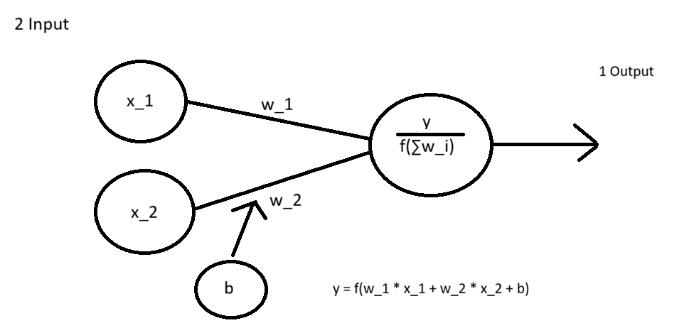

B) MLP with 1 Hidden Layer (8 neurons)
Input: 2 features → Hidden: 8 neurons → Output: 1 neuron
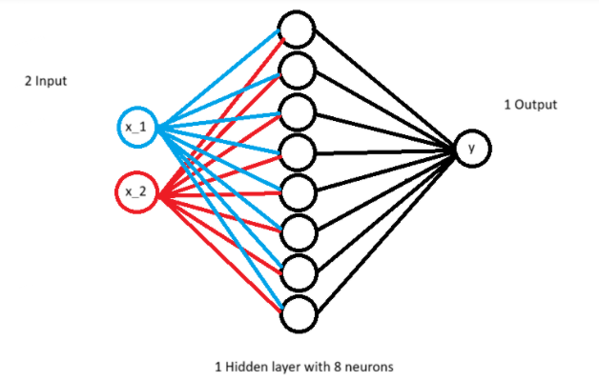

C) MLP with 2 Hidden Layers (16-8 neurons)
Input: 2 features → Hidden1: 16 neurons → Hidden2: 8 neurons → Output: 1 neuron
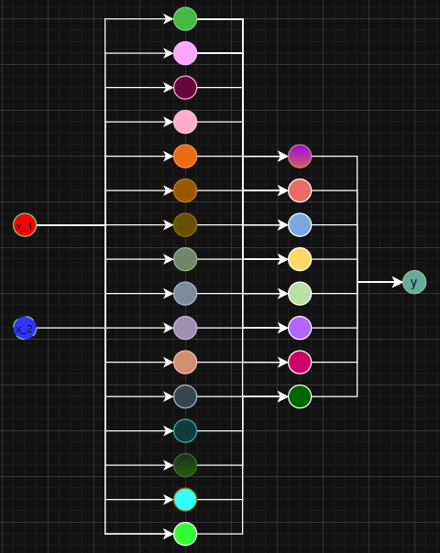

Task 2: Calculate Trainable Parameters
Calculate the number of trainable parameters for each network architecture.
Show your calculations step by step.
Architecture | Calculation (show work) | Total Parameters
Perceptron (2-1) | 2*1+1=3 | 3
MLP (2-4-1) | 2*4+4=12  4*1+1=5  12+5=17 | 17
MLP (2-8-1) | 2*8+8=24  8*1+1=9  24+9=33 | 33

Task 3: Run Experiments and Record Results
Execute the provided Python code and fill in the results tables.

Table 1: Classification Metrics Comparison
Model | Accuracy | Precision | Recall | F1-Score | Training Time (s)
Perceptron | 0.815 | 0.752 | 0.94 | 0.8355555555555556 | 0.0056645870208740234
MLP (2-4-1) | 0.86 | 0.86 | 0.86 | 0.86 | 0.9945745468139648
MLP (2-8-1) | 0.89 | 0.875 | 0.91 | 0.8921568627450981 | 1.2332541942596436
MLP (2-16-1) | 0.975 | 0.9702970297029703 | 0.98 | 0.9751243781094527 | 3.475132465362549
MLP (2-32-1) | 0.98 | 0.98 | 0.98 | 0.98 | 2.702578067779541
MLP (2-64-1) | 0.98 | 0.98 | 0.98 | 0.98 | 3.158998489379883
MLP (2-128-1) | 0.975 | 0.9797979797979798 | 0.97 | 0.9748743718592965 | 3.182939052581787

Table 2: Effect of Network Width (1 Hidden Layer, varying neurons)
Hidden Neurons | Parameters | Accuracy | F1-Score
4 | 17 | 0.86 | 0.86
8 | 33 | 0.89 | 0.8921568627450981
16 | 65 | 0.975 | 0.9751243781094527
32 | 129 | 0.98 | 0.98
64 | 257 | 0.98 | 0.98

Table 3: Effect of Network Depth (8 neurons per layer)
Number of Hidden Layers | Architecture | Parameters | Accuracy
1 | 2-8-1 | 33 | 0.89
2 | 2-8-8-1 | 105 | 0.98
3 | 2-8-8-8-1 | 177 | 0.985
4 | 2-8-8-8-8-1 | 249 | 0.98

Task 4: Visualize Decision Boundaries
Attach screenshots of decision boundary plots for:
- Perceptron
- MLP with best accuracy
- MLP with worst accuracy
Perceptron:
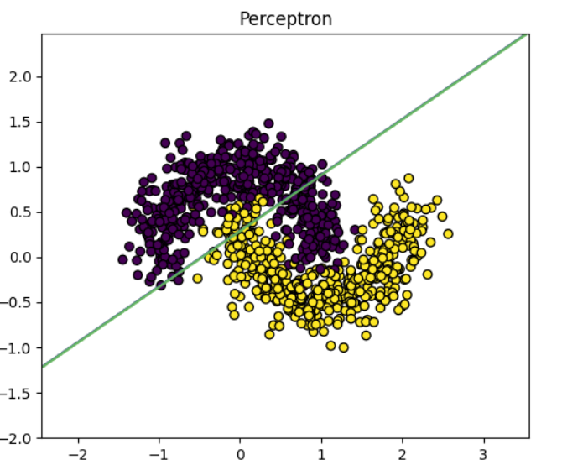

MLP with best accuracy:
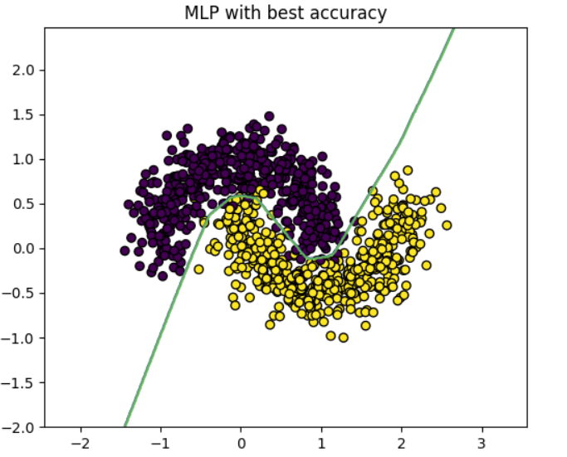

MLP with worst accuracy:
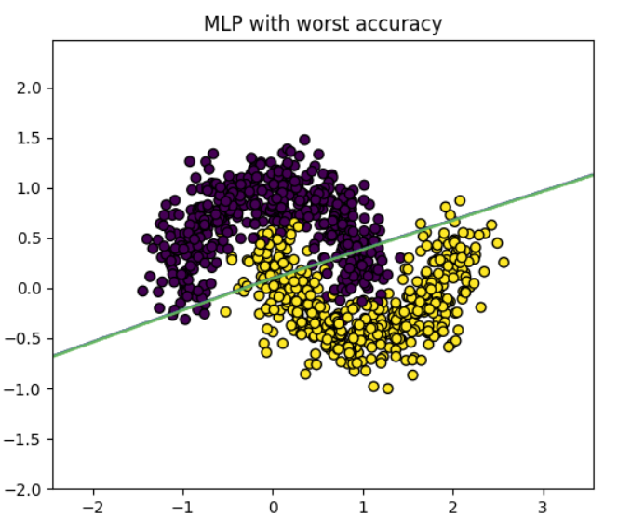

5. Analysis Questions
Q1: Why does the Perceptron perform poorly on the Moons dataset? Explain with reference to the decision boundary plot.
Answer:
Perceptron showed a lower accuracy (about 0.8) because it can only plot a straight line. The Moons dataset needs a curved border, so many points are classified incorrectly.

Q2: How does increasing the width (number of neurons) of a single hidden layer affect accuracy? Is there a point of diminishing returns?
Answer:
When we increased the number of neurons (from 4 to 32 or 64) our accuracy initially increased. But then the improvement became very small. Although the number of parameters increased significantly.

Q3: How does increasing the depth (number of hidden layers) affect accuracy and training time?
Answer:
Adding hidden layers improved the accuracy a bit at first. However, the training time increased and deeper models did not provide significant improvement for such a small dataset.

Q4: Which model achieved the best accuracy? Was it also the model with the most parameters?
Answer:
The best accuracy was obtained for a broader MLP (for example, with 32 or 64 neurons). It had more parameters but the largest model did not always show significantly better results.

Q5: What is the relationship between the number of parameters and the risk of overfitting?
Answer:
As the number of parameters increases the model becomes more flexible. However too many parameters can lead to overfitting especially with a small amount of data.

Q6: Based on your results, what architecture would you recommend for this dataset and why?
Answer:
In our experiment model with one hidden layer and 16-32 neurons performed best. It provided high accuracy without unnecessary complexity.

Q7: How would the results change if we used a linearly separable dataset (e.g., generated with make_blobs)?
Answer:
If the dataset were linearly separable perceptron would show an almost perfect result. In this case using MLP would not have provided a significant advantage.

7. Conclusions
Write your conclusions based on the experimental results (minimum 150 words):
In this SIS we compared Perceptron and MLP on Moons dataset. Perceptron showed lower accuracy as it is able to build only a linear boundary and the data has a nonlinear structure. MLP showed the best results due to hidden layers and nonlinear activation functions.
We also investigated the effects of network width and depth. Increasing the number of neurons increased accuracy at first but then the increase became insignificant. Adding hidden layers increased the training time and the number of parameters but it did not always result in a noticeable improvement in quality.
The optimal model turned out to be one with a hidden layer and a moderate number of neurons which provided a good balance between accuracy and complexity of the model.

