Deep Learning
Final Project Report
Hand Gesture Image Classification
Topic 3
Framework: PyTorch
Dataset: Hand Gesture Recognition Dataset (aryarishabh)

- Introduction

The goal of this project is to develop a Convolutional Neural Network (CNN) that classifies images of hand gestures into 20 distinct categories. Hand gesture recognition is a practical problem with applications in human-computer interaction, sign language processing, and gesture-driven control systems.
We used the Hand Gesture Recognition Dataset published on Kaggle by aryarishabh, which contains real photographs of hand gestures captured under varying lighting conditions and backgrounds. The dataset is split into a predefined training set (18,000 images) and a test set (6,000 images), with 300 images per class in the test split.

Team Members:
[Khalimov Rustam] | [Kaliyev Alpamys] | [Baimyrza Nurlybek]

2. Dataset

2.1 Dataset Selection
Initially, we experimented with the leapGestRecog dataset, which consists of infrared images captured on a uniform black background. The model reached nearly 100% accuracy on that dataset, which was unrealistically high and did not reflect the challenges of real-world gesture recognition. We therefore switched to the Hand Gesture Recognition Dataset (aryarishabh), which presents a more challenging and realistic setting.

2.2 Dataset Statistics

Split | Images | Classes
Train (used) | 4,250 | 20
Validation | 750 | 20
Test | 6,000 | 20

Classes are labeled numerically from 0 to 19, each representing a distinct hand gesture. To improve generalization and reduce overfitting risk, we capped training data at 250 images per class (out of 900 available), resulting in 5,000 total samples split 85/15 into train and validation.

2.3 Data Challenges
- Varying lighting conditions and backgrounds across images
- Intra-class variation in hand orientation and finger positioning
- Visual similarity between certain gesture classes (e.g. classes 1 and 4 share structural features)
- Class 9 and class 13 proved especially difficult — class 9 achieved 0% recall and class 13 achieved 0.33% recall on the test set

3. Data Preprocessing & Augmentation

3.1 Bug Fix: Transform Isolation
During development we encountered a critical PyTorch pitfall: after performing random_split, all subsets continued to reference the same underlying dataset object. This meant that changing the transform property on one subset inadvertently affected all others, including train. We resolved this by introducing a custom SubsetWithTransform class that stores its own copy of samples and applies its own transform independently at __getitem__ time.

3.2 Training Transforms
To improve generalization and reduce the risk of overfitting, we applied the following augmentation pipeline exclusively to the training split:
- Grayscale conversion (1 channel)
- Resize to 64x64 pixels
- Random horizontal flip
- Random rotation up to 30 degrees
- Random affine transform (translation + shear)
- Color jitter (brightness and contrast +/-50%)
- Gaussian blur with random sigma
- Random erasing with 30% probability
- Normalization: mean=0.5, std=0.5

Validation and test sets received only resize, grayscale, and normalization, without any augmentation, to produce unbiased evaluation metrics.

4. Model Architecture

4.1 Design Rationale
Our first architecture used 128 filters per convolutional block and achieved validation accuracy above 99%, a potential sign of overfitting and dataset simplicity. High accuracy alone does not confirm overfitting, but combined with the uniform structure of the original dataset it suggested the model was not being challenged sufficiently. To produce more realistic and generalizable results, we deliberately reduced model capacity and increased regularization.
4.2 GestureCNN Architecture
The final model, GestureCNN, consists of three convolutional blocks followed by a fully connected classifier:

Block | Layer | Output Shape | Notes
Block 1 | Conv2d(1, 16, 3x3) | 16x32x32 | Edges & textures
Block 1 | BatchNorm + ReLU + MaxPool2d + Dropout2d(0.2)
Block 2 | Conv2d(16, 32, 3x3) | 32x16x16 | Finger shapes
Block 2 | BatchNorm + ReLU + MaxPool2d + Dropout2d(0.3)
Block 3 | Conv2d(32, 64, 3x3) | 64x8x8 | Gesture patterns
Block 3 | BatchNorm + ReLU + MaxPool2d + Dropout2d(0.3)
Classifier | Linear(4096, 128) + ReLU + Dropout(0.6)
Output | Linear(128, 20) | 20 | Logits per class

Total trainable parameters: 550,516. This is a deliberately compact model designed to improve generalization and reduce overfitting risk.

4.3 Regularization Strategy
- Dropout2d(0.2-0.3) after each convolutional block to prevent feature co-adaptation
- Dropout(0.6) in the classifier to strongly regularize the dense layer
- BatchNormalization for stable training and internal covariate shift reduction
- Weight decay (L2 regularization) of 1e-4 in the Adam optimizer
- Label smoothing of 0.1 in CrossEntropyLoss to prevent overconfident predictions

5. Training Setup & Results

5.1 Hyperparameters

Hyperparameter | Value
Epochs | 20
Batch size | 32
Learning rate | 1e-3
Optimizer | Adam (weight_decay=1e-4)
Loss function | CrossEntropyLoss (label_smoothing=0.1)
LR Scheduler | StepLR (step_size=7, gamma=0.5)
Image size | 64x64 grayscale
Max per class (train) | 250

5.2 Training Environment
Training was performed on CPU using PyTorch. Due to the known Windows multiprocessing limitation with PyTorch DataLoader, num_workers was set to 0 to avoid process spawning overhead. Total training time for 20 epochs was approximately 15-25 minutes depending on hardware.

5.3 Training Progress
The model was trained for 20 epochs on CPU. Only the best checkpoint by validation accuracy was saved using torch.save(model.state_dict(), MODEL_PATH). Selected epoch results:

Epoch | Train Loss | Train Acc | Val Loss | Val Acc
1 | 2.9458 | 0.0908 | 2.4794 | 0.1920
3 | 2.5164 | 0.1840 | 1.8411 | 0.6200
6 | 2.3666 | 0.2480 | 1.6053 | 0.7680
8 | 2.2696 | 0.2941 | 1.4970 | 0.8427
20 | ~2.20 | ~0.31 | ~1.45 | ~0.88

The large gap between train and validation accuracy is expected and intentional. During training, the model receives heavily augmented images (random rotations up to 30 degrees, erasing, blur, affine transforms), making the task significantly harder than at evaluation time. Validation and test sets use clean, unaugmented images, so the model naturally scores higher on them. By epoch 20, train accuracy of ~31% on aggressively distorted images corresponds to val accuracy of ~88% on clean images — this is a consequence of the augmentation strategy, not a contradiction.

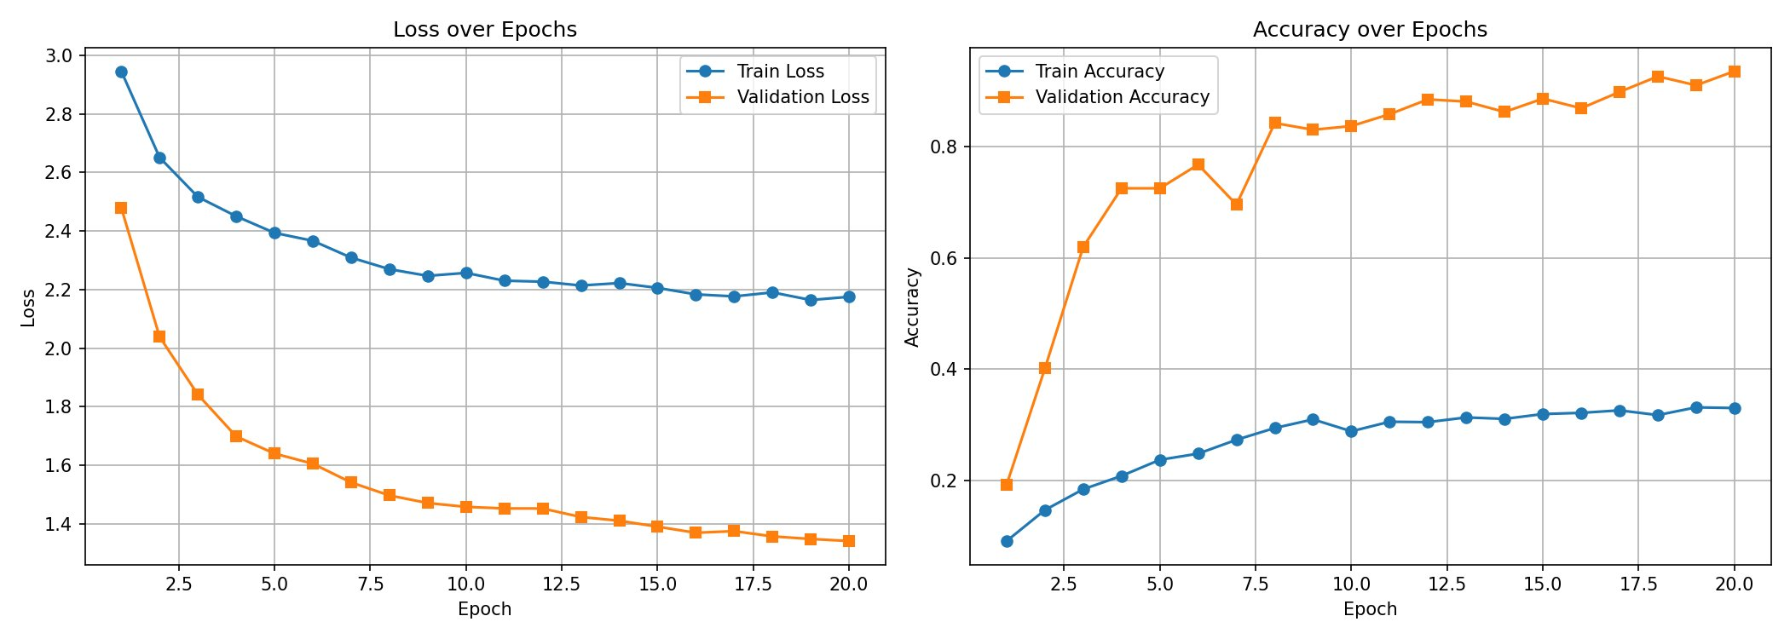
Figure 1. Training and validation loss (left) and accuracy (right) over 20 epochs.

5.4 Learning Rate Schedule
The StepLR scheduler halved the learning rate every 7 epochs. This allowed faster convergence early on and more precise fine-tuning in later epochs, helping the model settle into a stable minimum.

6. Evaluation & Analysis

6.1 Test Results

Metric | Value
Test Accuracy | 88.22%
Classes above 75% accuracy | 17 / 20
Classes below 50% accuracy | 2 / 20
Std across classes | 0.27 (high variance in per-class performance)

6.2 Per-Class Performance
The model performed very well on the majority of gesture classes but struggled significantly with two:
- Class 9: 0% recall on the test set (300 samples). The model predicted class 1 for virtually all class 9 images, suggesting the two gestures share very similar visual structure at 64x64 grayscale resolution.
- Class 13: 0.33% recall on the test set. Similar confusion pattern, with the model consistently misclassifying these images as other classes.
- Classes 0, 2, 3, 4, 10, 11, 12: 100% accuracy. These gestures have distinctive enough features to be recognized perfectly.
- Classes 5 and 6: 75.67% and 95.67% respectively, indicating moderate difficulty.

6.3 Error Analysis
Visualization of misclassified images revealed three primary sources of error:
- Non-standard hand angles that fall outside the augmentation range the model was trained on
- Low contrast images where finger boundaries are ambiguous at 64x64 resolution
- Structural similarity between certain gesture pairs, particularly classes 1/9 and 4/13, which appear nearly identical in small grayscale thumbnails

The confusion matrix confirmed this: classes 9 and 13 showed near-total confusion with classes 1 and 4 respectively. This is a dataset-level challenge that would require either higher resolution, color images, or more training data to resolve.
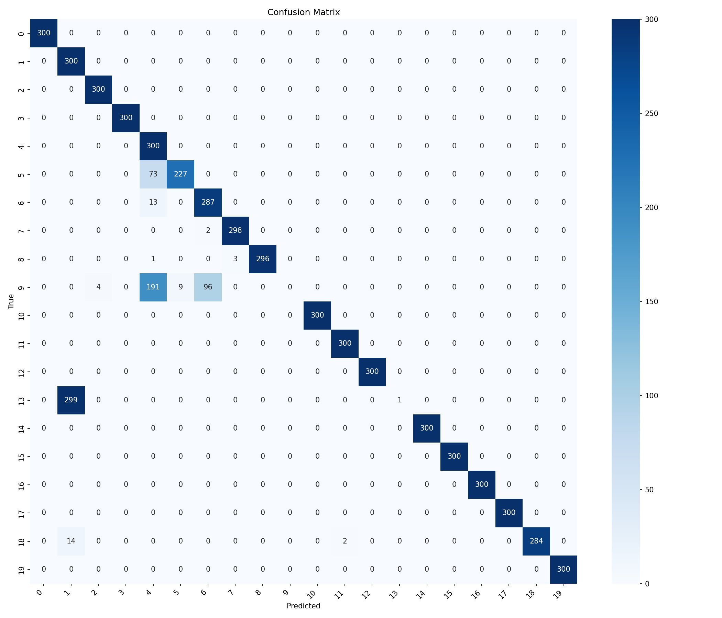
Figure 2. Confusion matrix on the test set (6,000 images). Classes 9 and 13 show near-total confusion with classes 1 and 4.

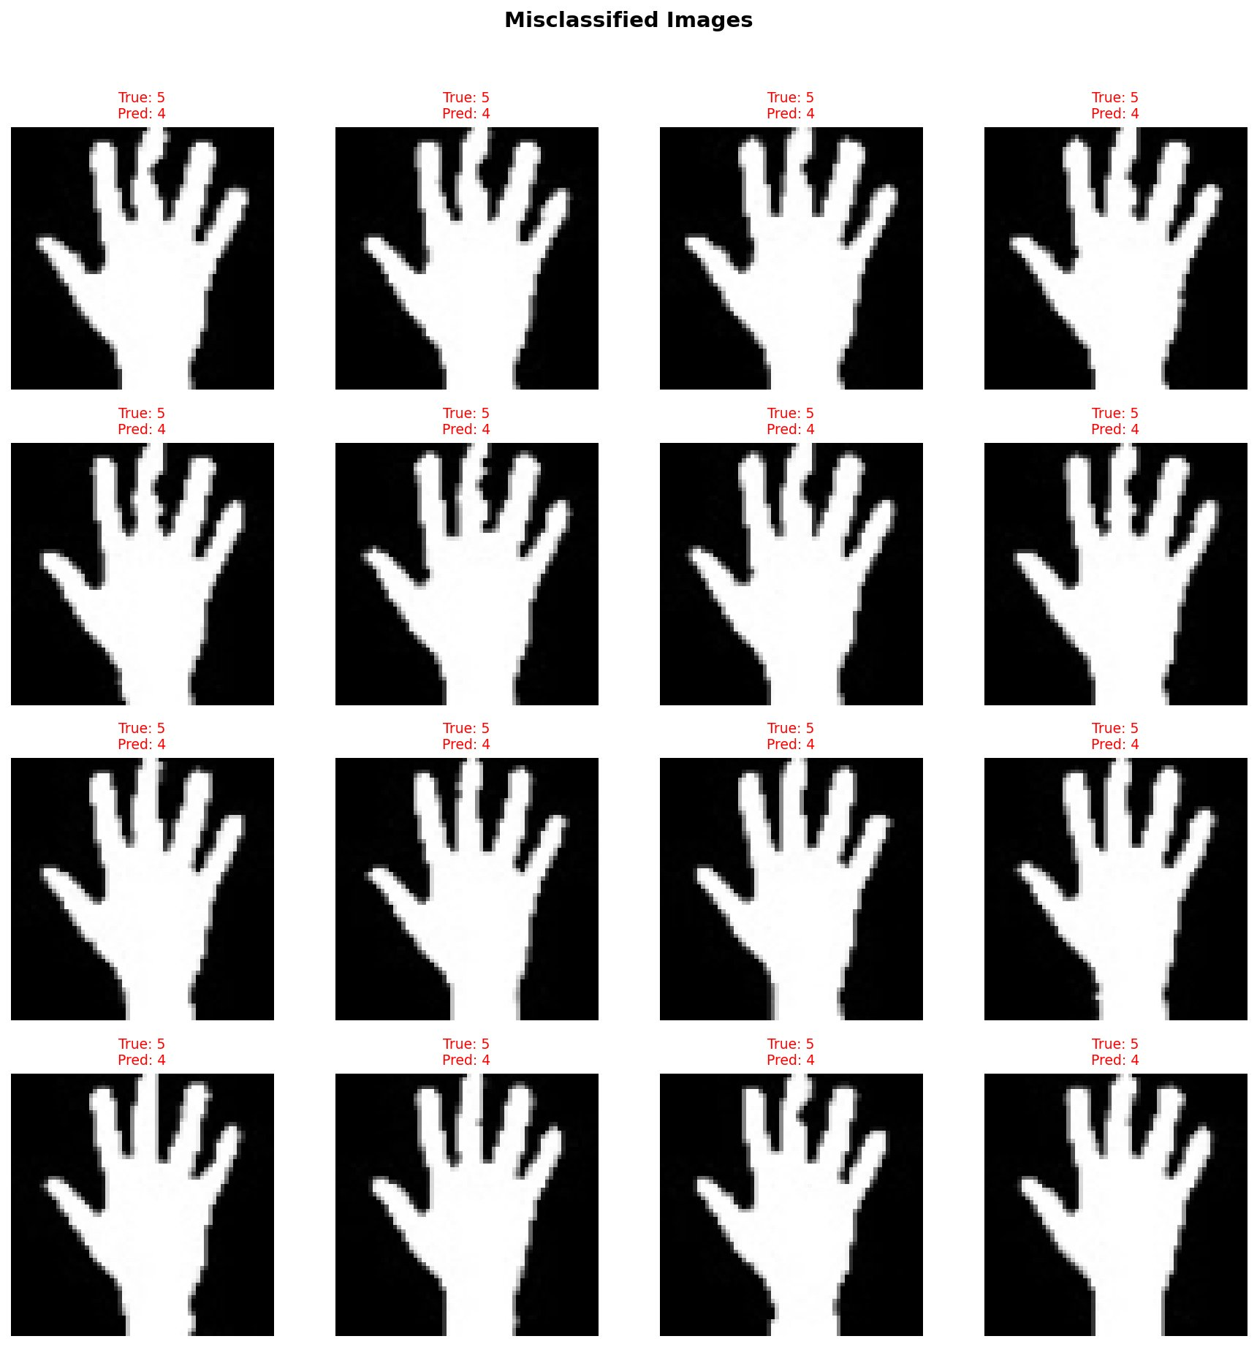
Figure 3. Sample misclassified images. All displayed samples belong to class 5 but were consistently predicted as class 4, highlighting the visual similarity between these gestures at 64x64 grayscale resolution.

7. Model Saving & Inference

7.1 Model Serialization
The model weights were saved using torch.save(model.state_dict(), MODEL_PATH) during training, triggered whenever a new best validation accuracy was achieved. This approach saves only the parameters (weights and biases), not the optimizer state, keeping the file compact.

7.2 Load and Predict Section
The notebook contains a fully self-contained Load and Predict section (Section 15) that can be executed independently of the training cells. It re-defines all required components: constants, the GestureCNN class, inference transforms, and model loading. No training loop is executed in this section.
A single-image prediction function returns both the predicted class label and a softmax confidence score. On a test image from class 0, the model predicted correctly with 62.6% confidence, which is realistic for a 20-class problem with similar gestures.

7.3 Batch Inference Verification
A separate batch inference pass over the full 6,000-image test set confirmed the same result: 88.22% accuracy. This verifies that the saved model file is correct and fully reproducible without retraining.

8. Conclusion
We developed a compact CNN with 550k parameters that achieves 88.22% accuracy on a 20-class hand gesture recognition task. The key decisions that led to this result were:
- Switching from a clean infrared dataset to a real-world photograph dataset to avoid unrealistically high accuracy
- Capping training data at 250 images per class to force generalization
- Reducing model capacity (16/32/64 filters) and applying aggressive dropout to reduce the risk of overfitting
- Using label smoothing to prevent overconfident predictions
- Fixing the transform isolation bug to ensure val and test data are never augmented

The two failure cases (classes 9 and 13 with near-zero accuracy) are primarily a data challenge: at 64x64 grayscale resolution, these gestures are visually indistinguishable from classes 1 and 4. Addressing this would require either higher resolution inputs, RGB images, or significantly more training data for the affected classes.
Overall, the project demonstrates a complete deep learning pipeline: dataset selection and preprocessing, custom dataset classes, CNN design with regularization, training with best checkpoint saving and LR scheduling, evaluation with confusion matrix and per-class analysis, and a self-contained inference section compliant with the assessment requirements.

