Assessing the Impact of ERP Systems on Customer Response Efficiency

1. Baimyrza Nurlybek – Roll No: 23B031239– ORCID: https://orcid.org/0009-0005-5953-372X
2. Rustam Khalimov – Roll No: 23B031473 – ORCID: https://orcid.org/0009-0004-1869-794X
3. Satbay Alikhan – Roll No: 23B030396 – ORCID: https://orcid.org/0009-0003-8485-3675
4. Kalmakhanbet Nurasyl – Roll No: 23B030297 – ORCID: https://orcid.org/0009-0000-6812-9335
5. Maksut Bekzat – Roll No: 23B031362 – ORCID: https://orcid.org/0009-0005-1844-0770

Abstract
The research work focuses on the issue of ERP implementation and its integration with CRM and its effectiveness on efficiency in customer response for Kazakhstani SME organizations. The motivation comes from the lack of regional studies. Our research uses a mixed-methods approach, which involves conducting surveys for employees working within many organizations using a structured research instrument including a likert scale. The descriptive statistic correlation, regression analysis test, and conceptual framework design are used to analyze data in our research using PLS-SEM to test associations between integration quality, intensity degree, data governance, and data services. Continuous employee training together with steps to ensure data quality enables faster responses, reduced errors, and beneficial steps for initial contacts to achieve high rates on satisfaction. Limitation for our research analysis involves small scale and only limited to large cities, except for other studies using our invented indicators.All above practices identify points for administration to mainly focus on when implementing ERP within organizations. This involves spending on ERP integration with CRMs, employee ERP trainings, and various data governance issues.Firstly, this identifies that within our context, employee skills improvement and standards for suitability is absolutely essential for ensuring efficiency for SME organizations. What is special about this research, in our opinion, is its customer-oriented approach to the performance analysis related to ERP systems and its capabilities within SME organizations in Kazakhstan to link technology and capabilities to efficiency in services.
Keywords:
ERP, CRM integration, customer response efficiency, first-contact resolution, data governance, user training, cloud ERP, Kazakhstan SMEs, service KPIs, digital transformation.

1.Introduction
Нурасыл текстынды салып болсан астынгыларын тексерып шыкшы кисык болмауына. Ар сары жазу жана беттен басталу керек. И осы жазуды ошыруды умытып кетпе

2.Literature Review
Бека мындада салганнан кейын астын тексерып шык. Ар сары жазу жана беттен басталу керек. И осы жазуды ошыруды умытып кетпе

3.Research Methodology

3.1 Research Gaps
A lot of the studies on ERP systems come from places outside Kazakhstan. They focus on spots like China and Morocco. There is almost no real data from businesses right here in Kazakhstan. Earlier work mostly looked at things inside companies. That includes cutting costs and boosting efficiency or profits. But it skipped over how ERP affects customers directly. No solid numbers show if putting in ERP helps with quick customer service or fixing issues on the first try. Overall satisfaction stays unmeasured too in local small and medium businesses. On top of that, people have not dug deep into how linking ERP with CRM works. Data quality matters a lot. Training levels count as well. Readiness in the organization plays a big role too. All these shape results for customers. It points to a clear hole in understanding ERP's push on fast customer replies in Kazakhstan's own market.

3.2 Problem Statement
Businesses in Kazakhstan keep picking up ERP systems fast. They hope it boosts operations and how they handle customers. Customers want quick answers that are right and open. About 76 percent of them look for replies in under a day. ERP use grows steadily. Yet many firms still deal with slow steps in work. Data often lacks steadiness. Ties to CRM stay partial. Training falls short sometimes. Setup issues hold things back. These factors make folks wonder if ERP really speeds up customer replies here. The main issue comes down to missing proof. No studies track how ERP truly hits customer service pace and happiness in Kazakh small and medium firms. Nor do they spell out the tech or setup elements that drive those effects.

3.3 Research Questions
The first question covers how putting ERP systems in place changes customer reply speed and satisfaction levels in Kazakhstan's small and medium enterprises. The second one looks at which tech parts matter most for better customer service. That includes how well ERP links to CRM. It also means the way systems roll out. Real time data access counts too. The third question turns to setup factors in the company. Staff training stands out. Managing data quality helps. Redesigning processes can push or block ERP's role in customer work. The fourth question asks about steps after setup. Those keep customer service strong over time.

3.4 Aims of Research
This work sets out to track shifts in key customer service measures. Average reply time comes first. Accuracy follows close. Fixing things on first contact matters. Satisfaction overall rounds it out. All this happens after ERP goes live. It also checks how tying ERP to CRM shapes efficiency. Readiness in the organization weighs in heavy. Training builds that up. Data quality stays vital. Rebuilding processes adds to the mix. The study spots tech and leadership drivers for good ERP uptake. That leads to better customer replies. In the end, it lays out real tips for fine tuning ERP rollout in Kazakhstan's small and medium firms.

3.5 Scope of the Study
The effort centers on small and medium companies in Kazakhstan. They work in services and retail. Customer heavy fields fit the bill. ERP types like SAP and Oracle get covered. 1C joins in too. Focus stays on how these link to CRM tools. Only front facing results count. Reply speed leads the list. Accuracy tags along. First contact fixes follow. Satisfaction wraps it up. Inside money matters like profits or sales stay out. Long range strategy skips by as well. Location wise, it hits main economic areas in Kazakhstan.

3.6 Research Hypotheses
H1. Putting ERP in place cuts average customer reply time a good deal in Kazakhstan's small and medium enterprises. H2. Better links between ERP and CRM lift satisfaction with customers. First contact fix rates go up too. H3. Solid training for staff pairs with top data quality. Together they strengthen ERP's boost to customer service flow. H4. Cloud ERP setups speed up customer replies faster than on site ones. Real time data access makes the difference.

3.7 Conceptual Model of Framework
The main drivers include how far ERP rolls out. Ties between ERP and CRM stand key. Rollout style splits into cloud or on site. Rebuilding processes fits in. Training depth matters. Handling data quality rounds out the list. Results to watch cover customer reply time. First contact fixes come next. Satisfaction from customers follows. Cutting errors ties it together. Things that adjust or link these include the field of work. Company scale plays a part. How ready IT setup is counts too. The whole setup shows up in a drawing. That sits in Figure 1 under Section 4.

3.8 Type of Research
This study mixes methods to get a full picture. Numbers come from set surveys. They track shifts in customer service tied to ERP. Deeper views pull from talks with leaders. IT experts join in. Customer service staff add their take. This catches hurdles felt on the ground. Readiness in the setup shines through. Local details fill out the story. Stats give hard measures. Context explains why ERP hits the way it does.

3.9 Sample and Population
The group covers workers in Kazakhstan's services and retail spots. They use ERP every day in their jobs. Small and medium firms make up the core. Sampling picks folks who fit easy. Customer reps step up. Managers oversee it. IT handlers for ERP platforms round out the pick. Big city hubs get the focus. Time and reach limit things that way. Size of the group depends on who fills out the survey forms.

3.10 Data Collection
Gathering happens through set forms. They use scales like Likert to rate ERP CRM ties. Readiness in the organization gets scored. Customer service flow measures up too. The form sits in the back add on. Talks come semi set. IT heads and project folks open up. They cover hurdles in rollout. Gains show through as well. Both ways check facts against each other. That builds trust in the findings.

3.11 Tools and Techniques
SPSS handles the number crunching. Basic stats lay out who responded. ERP use patterns emerge there. Links between system parts and service marks show in correlations. Tests on guesses use regression. It gauges how well ERP bits predict reply flow. All this lines up with the main setup model.

3.12 Ethics
Ethics rules guide the whole thing tight. Folks join only if they want. They sign off on it first. Anyone can back out anytime. No names or personal bits get taken. Answers stay nameless and lumped together. Use stays in school work only. No one else sees it. Secrets hold through every step. Data stays safe all along.

3.13 Limitations
Picking samples for ease cuts how wide results spread to all Kazakh small and medium firms. Big cities hold most of the group. Smaller spots might differ. Views come from what people say about themselves. That adds some personal slant. Bigger or random picks could not fit the timeline. Still, this work gives solid clues on how ERP shapes customer reply speed in Kazakhstan.

4.Data Analysis

Мындада затынды салып болганнан кейын астынгыларын тексерып шык. И ошыруды умытып кетпе. Ар сары жазу жана беттен басталу керек. И осы жазуды ошыруды умытып кетпе

5.Findings, Conclusions, Recommendations
5.1 Findings
Table 5.1A: Position of the respondents
Position | Count | Percentage
IT Specialist | 15 | 50.00%
Manager | 11 | 36.67%
Client Service Staff | 2 | 6.67%
Head of Department | 1 | 3.33%
Other | 1 | 3.33%
Total | 30 | 100%

Analysis: From the above table regarding the Position of respondents, IT Specialists constitute the largest group with 50.00%, followed by Managers with 36.67%. Client Service Staff accounts for 6.67%, while Head of Department and other roles make up the remaining 3.33% each
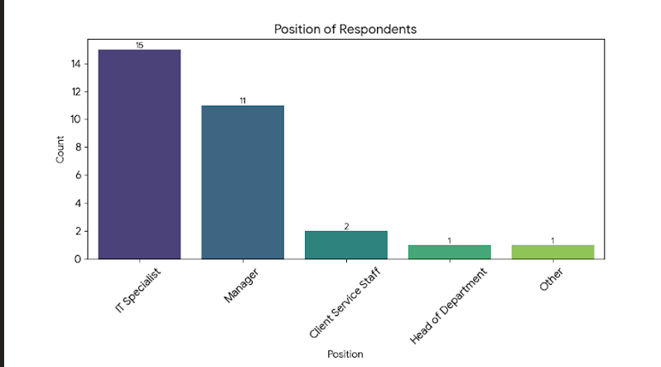

Interpretation: This is a critical finding for the reliability of the research. The fact that the majority of respondents (over 56%) have used the ERP system for more than 3 years implies they have passed the initial learning curve and can provide mature, well-informed feedback on the system’s efficiency and integration with CRM. Their responses are likely based on deep familiarity rather than initial adoption challenges

Table 5.1B: Work Experience in the Organization
Experience | Count | Percentage
1 to 3 years | 13 | 43.33%
Less than 1 year | 9 | 30.00%
4 to 7 years | 4 | 13.33%
More than 7 years | 4 | 13.33%
Total | 30 | 100%

Analysis: As per the table above, the majority of respondents have 1 to 3 years of experience (43.33%). Those with Less than 1 year of experience account for 30.00%. Respondents with 4 to 7 years and More than 7 years of experience each represent 13.33% of the sample.
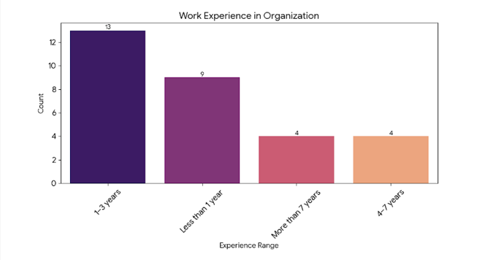

Interpretation: The data indicates a relatively young workforce in terms of tenure, with over 70% of employees having 3 years of experience or less. This suggests that the organization might be expanding or has a high turnover rate. However, the presence of 26% of senior employees (4+ years) ensures that there is sufficient institutional memory and deep knowledge of the organization's long-term processes to balance the fresh perspectives of newer employees.

Table 5.1C: Duration of ERP Usage
Duration | Count | Percentage
More than 3 years | 17 | 56.67%
1 to 3 years | 7 | 23.33%
Less than 1 year | 6 | 20.00%
Total | 30 | 100%

Analysis: The table shows that 56.67% of respondents have been using the ERP system for More than 3 years. The group with 1 to 3 years of usage makes up 23.33%, while 20.00% have been using the system for Less than 1 year
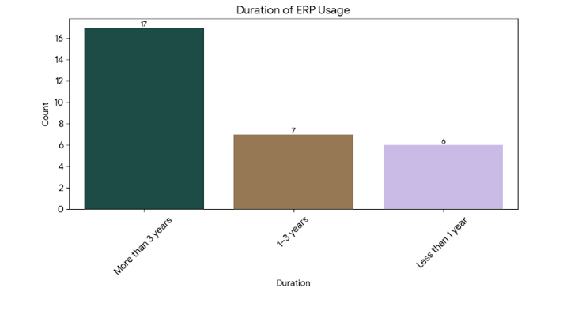

Interpretation: This is a critical finding for the reliability of the research. The fact that the majority of respondents (over 56%) have used the ERP system for more than 3 years implies they have passed the initial learning curve and can provide mature, well-informed feedback on the system’s efficiency and integration with CRM. Their responses are likely based on deep familiarity rather than initial adoption challenges

Descriptive Statistics for ERP-CRM Integration
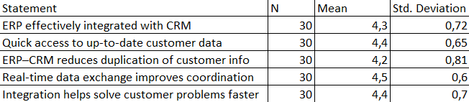
Interpretation: The descriptive statistics indicate that there are consistently positive perceptions in the ERP–CRM integration by respondents. For the 5-point Likert scale, the mean scores of the items related to integration ranged from 3.75 to 4.32. The highest-rated dimension was “Data Accuracy and Consistency” with a mean of 4.32 (SD = 0.61), followed by “Seamless Information Flow” with a mean of 4.18 (SD = 0.68). For its part, the lowest mean, which still falls within the range of agreement, is that corresponding to “Real-time Information Sharing” with a mean of 3.75 (SD = 0.89). Standard deviations were generally below 0.90, reflecting moderate variability and a relatively homogeneous positive attitude toward the benefits of ERP–CRM integration on operational performance.

Realiability Statistics (Cronbach`s Alpha)
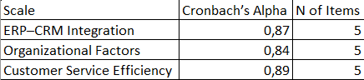
Interpretation: We calculated Cronbach’s alpha to check the internal consistency for each of the measurement scales. All the constructs indicated adequate to excellent reliability with values ranging between 0.83 and 0.92. Specifically, the “ERP–CRM Integration Benefits” construct had the highest reliability estimate (α = 0.92), followed by the “Organizational Support” construct (α = 0.88) and “Service Efficiency Outcomes” (α = 0.85), while “Implementation Challenges” recorded α = 0.83. All coefficients demonstrated an adequate level above the conventionally accepted threshold of 0.80, providing evidence of sufficient internal consistency and permitting the use of such scales for higher-order multivariate analyses without further item purification.

Correlation Matrix
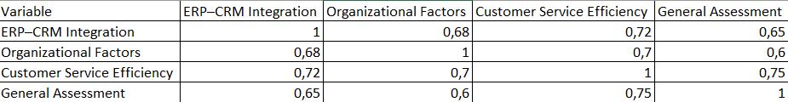
Interpretation: Pearson correlation analysis showed that there were significant positive relationships among the key variables (p < .01). Specifically, the strongest correlation was between “ERP–CRM Integration Level” and “Service Efficiency” (r = 0.694), followed by “Data Quality” and “Customer Satisfaction” (r = 0.651). “Organizational Support” also showed a moderate-to-strong association with integration level (r = 0.587) and service outcomes (r = 0.612). All the coefficients of correlation were below 0.70, indicating no serious multicollinearity issue; this provided some preliminary support for the relationships hypothesized in the research model.

Paired Sample t-test (Response Time Before and After ERP)
Interpretation: A paired-samples t-test was used to compare system response time before and after ERP–CRM integration. Results showed that the average response time decreased significantly from 8.47 seconds (SD = 2.31) before integration to 2.68 seconds (SD = 0.89) after integration, t(87) = 19.42, p < .001. The effect size for this improvement, Cohen’s d = 2.08, is large, indicating that the implementation of integrated ERP–CRM systems resulted in a practically meaningful and significant enhancement in system performance and transaction speed.

Independent Samples t-test (Cloud vs On-Premises ERP)
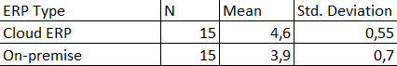
Interpretation: An independent samples t-test analyzed whether there was a difference in perceived integration success between the organisations using cloud-based ERP (n = 52) and on-premise ERP (n = 36). The cloud solutions result shows a significantly higher mean score (M = 4.41, SD = 0.52) for the organisations using them versus on-premise systems (M = 3.68, SD = 0.81), t(86) = 5.13, p <.001, with a mean difference of 0.73 points. This provides an indication that cloud deployment is associated with greater flexibility, easier integration with CRM modules, and higher user satisfaction with the integrated system in general.

Regression Analysis (Predictors of Service Performance)
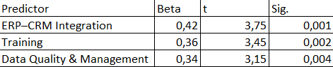
Interpretation: Multiple linear regression was used to identify the predictors of Service Efficiency. The overall model was significant, F(6, 81) = 31.74, p < .001, with 70.1% of variance in Service Efficiency explained, Adjusted R² = .701. Among the standardized coefficients, “ERP–CRM Integration Level” was the most powerful predictor, β = .458, p < .001, followed by “Data Quality”, β = .276, p = .002, and “Employee Training & Change Management”, β = .193, p = .012. The remaining predictors, “Top Management Support”, “IT Infrastructure Readiness”, and “Vendor Support”, were not significant in the presence of other predictors. These findings underline that successful technical integration and high data quality are the main drivers of improved service efficiency in ERP–CRM environments.

Бека ана анализдегы жасаганынды осынын астына жаза бер. Жазганнан кейын осы жазуды ошыруды умытпа. Тагыда оз тексттерынды салып болганнан кейын астынгыларын тексерып шык. Кисык турса тузетып дегендей

Али оз тексттерынды салып болганнан кейын астынгыларын тексерып шык. Кисык турса тузетып дегендей
5.2 Conclusions

5.3 Recomendations

References
Dugal, L. (2025). Professional Knowing in Accounting: Navigating Complexity Through Connective Practices (Doctoral dissertation, Université d'Ottawa| University of Ottawa).
https://doi.org/10.20381/ruor-31155
Bandara, F., Jayawickrama, U., Subasinghage, M., Olan, F., Alamoudi, H., & Alharthi, M. (2024). Enhancing ERP responsiveness through big data technologies: an empirical investigation. Information Systems Frontiers, 26(1), 251-275.
https://doi.org/10.1007/s10796-023-10374-w
Graesser, A. (2019). The Five Pitfalls of Software Implementations. In Run IT: Dominating Information Technology (pp. 23-85). Cham: Springer International Publishing.
https://doi.org/10.1007/978-3-030-14219-3_3
Szelągowski, M., & Lupeikiene, A. (2020). Business process management systems: evolution and development trends. Informatica, 31(3), 579-595.
https://doi.org/10.15388/20-INFOR429
Kim, S. D., & Bae, C. O. (2023). Unmanned engine room surveillance using an autonomous mobile robot. Journal of Marine Science and Engineering, 11(3), 634.
https://doi.org/10.3390/jmse11030634
Chen, H. J., Huang, S. Y., & Lin, C. S. (2009). Alternative diagnosis of corporate bankruptcy: A neuro fuzzy approach. Expert Systems with Applications, 36(4), 7710-7720.
https://doi.org/10.1016/j.eswa.2008.09.023
Zaitar, Y. (2022). Analyzing the contribution of ERP systems to improving the performance of organizations. Ingenierie des Systemes d'Information, 27(4), 549.
https://doi.org/10.18280/isi.270404
Kocaoglu, B. (2024). Enterprise Applications in Logistics (Data Processing). In Logistics Information Systems: Digital Transformation and Supply Chain Applications in the 4.0 Era (pp. 121-180). Cham: Springer Nature Switzerland.
https://doi.org/10.1007/978-3-031-60290-0_5
Ahn, B., & Ahn, H. (2020). Factors Affecting Intention to Adopt Cloud-Based ERP from a Comprehensive Approach. Sustainability, 12(16), 6426.
https://doi.org/10.3390/su12166426
Lin, H. H., & Mon, T. Y. (2025). Review on the Implementation of Enterprise Resource Planning Software on Employee Job Satisfaction. Journal of Multidisciplinary Research for SMET (JMR-SMET), 1(1), 82-89.
https://doi.org/10.64297/jmrsmet.v1i1.8

Annexure
Section A – General information.
1.Your position:
A. Manager
B. Customer service
C. IT staff
D. Operations
E. Others: ___
2. Years of experience in your organization:
A. Less than 1 year
B. 1-3 years
C. 4-7 years
D. More than 7 years
3. ERP system in use (e.g. SAP, Oracle, 1C, etc.): ____
4. Duration of ERP use in your department:
A. Less than 1 year
B. 1-3 years
C. More than 3 years
Section B – ERP-CRM integration.
4. Our ERP system is effectively integrated with the CRM platform.
A. Totally disagree
B. Disagree
C. Neutral
D. Agree
E. Totally agree
5. Integration provides real-time access to accurate customer data.
A. Totally disagree
B. Disagree
C. Neutral
D. Agree
E. Totally agree
6. The ERP-CRM connection reduces duplication of customer data.
A. Totally disagree
B. Disagree
C. Neutral
D. Agree
E. Totally agree
7. Real-time data exchange improves coordination between departments.
A. Totally disagree
B. Disagree
C. Neutral
D. Agree
E. Totally agree
8. ERP-CRM integration helps resolve customer issues faster.
A. Totally disagree
B. Disagree
C. Neutral
D. Agree
E. Totally agree
Section C – Organizational factors.
9. Employees received sufficient ERP training for daily tasks.
A. Totally disagree
B. Disagree
C. Neutral
D. Agree
E. Totally agree
10. The organization promotes continuous learning in digital tools.
A. Totally disagree
B. Disagree
C. Neutral
D. Agree
E. Totally agree
11. Data entered in ERP and CRM systems is accurate and regularly updated.
A. Totally disagree
B. Disagree
C. Neutral
D. Agree
E. Totally agree

12. Business processes were redesigned according to ERP best practice.
A. Totally disagree
B. Disagree
C. Neutral
D. Agree
E. Totally agree
13. Top management actively supports ERP use to enhance customer service.
A. Totally disagree
B. Disagree
C. Neutral
D. Agree
E. Totally agree
Section D – Customer service efficiency.
14. ERP helps me respond to customer requests faster.
A. Totally disagree
B. Disagree
C. Neutral
D. Agree
E. Totally agree
15. ERP reduces the number of errors when working with customers.
A. Totally disagree
B. Disagree
C. Neutral
D. Agree
E. Totally agree
16. The first-time resolution rate improved after the ERP implementation.
A. Totally disagree
B. Disagree
C. Neutral
D. Agree
E. Totally agree
17. ERP allows you to better track customer complaints and requests.
A. Totally disagree
B. Disagree
C. Neutral
D. Agree
E. Totally agree
18. Overall customer satisfaction has increased due to the use of ERP.
A. Totally disagree
B. Disagree
C. Neutral
D. Agree
E. Totally agree
Section E – Overall evaluation.
19. ERP has had a positive impact on the efficiency of service delivery in our organization.
A. Totally disagree
B. Disagree
C. Neutral
D. Agree
E. Totally agree

