**Easy**

Sub Stocks()

Dim tickername As String

Dim tickerall As Double

Dim Summary_Table As Integer

Summary_Table = 2

tickerall = 0

For i = 2 To 100000

If Cells(i + 1, 1).Value <> Cells(i, 1).Value Then

tickername = Cells(i, 1).Value

tickerall = tickerall + Cells(i, 7)

Range("I" & Summary_Table).Value = tickername

Range("J" & Summary_Table).Value = tickerall

Summary_Table = Summary_Table + 1

tickerall = 0

Else

tickerall = tickerall + Cells(i, 7).Value

End If

Next i

End Sub

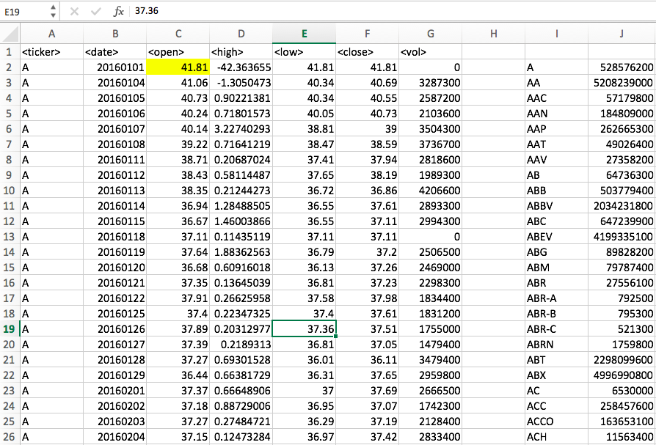

**Moderate**

Sub Stocks()

Dim tickername As String

Dim tickerall As Double

Dim Summary_Table As Integer

Dim PercentChange As Double

Dim Change As Double

Dim Start As String

Summary_Table = 2

tickerall = 0

Change = 0

PercentChange = 0

For i = 2 To 100000

If Cells(i + 1, 1).Value <> Cells(i, 1).Value Then

tickername = Cells(i, 1).Value

tickerall = tickerall + Cells(i, 7)

Start = Cells(i, 3)

Range("I" & Summary_Table).Value = tickername

Range("J" & Summary_Table).Value = tickerall

Range("K" & Summary_Table).Value = Change

Range("L" & Summary_Table).Value = PercentChange

Summary_Table = Summary_Table + 1

Change = (Cells(i, 6) - Cells(Start, 3))

PercentChange = Round((Change / Cells(Start, 3) * 100), 2)

tickerall = 0

Else

tickerall = tickerall + Cells(i, 7).Value

End If

If Cells(i, 11).Value < 1 Then

Cells(i, 11).Interior.ColorIndex = 3

Else

Cells(i, 11).Interior.ColorIndex = 4

End If

If Cells(i, 11).Value < 1 Then

Cells(i, 11).Interior.ColorIndex = 3

Else

Cells(i, 11).Interior.ColorIndex = 4

End If

Next i

End Sub

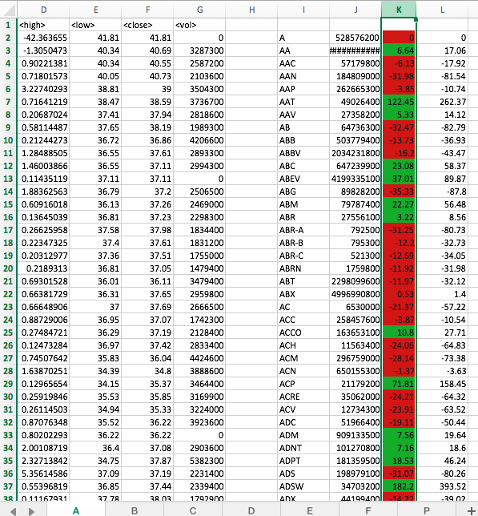

**Hard & Challenge (EXCEL SHOWS A BREAK @ CHANGE LINE)**

Sub Stocks()

For Each ws In Worksheets

Dim tickername As String

Dim tickerall As Double

Dim Summary_Table As Integer

Dim PercentChange As Double

Dim change As Double

Dim Start As String

Dim maxvol As Double

Dim WorksheetName As String

Summary_Table = 2

tickerall = 0

change = 0

PercentChange = 0

maxvol = 0

maxloss = 0

maxval = 0

Column = 10

maxvol = 0

column1 = 11

For i = 2 To 100000

If ws.Cells(i + 1, 1).Value <> ws.Cells(i, 1).Value Then

tickername = ws.Cells(i, 1).Value

tickerall = tickerall + ws.Cells(i, 7)

Start = ws.Cells(i, 3)

PercentChange = Round((change / ws.Cells(Start, 3) * 100), 2)

change = (ws.Cells(i, 6) - ws.Cells(Start, 3))

ws.Range("I" & Summary_Table).Value = tickername

ws.Range("J" & Summary_Table).Value = tickerall

ws.Range("K" & Summary_Table).Value = change

ws.Range("L" & Summary_Table).Value = PercentChange

Summary_Table = Summary_Table + 1

Else

tickerall = tickerall + ws.Cells(i, 7).Value

End If

If Cells(i, 11).Value < 1 Then

Cells(i, 11).Interior.ColorIndex = 3

Else

Cells(i, 11).Interior.ColorIndex = 4

End If

If ws.Cells(i + 1, Column).Value > ws.Cells(i, Column).Value Then

maxvol = maxvol + Cells(3, 15).Value

ElseIf ws.Cells(i + 1, column1).Value > ws.Cells(i, column1).Value Then

maxval = maxval + ws.Cells(3, 16).Value

ElseIf ws.Cells(i + 1, column1).Value < ws.Cells(i, column1).Value Then

maxloss = maxloss + Cells(3, 17).Value

End If

Next i

Next ws

End Sub

