

Rusty Degarmo, Mitchell Kwon, Aurora Lopez, Lucas Ramsey and Parrish Ward

Bellevue University

CSD 310: Database Development and Use

Project Milestone: Outland Adventures

Milestones 2

July 11, 2021

# **Milestone Two**

## Revised ORD

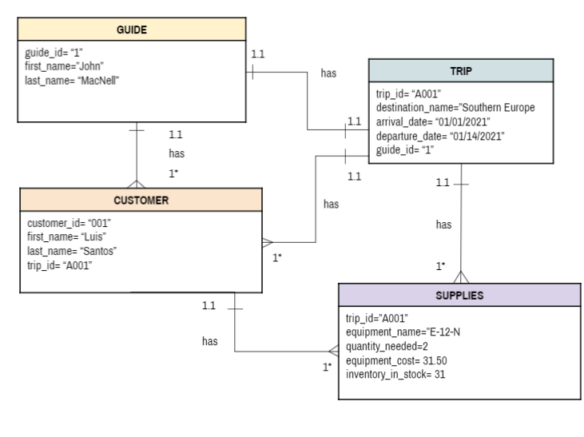

## 

## Python Script for Table Creation

import mysql.connector

#connect to the database

db = mysql.connector.connect(

host="localhost",

user="root",

password= "yourpasswordhere",

database= "outlandadventures"

)

#create a cursor

cursor = db.cursor()

#Get all customer info and print

cursor.execute("SELECT customer_id, first_name, last_name, supplies,trip_id FROM customer")

info = cursor.fetchall()

print("-- DISPLAYING CUSTOMER RECORDS --")

for customer in info:

print("Customer ID: {}".format(customer[0]))

print("First Name: {}".format(customer[1]))

print("Last Name: {}".format(customer[2]))

print("Supplies: {}".format(customer[3]))

print("Trip ID: {}".format(customer[4]))

print()

print()

#Get guide info and print

cursor.execute("SELECT guide_id, first_name, last_name, trip_id FROM guide")

info = cursor.fetchall()

print("-- DISPLAYING GUIDE RECORDS --")

for guide in info:

print("Guide ID: {}".format(guide[0]))

print("First Name: {}".format(guide[1]))

print("Last Name: {}".format(guide[2]))

print("Trip ID: {}".format(guide[3]))

print()

print()

#Get supply info an print

cursor.execute("SELECT equipment_name, quantity_needed, equipment_cost, inventory_in_stock, \

trip_id,date_added FROM supplies")

info = cursor.fetchall()

print("-- DISPLAYING SUPPLY RECORDS --")

for supply in info:

print("Equipment Name: {}".format(supply[0]))

print("Quantity Needed: {}".format(supply[1]))

print("Equipment Cost: {}".format(supply[2]))

print("Inventory: {}".format(supply[3]))

print("Trip ID: {}".format(supply[4]))

print("Date Added: {}".format(supply[5]))

print()

print()

#Get trip info and print

cursor.execute("SELECT trip_id, destination_name, arrival_date,departure_date FROM trip")

info = cursor.fetchall()

print("-- DISPLAYING Trip RECORDS --")

for trip in info:

print("Trip Id: {}".format(trip[0]))

print("Destination Name: {}".format(trip[1]))

print("Arrival Date: {}".format(trip[2]))

print("Departure Date: {}".format(trip[3]))

print()

print()

#close the database

db.close()

## Python Script for Data Display

import mysql.connector

#connect to the database

db = mysql.connector.connect(

host="localhost",

user="root",

password= "yourpasswordhere",

database= "outlandadventures"

)

#create a cursor

cursor = db.cursor()

#Get all customer info and print

cursor.execute("SELECT customer_id, first_name, last_name, supplies,trip_id FROM customer")

info = cursor.fetchall()

print("-- DISPLAYING CUSTOMER RECORDS --")

for customer in info:

print("Customer ID: {}".format(customer[0]))

print("First Name: {}".format(customer[1]))

print("Last Name: {}".format(customer[2]))

print("Supplies: {}".format(customer[3]))

print("Trip ID: {}".format(customer[4]))

print()

print()

#Get guide info and print

cursor.execute("SELECT guide_id, first_name, last_name, trip_id FROM guide")

info = cursor.fetchall()

print("-- DISPLAYING GUIDE RECORDS --")

for guide in info:

print("Guide ID: {}".format(guide[0]))

print("First Name: {}".format(guide[1]))

print("Last Name: {}".format(guide[2]))

print("Trip ID: {}".format(guide[3]))

print()

print()

#Get supply info an print

cursor.execute("SELECT equipment_name, quantity_needed, equipment_cost, inventory_in_stock, \

trip_id,date_added FROM supplies")

info = cursor.fetchall()

print("-- DISPLAYING SUPPLY RECORDS --")

for supply in info:

print("Equipment Name: {}".format(supply[0]))

print("Quantity Needed: {}".format(supply[1]))

print("Equipment Cost: {}".format(supply[2]))

print("Inventory: {}".format(supply[3]))

print("Trip ID: {}".format(supply[4]))

print("Date Added: {}".format(supply[5]))

print()

print()

#Get trip info and print

cursor.execute("SELECT trip_id, destination_name, arrival_date,departure_date FROM trip")

info = cursor.fetchall()

print("-- DISPLAYING Trip RECORDS --")

for trip in info:

print("Trip Id: {}".format(trip[0]))

print("Destination Name: {}".format(trip[1]))

print("Arrival Date: {}".format(trip[2]))

print("Departure Date: {}".format(trip[3]))

print()

print()

#close the database

db.close()

# Output Screenshot

## Guides Table

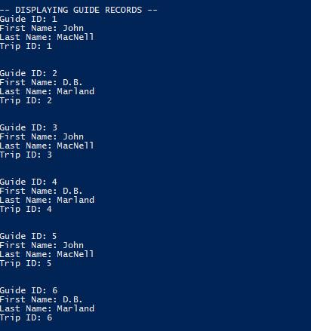

## Customer Table

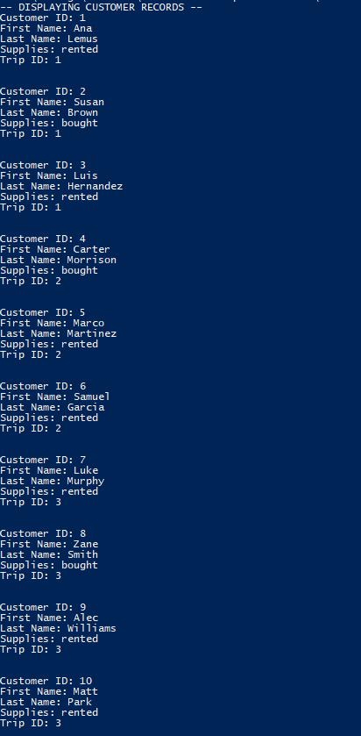

## Supply Table

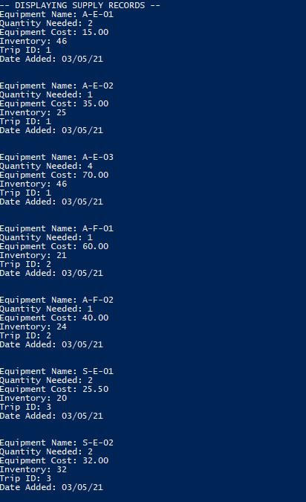

## Trip Table

