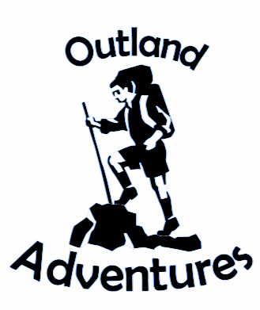

Rusty Degarmo, Mitchell Kwon, Aurora Lopez, Lucas Ramsey and Parrish Ward

Bellevue University

CSD 310: Database Development and Use

Project Milestone: Outland Adventures

Milestone 4

# **Milestone Four**

## Presentation

Video presentation: <https://youtu.be/yP575t-xrZs>

Google Slides: <https://docs.google.com/presentation/d/1YvXYdg0O7hQefHo4gzqBa-DiQa_BWSpC9AB81vPhI-o/edit#slide=id.ge2f2c86f8a_0_21>

