Seminar 3 Problem 2 Screenshots

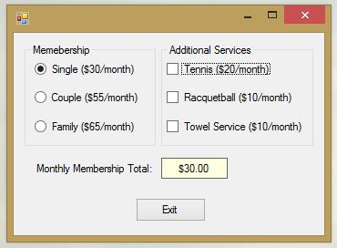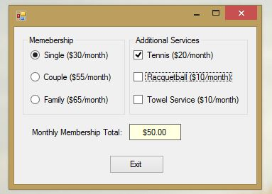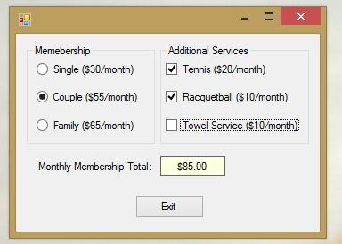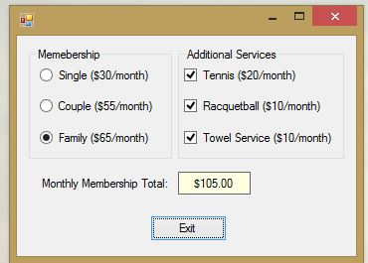

I set the access keys this problem, but when I launched the form they weren’t displayed. Perhaps Windows 8.1 doesn’t support this feature in the same way. I have an included a screenshot from the Visual Studio window below, to show that I did setup the access keys. In this case, since the form has not been initiated, the label for the calculated total is blank.

