**Vacation Calculator Outputs**

Test of initial load and property access

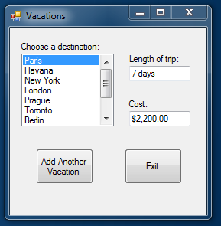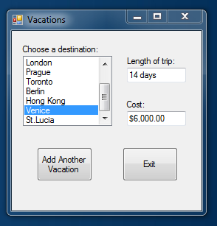

Test of adding a new vacation with a non-integer in trip length

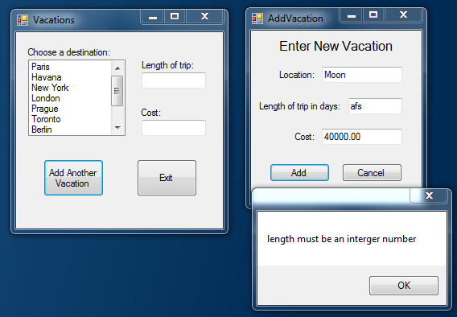

Test of adding a new vacation with a non-decimal in trip length

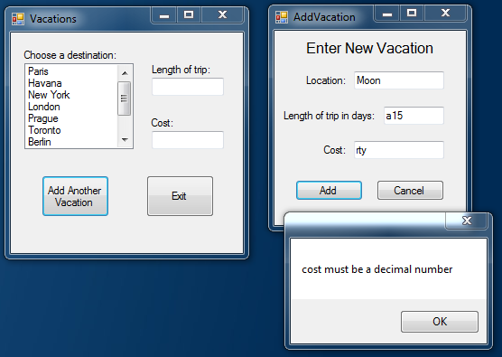

Testing of adding a new vacation pt.1

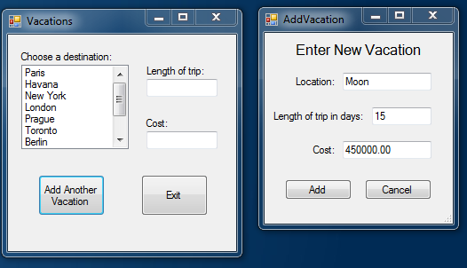

Testing of adding a new vacation pt.2

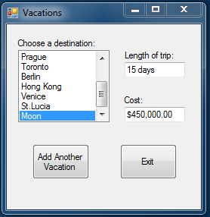

Test of adding a vacation when there are already 20 vacations

