THG-ENT-SOP-005 · Cross-Lifecycle · Personnel Controls
Standard Operating Procedure — Training & Competency
Defines how personnel are assigned, trained, assessed, and attested for the SOPs and controlled procedures they perform under.

A. Document Control
Document ID | THG-ENT-SOP-005
Version | 1.0
Status | BASELINE
Effective Date | YYYY-MM-DD
Document Owner | HR Director (with Quality co-ownership)
Approver / Signatory | Chief Operating Officer
Review Cycle | Annual
Classification | Confidential – Internal

B. Intake Linkage
Links this document to the originating cross-departmental request. Maintains traceability from intake to closure.
Intake ID | «auto-assigned at intake»
Originating Request | «linked Intake Form ID»
Triggering Department | HR / People
Lifecycle Phase | N/A — Governance
Linked Charter / Workstream | «Project / Program / Workstream reference»

C. Cross-Functional RACI Footprint
How each department engages with this document. R = Responsible, A = Accountable, C = Consulted, I = Informed. Leave blank if not engaged.
Department | Role | Specific Touchpoint
Clinical / Medical Affairs | I | «activity, decision, or artifact»
Regulatory / Quality | C | «activity, decision, or artifact»
R&D / Engineering | I | «activity, decision, or artifact»
Operations / PMO | C | «activity, decision, or artifact»
Finance / Procurement | I | «activity, decision, or artifact»
Commercial / Marketing | I | «activity, decision, or artifact»
IT / Data / Security | C | «activity, decision, or artifact»
HR / People | A | «activity, decision, or artifact»

D. Compliance & Traceability
Regulatory and methodological frames that govern this artifact. Cite specific clauses where they apply.
Frame | Applies To | Evidence / Reference
FDA 21 CFR Part 11 | «which sections of this doc» | «audit evidence, SOP, link»
ISO 13485 §6.2 | «which sections of this doc» | «audit evidence, SOP, link»
ISO 9001 §7.2 | «which sections of this doc» | «audit evidence, SOP, link»
PMBOK 7th Ed. | «which sections of this doc» | «audit evidence, SOP, link»

1. Purpose
To ensure that every individual performing controlled work at Theragen has read, understood, and attested to the relevant SOPs and procedures — and that this is documented to a standard that satisfies FDA, ISO 13485, and ISO 9001 expectations.

2. Scope

In scope
- All employees and contingent workers performing any controlled activity.
- All baselined SOPs and controlled procedures under this Standards system.
- Onboarding, role changes, and major SOP revisions.

Out of scope
- General workplace training (security awareness, HR compliance) not tied to a controlled SOP — covered by separate HR policy.
- External vendor training, unless the vendor performs controlled work on Theragen's behalf.

3. Definitions
Term | Definition
Training curriculum | The set of SOPs and references assigned to a role.
Attestation | Signed statement that the trainee has read and understood a controlled document.
Comprehension check | Short quiz with ≥80% pass threshold to confirm understanding.
Refresher | Periodic re-attestation, typically annual or upon major revision.
Major revision | A revision that changes the procedure, controls, scope, or compliance frame.

4. Roles & Responsibilities
These role assignments are binding under this SOP. They tighten — never loosen — the enterprise baseline in THG-ENT-RAC-001.
Role | Responsibility under this SOP
Manager | Identifies controlled work scope for the individual and assigns the curriculum.
Trainee | Completes the curriculum, the comprehension check, and signs attestation.
Training System | Assigns and tracks curricula and refresher cadence.
Assessor | Reviews comprehension-check results; certifies completion.
HR / Compliance | Files attestations; reports on training completeness for audit.

5. Procedure
The procedure below is mandatory. Deviations require a documented justification and follow §9 (Deviations & CAPA).

5.1 Identify the training requirement
Performed by: Manager
- Determine which SOPs apply to the role.
- Add new requirements at onboarding, role change, or major SOP revision.
Evidence recorded: Curriculum assignment requested in the training system.

5.2 Assign curriculum
Performed by: Training System
- Assign each required SOP with a target completion date (default 14 days from assignment).
- Notify the trainee and the manager.
Evidence recorded: Assignment record with date and target.

5.3 Read and study
Performed by: Trainee
- Read each assigned SOP and its linked references.
- Note any questions for the manager or assessor.
Evidence recorded: Read-receipt logged by the training system.

5.4 Complete the comprehension check
Performed by: Trainee
- Complete the short quiz attached to each SOP.
- Pass threshold is ≥80%; failures trigger restudy and retake.
Evidence recorded: Quiz score recorded.

5.5 Sign attestation
Performed by: Trainee
- Sign a statement: 'I have read, understood, and agree to perform work in accordance with this SOP.'
- Signature is recorded under 21 CFR Part 11 §11.50 with meaning 'Training Attestation'.
Evidence recorded: Signed attestation filed in the training record.

5.6 File and report
Performed by: HR / Compliance
- File attestation in the training record system.
- Generate completion reports for the Quality Council and for external audits on demand.
Evidence recorded: Training record updated; completion report generated.

5.7 Periodic refresher
Performed by: Manager + Training System
- Annual refresher attestation for all current curricula.
- Triggered refresher upon major SOP revision (recorded as a new attestation).
Evidence recorded: Refresher attestation in the training record.

6. Process Flowchart
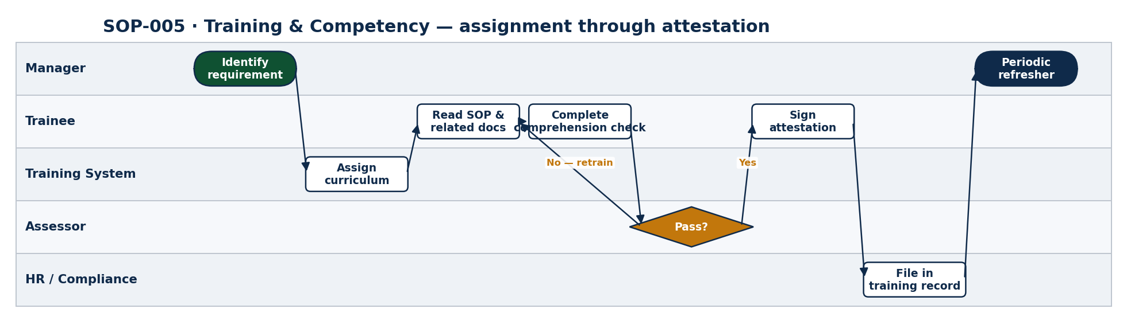
Figure 1. Training assignment to attestation, with retraining loop on comprehension failure.

7. Decision Authority / Approval Matrix
Decision class | Threshold / criteria | Approval authority | Records location
Initial assignment | Hire / role change / new SOP | Manager | Training system
Comprehension threshold | Pass = ≥80% | Assessor | Training system
Annual refresher | 1 year since last attestation | Training System (auto) | Training system
Major-revision refresher | Major revision to a current SOP | Document Owner triggers | Training system + eQMS
Granting authority to perform | All current curricula attested | Manager | Training system

8. KPIs & Monitoring
Process owner reports the following KPIs to the Quality Council on the stated cadence.
KPI | Target | Method | Cadence | Owner
Curriculum completion within target | ≥98% | Training system report | Monthly | HR / Compliance
Comprehension pass on first attempt | ≥90% | Training system report | Quarterly | HR / Compliance
Refresher attestation within 30 days of major revision | ≥98% | Training system | Per revision | HR / Compliance
Audit findings on training records | 0 | External audits | Annual | Quality

9. Deviations, Nonconformities & CAPA
Any deviation from this procedure shall be documented at the time of occurrence. The Document Owner evaluates each deviation for severity and may open a Corrective and Preventive Action (CAPA) record in the eQMS. Repeat deviations require root-cause analysis and SOP revision.
Severity | Definition | Required action | Owner
Minor | Isolated, no impact on record integrity or compliance | Log in deviation log; corrective action by next review | Document Owner
Major | Impact on record integrity, traceability, or stakeholder trust | Open CAPA; root-cause within 14 days | Quality Lead
Critical | Impact on regulatory submission, patient safety, or audit findings | Open CAPA immediately; notify Sponsor and Regulatory within 24 hours | Quality / Regulatory Director

10. Training Requirements
Personnel performing work under this SOP shall complete the training listed below before performing controlled activities, and again whenever a major revision is issued.
Audience | Training content | Comprehension check | Refresh cadence | Evidence
All personnel performing controlled work; Managers assigning curricula; Assessors | Read this SOP; review the linked Standards Guide block where referenced | Short comprehension quiz (≥80% pass) | Annual or upon major revision | HR / Compliance training records

11. References & Related Documents
Reference | Relationship
All controlled SOPs | Each SOP includes §10 Training Requirements; this SOP defines the procedure that implements them.
THG-ENT-STD-001 — Standards Guide | Defines the document classes that may require training.
21 CFR Part 11 §11.10(i) | Persons developing, maintaining, or using electronic record systems have education, training, and experience to perform their assigned tasks.
ISO 13485 §6.2 | Competence, awareness, and training requirement.

12. Records & Retention
Record | System of record | Retention | Disposition
Curriculum assignments | Training system | Life of employment + 7 yrs | Archive
Read receipts & quiz scores | Training system | Life of employment + 7 yrs | Archive
Signed attestations | Training system + HRIS | Life of employment + 7 yrs | Archive
Completion reports | HR / Compliance | 7 yrs | Archive

Z-1. Handoffs & Downstream Artifacts
Predecessors and successors in the integrated document lifecycle.

Receives input from
- All controlled SOPs — each references this SOP for the training procedure.

Feeds into
- Training records (HRIS / training system); audit reports.

Z-2. Approval Signatures
Role | Name | Signature | Date
Chief Operating Officer
HR Director
Quality / Regulatory Director

Z-3. Revision History
Version | Date | Author | Summary of Change | Approved By
0.1 | YYYY-MM-DD | «author» | Initial draft
1.0 | YYYY-MM-DD | «author» | Approved baseline

