Product Design Specification



Version 1.0
2/27/2013

Prepared for:
IT 484
Minnesota State University - Mankato

Prepared by:
Russell Walters, Chisomo Banda, Lindiwe Hove, Matt Ruppert

VERSION HISTORY
Version  # | Implemented  By | Revision  Date | Approved  By | Approval  Date | Reason
1.0 | Team | 3/10/2013 | Team | 3/12/2013 | Initial Design Definition draft
UP Template Version: 12/31/07

TABLE OF CONTENTS
1 Introduction 4
1.1 Purpose of The Product Design Specification Document 4
2 General Overview and Design Guidelines/Approach 4
2.1 Assumptions / Constraints / Standards 4
3 Architecture Design 4
4 System Design 4
4.1 Use-Cases 4
4.2 Database Design 5
4.3 Data Conversions 5
4.4 Application Program Interfaces (API) 5
4.5 User Interface Design 5
4.6 Performance 7
5 Detailed System Design 8
5.1 Package View 8
5.1.1 View Package 9
5.1.2 Controllers Package 10
5.1.3 Model Package 11
5.1.4 Resources Package 12
5.2 Use Case Realizations 13
5.2.1 Start the Game 13
5.2.2 Play Dots and Boxes 13
6 Product Design Specification Approval 13
Appendix A: References 15
Appendix B: Key Terms 16

Introduction

Purpose of The Product Design Specification Document
The Product Design Specification document documents and tracks the necessary information required to effectively define architecture and system design in order to give the development team guidance on architecture of the system to be developed. The Product Design Specification document is created during the Planning Phase of the project. Its intended audience is the project manager, project team, and development team. Some portions of this document such as the user interface (UI) may on occasion be shared with the client/user, and other stakeholder whose input/approval into the UI is needed.

General Overview and Design Guidelines/Approach
This section describes the principles and strategies to be used as guidelines when designing and implementing the system.

Assumptions / Constraints / Standards
- User Acceptance Test / System Acceptance Test Environment will be available for performing Usability testing.
- The basic TCP/IP (HTTP) protocol will be the only one used to access the application.
- An HTML 5 supported web browser will be the primary client used by players.

Architecture Design
Details on the architectural design are located in the architectural design document.

System Design

Use-Cases
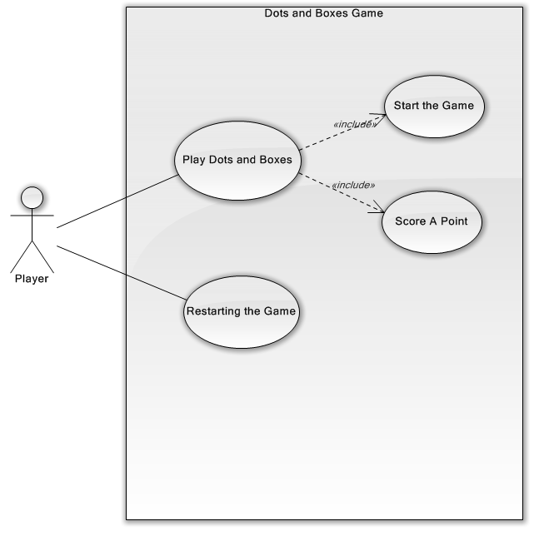
Additional Use Case information is available in the Software Requirements Specification.

Database Design
Dots and boxes does not use a database of any kind. No data is stored. In the future a database could be added to store high scores of users.

Data Conversions
There will be no data conversions as no legacy data is used.

Application Program Interfaces (API)
Dots and boxes uses the Play Framework API to run the program. Play is an open source web application framework that follows the model-view-controller architectural pattern.

User Interface Design
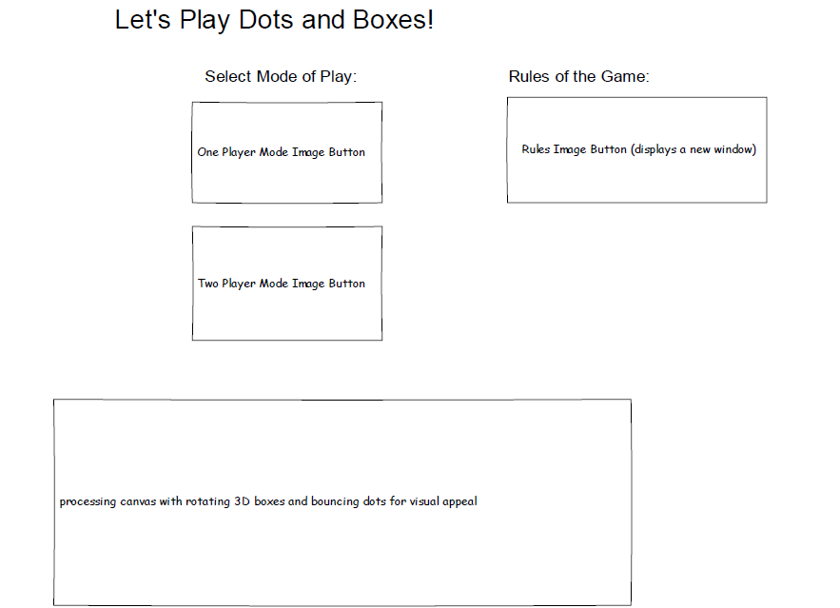

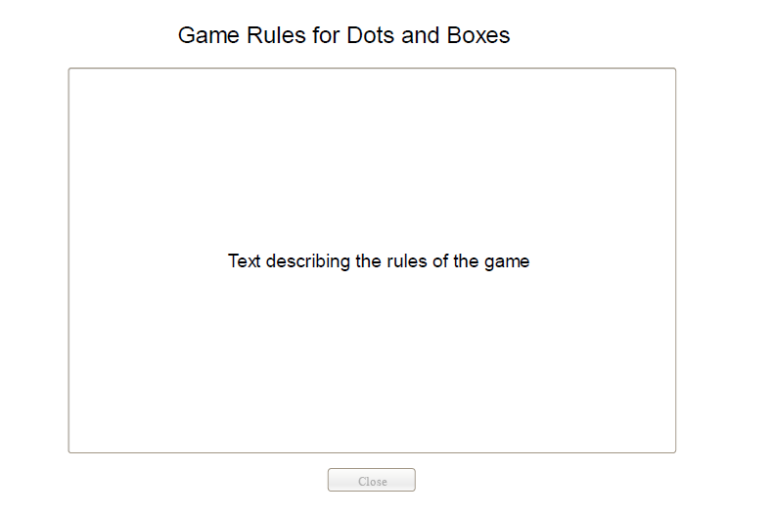

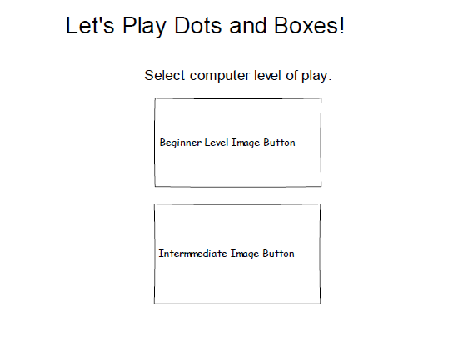

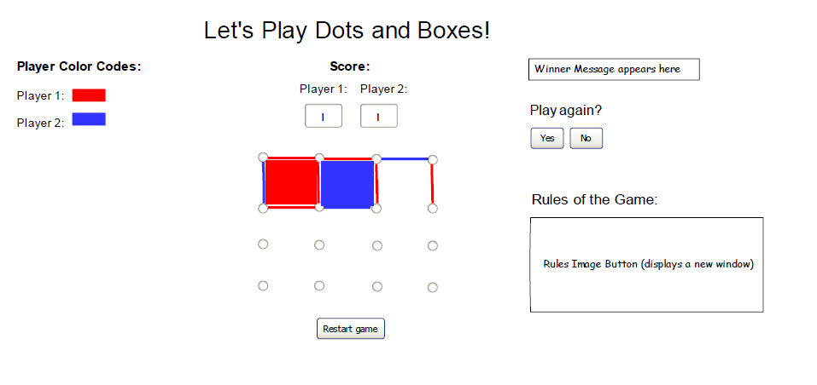
A player accesses the Dots and Boxes application to play a game. The player chooses a mode of play: human versus human or human versus computer. If the player selects human versus computer play, they will then choose a level of difficulty between easy and intermediate. The players will alternate taking turns by using a mouse to place a horizontal or vertical line on the grid of dots with the goal of creating a square. The player who places the fourth line and forms a square will score a point, and gets to take another turn. When all the lines have been placed, the game will end with the winner being the player having formed the most boxes.

Performance
In general, when a player has initiated an event, the application is expected to respond in 3 seconds or less.

Detailed System Design

Package View
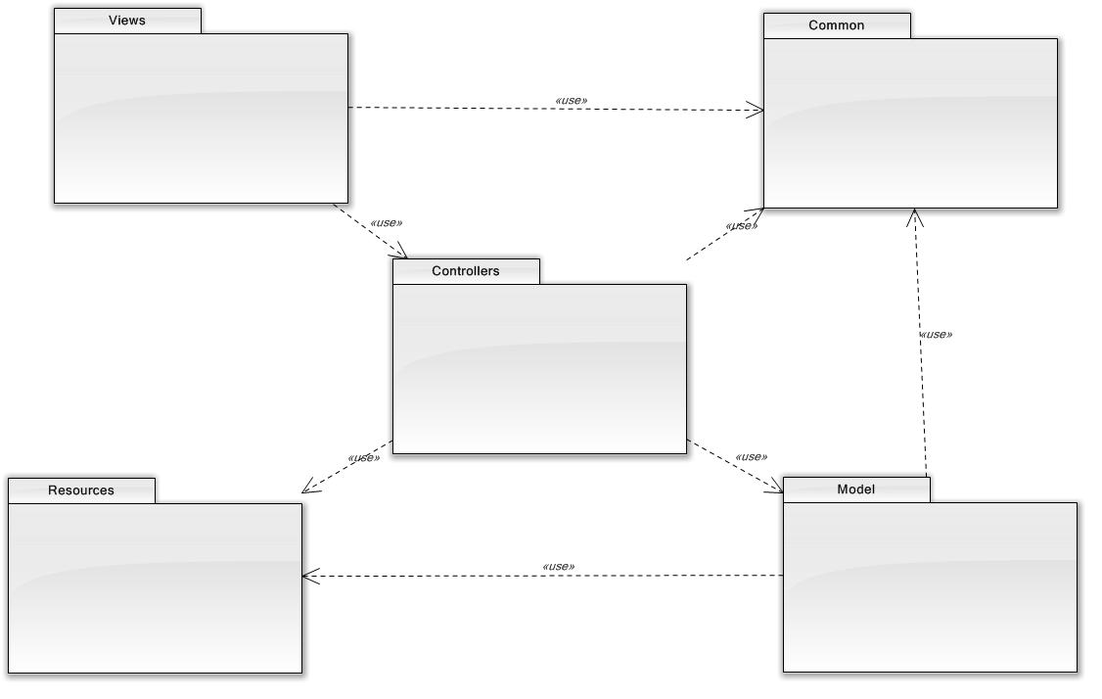
The high-level package structure of the application follows the model, view, controller architecture.
- The Model is the domain-specific representation of the information on which the application operates. Domain logic adds ‘meaning’ to raw data (e.g., calculating if today is the user’s birthday, or the totals, taxes, and shipping charges for a shopping cart). Most applications use a persistent storage mechanism such as a database to store data. MVC does not specifically mention the data access layer because it is understood to be underneath, or encapsulated by, the Model.

- The View renders the model into a form suitable for interactions, typically a user interface. Multiple views can exist for a single model, for different purposes. In a Web application the view is usually rendered in a ‘Web format’ like HTML, XML or JSON. However there are some cases where the view can be expressed in a binary form, e.g. dynamically rendered chart diagrams.

- The Controller responds to events (typically user actions) and processes them, and may also invoke changes on the model. In a Web application, events are typically HTTP requests: a Controller listens for HTTP requests, extracts relevant data from the ‘event’, such as query string parameters, request headers... And applies changes on the underlying model objects.

- The Common package will contain common objects that are available to all other packages.

- The Resources package will contain global resources particularly used by the view layer for things such as images, and scripts.

View Package
The view package contains the user interface modules for the application. We are using the Play Framework, which has support for a Scala based template engine. The four views identified in the package, will be implemented as Scala based template files. The user interface also is leveraging the Processing Language and specifically the ProcessingJS library for the 2D drawings using HTML 5 canvas support.
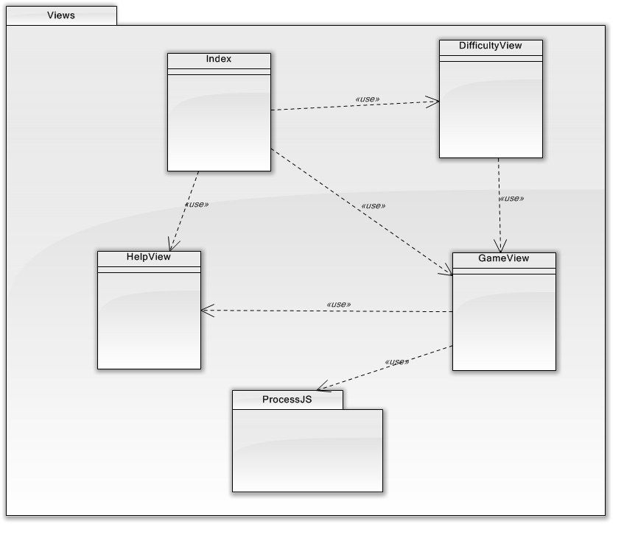
- Index – The main home page for the Dots and Boxes application.
- DifficultyView – The view to allow the player to select the level of difficulty the computer will play in the one player game.
- GameView – The main view while playing the game, which allows the player(s) to make moves, view the score, reset or quite the game.
- HelpView – The view to display help/game rules.
- ProcessJS – The third party package supporting the processing language for animation and graphics display.

Controllers Package
The controllers package will contain one Application controller class for the entire game. The Application Controller class contains the routing actions to be executed when the game player causes external events.
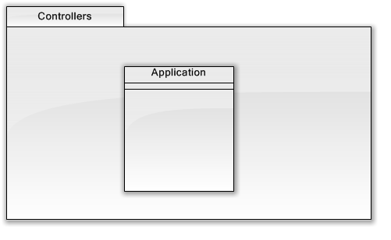

Model Package
The model package contains the classes representing the domain of the Dots and Boxes game. These classes represent the core domain concepts implementing the behavior and rules for the game.
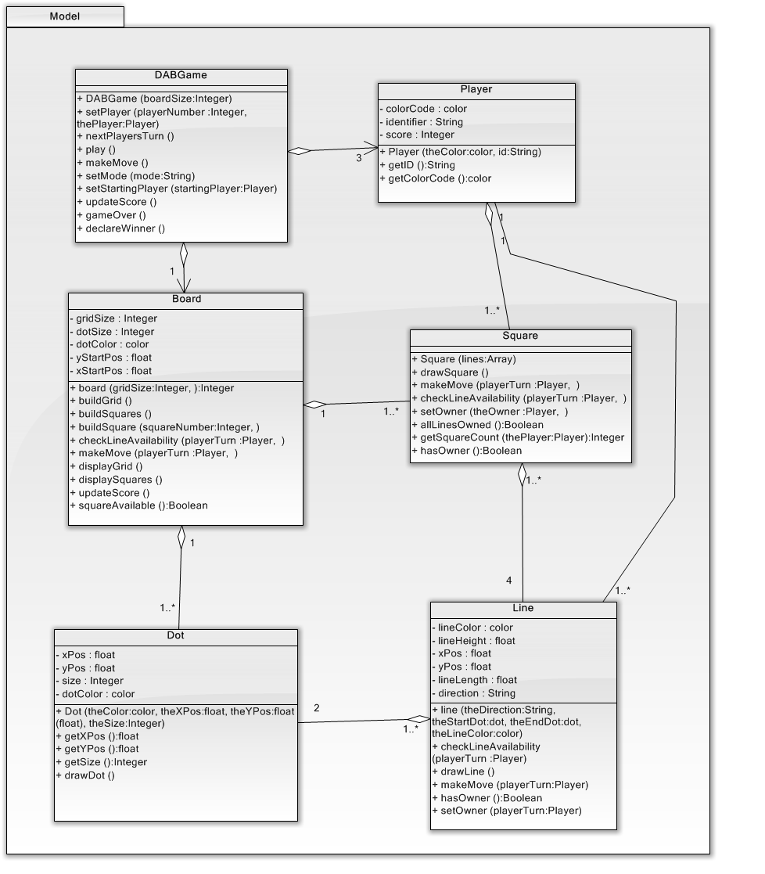
- Player – Represents the game players in both the one player and two player game modes. Responsible for making moves to own lines and squares. Knows its color coding scheme, its score and has a unique identifier.
- DABGame – Represents the overall game and is responsible for getting the game started, controlling game play, updating the score and declaring a winner.
- Board – Represents the board containing a grid of dots and the one-by-one squares. Responsible for checking if a square is owned or not as well as if a line has an owner.
- Square – Represents a square on the board. A square has four lines which are owned by players. When the fourth line is owned by a player, then the player takes ownership of the square regardless of who owns the other three lines.
- Line – Represents a valid line on the board, which can be horizontal or vertical, and has a starting dot and an ending dot. A line knows its ownership, color, x and y position, length and direction.
- Dot – Represents a dot on the grid making up the board. A dot knows it’s x and y position, color, and size.

Resources Package
The resources package contains the images, javascript and stylesheets leveraged by the application user interface for presentation as a web application.
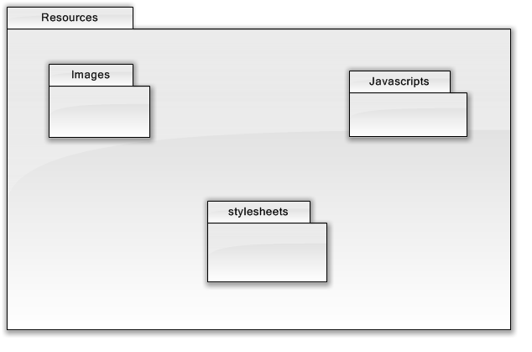

Use Case Realizations
This section contains depictions of the objects interacting to fulfill the main use cases of the system in the form of sequence diagrams. Each diagram will illustrate the messaging occurring between the objects using the classes from the model package.

Start the Game
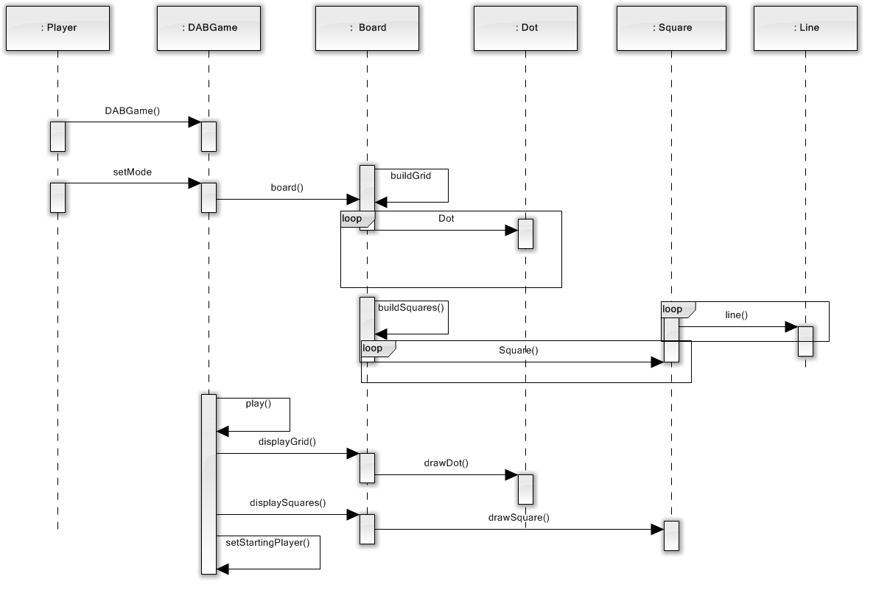

Play Dots and Boxes

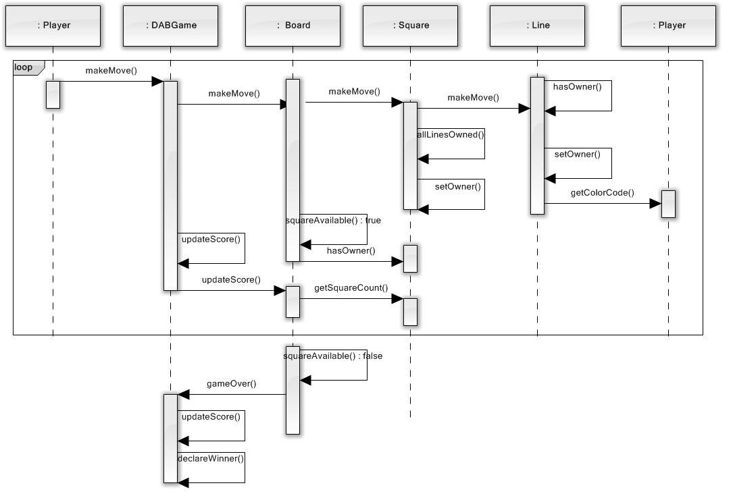

Product Design Specification Approval
The undersigned acknowledge they have reviewed the Dots & Boxes Product Design Specification document and agree with the approach it presents. Any changes to this Requirements Definition will be coordinated with and approved by the undersigned or their designated representatives.

Signature: |  | Date:
Print Name:
Title:
Role:

Signature: |  | Date:
Print Name:
Title:
Role:

Signature: |  | Date:
Print Name:
Title:
Role:

Appendix A: References
The following table summarizes the documents referenced in this document.
Document Name and Version | Description | Location
KRU41 | The “4+1” view model of software architecture. | http://www3.software.ibm.com/ibmdl/pub/software/rational/web/whitepapers/2003/Pbk4p1.pdf
RSA | The IBM Rational Software Architect | http://www-306.ibm.com/software/awdtools/architect/swarchitect/index.html
RUP | The IBM Rational Software Architect | http://www-306.ibm.com/software/awdtools/rup/index.html

Appendix B: Key Terms
The following table provides definitions for terms relevant to this document.
Term | Definition
RUP | Rational Unified Process
UML | Unified Modeling Language
SAD | Software Architecture Document

