Sample Software Architecture Document

Dots and Boxes Game

Version 1.0
3/5/2013

Prepared for:
IT 484
Minnesota State University - Mankato

Prepared by:
Russell Walters, Chisomo Banda, Lindiwe Hove, Matt Ruppert



SAD Revision History

Date | Version | Description | Author
3/5/2013 | 0.1 | Initial Draft | Project Team

Table of Contents

1. Introduction 4
1.1 Purpose 4
1.2 Scope 5
1.3 Definitions, Acronyms and Abbreviations 5
1.4 References 5
1.5 Overview 5
2. Architectural Representation 6
3. Architectural Goals and Constraints 7
3.1 Technical Platform 7
3.2 Transaction 7
3.3 Security 7
3.4 Persistence 7
3.5 Reliability/Availability (failover) 7
3.6 Performance 8
3.7 Internationalization (i18n) 8
4. Use-Case View 8
4.1 Ordering Menus 8
4.2 Use-Case Realizations 9
5. Logical View 9
5.1 Overview 9
5.2 Architecturally Significant Design Packages 11
6. Process View 13
7. Deployment View 13
8. Implementation View 15
8.1 Overview 15
8.2 Layers 15
9. Data View 15
10. Size and Performance 16
11. Quality 16

Introduction
The objective of this document is to define the architecture of the Dots and Boxes game project developed for the IT484 Spring 2013 class. In particular, this document outlines: the specifics of the layers of the architecture; identification of communication protocols; and identification of deployment components.

The overall objective of the project is to build a working Dots and Boxes game using a software development lifecycle to get a feel for the various activities, workflows and artifacts utilized in the development of a software application.

Purpose
The Software Architecture Document (SAD) provides a comprehensive architectural overview of the Dots and Boxes game. It presents a number of different architectural views to depict different aspects of the system. It is intended to capture and convey the significant architectural decisions which have been made on the system.

In order to depict the software as accurately as possible, the structure of this document is based on the “4+1” model view of architecture [KRU41].

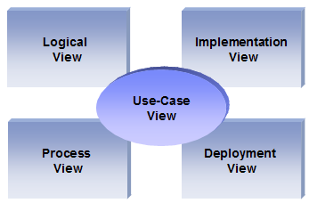
The “4+1” View Model allows various stakeholders to find what they need in the software architecture.

Scope
The scope of this SAD is to depict the architecture of the dots and boxes game developed by the project team.

Definitions, Acronyms and Abbreviations

RUP: Rational Unified Process
UML: Unified Modeling Language
SAD: Software Architecture Document

References

[KRU41]: The “4+1” view model of software architecture, Philippe Kruchten, November 1995, http://www3.software.ibm.com/ibmdl/pub/software/rational/web/whitepapers/2003/Pbk4p1.pdf

[RSA]: IBM Rational Software Architect
http://www-306.ibm.com/software/awdtools/architect/swarchitect/index.html

[RUP]: The IBM Rational Unified Process : http://www-306.ibm.com/software/awdtools/rup/index.html

Overview

In order to fully document all the aspects of the architecture, the Software Architecture Document contains the following subsections.
Section 2: describes the use of each view
Section 3: describes the architectural constraints of the system
Section 4: describes the functional requirements with a significant impact on the architecture
Section 5: describes the most important use-case realization. Will contain the Analysis Model and the Design Model
Section 6: describes design’s concurrency aspects
Section 7: describes how the system will be deployed. Will contain the Deployment Model
Section 8: describes the layers and subsystems of the application
Section 9: describes any significant persistent element. Will contain the Data Model
Section 10: describes any performance issues and constraints
Section 11: describes any aspects related to the quality of service (QoS) attributes

Architectural Representation

This document details the architecture using the views defined in the “4+1” model [KRU41], but using the RUP naming convention. The views used to document the Dots and Boxes application are:

Logical view
Audience: Designers.
Area: Functional Requirements: describes the design's object model. Also describes the most important use-case realizations.
Related Artifacts: Design model

Process view
Audience: Integrators.
Area: Non-functional requirements: describes the design's concurrency and synchronization aspects.
Related Artifacts: (no specific artifact).

Implementation view
Audience: Programmers.
Area: Software components: describes the layers and subsystems of the application.
Related Artifacts: Implementation model, components

Deployment view
Audience: Deployment managers.
Area: Topology: describes the mapping of the software onto the hardware and shows the system's distributed aspects.
Related Artifacts: Deployment model.

Use Case view
Audience: all the stakeholders of the system, including the end-users.
Area: describes the set of scenarios and/or use cases that represent some significant, central functionality of the system.
Related Artifacts : Use-Case Model, Use-Case documents

Data view (optional)
Audience: Data specialists, Database administrators
Area: Persistence: describes the architecturally significant persistent elements in the data model
Related Artifacts: Data model.

Architectural Goals and Constraints

This section describes the software requirements and objectives that have some significant impact on the architecture

Technical Platform
The Dots and Boxes application will be deployed onto a Java web application server which supports the Play Framework 2.1.

Transaction
The Dots and Boxes application does not require transactional support.

Security
The Dots and Boxes application is available to the general public and requires no security to access or play the game.

Persistence
Data persistence is not required for the Dots and Boxes game, as the requirements do not require such functionality.

Reliability/Availability (failover)
The Dots and Boxes application is not critical and is intended for entertainment purposes only. While every effort will be made to have the game operational at all times, there is no implied availability or SLA.

Performance
In general, when a player has initiated an event, the application is expected to respond in 3 seconds or less.

Internationalization (i18n)
The Dots and Boxes application will only support English and will not support any other language.

Use-Case View
This section lists use cases or scenarios from the use-case model if they represent some significant, central functionality of the final system. The only use-cases with a significant impact on the Dots and Boxes architecture is the one related playing Dots and Boxes and Starting the Game.

Playing Dots and Boxes
A player accesses the Dots and Boxes application to play a game. The player chooses a mode of play: human versus human or human versus computer. If the player selects human versus computer play, they will then choose a level of difficulty between easy and intermediate. The players will alternate taking turns by using a mouse to place a horizontal or vertical line on the grid of dots with the goal of creating a square. The player who places the fourth line and forms a square will score a point, and gets to take another turn. When all the lines have been placed, the game will end with the winner being the player having formed the most boxes.

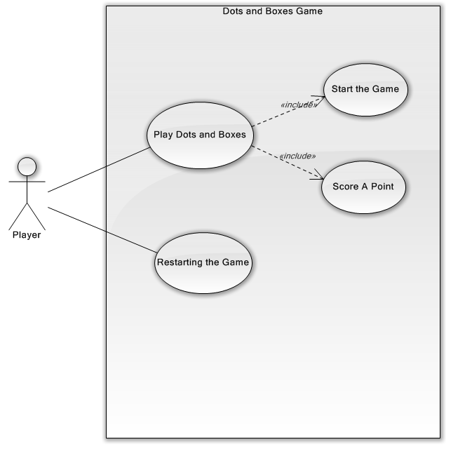

Use-Case Realizations
Refers to section 5.2 to see how design elements provide the functionalities identified in the significant use-cases.

Logical View

Overview
The Dots and Boxes application will be using a Model/View/Controller N-tier architecture (MVC) as supported by the Play framework.
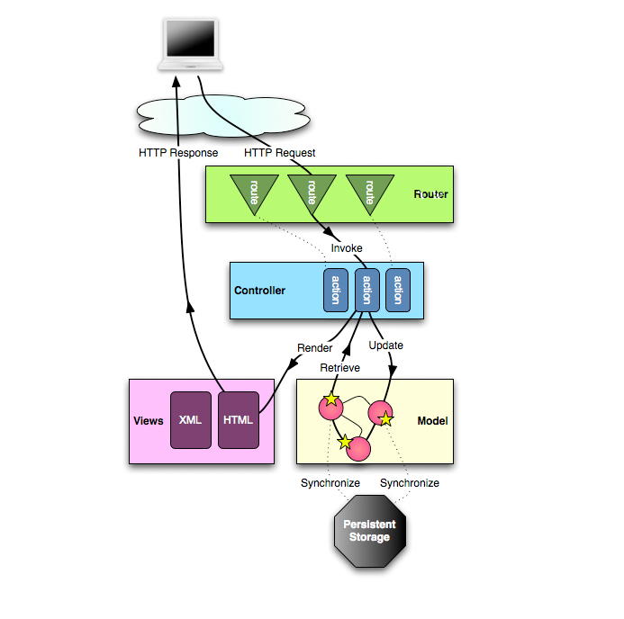
The layering model of the Dots and Boxes application is based on a responsibility layering strategy that associates each layer with a particular responsibility.
This strategy has been chosen because it isolates various system responsibilities from one another, so that it improves both system development and maintenance.
This pattern splits the application into separate layers: the Presentation layer and the Model layer. The Presentation layer is further split into a View and a Controller layer.
- The Model is the domain-specific representation of the information on which the application operates. Domain logic adds ‘meaning’ to raw data (e.g., calculating if today is the user’s birthday, or the totals, taxes, and shipping charges for a shopping cart). Most applications use a persistent storage mechanism such as a database to store data. MVC does not specifically mention the data access layer because it is understood to be underneath, or encapsulated by, the Model.

- The View renders the model into a form suitable for interactions, typically a user interface. Multiple views can exist for a single model, for different purposes. In a Web application the view is usually rendered in a ‘Web format’ like HTML, XML or JSON. However there are some cases where the view can be expressed in a binary form, e.g. dynamically rendered chart diagrams.

- The Controller responds to events (typically user actions) and processes them, and may also invoke changes on the model. In a Web application, events are typically HTTP requests: a Controller listens for HTTP requests, extracts relevant data from the ‘event’, such as query string parameters, request headers... And applies changes on the underlying model objects.

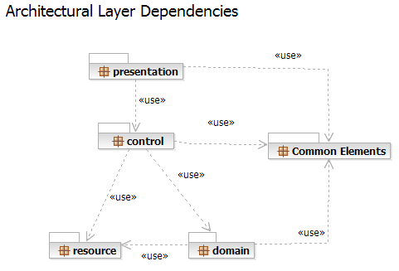

Each layer has specific responsibilities.
- The presentation layer deals with the presentation logic and the pages rendering
- The control layer manages the access to the domain layer
- The resource layer (integration layer) is responsible for the access to the enterprise information system (databases or other sources of information)
- The domain layer is related to the business logic and manages the accesses to the resource layer.
- The Common Elements layer gathers the common objects reused through all the layers

Domain Model
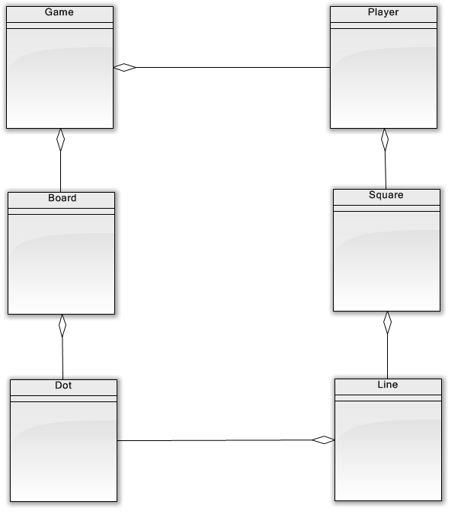

Architecturally Significant Design Packages
TBD

Basic Flow:

Process View

There’s only one process to take into account. The Play Framework model automatically handles threads which are instances of this process.

Deployment View

Global Overview
TBD

Implementation View

Overview

The Implementation view depicts the physical composition of the implementation in terms of Implementation Subsystems, and Implementation Elements (directories and files, including source code, data, and executable files).
Usually, the layers of the Implementation view do fit the layering defined in the Logical view

It is unnecessary to document the Implementation view in great details in this document.

Layers

Presentation Layer
The Presentation layer contains all the components needed to allow interactions with an end-user. It encompasses the user interface

Control Layer
The Control layer contains all the components used to access the domain layer or directly the resource layer when this is appropriate.

Resource Layer
The Resource layer contains the components needed to enable communication between the business tier and the enterprise information systems (Database, external services, ERP, etc…)

Domain layer
The Domain layer contains all the components related to the business logic. It gathers all the subsystems that meet the needs of a particular business domain. It also contains the business object model.
.

Common Elements Layer
The Common Element layer contains the components re-used within several layers.

Data View

The key data elements related to the Dots and Boxes application are:

TBD

Size and Performance

Volumes:
- Estimated concurrent games – maximum of 2 to 3

Performance:
- Time to process user events : less than 3 seconds required

Quality
As far as the Dots and Boxes application is concerned, the following quality goals have been identified:

Dependability:
- Description : The Dots and Boxes application conforms to the rules of game correctly.
- Solution : A modular design to emphasize ease of testing to ensure the game play is correct.

