Sample Software Architecture Document

Dots and Boxes Game

Version 1.0
3/22/2013

Prepared for:
IT 484
Minnesota State University - Mankato

Prepared by:
Russell Walters, Chisomo Banda, Lindiwe Hove, Matt Ruppert



FPA Revision History

Date | Version | Description | Author
3/22/2013 | 0.1 | Initial Draft | Project Team

Table of Contents

Table of Contents
1. Introduction 5
1.1 Purpose 5
1.2 Scope 5
1.3 Definitions, Acronyms and Abbreviations 5
1.4 References 6
2. System Boundary 7
3. Function Point Analysis 8
3.1 Unadjusted Function Points 8
3.2 Technical Complexity 9
3.3 Adjusted Function Points 9
3.4 Estimates Using Function Point Total 10
3.4.1 Lines of Code 10
3.4.2 Estimate of Test Cases 10

Introduction
The objective of this document is to calculate the function points of the Dots and Boxes game design to be developed for the IT484 Spring 2013 class. In particular, this document shows the function point analysis.

The overall objective of the project is to build a working Dots and Boxes game using a software development lifecycle to get a feel for the various activities, workflows and artifacts utilized in the development of a software application.

Purpose
The Function Point Analysis document provides a way to size various aspects of a software development project such as the Dots and Boxes game. The analysis will view the system by five major categories: internal logical files, external logical files, external inputs, external outputs and external inquiries.

A complexity factor will be applied for each module based on the number of record element types, file type references and data element types. Each function will then be given an unadjusted function point providing an estimate of the size. A total of all unadjusted function points is calculated by summing the individual unadjusted function points for each identified function.

The next analysis of the system under development is the technical complexity. There are fourteen factors to consider where each is given a weight of zero (not important or not applicable) to five (essential). The sum of these weights is called the degree of influence. A formula is then utilized to compute the technical complexity factor using the degree of influence.

The final total function points for the system are computed by multiplying the unadjusted function points by the technical complexity factor. The final function point total can then be utilized to size various aspects of the proposed system.

Scope
The scope of this functional point analysis is for the dots and boxes game developed by the project team.

Definitions, Acronyms and Abbreviations

Record Element Type (RET): A RET is a user recognizable sub group of data elements within an internal logical file or external interface file.
File Type Referenced (FTR): A FTR is a file type referenced by a transaction. An FTR must also be an internal logical file or external interface file.
Data Element Type (DET): A DET is a unique recognizable, non-recursive (non-repetitive) field. A DET is information that is dynamic and not static.
External Inputs (EI): Is an elementary process in which data crosses the boundary from outside to inside. The data is coming external to the application.
Boundary: Indicates the border between the project or application being measured and the external applications or user domain.
External Outputs (EO): Is an elementary process in which derived data passes across the boundary from inside to outside. An EO may update and ILF. The data creates reports or output files sent to other applications.
Internal Logical File (ILF): Data at rest that is maintained by the application in question.
External Interface File (EIF): Data at rest that is maintained by another application in question.

References

[SoftMetrics]: Fundamentals of FPA
http://www.softwaremetrics.com/fpafund.htm

[SoftMetricsAr]: Using Function Points
http://www.softwaremetrics.com/Articles/using.htm

[QSM]: Function Point Languages Table
http://www.qsm.com/resources/function-point-languages-table

System Boundary
The application boundary for the dots and boxes game with regards to the function point analysis consists of the user’s browser on the client machine and the web application server housing the application. Even though there are two different physical machines, the application boundary contains both. The actual game player(s) are external users and outside the application boundary.
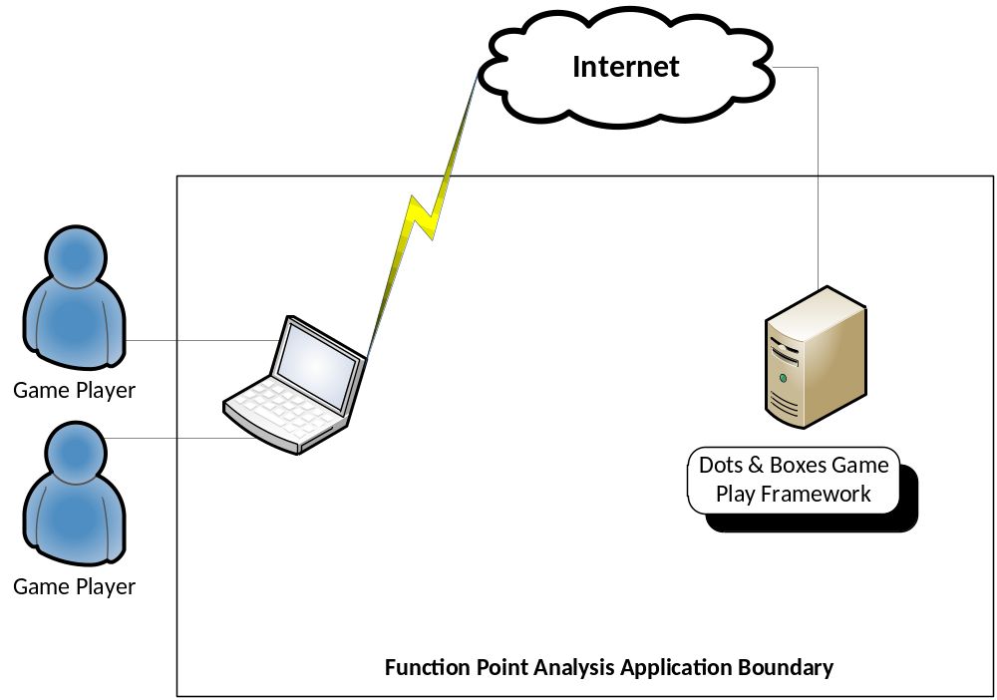

Function Point Analysis
This section identifies and rates the functions of the dots and boxes application into the 5 major components of external input, external output, external inquiry, internal logical file and external interface file.

Unadjusted Function Points
Module | Function Description | Type | RET/FTR | DET | Function Complexity  Rating | Function Points
Game | Game mode of play | EI | 1 | 2 | Low | 3
Game | Rules of the game | EI | 1 | 2 | Low | 3
Game | Computer level of play | EI | 1 | 2 | Low | 3
Game | Rules of the game output | EO | 1 | 2 | Low | 4
Player | Makes a move | EI | 1 | 1 | Low | 3
Game | Keep score | EO | 3 | 6 | Average | 5
Game | Restart Game | EI | 1 | 1 | Low | 3
Game | Declare winner | EO | 3 | 6 | Average | 5
Game | Play again | EI | 1 | 2 | Low | 3
Game | Represents the entire game concept | ILF | 1 | 6 | Low | 7
Board | Represents the playing grid of dots | ILF | 1 | 7 | Low | 7
Dot | Represents a dot location on the board | ILF | 1 | 4 | Low | 7
Line | Represents a horizontal or vertical line between two dots. Can be owned by a player | ILF | 1 | 8 | Low | 7
Square | Represents a square which consists of 4 lines and is owned by a player | ILF | 1 | 4 | Low | 7
Player | Represents the player in the game. They own lines and squares. Owned squares count towards a point in the game score | ILF | 1 | 4 | Low | 7
 |  |  |  |  | Total Unadjusted function points | 74

Technical Complexity
There are 14 identified technical factors. Each of these factors is given a weight from 0 (either not important or not applicable) through 5 (essential). The sum of these weights is called the degree of influence.

Technical Factor | Weight
Data Communication | 4
Distributed Data Processing | 0
Performance Criteria | 1
Heavily Utilized Hardware | 0
High Transaction Rates | 0
Online Data Entry | 5
End-user Efficiency | 1
Online Updating | 3
Complex Computations | 1
Reusability | 1
Ease of Installation | 0
Ease of Operation | 0
Portability | 0
Maintainability | 0
Degree of Influence | 16

Technical Complexity Factor = 0.65 +0.01 * 16
Technical Complexity Factor = 0.81

Adjusted Function Points
The adjusted function point total is equal to the unadjusted function point total multiplied by the technical complexity factor.
Function Points = 74 function points X 0.81
Function Points = 59.94

Estimates Using Function Point Total
This section will utilize the adjusted function point total calculated for the Dots and Boxes application to determine various sizing estimates for the project.

Lines of Code
The Dots and Boxes application is being primarily developed in Java and JavaScript. The function point languages table provided by the QSM web site indicates a median of 53 source statements per function point.
The estimated SLOC for Java = 53 source statements/FP X 60
Estimated SLOC for Java = 3,180

Estimate of Test Cases
The relationship between function points and the number of test cases is very strong. Capers Jones estimates that the number of total number of test cases will approximately equal the number of Function Points raised to the 1.2 power (FP^{1.2}). Data gathering and laboratory research indicates that Function Points times 1.2 estimates the number of acceptance test cases. Again the difference between the two is that FP raised to the 1.2 power estimates all test cases and FP times 1.2 estimates only acceptance test cases.

Total Test Cases = 60 FP raised to the power of 1.2
Total Test Cases = 136

Total Acceptance Test Cases = 60 FP times 1.2
Total Acceptance Test Cases = 72

