SEMCO Form Controls Documentation
  - Web Based Loan Management System with Decision Support
Senate Employees Multipurpose Cooperative
CS 301 Software Engineering 1 | October 27, 2026

Purpose and scope
This document describes two major forms and two supporting forms implemented in the SEMCO prototype. It identifies their controls, input rules, error feedback and visible results. The accompanying screenshot set contains complete views of each form and its error state, plus the actual project directory in VS Code.
Category | Form | HTML controls
Major | Member registration | 14 data controls plus a visibility toggle
Major | Loan application details | 10 required controls
Supporting | Profile update | 10 editable controls plus 1 read-only ID
Supporting | Record search and filters | 12 controls

Counts exclude submit and reset buttons. Each radio choice is counted as an HTML control. The additional login, OTP, calculator and staff screens support the prototype; the four forms above are the designated assignment forms.

Implementation and accessibility
The interface uses HTML5, CSS3, JavaScript and Bootstrap 5.3.8. The Python server provides the local credit-evaluation API. Registration, profile details, applications and submitted search filters are retained in browser local storage; this prototype has no shared database.
- Every field has a label and helper text. Related radio choices use a fieldset and legend.
- Invalid submission shows a linked error summary and field messages, marks invalid controls, and focuses the first invalid field.
- Keyboard order follows the page structure. Submit and reset labels describe their action; no positive tabindex is used.
- Form data uses fictional records. Credit recommendations are advisory; the Chairman or Vice Chairman makes the simulated final decision.
The existing checks comprise 13 form and demo-credential tests and 8 Python calculation/API tests. Both suites passed during the implementation walkthrough on October 27, 2026.

Member registration
Purpose: Create a fictional cooperative member account and collect the information needed for the member profile and initial financial snapshot. Open Sign out, then select Create a member account.
Control | HTML type | Validation or behavior
Full name | Text | Required; 2 to 70 characters after trimming.
Email address | Email | Required; valid format, maximum 120 characters; unique across demo members and users.
Mobile number | Telephone | Required; 09 plus 9 digits, or +639 plus 9 digits. Spaces and hyphens are accepted here.
Date of birth | Date | Required; a real date representing a sample age of 18 to 100.
Department | Select | Required; select an office or department.
Employment type | Select | Required; Permanent, Contractual or Coterminous.
Employee reference | Text | Required; 3 to 24 letters, numbers or hyphens. Use a fictional reference.
Monthly income | Number | Required; above PHP 0 and at most PHP 10,000,000; two decimal places.
Password | Password | Required; 8 to 64 characters with at least one letter and one number.
Confirm password | Password | Required; must exactly match the password.
Contact method | Two radio choices | Required; choose Email or SMS.
Application updates | Switch | Optional; saves the notification preference.
Fictional data confirmation | Checkbox | Required; confirm the data is for the prototype.
Show passwords | Checkbox | Optional; shows or hides both password inputs.

Actions: Create member account validates the form. Clear registration form resets the inputs and removes errors. A valid form proceeds to the simulated OTP screen; the demo code is 123456. The member and user records are saved only after successful verification.
Data handling: The portal opens with the saved member name. The new member appears in the staff directory and can sign in again using the registered demo credentials. Passwords are stored as salted derived hashes, not plaintext. This remains a browser-local authentication demonstration.
Error example: The captured error state rejects an invalid email, a short mobile number, a weak password, mismatched confirmation and an unchecked confirmation box.

Loan application details
Purpose: Collect a loan request, estimate repayment and prepare the record for staff verification and advisory evaluation. Open Member, New application, select a loan facility, then continue to Your details.
Control | HTML type | Validation rule
Loan amount | Number | Required; PHP 1,000 to PHP 2,000,000, in increments of PHP 100.
Repayment term | Select | Required; 6, 12, 18, 24, 36, 48 or 60 months.
Loan purpose | Text | Required; 5 to 180 characters.
Monthly income | Number | Required; PHP 1 to PHP 10,000,000; up to 2 decimal places.
Existing monthly payments | Number | Required; PHP 0 to PHP 10,000,000.
Share capital or savings | Number | Required; PHP 0 to PHP 10,000,000.
On-time payment history | Number | Required; a whole percentage from 0 to 100.
Co-maker name | Text | Required; 2 to 70 characters.
Co-maker monthly income | Number | Required; PHP 1 to PHP 10,000,000.
Co-maker monthly payments | Number | Required; PHP 0 to PHP 10,000,000.

Submission and data handling
Review application validates all ten fields before showing the final review. Restore draft values returns the details and estimate to the rendered draft. Invalid edits cannot advance or overwrite the saved draft through Back navigation.
The final review displays the entered values and requires a fictional-data confirmation. Submit application runs the initial SCEA/Belief Rule Base check and stores the request as Pending. Members can see it in My applications; staff can verify and evaluate it before routing a simulated officer decision.
The calculator supports fixed/flat and diminishing interest. Rates, fees, limits and evaluation thresholds are illustrative, not verified SEMCO policy. The advisory score never approves an application automatically.
Error example: The captured state rejects a PHP 500 amount, negative income, a repayment percentage above 100 and a purpose shorter than five characters.

Profile update
Purpose: Let a member, staff user or administrator maintain fictional contact details and preferences while preserving the record identifier. Open My profile.
Control | HTML type | Validation or behavior
Member or employee ID | Read-only text | Displayed for reference; cannot be edited.
Full name | Text | Required; 2 to 70 characters.
Email address | Email | Required; valid format and at most 120 characters; cannot duplicate another account.
Mobile number | Telephone | Required; 09175550186 or +639175550186 format, with no spaces.
Date of birth | Date | Required; real calendar date for a sample age of 18 to 100.
Department or office | Select | Required; select an available department.
Contact address | Textarea | Required; 10 to 200 characters.
Preferred contact | Two radio choices | Required; choose Email or SMS.
Cooperative updates | Switch | Optional; stores the notification preference.
Accuracy confirmation | Checkbox | Required; review and confirm the fictional details before each save.

Submission and data handling
Save profile changes blocks invalid data and displays specific feedback. A valid save updates local storage and shows a confirmation summary. The updated name appears in the sidebar and associated application and payment records, while the member ID remains unchanged.
Discard profile changes restores the latest saved values and clears errors and success feedback. Identification uploads and changes to identity documents are outside this form. No actual email or SMS is sent.
Error example: The captured state leaves the stored profile unchanged when the name is blank, the email is invalid and the accuracy box is unchecked.

Record search and filters
Purpose: Retrieve applications, loans or payments using combined search conditions. Open Record search from the account navigation. Member results are scoped to the current member before filters are applied.
Control | HTML type | Validation or behavior
Keyword | Search text | Optional; if entered, 2 to 80 characters. Matches ID, member name, member ID or facility.
Record type | Select | Required; applications, loan accounts or payments.
Record status | Select | Optional; options depend on the selected record type.
Loan facility | Select | Optional; choose one of the ten demo facilities, or all.
From date | Date | Optional; must be a valid calendar date.
To date | Date | Optional; valid date on or after From date.
Minimum amount | Number | Optional; PHP 0 to PHP 10,000,000.
Maximum amount | Number | Optional; PHP 0 to PHP 10,000,000 and at least the minimum.
Sort order | Select | Required; newest, oldest, highest amount or lowest amount.
Keyword matching | Two radio choices | Required; contains or exact match, ignoring case.
Include closed records | Switch | Includes approved/rejected applications and completed loans. Posted payments remain visible.

Submission and data handling
Search records applies all submitted filters together and updates the result count and rows. A valid search with no matches shows an empty state. The last submitted filters are saved separately for each role in the browser.
Invalid filters do not replace the previous results. Clear search filters returns to the default choices and result list. Seeded loans use their next payment date where a separate record date is unavailable.
Error example: The captured state rejects a one-character keyword, an end date before the start date and a maximum amount below the minimum.

Major form requirement matrix
The tables below map each assignment requirement to the implemented forms. Counts exclude action buttons and hidden fields; each radio choice is a separate HTML control. The preceding control tables give the individual field rules.
Requirement | Member registration | Loan application details
Control count and types | 14 data controls plus visibility checkbox. Text, email, telephone, date, select, number, password, radio, switch and checkbox. | 10 required controls. Number, select and text inputs.
Required fields | Identity, employment, income, both passwords, contact choice and fictional-data confirmation are required. Updates and password visibility are optional. | All ten details fields are required. Final review also requires the fictional-data confirmation.
Format and limits | Email and phone formats; adult date; name/reference lengths; positive income; password length, letter/number and matching confirmation. | Principal PHP 1,000–2,000,000 in PHP 100 steps; valid term; purpose 5–180 characters; financial limits; repayment 0–100.
Errors and prevention | Inline errors and linked summary; first invalid field receives focus. Invalid data cannot proceed to OTP or create a member. | Inline errors and linked summary; first invalid field receives focus. Invalid data cannot advance to review or replace the saved draft.
Labels | Every input has an explicit or wrapping label. Radio groups have a fieldset and legend. | Every input has a label associated with its ID. Required markers identify mandatory details.
Placeholders or helpers | Field hints explain formats, examples and fictional data. Helpers are linked with aria-describedby. | Field helpers explain financial ranges, repayment history and co-maker data; hints are linked to controls.
Tabindex and keyboard | Native inputs follow DOM order with Tab/Shift+Tab; no positive tabindex. Error summary uses tabindex=-1. Enter submits; Space toggles checks; arrow keys select radio options. | Native inputs follow DOM order with Tab/Shift+Tab; no positive tabindex. Error summary uses tabindex=-1. Enter submits; select options support keyboard navigation.
Submit and reset labels | Create member account; Clear registration form. | Review application; Restore draft values. Final review uses Submit application.
System handles data | Successful demo OTP saves member/user records in local storage. Portal and staff directory reflect the account; saved demo credentials allow later sign-in. | Valid submission runs the advisory SCEA/BRB check and stores the application. Member tracking and the staff queue display the pending record.

Invalid submission is prevented before record creation or workflow advancement. Browser-local storage and visible UI results satisfy this prototype activity without requiring a shared database.

Supporting form requirement matrix
Both supporting forms exceed eight controls and handle submitted values through saved profile updates or filtered records. Optional search fields remain optional so users can search with only the conditions they need.
Requirement | Profile update | Record search and filters
Control count and types | 10 editable controls plus read-only ID. Text, email, telephone, date, select, textarea, radio, switch and checkbox. | 12 controls. Search text, select, date, number, radio and switch.
Required fields | Name, email, phone, birth date, department, address, contact choice and accuracy confirmation are required. Updates switch is optional. | Record type, sort order and matching mode are required. Keyword, status, facility, dates and amount range are optional.
Format and limits | Name 2–70 characters; valid unique email and mobile format; adult date; address 10–200 characters. | Keyword 2–80 characters when entered; valid dates with end on/after start; amounts PHP 0–10,000,000 with maximum at least minimum.
Errors and prevention | Inline errors and linked summary; first invalid input receives focus. Invalid data cannot overwrite the stored profile. | Inline errors and linked summary; first invalid input receives focus. Invalid filters cannot replace the previous result list.
Labels | Every editable and read-only input has a label. Contact options use a fieldset, legend and individual labels. | Every input has a label. Keyword matching has a fieldset, legend and individual radio labels.
Placeholders or helpers | Helpers explain each format, the fixed identifier and fictional-data confirmation; aria-describedby links them. | Placeholders and linked helpers explain optional keyword, date and amount conditions and available records.
Tabindex and keyboard | Native Tab/Shift+Tab order; no positive tabindex. Error and save-feedback regions use tabindex=-1 for programmatic focus. Enter submits; Space toggles; arrows select radios. | Native Tab/Shift+Tab order; no positive tabindex. Error summary uses tabindex=-1. Enter submits; Space toggles; arrow keys operate radio/select choices.
Submit and reset labels | Save profile changes; Discard profile changes. Reset restores the latest saved values. | Search records; Clear search filters. Reset restores default filters and results.
System handles data | Valid details/preferences persist in local storage. Sidebar and linked record names update; a live saved-status message confirms success. | Valid filters update result rows/count or show an empty state. Filters persist per role; members see only their own records. Result count uses a live status region.

Each designated form therefore includes at least eight controls, required-field and format checks, blocked invalid submission, labeled inputs with guidance, keyboard access, descriptive actions and a visible system result.

Validation screenshot evidence
These are cropped views of actual error summaries. Complete form screenshots and complete error-state screenshots are supplied separately in docs/form_screenshots.
Registration email phone password and confirmation errors
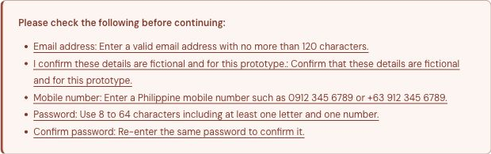
Loan amount income repayment and purpose errors
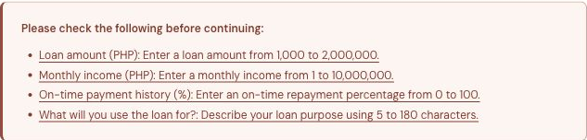
Profile required name email and accuracy errors
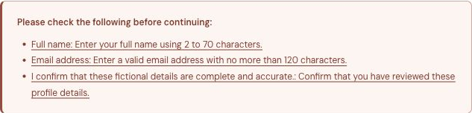
Search keyword date order and amount range errors
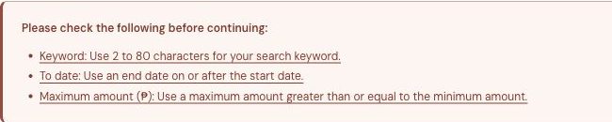

Project directory structure
The screenshot below shows the actual semco-portal directory in VS Code, with the dist folder expanded. The document displays the Explorer region for legibility; the full original screenshot is included in the screenshot set.
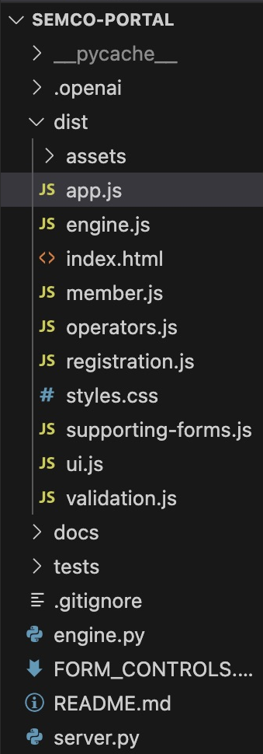 | Key files and folders  dist/  HTML, CSS, browser JavaScript and bundled Bootstrap/font assets.  dist/registration.js  Registration controls and demo credential processing.  dist/member.js  Member pages and loan application workflow.  dist/supporting-forms.js  Profile update and record search forms.  dist/validation.js  Shared input rules, errors, focus and reset behavior.  engine.py and server.py  Python evaluation logic and local web/API server.  tests/  Form validation, calculation and API checks.  docs/  Documentation and screenshot evidence.  README.md  Local run instructions and prototype scope.  FORM_CONTROLS.md  Detailed assignment requirement mapping.
Generated Python caches are local runtime files. The clean GitHub source package excludes .git history, hosting metadata, caches and archive files. The source code, tests, documentation and screenshot evidence are included.

Upload the project to GitHub
Use the updated SEMCO-Prototype.zip for a clean upload. Extract it, then open the inner semco-portal folder in VS Code. The instructions below create a new repository; they do not upload anything until you complete the publish action.

Publish from VS Code
1. Create or sign in to your own GitHub account. In the VS Code terminal, run git --version to check that Git is installed.
2. Open Source Control from the left sidebar. If shown, choose Initialize Repository. If the folder is already a repository, keep the existing history and skip initialization.
3. Configure your own commit identity before committing. Use an email connected to your GitHub account, or your GitHub noreply address from Settings and Emails.
4. Review the changed files. Keep .gitignore, the full dist folder, engine.py, server.py, tests, README.md and the documentation/screenshots. Do not add real personal data or credentials.
5. Stage the reviewed files and commit with a clear message such as Add SEMCO form controls and documentation.
6. Open the Command Palette with Command+Shift+P on Mac or Ctrl+Shift+P on Windows. Run Publish to GitHub and complete the browser sign-in if prompted.
7. Choose a repository name such as semco-loan-management. Select private or public according to your course requirements. A private repository must be accessible to your instructor.
8. Open the repository on GitHub. Confirm that the source folders, documentation and first commit are visible. Copy the repository URL for submission.
git config user.name "YOUR OWN NAME"
git config user.email "YOUR GITHUB EMAIL"

If your group already has a repository
Clone that repository first using Git Clone in VS Code, then copy the extracted project contents into the clone. Do not replace its .git folder. Review, commit and push the changes to a branch for review. This preserves your group history instead of starting a second project.

Check the uploaded project
python3 server.py --port 8000
node tests/test_forms.mjs
python3 -m unittest discover -s tests -v
Open http://127.0.0.1:8000 while the server runs. On Windows, use py in place of python3 if needed. Uploading code to GitHub does not run the Python server online.

Show genuine commits from every member
One person uploading the finished project creates history for that uploader. To meet the group requirement, each member must make a real change using their own GitHub account and commit identity. Record actual work; do not rename an author to imitate another member.
1. The repository owner opens Settings, Collaborators, Add people and invites each group member. Members accept the invitation.
2. Each member clones the repository and configures their own user.name and GitHub-linked user.email. They create a separate branch, such as member-name/profile-validation.
3. Each member makes a meaningful contribution: improve a form helper, fix a validation rule, add a test, refine accessibility, or update verified documentation. Review and test that change.
4. The member stages and commits only their contribution, pushes the branch, then opens a pull request. Another group member reviews it.
5. Merge using Create a merge commit when available to retain the individual branch commits. Before submission, open the repository commit history and confirm that all member authors appear.
git switch -c member-name/profile-validation
git add dist/supporting-forms.js
git commit -m "Improve profile validation feedback"
git push -u origin member-name/profile-validation
The filename and message above are examples. Stage the files you actually changed. Before editing again, update your local main branch from the shared repository. If a push is rejected or conflicts appear, synchronize and resolve them; do not force-push over another member’s work.

Submission checklist
- Nine screenshots: four complete assignment forms, four representative error states and one original VS Code directory screenshot.
- This Word document: form purposes, controls, validation rules, directory evidence and GitHub instructions.
- Repository link: accessible to the instructor, with genuine commits from every group member.
- Demo video: record separately for 2 to 4 minutes and show validation plus a visible saved or filtered result.

Official guidance
VS Code publishing and remotes
https://code.visualstudio.com/docs/sourcecontrol/repos-remotes
Git setup and identity
https://docs.github.com/en/get-started/git-basics/set-up-git
Invite repository collaborators
https://docs.github.com/en/repositories/managing-your-repositorys-settings-and-features/repository-access-and-collaboration/inviting-collaborators-to-a-personal-repository
Preserve pull request commits
https://docs.github.com/en/pull-requests/reference/pull-request-merges

