Bar chart example empty unmodified placeholder

Line chart example empty unmodified etc

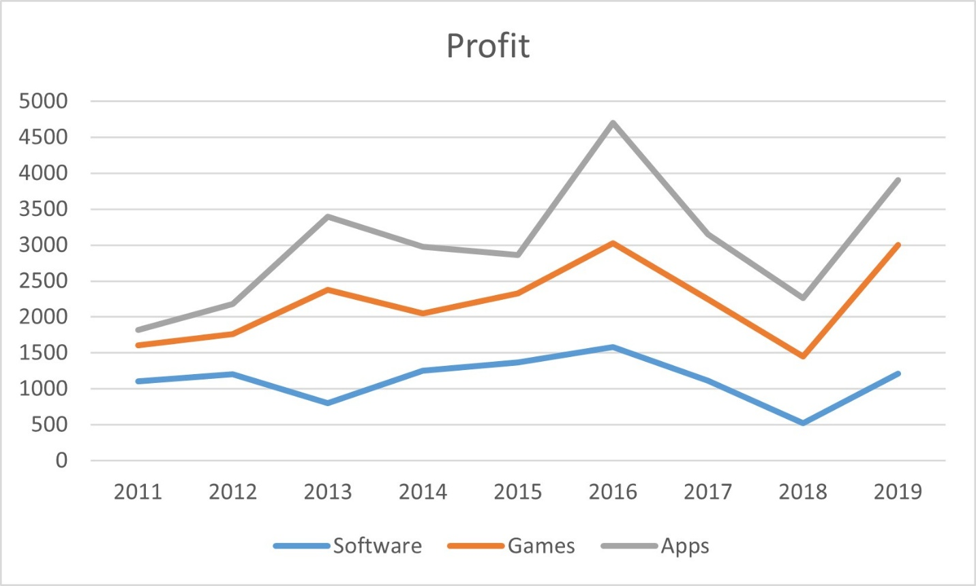

Line chart example from internet about profit of EA company.P