Name : Rut Rupala

Practical 6 : Code for Converting Temperature :

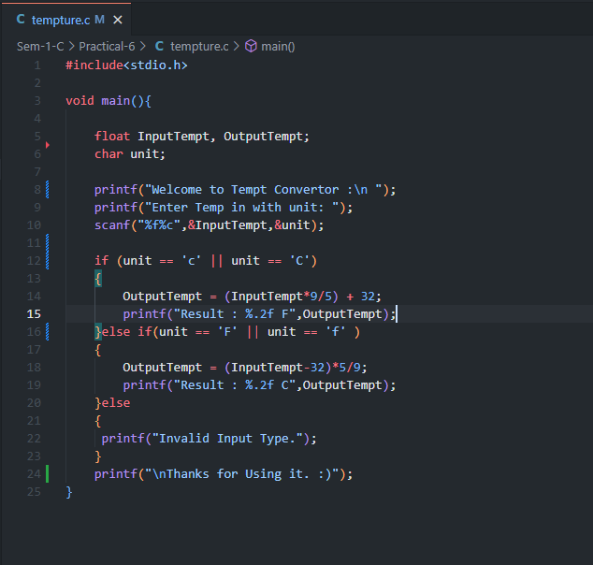

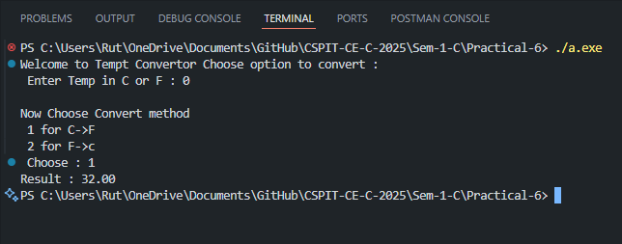
Output for 0 degree Celsius :

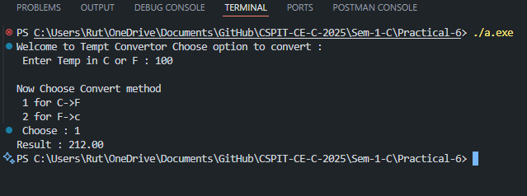
Output for 100 degree Celsius :

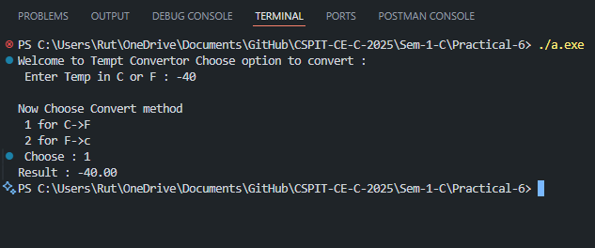
Output for -40 degree Celsius :

