Name : Rut Rupala

Practical 6 : Code for Converting Temperature :

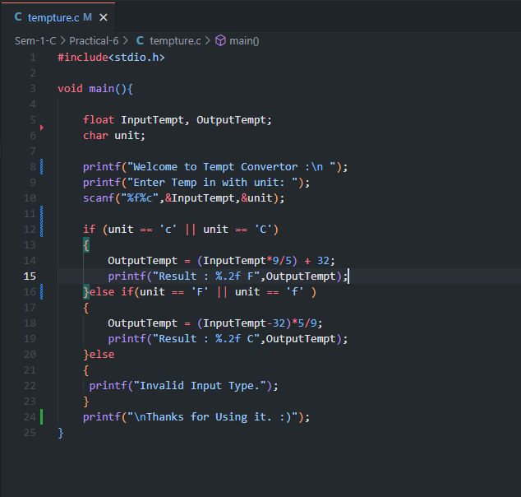

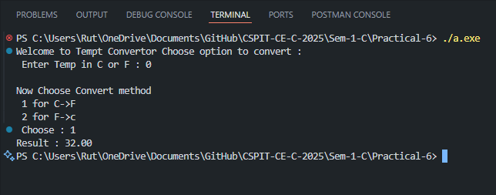Output for 0 degree Celsius :

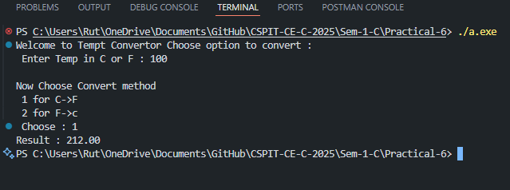

Output for 100 degree Celsius :

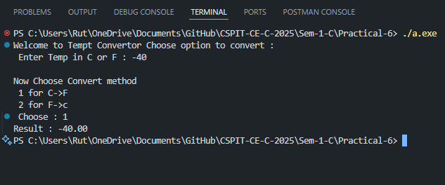

Output for -40 degree Celsius :

Practical 7 : Automated ticket Calc

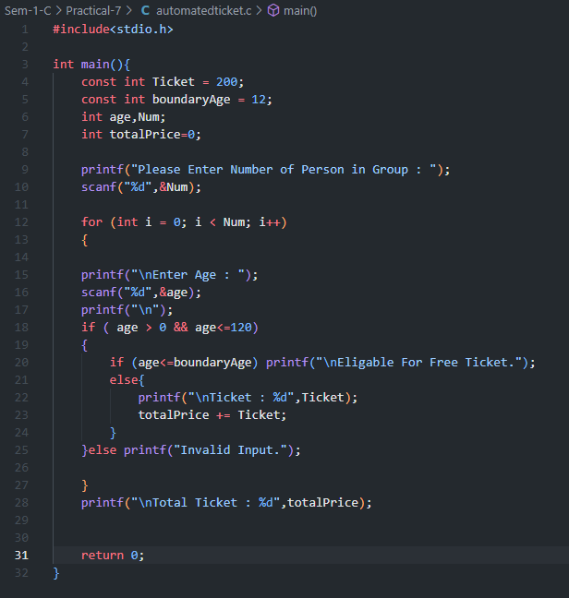

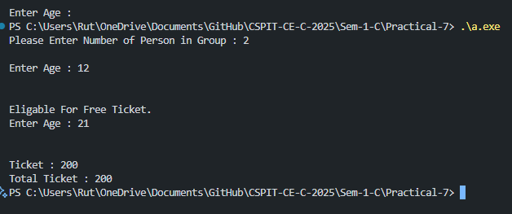

Output :