1. Create the tables below with given instructions and load sample data after that

* Give appropriate data type to columns
* Implement primary key in both tables
* Establish primary key - foreign key relationship between the tables
* Identify a column in employee table to implement unique key and not null constraint

Table 1: Department

|  |
| --- |
| **DeptID** |
| **DeptName** |
| **DeptCode** |

Create table Department (Primary Key DeptID numeric, DeptName varchar(50),DeptCode varchar(6));

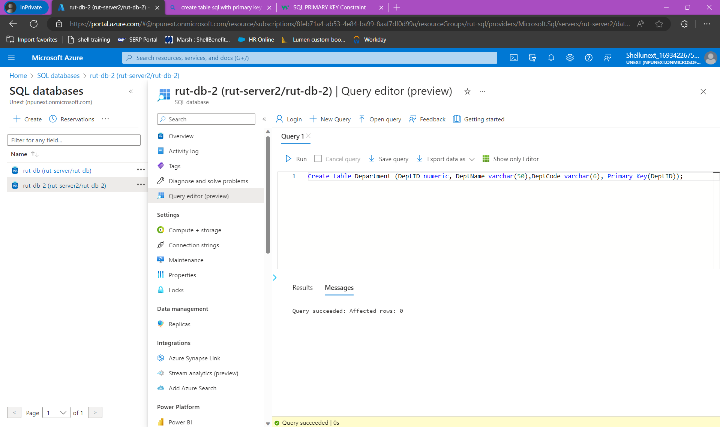

Table 2: Employee

|  |
| --- |
| **EmpID** |
| **EmpName** |
| **EmailId** |
| **DeptID** |
| **Designation** |

Create table Employee (Primary Key EmpID numeric, EmpName varchar(50),EmailId varchar(50),Foreign Key DeptID references Department(DepartmentID),Designation varchar(50));

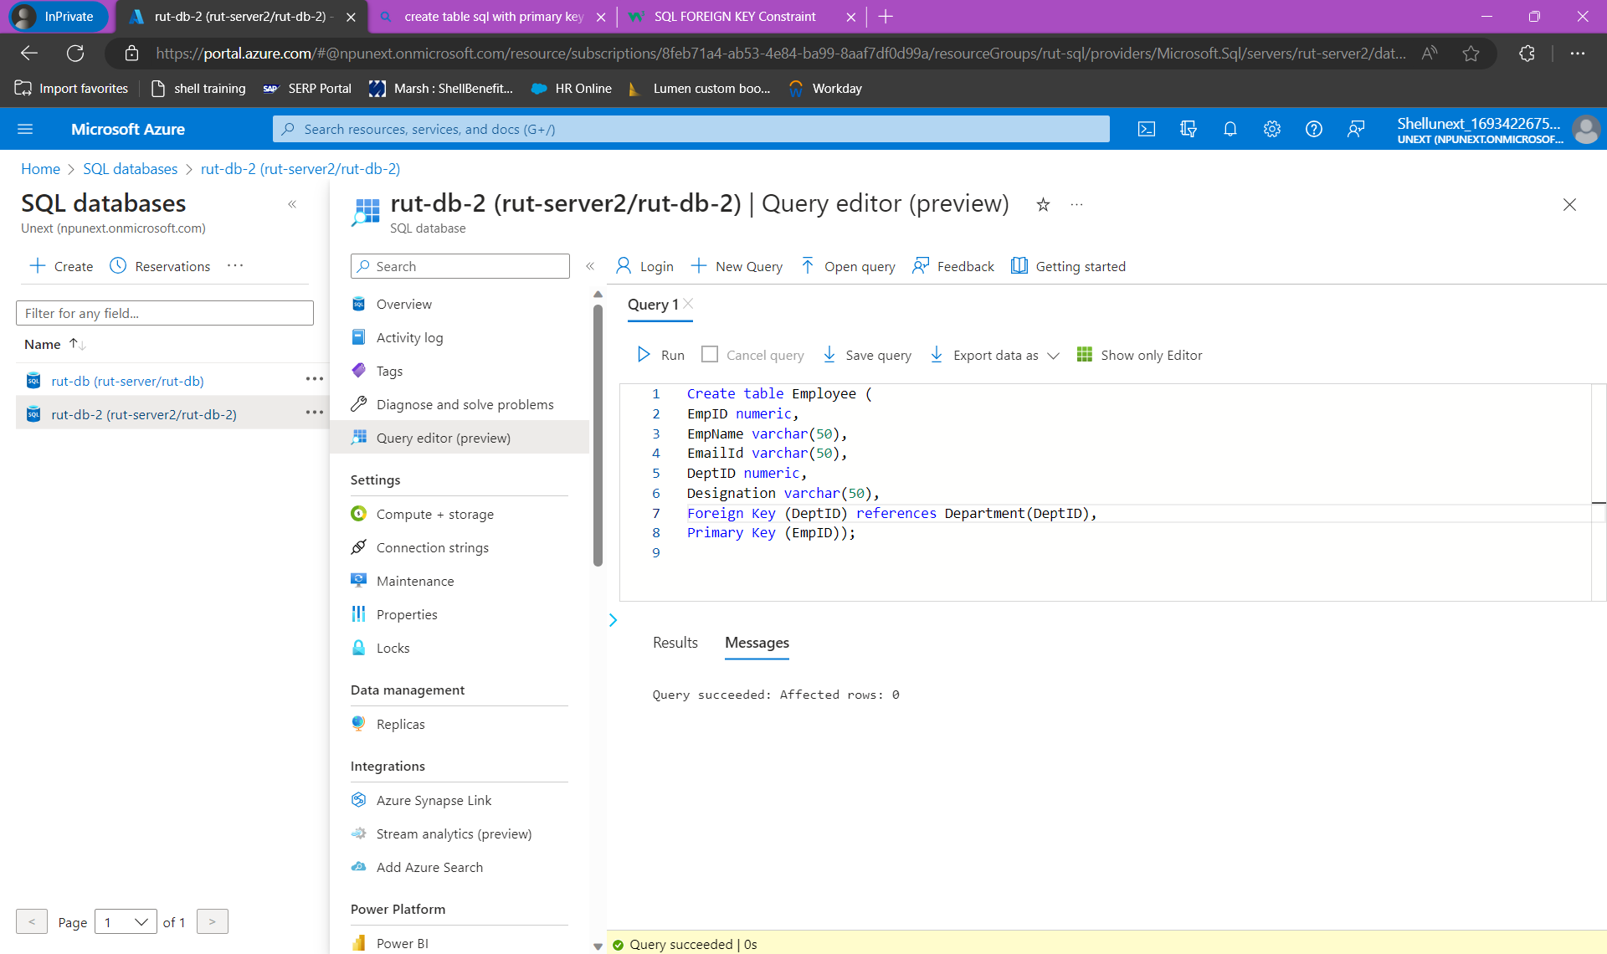

1. Create the below table & Write queries based on below table

|  |  |
| --- | --- |
| Table Name: **students** |  |
|  |  |
| Column Name | Type |
| slno | Integer |
| id | integer |
| name | String |
| subject | String |
| marks | Integer |

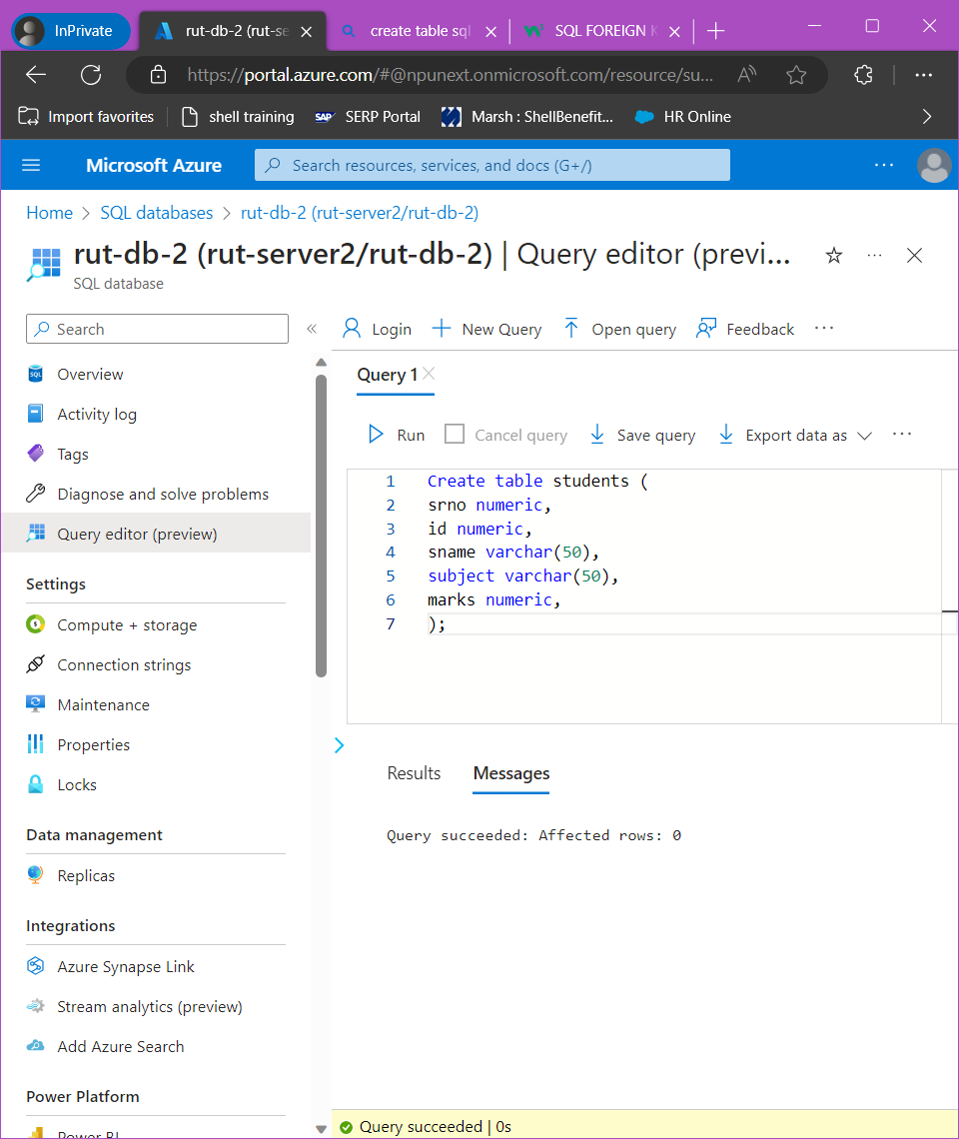

Sample Input

|  |  |  |  |  |
| --- | --- | --- | --- | --- |
| slno | id | name | subject | marks |
| 1 | 5030 | Ashley | DWH | 50 |
| 2 | 5031 | Priya | DWH | 61 |
| 3 | 5032 | Julia | DWH | 90 |
| 4 | 5033 | Don | DWH | 50 |
| 5 | 5034 | Bob | DWH | 65 |
| 6 | 5030 | Ashley | SQL | 75 |
| 7 | 5031 | Priya | SQL | 80 |
| 8 | 5032 | Julia | SQL | 40 |
| 9 | 5033 | Don | SQL | 88 |
| 10 | 5034 | Bob | SQL | 92 |
| 11 | 5030 | Ashley | Azure | 95 |
| 12 | 5031 | Priya | Azure | 45 |
| 13 | 5032 | Julia | Azure | 85 |
| 14 | 5033 | Don | Azure | 57 |
| 15 | 5034 | Bob | Azure | 44 |

insert into students (srno,id,sname,subject,marks) values

    (1,5030,'Ashley','DWH',50),

    (2,5031,'Priya','DWH',61),

    (3,5032,'Julia','DWH',90),

    (4,5033,'Don','DWH',50),

    (5,5034,'Bob','DWH',65),

    (6,5030,'Ashley','SQL',75),

    (7,5031,'Priya','SQL',80),

    (8,5032,'Julia','SQL',40),

    (9,5033,'Don','SQL',88),

    (10,5034,'Bob','SQL',92),

    (11,5030,'Ashley','Azure',95),

    (12,5031,'Priya','Azure',45),

    (13,5032,'Julia','Azure',85),

    (14,5033,'Don','Azure',57),

    (15,5034,'Bob','Azure',44)

    ;

Write queries to display

1. the record of the students who scored highest score in each subject
2. the records of the students in the order of highest to lowest marks in each subject and subjects in the ascending order
3. the record of the students with marks less than 50
4. the records of students with highest to lowest marks in ’Azure’
5. display the total score (sum of the score in all subjects) of each student in a new column
6. display the rank of the students in ascending order based on total score
7. display the rank of the department in ascending order based on total score
8. display the record of the students with the second highest scorer in each subject
9. display the highest mark for each subject as a new column against corresponding subjects.

Eg given below

|  |  |  |  |  |
| --- | --- | --- | --- | --- |
| slno | name | subject | marks | highest_score |
| 1 | Ashley | DWH | 50 | 90 |
| 2 | Priya | DWH | 65 | 90 |
| 3 | Julia | DWH | 90 | 90 |

1. Display a new column email id combining name & id column. Format should be

first 3 characters of the name underscore last 2 characters of the id column @ta.com

**Note: Prepare data dictionary for the tables in Q1 and Q2.**