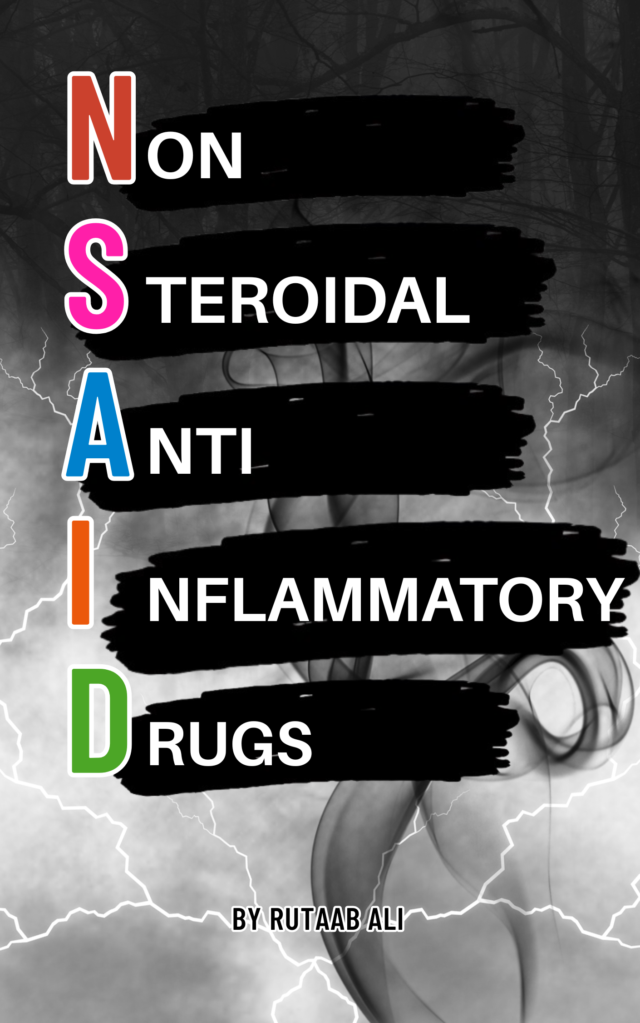

Table of Contents
Introduction to NSAIDs 4
Historical Context 4
General Pharmacology of NSAIDs 4
Types of NSAID Inhibition 4
NSAID Classes 5
Salicylates 5
Aspirin (Acetylsalicylic Acid) 5
• Reye's syndrome 5
Diflunisal 6
Propionic Acid Derivatives 6
Ibuprofen 6
Naproxen 6
Ketoprofen 6
Flurbiprofen 7
Oxaprozin 7
Acetic Acid Derivatives 7
Indomethacin 7
Diclofenac 7
Ketorolac 7
Sulindac 8
Etodolac 8
Enolic Acid Derivatives (Oxicams) 8
Piroxicam 8
Meloxicam 8
Anthranilic Acid Derivatives (Fenamates) 8
Mefenamic Acid 8
Selective COX-2 Inhibitors 9
Celecoxib 9
Etoricoxib 9
Topical NSAIDs 9
Diclofenac (Topical) 9
Ibuprofen (Topical) 9
Drug Interactions 9
• Anticoagulants 9
• Antihypertensives 9
• Methotrexate 10
• Corticosteroids 10
Special Populations 10
• Elderly 10
• Pregnancy 10
• Pediatrics 10
• Renal Impairment 10
• Hepatic Impairment 10

NSAIDs

Introduction to NSAIDs
Non-Steroidal Anti-Inflammatory Drugs (NSAIDs) are a cornerstone of modern medicine, widely used for their ability to relieve pain (analgesic), reduce inflammation (anti-inflammatory), and lower fever (antipyretic). They are available in both prescription and over-the-counter forms. Despite their widespread use and effectiveness, NSAIDs are associated with significant adverse effects which necessitate careful patient selection and monitoring.

Historical Context
The use of NSAIDs has ancient roots, tracing back to civilizations that utilized willow bark, a source of salicylates, for pain and fever relief. Key historical milestones include:
- Ancient Civilizations: Documented use of willow bark in "Egyptian papyri (circa 1500 BCE) and by Hippocrates in Greece."
- 1829: Isolation of salicin from willow bark.
- 1897: Felix Hoffmann at Bayer synthesized acetylsalicylic acid (aspirin), marking a revolution in pain management.
- 1971: John Vane identified "cyclooxygenase (COX) inhibition as the primary mechanism of NSAIDs," a discovery that earned him a Nobel Prize.

General Pharmacology of NSAIDs
NSAIDs primarily function by inhibiting cyclooxygenase (COX) enzymes, which are crucial for converting arachidonic acid into prostaglandins, prostacyclins, and thromboxanes—key mediators of inflammation, pain, and fever. There are two main isoforms of COX:
- COX-1: This enzyme is "constitutively expressed" in various tissues, including the stomach, kidneys, and platelets. It produces prostaglandins (e.g., PGE2, PGI2) essential for maintaining "gastric mucosal integrity, and promote platelet aggregation via thromboxane A2."
- COX-2: This isoform is "inducible during inflammation," upregulated by cytokines and growth factors, and primarily responsible for generating prostaglandins that "drive pain, swelling, and fever."

Types of NSAID Inhibition
- Non-selective NSAIDs: These drugs inhibit both COX-1 and COX-2. While offering therapeutic benefits, they can lead to side effects such as "gastrointestinal ulceration due to reduced protective prostaglandins."
- Selective COX-2 inhibitors: These drugs target COX-2, aiming to reduce inflammation while minimizing gastrointestinal risks associated with COX-1 inhibition. However, this selectivity "potentially increasing cardiovascular events due to imbalanced thromboxane-prostacyclin ratios."
Beyond COX inhibition, some NSAIDs also modulate other pathways, such as nuclear factor-kappa B (NF-κB) to reduce cytokine production, lipoxygenase to decrease leukotrienes, or central pain pathways via spinal serotonin receptors.

NSAID Classes
NSAIDs are classified by their chemical structure, COX selectivity, and administration route.

Salicylates
One of the oldest NSAID classes, with aspirin as the prototype. Used for pain, inflammation, and cardiovascular indications, but with risks of gastrointestinal bleeding and hypersensitivity.

Aspirin (Acetylsalicylic Acid)
- Mechanism: Irreversibly acetylates COX-1 and COX-2, inhibiting prostaglandin and thromboxane A2 synthesis.
  - Low doses (75-100 mg) selectively inhibit platelet COX-1 for antiplatelet effects, while higher doses (2-4 g/day) are anti-inflammatory. Also inhibits NF-κB.
- Pharmacokinetics:
  - Absorption: Rapidly absorbed in the stomach (pH-dependent) and small intestine; bioavailability 50–70%.
  - Distribution: 90–95% bound to albumin; crosses blood-brain barrier and placenta, posing risks in pregnancy.
  - Metabolism: Hydrolyzed to salicylic acid by esterases in the gut, plasma, and liver; salicylic acid undergoes glucuronidation and glycine conjugation to form salicyluric acid.
  - Excretion: Renal; half-life ~15–20 minutes for aspirin; high doses exhibit zero-order kinetics, prolonging clearance.
- Clinical Uses: Secondary prevention of myocardial infarction and ischemic stroke (low dose); analgesia; anti-inflammatory for conditions like rheumatoid arthritis; Kawasaki disease.
- Adverse Effects: Gastritis, gastric ulcers, bleeding, prolonged bleeding time, hypersensitivity (AERD: Aspirin-exacerbated respiratory disease in 10–20% of asthmatics, presenting as asthma, nasal polyps, and NSAID sensitivity), Reye's syndrome (in children with viral infections), and acute kidney injury.
- Reye's syndrome: A rare but serious condition, strongly linked to aspirin use during viral infections (influenza, varicella), primarily affecting children and adolescents. It causes "acute, non-inflammatory encephalopathy accompanied by fatty infiltration of the liver," leading to rapid brain and hepatic dysfunction. Incidence peaked in the 1970s-early 1980s but is now "exceedingly rare in developed countries due to restricted aspirin use in pediatric populations." Prevention involves "avoiding aspirin in children and adolescents with viral infections."
  - Clinical Presentation
Reye’s syndrome typically presents in a previously healthy child recovering from a viral illness. The initial viral phase (e.g., influenza or chickenpox) is followed by a brief period of apparent recovery, after which symptoms of Reye’s syndrome emerge, usually within 3–5 days.
    - Early Symptoms: Persistent, severe vomiting is often the first sign (stage I or II), accompanied by lethargy. These reflect early encephalopathy and hepatic dysfunction.
    - Neurological Symptoms: As encephalopathy progresses (stage II-IV), patients may exhibit altered mental status, ranging from mild disorientation to agitation, seizures, or coma.
    - Hepatic Dysfunction: Laboratory findings include elevated transaminases (AST, ALT), prolonged prothrombin time, and hypoglycemia.
  - Contraindications: Children/adolescents with viral infections, active peptic ulcer disease, bleeding disorders, severe renal/hepatic impairment, NSAID hypersensitivity, third-trimester pregnancy.

Diflunisal
  - Mechanism: Non-acetylated salicylate, reversibly inhibits COX-1 and COX-2. Less GI toxicity than aspirin.
  - Clinical Uses: Osteoarthritis, rheumatoid arthritis, mild to moderate pain.
  - Adverse Effects: Dyspepsia, gastric ulcers (less severe than aspirin), acute kidney injury.

Propionic Acid Derivatives
Reversible COX inhibition and shorter half-lives make them suitable for acute and chronic conditions.

Ibuprofen
  - Mechanism: Non-selective, reversible COX-1/COX-2 inhibitor. Also inhibits NF-Κb. Inhibition of fatty acid amide hydrolase (FAAH), enhancing endocannabinoid signaling.
  - Clinical Uses: Headaches, dental/postoperative pain, rheumatoid arthritis, osteoarthritis, fever (adults/children), patent ductus arteriosus closure (neonates).
  - Adverse Effects: Dyspepsia, gastric ulcers (less severe than aspirin), acute kidney injury, slight increase in MI risk with prolonged high doses. Avoid in third-trimester pregnancy.
  - Contraindications: Active gastrointestinal bleeding, severe renal or hepatic impairment, NSAID hypersensitivity, third-trimester pregnancy.

Naproxen
  - Mechanism: Non-selective, reversible COX-1/COX-2 inhibitor. Longer duration than ibuprofen.
  - Clinical Uses: Rheumatoid arthritis, osteoarthritis, spondylitis, acute gout, dysmenorrhea, migraines, musculoskeletal pain, fever.
  - Adverse Effects: Similar to ibuprofen, including GI and renal effects, slight MI risk.
  - Contraindications: Active gastrointestinal bleeding, severe renal or hepatic impairment, NSAID hypersensitivity, third-trimester pregnancy.

Ketoprofen
  - Mechanism: Non-selective, reversible COX-1/COX-2 inhibitor. Inhibits lipoxygenase and stabilizes lysosomal membranes, reducing inflammatory mediator release. Potential central effects via spinal pathways.
  - Clinical Uses: Rheumatoid arthritis, osteoarthritis, acute/dysmenorrheal pain.
  - Adverse Effects: Higher ulcer and bleeding risk than ibuprofen, renal toxicity.
  - Contraindications: Same as of ibuprofen.

Flurbiprofen
  - Mechanism: Non-selective, reversible COX-1/COX-2 inhibitor. Effective in synovial fluid.
  - Clinical Uses: Rheumatoid arthritis, osteoarthritis, postoperative ocular inflammation.
  - Adverse Effects: GI upset, renal, ocular burning/stinging.
  - Contraindications: Same as of ibuprofen.

Oxaprozin
  - Mechanism: Non-selective, reversible COX-1/COX-2 inhibitor with a long half-life.
  - Clinical Uses: Rheumatoid arthritis, osteoarthritis.
  - Adverse Effects: GI upset (prolonged exposure increases risk), renal toxicity.
  - Contraindications: Same as of ibuprofen.

Acetic Acid Derivatives
Potent NSAIDs, often reserved for severe inflammatory conditions, with higher GI and renal toxicity.

Indomethacin
  - Mechanism: Potent non-selective COX-1/COX-2 inhibitor. Inhibits phospholipase A2, decreasing arachidonic acid availability and suppresses neutrophil migration.
  - Clinical Uses: Acute gout, spondylitis, rheumatoid arthritis, patent ductus arteriosus closure (preterm infants).
  - Adverse Effects: High risk of gastric ulcers, CNS effects (headache, dizziness, confusion), renal toxicity, Bone marrow suppression (rare, e.g., aplastic anemia). Avoid in elderly due to CNS toxicity.

Diclofenac
  - Mechanism: Non-selective COX-1/COX-2 inhibitor. High synovial fluid penetration.
  - Clinical Uses: Rheumatoid arthritis, osteoarthritis, ankylosing spondylitis, acute pain, migraines, topical for Osteoarthritis of knees/hands (1% gel), actinic keratosis (3% gel), ophthalmic for inflammation.
  - Adverse Effects: Gastric ulcers, bleeding, hepatotoxicity (elevated liver enzymes), renal toxicity, slight MI risk.
  - Contraindications: Avoid in severe liver disease due to hepatotoxicity risk.

Ketorolac
  - Mechanism: Potent non-selective COX-1/COX-2 inhibitor, primarily analgesic. Minimal anti-inflammatory effect at standard doses; may modulate central pain pathways via spinal mechanisms.
  - Clinical Uses: Short-term (<5 days) management of moderate to severe pain (e.g., postoperative, renal colic), ophthalmic for inflammation.
  - Adverse Effects: High risk of gastric ulcers, bleeding, renal injury (especially with prolonged use >5 days). Use restricted to short-term due to toxicity.
  - Contraindications: Avoid in patients at risk of bleeding (e.g., pre-surgery, coagulopathy).

Sulindac
  - Mechanism: Prodrug metabolized to active sulfide metabolite. Minimal renal COX inhibition, potentially "reducing nephrotoxicity."
  - Clinical Uses: Rheumatoid arthritis, osteoarthritis, ankylosing spondylitis, acute gout.
  - Adverse Effects: Lower ulcer/bleeding risk than indomethacin but still significant. Less nephrotoxic.

Etodolac
  - Mechanism: Preferentially inhibits COX-2 over COX-1, leading to "less gastrointestinal toxicity."
  - Clinical Uses: Rheumatoid arthritis, osteoarthritis, musculoskeletal pain.
  - Adverse Effects: Lower ulcer risk than indomethacin, renal toxicity, slight MI risk.

Enolic Acid Derivatives (Oxicams)
Characterized by long half-lives, suitable for once-daily dosing but with increased risk of accumulation and toxicity.

Piroxicam
  - Mechanism: Non-selective COX-1/COX-2 inhibitor with prolonged action. It inhibits neutrophil activation and migration, and may reduce leukotriene production via lipoxygenase inhibition.
  - Clinical Uses: Rheumatoid arthritis, osteoarthritis.
  - Adverse Effects: High risk of gastric ulcers, bleeding due to prolonged COX-1 inhibition, renal toxicity, skin photosensitivity. Avoid in elderly.
  - Contraindications: Avoid in elderly due to long half-life and increased toxicity risk.

Meloxicam
  - Mechanism: Preferentially inhibits COX-2 over COX-1, resulting in "less gastrointestinal toxicity."
  - Clinical Uses: Rheumatoid arthritis, osteoarthritis.
  - Adverse Effects: Lower ulcer risk than piroxicam, renal toxicity, slight MI risk. Safer for chronic use than piroxicam due to better GI tolerability.

Anthranilic Acid Derivatives (Fenamates)
Less commonly used, with specific indications like dysmenorrhea due to unique prostaglandin receptor inhibition.

Mefenamic Acid
  - Mechanism: Non-selective COX-1/COX-2 inhibitor; uniquely inhibits prostaglandin F (FP) receptors, enhancing analgesia in dysmenorrhea.
  - Clinical Uses: Primary dysmenorrhea (first-line), mild to moderate pain.
  - Adverse Effects: Diarrhea (common), gastric ulcers, hemolytic anemia (rare). Use limited to short-term (<7 days).
  - Contraindications: Inflammatory bowel disease due to diarrhea risk.

Selective COX-2 Inhibitors
Developed to minimize GI toxicity by sparing COX-1. They have reduced bleeding risk but increase cardiovascular risk due to selective prostacyclin inhibition.

Celecoxib
  - Mechanism: Selectively inhibits COX-2, "preserving gastric mucosal protection and platelet function." No significant antiplatelet effect.
  - Clinical Uses: Rheumatoid arthritis, osteoarthritis, acute pain, dysmenorrhea.
  - Adverse Effects: Increased risk of myocardial infarction and stroke, especially at high doses or prolonged use. Renal toxicity, fluid retention, hypertension.
  - Contraindicated in sulfonamide hypersensitivity, post-coronary artery bypass graft (CABG) surgery due to cardiovascular risk.

Etoricoxib
  - Mechanism: Highly selective COX-2 inhibitor. Lacks significant antiplatelet effects.
  - Clinical Uses: Rheumatoid arthritis, osteoarthritis, ankylosing spondylitis, acute gout, postoperative pain.
  - Adverse Effects: Increased MI and stroke risk, renal toxicity, fluid retention, hypertension.

Topical NSAIDs
Deliver localized analgesia and anti-inflammatory effects, minimizing systemic exposure and risks. Ideal for patients with systemic NSAID contraindications.

Diclofenac (Topical)
  - Mechanism: Localized non-selective COX-1/COX-2 inhibition. Systemic absorption <10%.
  - Clinical Uses: Osteoarthritis of knees/hands, actinic keratosis.
  - Adverse Effects: Local skin irritation. Minimal systemic GI, renal, or cardiovascular risks.

Ibuprofen (Topical)
  - Mechanism: Localized non-selective COX-1/COX-2 inhibition. Systemic absorption <5%.
  - Clinical Uses: Localized muscle or joint pain (e.g., sprains, strains).
  - Adverse Effects: Local skin irritation. Minimal systemic risks.

Drug Interactions
NSAIDs can interact with several medications, requiring careful management:
- Anticoagulants (e.g., warfarin): Increased bleeding risk due to platelet inhibition and displacement from plasma proteins, elevating free anticoagulant levels.
- Antihypertensives (e.g., ACE inhibitors, diuretics): Reduced efficacy due to NSAID-induced sodium and water retention.
- Methotrexate: Reduced renal clearance, increasing toxicity.
- Corticosteroids: Increased GI bleeding risk due to synergistic mucosal damage.
- Other NSAIDs: Concurrent use increases toxicity without additional benefit; "avoid combining multiple NSAIDs."

Special Populations
- Elderly: Higher risk of "gastrointestinal, renal, and cardiovascular adverse effects." Use lowest effective dose; consider PPIs or COX-2 inhibitors for GI risk.
- Pregnancy: Most NSAIDs are Category C in first/second trimesters and Category D in the third trimester due to risks of "premature ductus arteriosus closure." Low-dose aspirin may be used for preeclampsia under medical supervision.
- Pediatrics: Ibuprofen is preferred. Aspirin is contraindicated in children/adolescents with viral infections due to Reye's syndrome risk.
- Renal Impairment: Avoid long-acting NSAIDs. Sulindac may be preferred due to its "renal-sparing profile," but monitoring is still required.
- Hepatic Impairment: Avoid NSAIDs with significant hepatic metabolism or hepatotoxicity risk (e.g., diclofenac).

