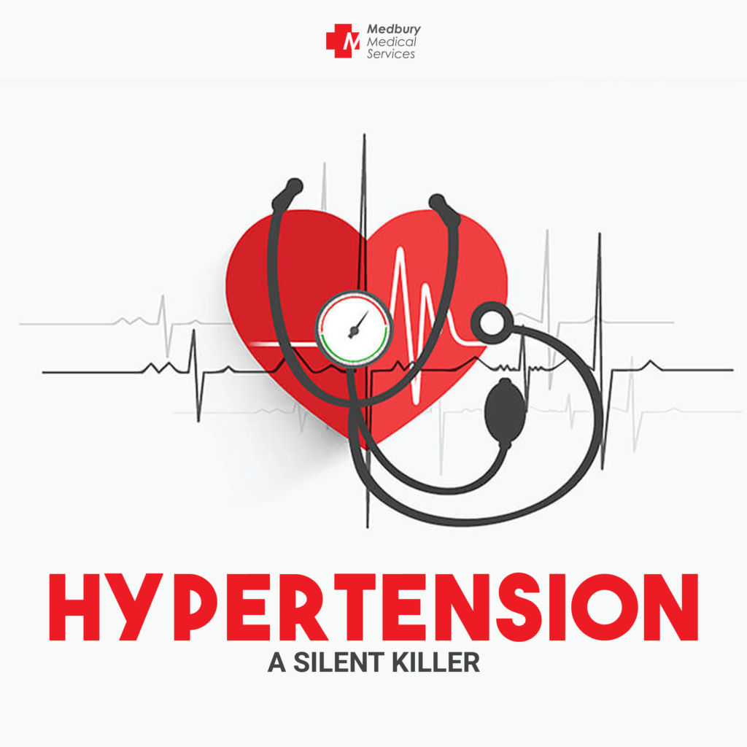
Vascular Diseases:
Vascular disease develops through two principal mechanisms:
- Narrowing or complete obstruction of vessel lumina. This can occur progressively, as seen in atherosclerosis, or acutely, such as through thrombosis or embolism.
- Weakening of vessel walls, which can lead to dilation and/or rupture.
1. Hypertension (High Blood Pressure) is a common vascular disease where blood flows through arteries at persistently higher-than-normal pressures, typically measured as systolic pressure (when the ventricles pump blood) and diastolic pressure (when the heart is filling with blood). For most adults, a healthy blood pressure is less than 120/80 mm Hg (systolic/diastolic). Hypertension is classified into stages, including:
- Normal: <120/80 mm Hg
- Prehypertension: 120-139/80-89 mm Hg
- Hypertension: ≥140/90 mm Hg
- Malignant Hypertension: Severe cases with systolic pressures >200 mm Hg or diastolic pressures >120 mm Hg, often leading to rapid organ damage if untreated.
Hypertension is a significant risk factor that accelerates atherogenesis and causes degenerative changes in the walls of large and medium-sized arteries, potentially leading to conditions like aortic dissection and cerebrovascular hemorrhage.
2. Vascular Organization and Its Role in Hypertension
To understand vascular disease, it's helpful to first understand the structure and function of blood vessels:
General Structure of Blood Vessels
All blood vessels are essentially tubes made primarily of smooth muscle cells (SMCs) and extracellular matrix (ECM). They have an inner lining composed of endothelial cells (ECs). These vessel walls are organized into three concentric layers:
- Tunica intima: This is the innermost layer, lined by those endothelial cells.
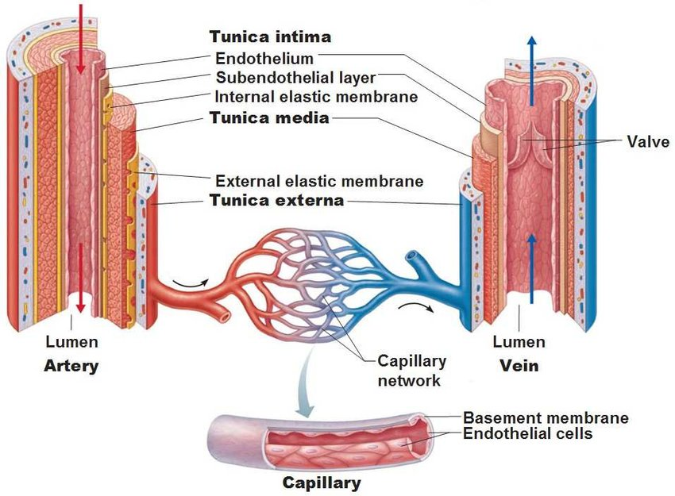
- Tunica media: This is the middle layer, primarily containing smooth muscle cells.
- Tunica adventitia: This is the outermost layer.
Types of Arteries
Arteries are generally thicker-walled than veins because they carry blood under higher pressure from the heart. They are designed to manage and regulate this pressure. Arteries are categorized into three main types based on their size and structure:
- Large Elastic Arteries (e.g., aorta, iliac arteries, pulmonary arteries):
  - These are the biggest arteries, like the aorta, which leaves your heart.
  - Their walls have many elastic fibers mixed with smooth muscle cells in their middle layer.
  - This elasticity allows them to stretch (expand) when heart pumps blood (during systole), storing some of that energy. Then, they snap back (recoil) between heartbeats (during diastole) to keep the blood flowing smoothly to the body.
  - However, with age or conditions like diabetes and hypertension (high blood pressure), these vessels can lose their elasticity and become "stiff pipes." This means they transmit high pressure directly to smaller, more delicate organs, or they can become dilated and prone to rupture.
- Medium-sized Muscular Arteries (e.g., coronary and renal arteries):
  - These arteries, like those supplying your heart (coronary arteries) or kidneys (renal arteries), have a middle layer mostly made of smooth muscle cells.
  - These smooth muscle cells are arranged to constrict (vasoconstriction) or relax (vasodilation).
  - This tight control over their diameter allows them to regulate blood flow to specific regions of the body. This process is influenced by the autonomic nervous system, local metabolic needs (like acidity in tissues), and even signals from the endothelial cells themselves (for example, by releasing nitric oxide for relaxation or endothelin for constriction).
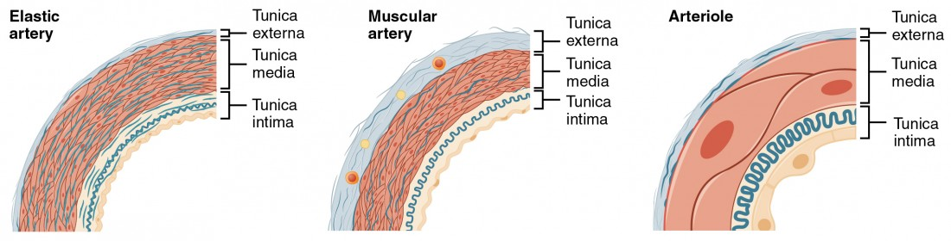
- Small Arteries and Arterioles (very tiny arteries, 2 mm or less down to 20-100 µm in diameter):
  - These are the smallest arteries, found within the connective tissue of organs.
  - Their middle layer is also mainly made of smooth muscle cells.
  - Arterioles are crucial for regulating blood flow resistance. Even small changes in their opening (lumen size) can have a massive effect on blood pressure because the resistance to blood flow is very sensitive to diameter – if you halve the diameter, resistance increases 16-fold.
  - As blood passes through arterioles, the pressure drops significantly, and the blood flow becomes steady rather than pulsatile.
Capillaries
- These are your body's tiniest blood vessels, with lumens barely wider than a red blood cell.
- They are uniquely structured with very thin walls, essentially just a single layer of endothelial cells on a basement membrane. Some are also partially surrounded by SMC-like cells called pericytes.
- Collectively, capillary beds have a huge total cross-sectional area but very slow blood flow.
- This combination of thin walls and slow flow makes capillaries perfectly suited for their main job: the rapid exchange of substances like oxygen and nutrients between the blood and the surrounding tissues. Tissues that are very active metabolically, like your heart, have a much higher density of capillaries.
Veins
- Veins are the vessels that carry blood back to the heart from the capillary beds.
- Compared to arteries, veins have larger diameters, bigger openings (lumina), and much thinner walls with less distinct layers. These features are adaptations to the low pressures found in the venous side of the circulation.
- High capacitance, containing approximately two-thirds of the body’s blood volume.
- Because of their thin, distensible walls, veins are more prone to dilation, external compression, and penetration by things like tumors or inflammation.
- In areas where blood flows against gravity, such as in your lower legs, veins have valves to prevent blood from flowing backward.
- The venous system has a huge capacity, typically holding about two-thirds of your total blood volume.
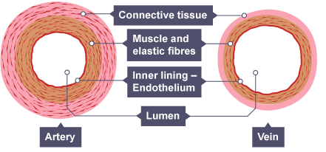
In inflammation, postcapillary venules are the primary sites for vascular leakage (edema) and leukocyte emigration, contributing to the pathophysiology of hypertension-related complications.
3. Blood Pressure Regulation
Maintaining blood pressure within a specific range is crucial for good health. If blood pressure is too low (hypotension), organs might not get enough blood, leading to dysfunction or even tissue damage. Conversely, if it's too high (hypertension), it can damage blood vessels and organs and is a major risk factor for conditions like atherosclerosis.
Our body regulates blood pressure by balancing two main factors: cardiac output and peripheral vascular resistance. Both are influenced by many genetic and environmental factors.
Here's how these factors are regulated:
- Cardiac Output: This refers to the amount of blood heart pumps out. It's determined by two things:
  - Stroke volume: The amount of blood pumped with each heartbeat. The most important factor affecting stroke volume is the filling pressure, which is regulated by how body handles sodium and its effect on your blood volume.
  - Heart rate: How many times heart beats per minute. Both heart rate and myocardial contractility (how strongly heart muscles contract) are regulated by the alpha- and beta-adrenergic systems.
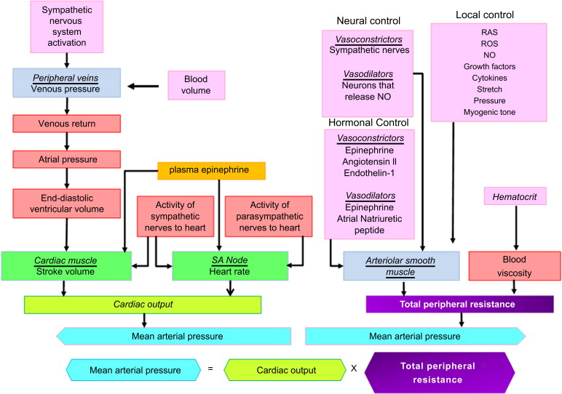
- Peripheral Vascular Resistance: This is the resistance to blood flow in blood vessels, predominantly regulated at the level of the arterioles (small arteries).
  - The smooth muscle cells in the walls of arterioles control their opening size. Small changes in arteriolar diameter can have a profound effect on blood pressure because resistance to fluid flow is highly sensitive to the vessel's diameter; for instance, halving the diameter increases resistance 16-fold.
  - Vascular tone (how constricted or relaxed vessels are) is a balance between substances that cause vasoconstriction (narrowing of vessels), such as angiotensin II, catecholamines, and endothelin, and those that cause vasodilation (widening of vessels), like kinins, prostaglandins, and nitric oxide (NO).
  - Vessels also have a mechanism called autoregulation, where increased blood flow can cause vasoconstriction to protect tissues from receiving too much blood. Additionally, local metabolic needs, such as tissue pH and hypoxia (low oxygen), help fine-tune blood pressure.
- Local Factors
  - Autoregulation: Resistance vessels constrict in response to increased blood flow to prevent hyper-perfusion.
  - Tissue pH and Hypoxia: These fine-tune blood pressure to meet local metabolic demands.
- Neural Factors
  - Adrenergic Systems: α-adrenergic (vasoconstrictors) and β-adrenergic (affecting heart rate and myocardial contractility) systems regulate vascular tone and cardiac output.
The Role of the Kidneys in Blood Pressure Regulation Kidneys play a significant role in influencing peripheral resistance and how much sodium body retains or excretes, primarily through the renin-angiotensin system.
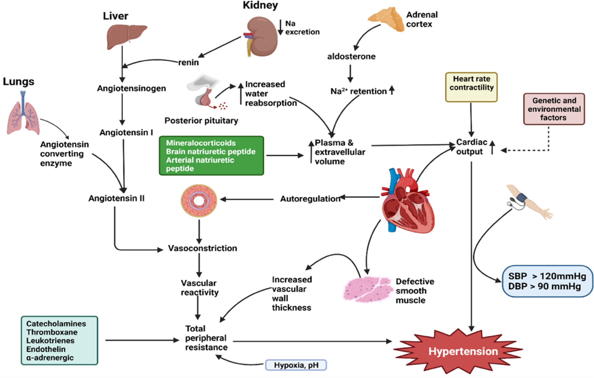
- Cells in kidneys and heart sense changes in blood pressure or blood volume.
- In response, kidneys can release renin, an enzyme produced by juxtaglomerular cells. Renin is released when blood pressure is low in the afferent arterioles, when circulating catecholamines (stress hormones) are high, or when sodium levels in the kidney tubules are low.
- Renin then triggers a cascade: it converts plasma angiotensinogen into angiotensin I, which is then converted to angiotensin II by angiotensin-converting enzyme (ACE).
- Angiotensin II helps raise blood pressure by:
  - Making vascular smooth muscle cells contract (vasoconstriction).
  - Stimulating the adrenal gland to secrete aldosterone.
  - Increasing sodium reabsorption in the kidney tubules.
- Aldosterone increases blood pressure by boosting sodium reabsorption (and thus water) in the kidney tubules, which increases blood volume.
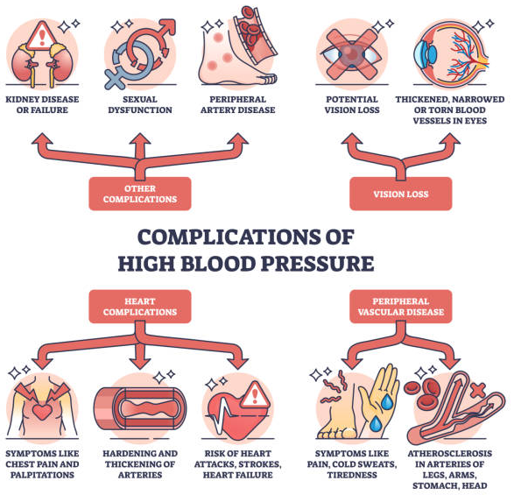
- The kidneys also produce substances that relax blood vessels, like prostaglandins and NO, which can counteract the effects of blood pressure-raising substances.
- Finally atrial natriuretic peptide (ANP), released from your heart in response to increased blood volume, work to lower blood pressure by inhibiting sodium reabsorption in the kidneys, leading to sodium excretion and diuresis (increased urination), and by causing systemic vasodilation.
4. Consequences and Epidemiology of Hypertension:
- Hypertension causes vessel and end-organ damage and is a major risk factor for atherosclerosis.
- It affects over 25% of the general population, with its pathological effects increasing with age and influenced by genetic/ethnic background (e.g., higher prevalence in African Americans).
- Untreated hypertension can lead to severe outcomes: about 50% of patients die from ischemic heart disease (IHD) or congestive heart failure, and another one-third (33%) succumb to stroke.
- A small percentage (approximately 5%) experience malignant hypertension, characterized by rapidly rising blood pressure (systolic over 200 mm Hg or diastolic over 120 mm Hg). If untreated, this can be fatal within 1 to 2 years and is often associated with renal failure and retinal hemorrhages. It can develop de novo but more commonly occurs superimposed on existing benign hypertension.
5. Pathogenesis of Hypertension
Hypertension is classified into two main types: primary (essential) and secondary.
5.1 Primary (Essential) Hypertension
- Accounts for 90-95% of cases, with unknown specific triggers.
- Key Mechanisms:
- Problems with Kidney Sodium Handling: One of the key features of essential hypertension is a reduced ability of the kidneys to excrete sodium at normal blood pressure levels. When the kidneys don't get rid of enough sodium, it leads to an increase in the body's fluid volume and, consequently, a higher amount of blood the heart pumps out (increased cardiac output). This elevates blood pressure. The body eventually reaches a new balance where sodium is excreted, but only at the cost of having persistently high blood pressure.
- Increased Resistance in Blood Vessels: Another contributing factor is increased resistance to blood flow within your blood vessels. This can happen due to:
  - Vasoconstriction: Your blood vessels, particularly the small arteries (arterioles), become narrower. This narrowing greatly increases resistance because, halving the diameter of a vessel increases resistance 16-fold.
  - Structural Changes: Over time, if vessels are constantly constricted, their walls can become permanently thicker, which also contributes to increased resistance.
- Genetic Factors: Familial clustering and twin studies indicate a genetic basis. Specific polymorphisms in the renin-angiotensin system (e.g., angiotensinogen and angiotensin II receptor variants) contribute, particularly to racial differences in blood pressure regulation. Most susceptibility genes remain unidentified but likely influence sodium resorption, endogenous pressors, and smooth muscle cell (SMC) growth.
- Environmental Factors: Lifestyle and environmental elements can significantly modify how these genetic factors express themselves. Key environmental contributors include:
  - Stress
  - Obesity
  - Smoking
  - Lack of physical activity
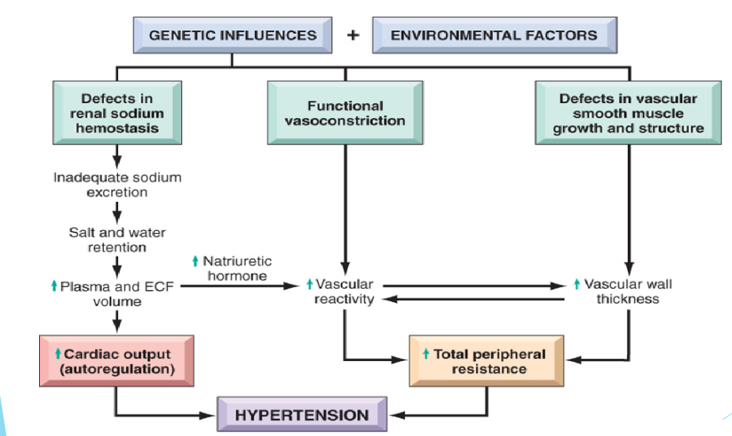
  - High consumption of salt: The connection between the amount of salt in your diet and the occurrence of hypertension is particularly strong.
5.2 Secondary Hypertension
- This is less common and results from an identifiable underlying condition. Most cases of secondary hypertension are due to primary renal disease, narrowing of the renal artery (renovascular hypertension), or adrenal gland disorders. Rare single-gene disorders affecting kidney sodium reabsorption can also cause hypertension.
- Single-Gene Disorders:
  - Aldosterone Metabolism Defects: Mutations in enzymes like aldosterone synthase, 11β-hydroxylase, or 17α-hydroxylase increase aldosterone secretion, enhancing sodium and water resorption, leading to plasma volume expansion.
  - Liddle Syndrome: Mutations prevent degradation of the ENaC sodium channel, increasing distal tubular sodium resorption.
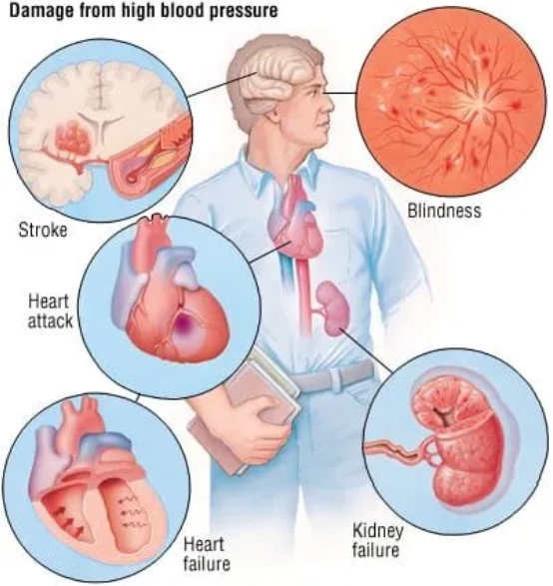
7. Clinical Implications and Management
- Complications: Hypertension significantly increases the risk of ischemic heart disease, heart failure, stroke, and renal failure. Malignant hypertension is a medical emergency requiring immediate intervention.
- Management Strategies:
  - Lifestyle Modifications: Sodium restriction, weight loss, exercise, and stress management.
  - Pharmacological Interventions: Target blood volume (diuretics), vascular resistance (ACE inhibitors, calcium channel blockers), or neural factors (beta-blockers).
  - Monitoring: Regular blood pressure checks and management of coexisting risk factors (e.g., diabetes) are critical.
Vascular Changes (Morphology) Caused by Hypertension
Hypertension not only speeds up atherosclerosis but also causes degenerative changes in the walls of large and medium-sized arteries, which can lead to serious conditions like aortic dissection (a tear in the aorta) and cerebrovascular hemorrhage (bleeding in the brain).
Beyond these larger vessels, hypertension causes specific forms of disease in your small blood vessels:
- Hyaline Arteriolosclerosis
  - This type of change is typically seen with less severe, or "benign," hypertension.
  - When looked at under a microscope, the walls of the tiny arteries (arterioles) appear homogeneously pink and glassy, or "hyaline," and are noticeably thickened. This thickening makes the central opening of the vessel (the lumen) narrower.
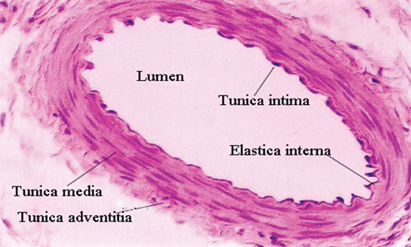
  - These changes happen because components from the blood plasma leak out of injured cells lining the vessels (endothelial cells) and into the vessel walls. Also, the smooth muscle cells in the vessel walls produce more structural material (extracellular matrix) in response to the constant high pressure.
  - In the kidneys, this narrowing caused by hyaline arteriosclerosis can lead to widespread damage to the blood vessels and scarring of the kidney tissue (nephrosclerosis). While similar changes can be seen in older people without hypertension, these changes are more widespread and severe in those with hypertension. They are also common in people with diabetes.
- Hyperplastic Arteriolosclerosis
  - This condition is more characteristic of severe hypertension.
  - The blood vessels take on an "onion skin" appearance. This means there are concentric, layered thickenings of the arteriolar walls. These layers are made up of smooth muscle cells and a thickened, duplicated basement membrane (a supporting layer of the vessel wall).
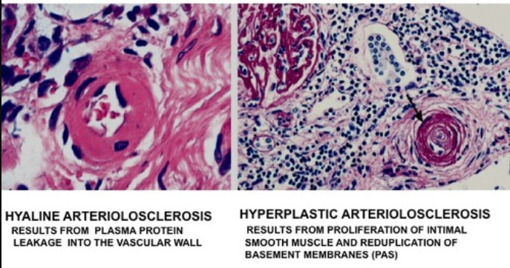
  - Similar to hyaline arteriolosclerosis, this also causes the central opening of the vessel to become significantly narrower.
  - In cases of malignant hypertension (a very rapid and severe form of high blood pressure), these "onion skin" changes are often accompanied by fibrinoid deposits (protein deposits) and the death of vessel wall tissue (necrosis), particularly noticeable in the kidneys.

