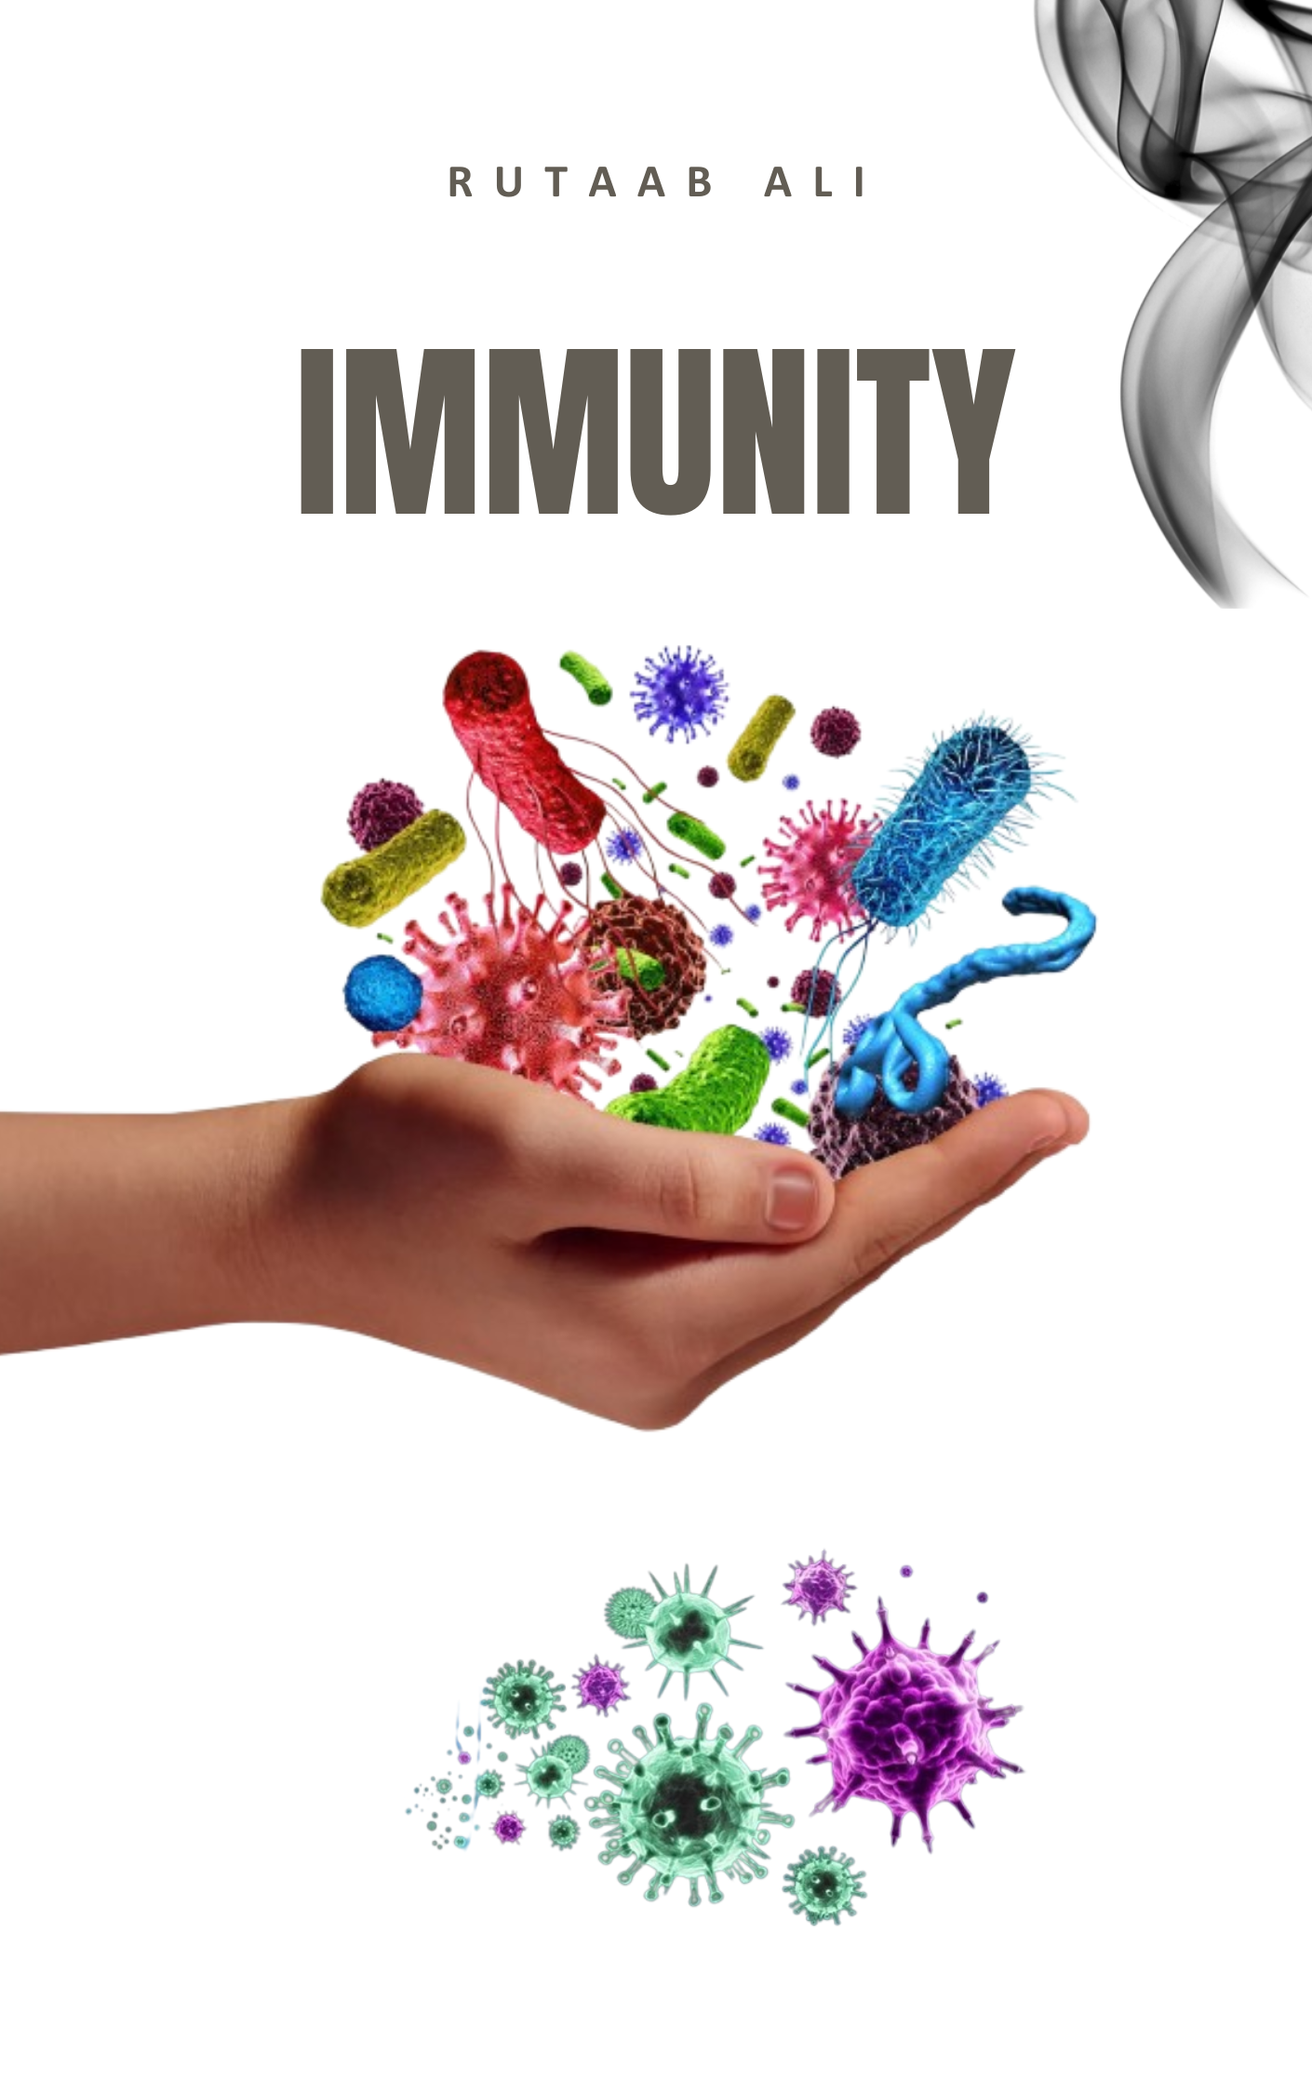

Immunity
Immunity refers to the body's protection against infections. The immune system comprises a collection of cells and molecules responsible for defending the body against numerous pathogens. When the immune system is defective, individuals become susceptible to infections, leading to immunodeficiency diseases. Conversely, the immune system itself can cause tissue injury and disease, known as hypersensitivity disorders.
The immune system operates through different lines of defense:
- First Line of Defense (Innate Immunity): This involves physical and chemical barriers that prevent pathogens from entering the body. Examples include "skin, mucus layers, and saliva" and "mucous membranes, and secretions of skin and mucous membranes", "phagocytes" or "Phagocytic white blood cells", as well as "antimicrobial proteins" and "the inflammatory response". These mechanisms work to eliminate dangerous microorganisms once they enter the body.
- Second Line of Defense (Adaptive/Acquired Immunity): This is a specific immune response involving "lymphocytes and antibodies", which are highly specialized to target specific antigens.
There are two primary types of immunity: Innate (Nonspecific) Immunity and Acquired (Adaptive/Specific) Immunity.
Innate Immunity
Innate immunity is the immunity an organism is born with, and it is genetically determined. This type of immunity does not get enhanced by repetition. Examples of innate immunity include physical barriers like skin and mucous membranes, chemical barriers such as saliva and gastric juices, cellular defenses like phagocytes (e.g., neutrophils, macrophages), and blood/lymph systems.
Acquired Immunity
Acquired immunity, also known as adaptive or specific immunity, is developed by an organism during its lifetime. Unlike innate immunity, acquired immunity is not genetically determined and can be enhanced by repeated exposure to a pathogen. By convention, the terms "immune system" and "immune response" generally refer to adaptive immunity. This system consists of lymphocytes and their products, including antibodies, and can recognize a vast array of foreign substances. Acquired immunity is further categorized into active immunity and passive immunity.
Active Immunity
Active immunity is developed when antibodies are produced in one's own body in response to direct contact with an antigen. This type of immunity is usually long-lasting, sometimes life-long, and produces an immunological memory. But it takes weeks to develop.
Active immunity can be acquired in two ways:
- Naturally Acquired Active Immunity: This occurs when antigens or pathogens enter the body naturally, leading the body to generate an immune response. For example, if you had chickenpox (varicella) as a child, your immune system fought it off, creating antibodies, which provides you with lifelong immunity.
- Artificially Acquired Active Immunity: This type of immunity is attained when antigens are introduced into the body through vaccines, a process known as immunization. The body then actively fights this artificial introduction, which triggers the immune system to create its own antibodies. Examples include the COVID vaccine or the oral polio vaccine, which can provide lifelong immunity.
Passive Immunity
Passive immunity is developed by the introduction of antibodies that are produced outside and then introduced into the body. Passive protection is immediate because readymade antibodies are administered, but it is short-lived, lasting only a few weeks or months. It does not produce an immunological memory in the host.
Passive immunity can also be acquired in two ways:
- Naturally Acquired Passive Immunity: This occurs when antibodies are naturally passed from a mother to her fetus via the placenta or to an infant through breast milk (colostrum). This provides temporary protection to the child until their own immune system develops.
- Artificially Acquired Passive Immunity: This is acquired when preformed antibodies (antiserum) are introduced into the body, usually through vaccines or injections. Examples include receiving IV immune globulin for certain autoimmune conditions or for COVID patients, or antivenom injections from animals like horses or rabbits for snake bites.
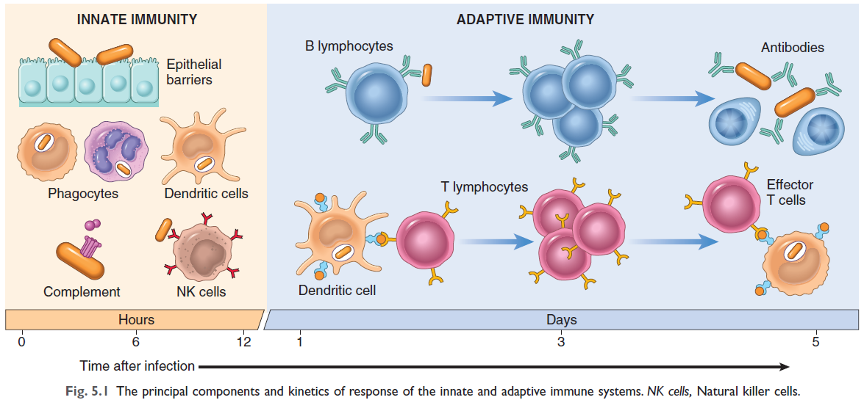
Key Differences Between Active and Passive Immunity
Feature | Active Immunity | Passive Immunity
Antibody Production | Produced by the host's own body in response to direct contact with an antigen. | Produced outside and introduced into the body.
Duration | Usually long-lasting, sometimes life-long. | Lasts only for a few weeks or months; typically short-lived.
Immunological Memory | Produces an immunological memory. | Does not produce immunological memory.
Onset of Immunity | Does not occur immediately; takes several weeks to develop. | Develops immediately; immediate protection.
Side Effects/Reactions | Generally no side-effects. | May cause reactions.
Examples | Infection (chickenpox, measles), Vaccination (COVID vaccine, polio vaccine). | Maternal antibodies (placenta, breast milk), Immune serum injection (antivenom, IV immune globulin).
Mechanism | Body actively fights the pathogen or its component. | Immune system passively receives the gift of antibodies.

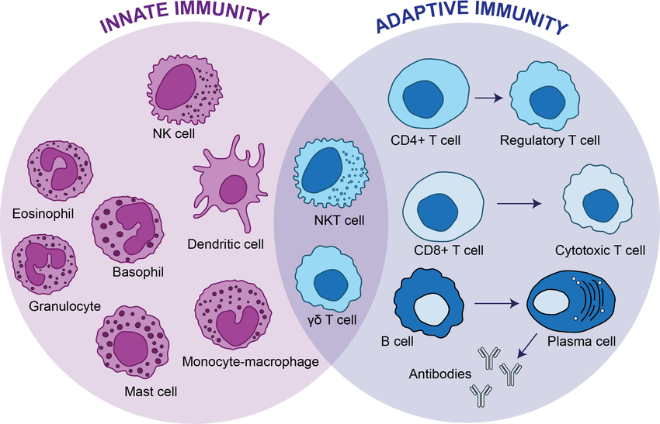
Cells and Tissues of the Immune System
The immune system is comprised of a collection of cells and molecules responsible for defending the body against countless pathogens. These cells include lymphocytes, specialized antigen-presenting cells (APCs), and various effector cells that work to eliminate microbes and other antigens.
- Lymphocytes: Lymphocytes are present in circulation and lymphoid organs and are the mediators of adaptive immunity, producing specific and diverse antigen receptors. They develop from precursors in generative (primary) lymphoid organs:
Key Characteristics of Lymphocytes:
- They develop from precursors in generative (primary) lymphoid organs: T lymphocytes mature in the thymus, and B lymphocytes mature in the bone marrow.
- Each T or B lymphocyte and its progeny (a clone) express a single antigen receptor.
- The total lymphocyte population (approximately 10¹² in humans) can recognize tens or hundreds of millions of antigens due to the enormous diversity of their antigen receptors, which is encoded by variant DNA sequences.
- Clonal Selection: Foreign antigens are concentrated in peripheral lymphoid organs where they bind to and activate specific lymphocyte clones.
- Lymphocytes go through distinct phases:
- Naïve lymphocytes express antigen receptors but have not yet encountered antigens.
- Effector lymphocytes are induced by activation and perform functions to eliminate microbes.
- Memory lymphocytes are induced during activation, survive in a functionally silent state after antigen elimination, and respond rapidly upon subsequent encounters with the antigen. The generation of memory cells is a crucial goal of vaccination.
- Lymphocytes constantly recirculate between tissues and home to specific sites. Naïve lymphocytes patrol peripheral lymphoid organs to find antigens, while effector lymphocytes migrate to infection sites to eliminate microbes.
- Natural Killer (NK) Cells: Lymphocytes that are part of the innate immune system, functional without prior activation, and do not express highly variable antigen receptors.
- They possess inhibitory receptors (recognize self-class I MHC molecules on healthy cells) and activating receptors (recognize molecules on stressed or infected cells).
- Normally, inhibitory signals dominate, preventing NK cells from killing healthy cells.
- Infections (especially viral) and stress lead to reduced class I MHC expression and increased activating receptor engagement, causing NK cells to kill infected or stressed cells.
- They also secrete interferon-γ (IFN-γ), which activates macrophages to destroy ingested microbes, providing early defense against intracellular infections.
- Innate lymphoid cells (ILCs): Populations of lymphocytes that lack TCRs but produce cytokines similar to those made by T cells. They are classified into three groups based on cytokine production (IFN-γ, IL-5, or IL-17). ILCs primarily reside in tissues, providing early defense against infections before T cells are activated.
- Antigen-Presenting Cells (APCs)
APCs are specialized cells that capture antigens and display them to lymphocytes.
- Dendritic Cells (DCs):
- The most important APCs for initiating T-cell responses against protein antigens.
- Located under epithelia (where microbes enter) and in tissue interstitia (e.g., Langerhans cells in the epidermis).
- Express many receptors (e.g., TLRs, C-type lectin receptors) for capturing microbes and antigens.
- Upon encountering microbes, DCs migrate to the T-cell zones of lymphoid organs, where they present antigens to T cells.
- Express high levels of MHC and costimulatory molecules needed to activate T cells.
- Plasmacytoid DCs resemble plasma cells and are major sources of type I interferon in response to viruses.
- Follicular Dendritic Cells (FDCs): Found in lymphoid follicle germinal centers. They trap antigen bound to antibodies or complement proteins and display antigens to B lymphocytes to promote antibody responses, but are not involved in presenting antigens to T cells.
- Macrophages: Ingest microbes and other particulate antigens and display peptides for recognition by T lymphocytes. Activated by T cells, they then kill the microbes.
- B cells act as APCs as well, by ingesting protein antigens, degrading them, and presenting the resulting peptides complexed with Class II MHC molecules to helper T cells.
- Other Effector Cells:
- Mast Cells:
  - Widely distributed in tissues, especially near blood vessels and nerves.
  - Express a high-affinity receptor for IgE (FcεRI).
  - When an allergen binds to IgE on their surface, mast cells become activated and rapidly release various mediators, including histamine, lipid mediators (prostaglandins and leukotrienes), and cytokines.
  - These mediators cause the symptoms of immediate hypersensitivity reactions (allergies), such as vasodilation, increased vascular permeability, and smooth muscle contraction.
  - They also play a protective role against parasitic infections and some toxins.
- Basophils:
  - Circulating cells that resemble mast cells and also express FcεRI.
  - Their specific role in most immediate hypersensitivity reactions occurring in tissues is not fully established.
- Eosinophils:
  - Often recruited to allergic reaction sites by chemokines like eotaxin.
  - Express FcεRI.
  - Activated by IL-5 from TH2 cells.
  - They are important effectors of tissue injury in the late-phase of immediate hypersensitivity reactions, producing toxic proteins (major basic protein, eosinophil cationic protein) and lipid mediators (LTC4, platelet-activating factor) that promote inflammation.
  - Eosinophils kill IgE-coated helminthic parasites.
- Lymphoid Tissues: The immune system's tissues are organized into generative and peripheral lymphoid organs.
- Generative (primary, or central) lymphoid organs: Sites where T and B lymphocytes mature and become competent to respond to antigens.
- Thymus: Where T cells develop.
- Bone marrow: Site of production for all blood cells and where B lymphocytes mature.
- Peripheral (secondary) lymphoid organs: Sites where adaptive immune responses to microbes are initiated. They concentrate antigens, APCs, and lymphocytes to optimize interactions.
- Lymph nodes:
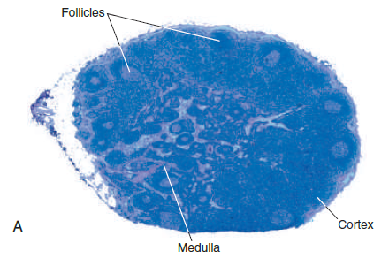
  - Lymph nodes are encapsulated, highly organized collections of lymphoid cells and innate immune cells found along lymphatic channels throughout the body. They have an outer cortex containing follicles and an inner medulla.
  - Antigen Capture: As lymph, derived from the interstitial fluids of tissues, passes through lymph nodes, resident APCs can sample antigens. Additionally, dendritic cells (DCs) transport antigens from nearby epithelial surfaces and tissues, migrating through lymphatic vessels to the lymph nodes. This process concentrates antigens in the draining lymph nodes.
  - Lymphocyte Segregation: Within lymph nodes, B lymphocytes are concentrated in discrete structures called follicles, located in the cortex. If B cells in a follicle have recently responded to an antigen, the follicle develops a central pale-staining region known as a germinal center. T lymphocytes are concentrated in the parafollicular cortex.

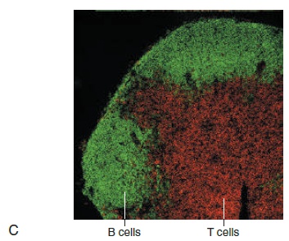
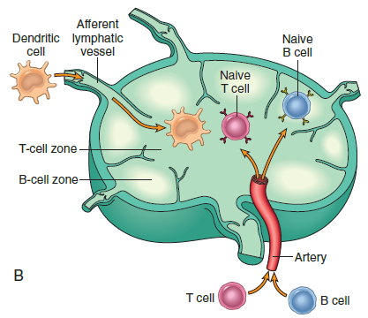
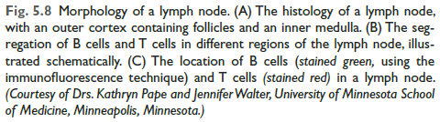
  - Role of APCs: Follicular dendritic cells (FDCs) within the follicles are involved in the activation of B cells and trap antigen bound to antibodies or complement proteins, displaying them to B lymphocytes. The paracortex contains dendritic cells that present antigens to T lymphocytes.
- Spleen: Important for immune responses to blood borne antigens. T lymphocytes are in periarteriolar lymphoid sheaths, and B cells reside in follicles. Blood entering the spleen flows through a network of sinusoids, allowing resident dendritic cells and macrophages to trap blood borne antigens.
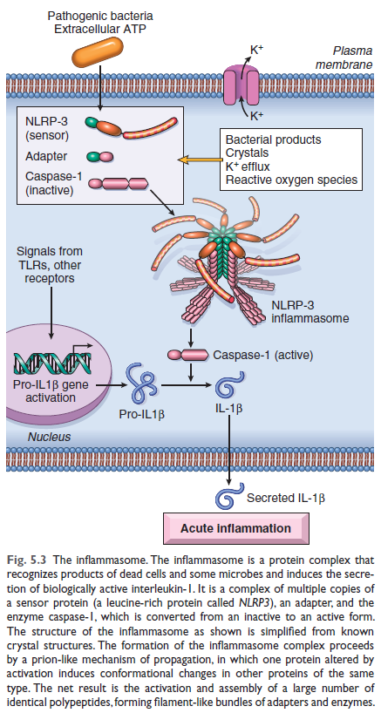
- Cutaneous and mucosal lymphoid systems: Located under skin, gastrointestinal, and respiratory epithelia, responding to antigens entering through breaches. Examples include pharyngeal tonsils and Peyer’s patches. Lymphocyte recirculation is crucial for T cells to find antigens in distributed peripheral lymphoid organs and for effector T cells to home to infection sites.
The Normal Immune Response
Innate Immunity:
Innate immunity, also known as natural or native immunity, is mediated by cells and proteins that are always present and ready to react against infectious pathogens. These mechanisms are activated immediately in response to infection, forming the first line of defense, and are also involved in clearing damaged cells and tissues. A significant reaction of innate immunity is inflammation.
Major Components of Innate Immunity:
- Epithelial barriers that block the entry of microbes.
- Phagocytic cells, primarily neutrophils and macrophages.
- Dendritic cells (DCs).
- Natural Killer (NK) cells
- Several plasma proteins, including those of the complement system.
- Innate Lymphoid Cells (ILCs)

Receptors of Innate Immunity: Phagocytes, dendritic cells, and many epithelial cells express receptors that sense infectious agents and substances released from dead cells.
Pathogen-associated molecular patterns (PAMPs): Microbial structures recognized by these receptors, shared among microbes of the same type and essential for microbial survival.
Damage-associated molecular patterns (DAMPs): Substances released from injured and necrotic cells.
Pattern recognition receptors (PRRs): Cellular receptors that recognize PAMPs and DAMPs. PRRs are located in the plasma membrane (detect extracellular pathogens), endosomal receptors (detect ingested microbes), and cytosolic receptors (detect microbes in the cytoplasm).
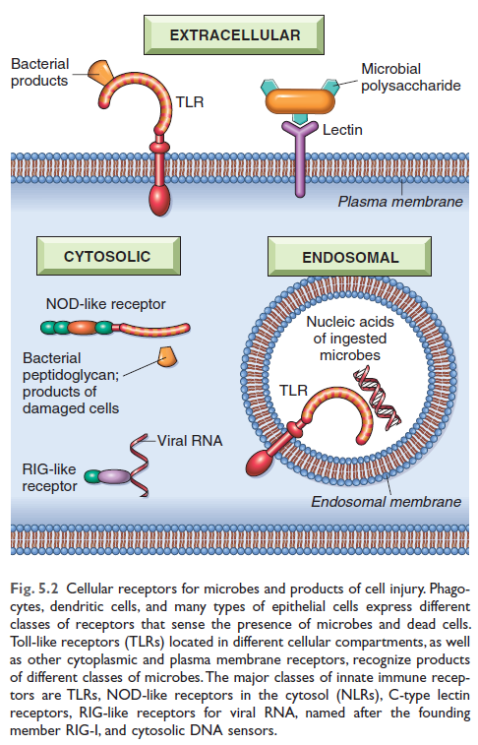
Toll-like receptors (TLRs): The best-known PRRs, with 10 types in mammals recognizing a wide range of microbial molecules. Plasma membrane TLRs recognize bacterial products like lipopolysaccharide (LPS), while endosomal TLRs recognize viral and bacterial RNA and DNA. Recognition by TLRs activates transcription factors, stimulating the production of inflammation mediators, antiviral cytokines (interferons), and proteins that promote lymphocyte activation.
NOD-like receptors (NLRs): Cytosolic receptors that recognize various substances, including products of necrotic cells, ion disturbances, and some microbial products. Several NLRs signal via the inflammasome, a cytosolic multiprotein complex that activates caspase-1, which cleaves pro-interleukin-1 (IL-1) into its active form. IL-1 is a mediator of inflammation, recruiting leukocytes and inducing fever.
C-type lectin receptors (CLRs): On macrophages and DCs, detect fungal glycans and elicit inflammatory reactions.
RIG-like receptors for viral RNA and cytosolic DNA sensors recognize microbial RNA and DNA.
G protein–coupled receptors on leukocytes recognize short bacterial peptides.
Mannose receptors recognize microbial sugars and induce phagocytosis.
Reactions of Innate Immunity:
Inflammation: Cytokines, complement products, and other mediators produced during innate immune reactions trigger vascular and cellular components of inflammation, leading to recruited leukocytes destroying pathogens and eliminating damaged cells.
Anti-viral defense: Type I interferons produced in response to viruses activate enzymes that degrade viral nucleic acids and inhibit viral replication in infected and uninfected cells. The innate immune system also generates signals that stimulate the subsequent, more powerful adaptive immune response.
Adaptive (Acquired) Immunity
There are two types of adaptive immunity:
- Humoral immunity: Mediated by soluble proteins called antibodies, produced by B lymphocytes (B cells). Antibodies protect against extracellular pathogens in blood, mucosal surfaces, and tissues.
- Cell-mediated (or cellular) immunity: Mediated by T lymphocytes (T cells). T cells are crucial in defending against intracellular microbes by either directly killing infected cells (cytotoxic T lymphocytes) or by activating phagocytes to kill ingested microbes via cytokines (helper T cells).
- Humoral Immunity:
- Mediators: This type of immunity is mediated by soluble proteins called antibodies. These antibodies are produced by B lymphocytes, also known as B cells.
- B Lymphocytes make up 10% to 20% of circulating peripheral lymphocytes and are found in bone marrow and follicles of peripheral lymphoid organs.
- Antigen Recognition: B cells recognize antigens via membrane-bound antibody (immunoglobulin M (IgM) or IgD) on their surface, forming the B-cell receptor (BCR) complex. Unlike T cells, B cells can recognize a vast array of chemical structures (proteins, lipids, polysaccharides, nucleic acids, small chemicals) without requiring MHC presentation.
- CD21 (CR2): A receptor on B cells that recognizes a complement breakdown product often deposited on microbes, promoting B-cell responses. The Epstein-Barr virus uses CD21 to infect B cells.
- Differentiation: After stimulation, B cells proliferate and differentiate into plasma cells, which secrete large amounts of antibodies. Some progeny become long-lived memory B cells.
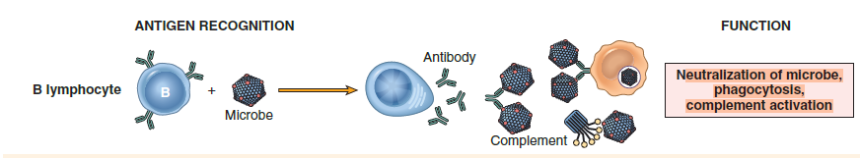
- B-cell Activation Pathways:
- T cell–independent: Polysaccharide and lipid antigens with multiple identical determinants can directly cross-link several antibody molecules on a B cell, activating it. Primarily stimulates IgM antibody secretion.
- T cell–dependent: Globular protein antigens require help from CD4+ T cells. B cells act as APCs, ingesting and presenting protein antigen peptides via class II MHC molecules to helper T cells. Helper T cells then express CD40L and secrete cytokines to activate the B cells. This leads to production of different antibody classes (IgG, IgA, IgE) through heavy-chain class (isotype) switching and affinity maturation (improving antibody quality).
- Antigen Receptors:
- B-cell Receptor (BCR): Membrane-bound antibody (IgM/IgD) on B cells, associated with signaling molecules (Igα and Igβ). Recognizes various chemical structures.
- Antibody Production and Isotypes
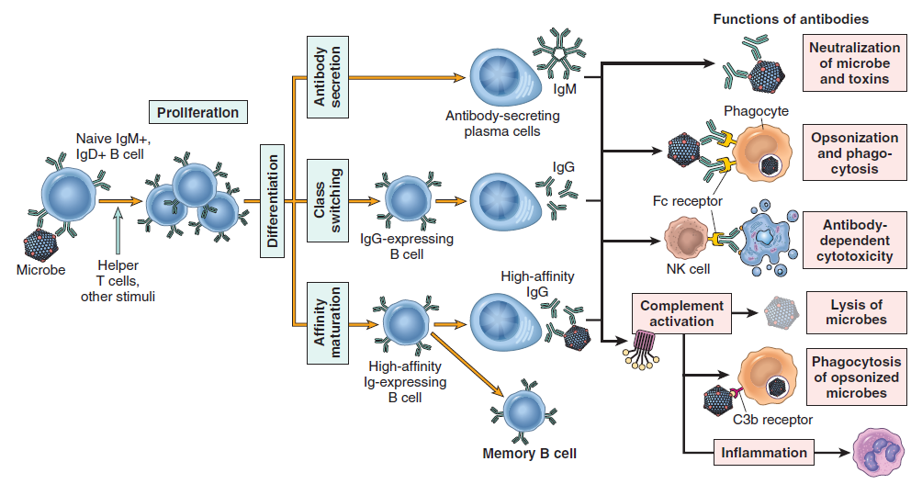
Protein antigens, with the help of CD4+ T cells, induce heavy-chain class (isotype) switching, leading to the production of different classes of antibodies (IgG, IgA, IgE) all with the same antigen specificity. This process, along with affinity maturation (which increases the binding affinity of antibodies for the antigen), typically occurs in germinal centers within lymphoid follicles, stimulated by follicular helper T (Tfh) cells.
There are five main classes, or isotypes, of immunoglobulins:
  - IgG: Constitutes more than 95% of circulating antibodies along with IgM and IgA. IgG antibodies are crucial for opsonization (coating microbes for phagocytosis), activating the complement system, and providing passive immunity to newborns by active transport across the placenta. IgG also has a long half-life in circulation (about 3 weeks) due to special recycling mechanisms.
  - IgM: Also contributes to over 95% of circulating antibodies alongside IgG and IgA. IgM is often produced in T cell-independent responses and is highly effective at activating the complement system by the classical pathway.
  - IgA: The major isotype found in mucosal secretions, where it neutralizes microbes in the lumens of the respiratory and gastrointestinal tracts and other mucosal tissues.
  - IgE: Present in very low concentrations in circulation but binds to the surfaces of tissue mast cells. IgE antibodies are primarily involved in defense against helminthic parasites by coating them and functioning with mast cells and eosinophils to kill them. It is also the key mediator in immediate (Type I) hypersensitivity reactions (allergies).
  - IgD: Expressed on the surfaces of B cells, similar to IgM, but secreted at very low levels, and its precise functional roles are less established.
  - These isotypes differ in their ability to activate complement and recruit inflammatory cells, thus having different roles in host defense and disease.
- Functions of Antibodies:
Function: Antibodies primarily provide protection against extracellular pathogens. They are effective against microbes found in the blood, mucosal surfaces, and tissues, as well as in mucosal lumens.
- Neutralization: Bind to microbes and toxins, preventing them from infecting cells.
- Opsonization and phagocytosis: IgG antibodies coat microbes, targeting them for ingestion by phagocytes (neutrophils and macrophages).
- Complement activation: IgG and IgM activate the classical complement pathway, leading to phagocytosis and destruction of microbes.
- Mucosal immunity: IgA secreted in mucosal tissues neutralizes microbes.
- Passive immunity: IgG is actively transported across the placenta, protecting newborns.
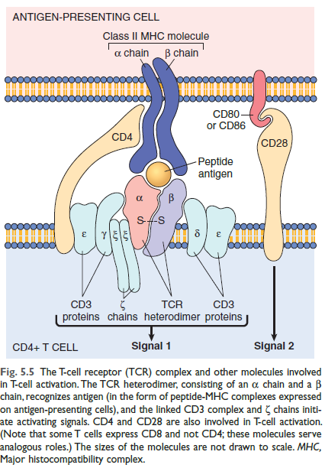
- Parasite defense: IgE coats helminthic parasites, working with mast cells and eosinophils to kill them.
2. Cell-Mediated (or Cellular) Immunity:
- Mediators: This type of immunity is mediated by T lymphocytes, also known as T cells. T cells cannot recognize free or circulating antigens; instead, they primarily recognize peptide fragments of proteins displayed by Major Histocompatibility Complex (MHC) molecules on the surface of other cells.
- T Lymphocytes:
Constitute 60% to 70% of peripheral blood lymphocytes.
Cannot recognize free or circulating antigens; they primarily recognize peptide fragments of proteins displayed by Major Histocompatibility Complex (MHC) molecules on other cells.
The T-cell receptor (TCR), typically a α and β protein chain heterodimer, recognizes MHC-bound peptides. The TCR is noncovalently linked to the CD₃ molecular complex and zeta (ζ) chains, which initiate intracellular signals upon antigen recognition.
Beyond antigen recognition ("signal 1"), T cells require a second signal for full activation, provided by co-stimulators expressed on APCs. The principal co-stimulators for T cells are the B7 proteins (CD80 and CD86) on APCs, which are recognized by the CD28 receptor on naive T cells. This requirement for microbe-triggered "signal 2" ensures that the adaptive immune response is induced by microbes and not by harmless substances.
T-cell Proliferation and Differentiation:
- Upon activation by antigen and co-stimulators in peripheral lymphoid organs, naive T lymphocytes proliferate and differentiate into effector and memory cells.
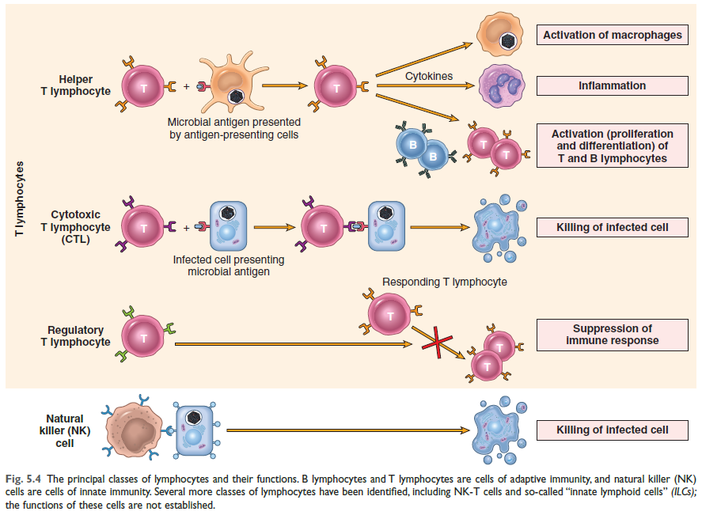
- An early response of CD4+ helper T cells is the secretion of interleukin-2 (IL-2) and expression of high-affinity receptors for IL-2. IL-2 acts as a growth factor, stimulating the proliferation of these T lymphocytes and increasing the number of antigen-specific lymphocytes.
There are different types of T cells involved:
CD₄ and CD₈ are co-receptors expressed on distinct T-cell subsets during activation.
- CD₄₊ T cells (Helper T cells): Account for 50% to 60% of T cells. They secrete cytokines that help B cells produce antibodies and help macrophages destroy phagocytosed microbes. Act as coreceptors during T-cell activation, binding to class II MHC molecules on APCs. Their central role is highlighted by the severe compromise caused by HIV infection, which destroys these cells. Activated CD4+ T cells differentiate into different subsets:
- T_{H1} cells: Secrete IFN-γ, a potent macrophage activator, leading to "classical" macrophage activation and destruction of ingested microbes. They combat intracellular pathogens and are involved in autoimmunity and chronic inflammation.
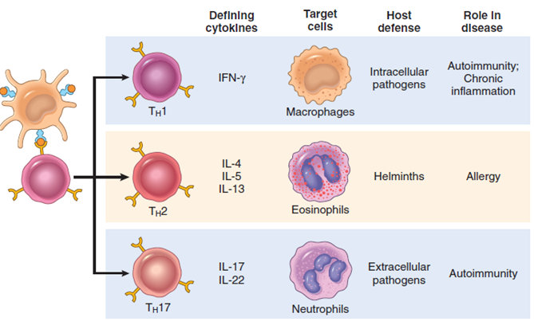
- T_{H2} cells: Produce IL-4 (stimulates B cells to IgE-secreting plasma cells), IL-5 (activates eosinophils), and IL-13 (activates mucosal epithelial cells to secrete mucus, alternative macrophage activation for tissue repair). They combat helminthic parasites and are associated with allergies.
- T_{H17} cells: Secrete IL-17 (and IL-22), recruiting neutrophils and monocytes to destroy extracellular bacteria and fungi. They are involved in autoimmunity and chronic inflammation.
  - Follicular helper T (Tfh) cells: A specialized subset that resides in germinal centers and stimulates B cell processes like isotype switching and affinity maturation.
- CD8+ T cells (Cytotoxic T Lymphocytes - CTLs):
Constitute about 40% of T cells. Act as coreceptors during T-cell activation, binding to class I MHC molecules. Directly kill virus-infected cells and tumor cells sheltering cytoplasmic microbes. Its killing mechanism relies on the perforin–granzyme system, where perforin helps granzymes (proteases) enter target cells to activate caspases and induce apoptosis. It can also produce cytokines like IFN-γ.
- Regulatory T lymphocytes: Function to suppress immune responses and are involved in tolerance to self-antigens.
- γδ T cells and NKT cells: A minority of T cells that recognize nonprotein molecules (γδ T cells) or microbial glycolipids (NKT cells), independent of MHC molecules. Their functional roles are less understood.
Other Important Molecules on T cells:
- CD28: A receptor for costimulators (B7 proteins like CD80 and CD86) induced on APCs by microbes, providing a "second signal" for T cell activation alongside antigen recognition ("signal 1").
- Coinhibitory receptors (CTLA-4 and PD-1): Belong to the CD28 family and block TCR and CD28 signals, terminating T cell responses. Blocking these can enhance anti-tumor responses.
- Adhesion molecules: Strengthen the bond between T cells and APCs and control T cell migration.
- Function: T lymphocytes are important in defense against intracellular microbes. This includes combating cell-associated microbes, such as those that have been phagocytosed or those residing in the cytoplasm of infected cells. They eliminate microbes by either directly killing infected cells or by activating phagocytes to kill ingested microbes.
Histocompatibility Complex (MHC) Molecules:
These molecules are fundamental to T-cell recognition of antigens, and genetic variations in them are associated with many immunological diseases. The human MHC is called the human leukocyte antigen (HLA) complex, located on chromosome 6.
- Class I MHC molecules: Expressed on all nucleated cells (encoded by HLA-A, HLA-B, HLA-C).
  - Structure: Each Class I MHC molecule consists of a polymorphic alpha (α) chain noncovalently associated with an invariant beta-2 microglobulin (β2m) polypeptide. The extracellular portion of the α chain contains a cleft where polymorphic residues are located and where foreign peptides bind for presentation to T cells.
  - Peptide Binding: They display peptides derived from protein antigens present in the cytosol of the cell (e.g., viral and tumor antigens) to CD8+ T cells.
  - T-cell Co-receptor Binding: The conserved region of Class I MHC molecules binds to CD8 molecules on T cells, ensuring that only CD8+ T cells (cytotoxic T lymphocytes, or CTLs) can respond to peptides displayed by Class I molecules. This enables CD8+ T cells to kill infected cells harboring microbes in their cytoplasm.
- Class II MHC molecules: Expression is restricted to a few cell types, mainly APCs (dendritic cells, macrophages, and B cells). They display peptides derived from extracellular proteins (e.g., ingested microbes) to CD4+ T cells.
  - Structure: These are heterodimers composed of noncovalently linked alpha (α) and beta (β) subunits. The extracellular part contains a cleft for peptide binding.
  - Peptide Binding: They bind to peptides derived from extracellular proteins synthesized outside the cell. This includes microbes that are ingested and then broken down inside the cell. This property allows CD4+ T cells to recognize the presence of extracellular pathogens.
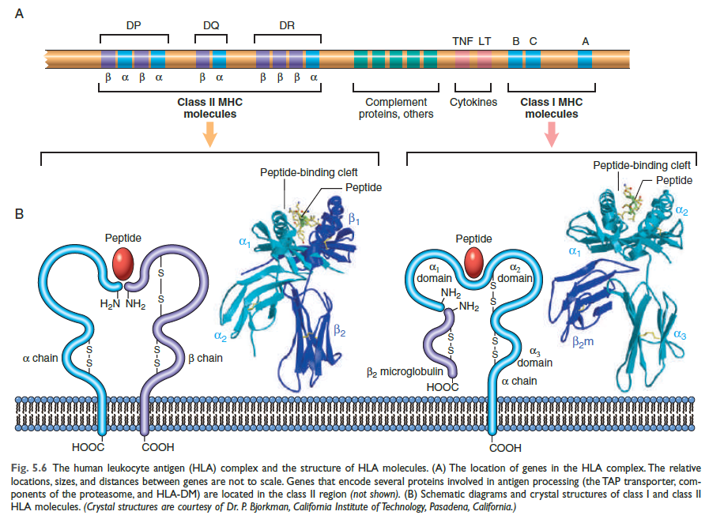
  - T-cell Co-receptor Binding: A region on Class II MHC molecules binds to CD4 molecules on T cells. CD4+ T cells are also known as helper T cells and are crucial for helping B cells produce antibodies and activating macrophages to destroy ingested microbes.
- HLA genes are highly polymorphic, with many alternative forms (alleles), leading to a vast number of HLA molecule combinations in the population. This polymorphism evolved to enable the display and response to diverse microbial peptides. The inheritance of specific HLA alleles influences susceptibility to protective responses, allergic reactions, and many autoimmune diseases. MHC molecules' ability to trigger immune responses is why they are sometimes called antigens.
- MHC Restriction: In any given person, T cells will only recognize peptides displayed by that individual's own MHC molecules, a phenomenon known as MHC restriction.
Self-tolerance
- Self-tolerance is the phenomenon where the immune system normally does not react against an individual's own antigens.
- During the development of T and B lymphocytes, billions of different antigen receptors are randomly generated, and it is expected that some of these receptors will be able to recognize self-antigens. Therefore, mechanisms exist to eliminate or control these self-recognizing lymphocytes to maintain self-tolerance. A failure of self-tolerance can lead to reactions against one's own cells and tissues, a process known as autoimmunity.
- Autoimmunity occurs when these mechanisms of self-tolerance fail, leading to the immune system attacking its own cells and tissues. Autoimmune diseases can be categorized as:
  - Organ-specific: In these diseases, the immune responses are directed against a particular organ or cell type, resulting in localized tissue damage. Examples include autoimmune hemolytic anemia and Graves’ disease.
  - Systemic: These are characterized by lesions affecting multiple organs. Often, lesions principally impact connective tissues and blood vessels. Examples include Systemic Lupus Erythematosus and Rheumatoid Arthritis.
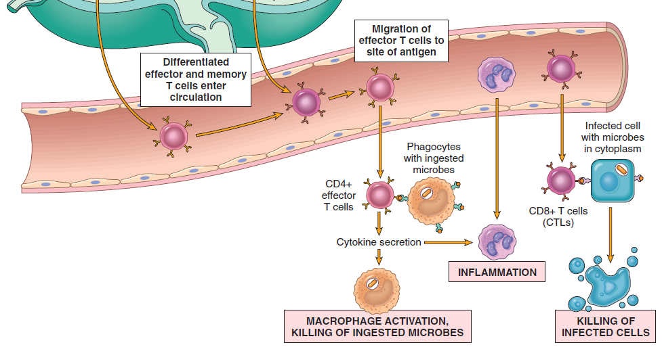
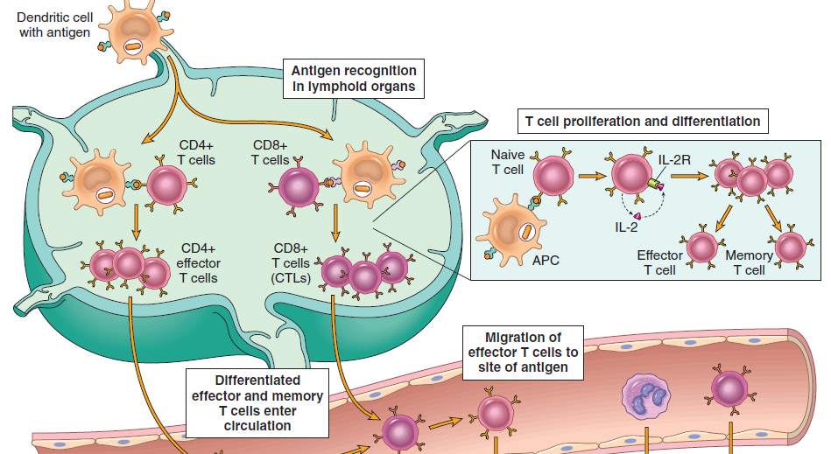
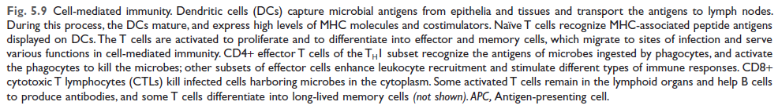
  - Amyloidosis: A disease involving the deposition of abnormal proteins (often from antibody fragments or chronic inflammatory disorders) in tissues.
Hypersensitivity Reactions
Hypersensitivity reactions refer to immunologically mediated tissue injury. These diseases arise when normal immune responses are either inadequately controlled, directed against harmless antigens, or inappropriately targeted to host tissues, leading to a beneficial response becoming the cause of disease.
Causes of Hypersensitivity Reactions
The causes of hypersensitivity reactions can be broadly categorized into three main areas:
- Autoimmunity:
  - Reactions against Self Antigens
    - Normally, the immune system exhibits self-tolerance, meaning it does not react against the body's own antigens. However, when self-tolerance fails, it can lead to autoimmunity, where immune reactions are directed against an individual's own cells and tissues, causing autoimmune diseases.
    - Examples: Many organ-specific and systemic autoimmune diseases, such as rheumatoid arthritis and multiple sclerosis, involve T cell-mediated inflammation. Type 1 diabetes mellitus is an example where cytotoxic T lymphocytes (CTLs) directly destroy pancreatic islet cells.
- Reactions against Microbes
Immune responses against microbial antigens can also cause disease if they are excessive or if the microbial antigen persists unusually long.
  - Immune Complex Formation: If antibodies are produced against persistent microbial antigens, they may bind to these antigens to form immune complexes. These complexes can then deposit in tissues and trigger inflammation, as seen in post-streptococcal glomerulonephritis.
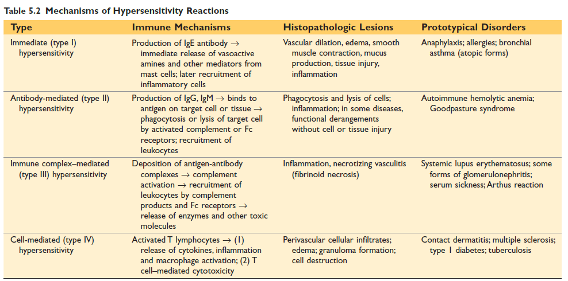
  - Cross-Reactivity: Rarely, antibodies or T cells that react with a microbe may cross-react with a host tissue. This cross-reactivity is believed to be the basis for diseases like rheumatic heart disease.
  - Normal Immune Response Causing Damage: A notable example is viral hepatitis, where the virus infecting liver cells is not directly cytopathic, but the cytotoxic T cells attempting to eliminate the virus-infected cells cause cell damage to the liver.
- Reactions Against Environmental Antigens A significant portion of the population (almost 20%) is allergic to common environmental substances, such as pollens, animal danders, dust mites, some metal ions, and therapeutic drugs. These individuals often have a genetic predisposition.
  - Mechanism: In these reactions, environmental chemicals (e.g., urushiol from poison ivy or oak) bind to self-proteins. Peptides derived from these modified proteins are then recognized by T cells, which produce an inflammatory reaction through cytokine production.
  - Examples: Contact dermatitis (e.g., from poison ivy/oak) is a common example of tissue injury resulting from delayed-type hypersensitivity (DTH) reactions. Various allergies and anaphylaxis are also triggered by environmental antigens.
Hypersensitivity Reaction (Type 1)
Immediate (Type I) Hypersensitivity, commonly known as allergy, is an immunologically mediated tissue injury that occurs rapidly, typically within minutes, after an antigen (called an allergen) interacts with IgE antibodies bound to the surface of mast cells. This type of hypersensitivity primarily involves T_{H2} cells, IgE antibodies, and mast cells, along with other leukocytes.
Susceptibility to Allergies
- Genetic Predisposition (Atopy): Susceptibility to immediate hypersensitivity is genetically determined, with an increased propensity to develop these reactions termed atopy. Atopic individuals tend to have higher serum IgE levels and more IL-4–producing TH2 cells.
- Environmental Factors: Exposure to environmental pollutants is an important predisposing factor. The incidence of many allergic diseases is increasing in developed countries, possibly linked to a decrease in infections during early life, a concept known as the hygiene hypothesis.
- Non-Antigenic Triggers: Approximately 20% to 30% of immediate hypersensitivity reactions can be triggered by non-antigenic stimuli, such as temperature extremes and exercise.
Sequence of Events in Type 1 Hypersensitivity
Immediate hypersensitivity reactions generally follow a specific sequence of cellular responses:
- Activation of T_{H2} cells and Production of IgE Antibody:
  - Allergens, which are antigens triggering allergy, can enter the body through inhalation, ingestion, or injection.
  - Upon initial exposure, these allergens stimulate strong T_{H2} responses and IgE production in genetically susceptible individuals.
  - T_{H2} cells, which are a subset of CD4+ helper T cells, secrete several key cytokines, including IL-4, IL-5, and IL-13.
    - IL-4 stimulates B cells, which are specific for the allergen, to undergo heavy-chain class switching to produce IgE.
    - IL-5 activates eosinophils, which are recruited to the reaction site.
    - IL-13 acts on epithelial cells to stimulate mucus secretion and induces the alternative pathway of macrophage activation.
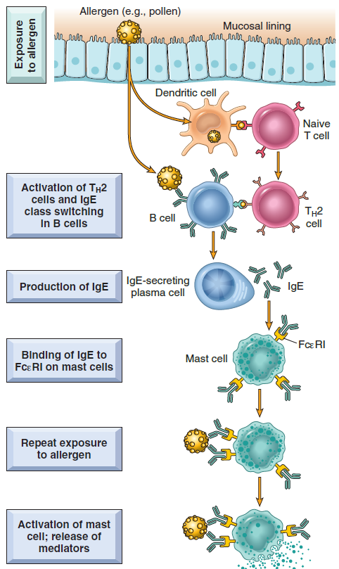
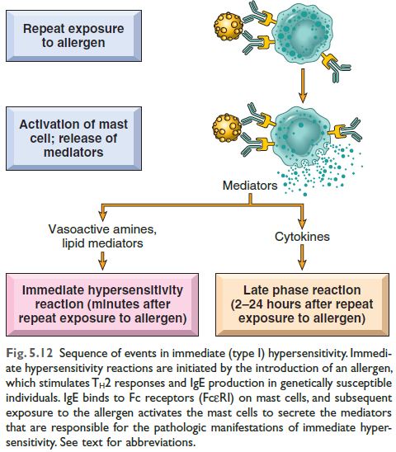
  - T_{H2} cells are often recruited to the site of allergic reactions by chemokines like eotaxin, which also recruits eosinophils.
- Sensitization of Mast Cells by IgE Antibody:
  - IgE antibodies then bind with high affinity to specialized receptors called FcεRI on the surface of mast cells.
  - Despite low serum IgE concentrations, the high affinity of FcεRI ensures that these receptors are almost always occupied by IgE.
  - These IgE-coated mast cells are thus "sensitized" and ready to react upon subsequent exposure to the specific allergen. Basophils, circulating cells resembling mast cells, also express FcεRI, as do eosinophils.
- Activation of Mast Cells and Release of Mediators:
  - Upon re-exposure to the allergen, the allergen binds to and cross-links antigen-specific IgE molecules on the sensitized mast cells. This typically occurs at or near the site of allergen entry.
  - This cross-linking triggers a cascade of biochemical signals within the mast cell, leading to the rapid secretion of various mediators.
Key Mediators of Immediate Hypersensitivity
Three main groups of mediators contribute to the reactions:
- Vasoactive Amines (Preformed in Granules):
- Histamine is released within seconds or minutes of mast cell activation. It causes vasodilation, increased vascular permeability, smooth muscle contraction, and increased secretion of mucus.
- Granules also contain acidic proteoglycans (heparin, chondroitin sulfate) that serve as a storage matrix for the amines.
- Newly Synthesized Lipid Mediators:
Mast cells synthesize and secrete prostaglandins and leukotrienes.
- Prostaglandin D2 (PGD2), the most abundant mediator from the cyclooxygenase pathway in mast cells, causes intense bronchospasm and increased mucus secretion.
- Leukotrienes (LTC4, LTD4) are extremely potent vasoactive and spasmogenic agents, several thousand times more active than histamine in increasing vascular permeability and causing bronchial smooth muscle contraction. Leukotriene B4 (LTB4) is highly chemotactic for neutrophils, eosinophils, and monocytes.
- Cytokines:
- Mast cell activation leads to the synthesis and secretion of cytokines crucial for the late-phase reaction.
- These include TNF and chemokines, which recruit and activate leukocytes.
Phases of Reaction
IgE-triggered reactions often have two distinct phases:
- Immediate Response:
- Occurs rapidly, usually within 5 to 30 minutes after allergen exposure.
- Characterized by vasodilation, vascular leakage (edema), and smooth muscle spasm.
- Driven primarily by mast cell granule contents (histamine) and newly synthesized lipid mediators.
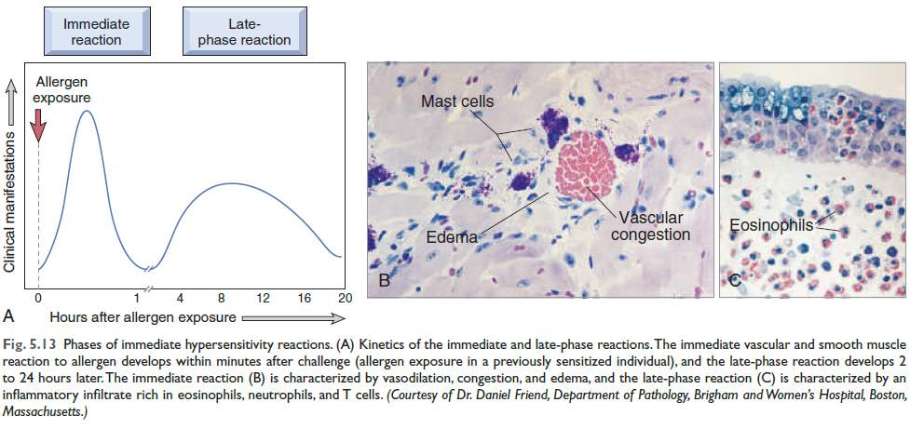
- Typically subsides within 60 minutes.
- Late-Phase Reaction:
- Develops 2 to 8 hours later and can persist for several days.
- Characterized by inflammation and tissue destruction, such as mucosal epithelial cell damage.
- Stimulated mainly by cytokines released from mast cells and other recruited cells.
- The dominant inflammatory cells are neutrophils, eosinophils, and lymphocytes, particularly T_{H2} cells.
- Eosinophils are crucial effectors of tissue injury in this phase as it can amplify and sustain the inflammatory response, even without continuous allergen exposure, and are responsible for much of the epithelial cell injury.
Clinical Manifestations
Immediate hypersensitivity reactions can be systemic or local, with the route of antigen exposure often determining the nature of the reaction.
- Systemic Reactions (e.g., Anaphylaxis):
Anaphylaxis is a severe, often fatal, systemic immediate (type I) hypersensitivity reaction. It is commonly known as an allergy.
- Cause and Triggers:
- Anaphylaxis results from systemic exposure to protein antigens.
- Common triggers include drugs (e.g., penicillin), bee venom, and certain foods.
- It occurs in a sensitized host.
- Clinical and Pathologic Manifestations:
- Anaphylaxis manifests with an immediate response, usually within 5 to 30 minutes of allergen exposure, characterized by vasodilation, vascular leakage, and smooth muscle spasm.
- Within minutes of exposure in a sensitized host, symptoms include:
  - Itching and urticaria (hives).
  - Skin erythema.
  - Profound respiratory difficulty due to pulmonary bronchoconstriction and hypersecretion of mucus.
  - Gastrointestinal involvement with vomiting, abdominal cramps, and diarrhea due to affected musculature.
  - Systemic vasodilation leading to a fall in blood pressure (anaphylactic shock), potentially resulting in circulatory collapse and death within minutes.
- Severity:
- While immediate hypersensitivity can be merely annoying (e.g., hay fever) or severely debilitating (e.g., asthma), anaphylaxis is the most severe form and can be fatal without immediate intervention.
- Local Reactions:
- Occur when the antigen is confined to a particular site, such as the skin, gastrointestinal tract, or lungs.
- Examples include:
- Allergic rhinitis (hay fever): Characterized by increased mucus secretion and inflammation of the upper airways and sinuses.
- Bronchial asthma: Causes airway obstruction due to bronchial smooth muscle hyperactivity, inflammation, and tissue injury from the late-phase reaction.
- Food allergies: Lead to increased peristalsis due to intestinal muscle contraction, resulting in vomiting and diarrhea.
Hypersensitivity Reaction (Type 2)
Hypersensitivity Reaction (Type II), also known as Antibody-Mediated Diseases, are disorders caused by secreted IgG and IgM antibodies that bind to cell surface antigens. These antigens can be normal molecules found intrinsically on cell membranes or within the extracellular matrix, or they can be adsorbed exogenous antigens, such as drug metabolites.
The mechanisms by which these antibodies cause tissue injury and disease are primarily threefold:
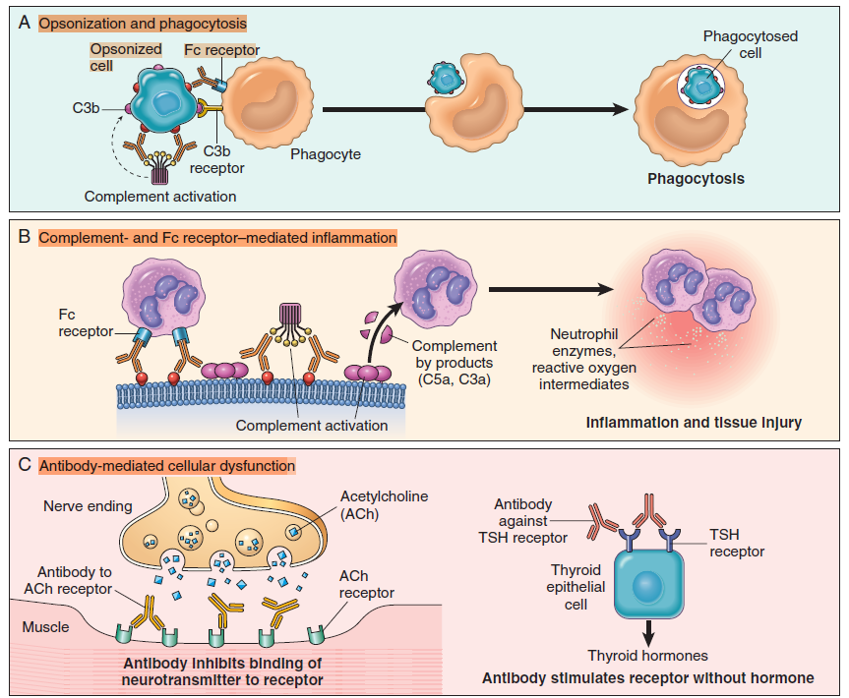
- Opsonization and Phagocytosis: When circulating cells, like red blood cells or platelets, become coated (opsonized) with autoantibodies, either with or without complement proteins, they become targets for phagocytosis by neutrophils and macrophages. These phagocytes express receptors for the Fc tails of IgG antibodies and for breakdown products of the C3 complement protein. Opsonized cells are typically eliminated in the spleen, which is why splenectomy can be clinically beneficial in some antibody-mediated diseases.
- Clinical situations where this mechanism occurs include:
  - Transfusion reactions, where incompatible cells react with preformed antibody in the host.
  - Hemolytic disease of the newborn (erythroblastosis fetalis), where maternal IgG anti–red blood cell antibodies cross the placenta and destroy fetal red blood cells.
  - Certain drug reactions, where a drug attaches to plasma membrane proteins of red blood cells, leading to antibody production against the drug-protein complex.
- Inflammation: Antibodies that are bound to cellular or tissue antigens can activate the complement system via the classical pathway. The products of complement activation serve to recruit neutrophils and monocytes, which in turn trigger inflammation in the tissues.
- This antibody-mediated inflammation is responsible for tissue injury in conditions such as some forms of glomerulonephritis and vascular rejection in organ grafts.
- Antibody-Mediated Cellular Dysfunction: In certain instances, antibodies directed against a host protein can impair or dysregulate important functions.
- For example, in myasthenia gravis, antibodies against acetylcholine receptors at the motor end plates of skeletal muscles inhibit neuromuscular transmission, leading to muscle weakness.
- In Graves’ disease, antibodies against the thyroid-stimulating hormone (TSH) receptor stimulate thyroid epithelial cells to secrete thyroid hormones, resulting in hyperthyroidism.
Prototypical Disorders Caused by Type II Hypersensitivity:
- Autoimmune hemolytic anemia: Antibodies target red blood cell membrane proteins, leading to opsonization and phagocytosis, and ultimately hemolysis and anemia.
- Autoimmune thrombocytopenic purpura: Antibodies target platelet membrane proteins, leading to opsonization and phagocytosis of platelets and causing bleeding.
- Good pasture syndrome: Antibodies target protein in the basement membranes of kidney glomeruli and lung alveoli, causing complement- and Fc receptor–mediated inflammation, resulting in nephritis and lung hemorrhage.
- Acute rheumatic fever: Streptococcal cell wall antigen leads to antibodies that cross-react with myocardial antigen, causing inflammation and macrophage activation, leading to myocarditis and arthritis.
- Myasthenia gravis: Antibodies target the acetylcholine receptor, inhibiting acetylcholine binding and down-modulating receptors, resulting in muscle weakness and paralysis.
- Graves’ disease (hyperthyroidism): Antibodies stimulate the TSH receptor, causing hyperthyroidism.
- Pernicious anemia: Antibodies neutralize intrinsic factor of gastric parietal cells, leading to decreased absorption of vitamin B12, abnormal erythropoiesis, and anemia.
Hypersensitivity Reaction (Type 3)
Hypersensitivity Reaction (Type III), also known as Immune Complex–Mediated Diseases, occurs when IgG and IgM antibodies bind antigens, usually in the circulation, to form antigen-antibody complexes that then deposit in vascular beds and induce inflammation. The subsequent recruitment of leukocytes (neutrophils and monocytes) leads to tissue damage through the release of lysosomal enzymes and generation of toxic free radicals.
Key Mechanisms of Type III Hypersensitivity:
- Formation of Antigen-Antibody Complexes: This type of hypersensitivity is triggered by the deposition of antigen-antibody complexes. These complexes can form in the circulation or, less frequently, at sites where antigen has been "planted" previously (referred to as in situ immune complexes). The antigens involved can be exogenous (e.g., a foreign protein injected or produced by an infectious microbe) or endogenous (if the individual produces antibodies against self-antigens, i.e., autoimmunity).
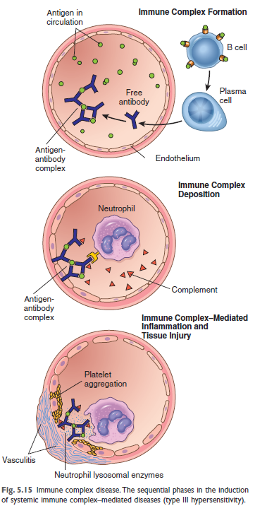
- Deposition of Immune Complexes: Circulating antigen-antibody complexes are deposited in various tissues.
  - Organs where blood is filtered at high pressure to form other fluids, like urine and synovial fluid, are sites where immune complexes become concentrated and deposit; hence, immune complex disease often affects glomeruli and joints.
- Inflammation and Tissue Injury: Once deposited, immune complexes initiate an acute inflammatory reaction by activating complement and engaging leukocyte Fc receptors. This leads to clinical features such as fever, urticaria, joint pain (arthralgia), lymph node enlargement, and proteinuria, typically appearing around 10 days after antigen administration.
Clinicopathologic Manifestations: Type III hypersensitivity diseases tend to be systemic, but often preferentially involve specific sites due to immune complex deposition:
- Kidney (leading to glomerulonephritis).
- Joints (leading to arthritis).
- Small blood vessels (leading to vasculitis).
- Wherever complexes deposit, the resulting inflammatory lesion is termed vasculitis in blood vessels, glomerulonephritis in renal glomeruli, and arthritis in joints.
Prototypical Disorders Caused by Type III Hypersensitivity:
- Poststreptococcal Glomerulonephritis: Caused by streptococcal cell wall antigen(s), which may be "planted" in the glomerular basement membrane, leading to nephritis.
- Polyarteritis Nodosa: Associated with Hepatitis B virus antigens in some cases, resulting in systemic vasculitis.
- Serum Sickness (Acute and Chronic): It was historically seen after administration of foreign serum (e.g., horse serum) and is now rare, usually occurring in individuals receiving antibodies from other species (e.g., horse or rabbit anti-thymocyte globulin for organ grafts).
  - Acute serum sickness induced by a single large dose of antigen often resolves as immune complexes are phagocytosed and degraded.
  - Chronic serum sickness results from repeated or prolonged antigen exposure.
- Arthus Reaction (Local Immune Complex Disease): An experimental model where tissue necrosis occurs due to acute immune complex vasculitis. It is produced by injecting an antigen into the skin of a previously immunized animal with preformed antibody.
Morphology of Type III Hypersensitivity:
- The primary morphological manifestation of immune complex injury is acute vasculitis, characterized by fibrinoid necrosis of the vessel wall and intense neutrophilic infiltration.
- In the kidney, the complexes can be observed as granular deposits of immunoglobulin and complement via immunofluorescence microscopy, and as electron-dense deposits along the glomerular basement membrane via electron microscopy.
Hypersensitivity Reaction (Type 4)
Hypersensitivity Reaction (Type IV), also known as T cell–mediated diseases, are primarily caused by immune responses involving T lymphocytes. This type of hypersensitivity leads to tissue injury through two main mechanisms: cytokine-mediated inflammation and direct cell cytotoxicity.
Mechanisms of Tissue Injury in Type IV Hypersensitivity
- Cytokine-Mediated Inflammation (Delayed-Type Hypersensitivity - DTH)
- This is the prototype of T cell–mediated inflammation. It occurs as a tissue reaction to antigens administered to individuals who have been previously immunized.
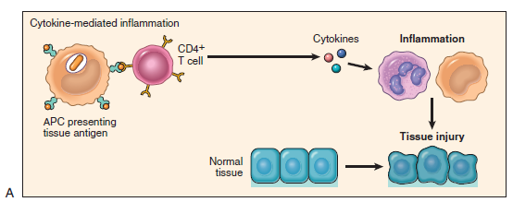
- Cells Involved:
  - CD4+ T cells are central to this mechanism. Naïve T cells are activated in peripheral lymphoid organs by recognizing peptide antigens displayed by dendritic cells (DCs).
  - These T cells then differentiate into effector cells, primarily T_{H1} and T_{H17} subsets, under the influence of various cytokines.
  - Macrophages are also critically involved.
- Cytokines and Their Roles:
  - T_{H1} cells secrete cytokines, predominantly interferon-gamma (IFN-γ), which is a potent macrophage activator. IFN-γ-activated (classically activated) macrophages produce substances that destroy microbes and damage tissues, and also release mediators that promote inflammation.
  - T_{H17} cells secrete cytokines, particularly IL-17 and IL-22 that recruit neutrophils and monocytes, contributing to inflammation. They are involved in destroying some extracellular bacteria and fungi and play a role in certain inflammatory diseases.
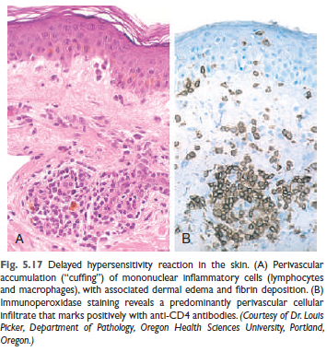
- Timing: The reaction is termed "delayed" because, when an antigen is injected into the skin of a previously immunized individual, a detectable cutaneous reaction appears within 24 to 48 hours, peaking between 24 to 72 hours, and then slowly subsides. This contrasts with the rapid onset of immediate hypersensitivity.
- Morphology: Characterized by the accumulation of mononuclear cells (lymphocytes and macrophages), typically forming perivascular "cuffing" around venules.
- Granuloma Formation: An aggregate of epithelioid cells, usually surrounded by lymphocytes, is called a granuloma. This is considered a chronic form of T_{H1}-mediated inflammation and macrophage activation. The recognition of granulomas is diagnostically important as they are seen in a limited number of conditions.
- Clinical Examples:
  - Tuberculin reaction (PPD skin test): A classic example of DTH, where injection of Mycobacterium tuberculosis antigen into the skin of a previously exposed individual causes reddening and induration within 24 to 72 hours.
  - Contact dermatitis: A common DTH reaction evoked by contact with environmental chemicals (e.g., urushiol from poison ivy/oak), presenting as a vesicular skin rash. It is thought that these chemicals bind to and modify self-proteins, creating neoantigens recognized by T cells, leading to cytokine production and inflammation.
  - Drug reactions: Many drug reactions occur via a similar mechanism, where the drug alters self-proteins, which are then recognized as foreign by T cells, causing cytokine production and inflammation.
  - Autoimmune diseases: CD4+ T cell-mediated inflammation is the basis of tissue injury in many organ-specific and systemic autoimmune diseases. Examples include:
    - Rheumatoid arthritis: Involves inflammation mediated by TH17 (and potentially TH1) cytokines, leading to chronic arthritis and destruction of articular cartilage.
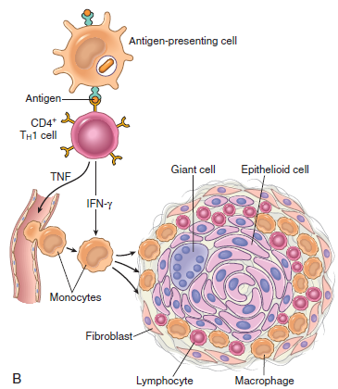
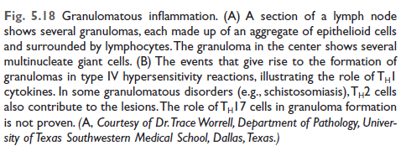
    - Multiple sclerosis: Involves inflammation mediated by TH1 and TH17 cytokines, causing myelin destruction by activated macrophages and demyelination in the central nervous system.
    - Inflammatory bowel disease: Characterized by chronic intestinal inflammation, possibly due to excessive immune responses to commensal microbes, autoimmunity, or both.
- Direct Cell Cytotoxicity (CD8+ T cell-mediated)
- Cells Involved: CD8+ cytotoxic T lymphocytes (CTLs).
- Mechanism: These CTLs directly kill antigen-expressing target cells.
- Role: CTLs play a significant role in graft rejection by targeting cell surface histocompatibility antigens. They are also involved in reactions against viruses, where they kill virus-infected cells displaying viral peptides on class I MHC molecules, which can lead to cell damage accompanying the infection (e.g., in viral hepatitis).
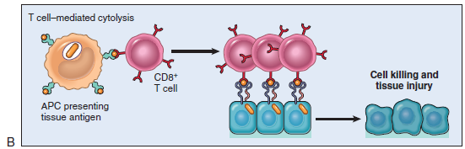
- Clinical Examples:
  - Type 1 diabetes mellitus: CTLs destroy pancreatic islet beta cells, which express specific antigens, leading to chronic inflammation (insulitis) and the destruction of insulin-producing cells.
  - Graft rejection: CTLs directed against cell surface histocompatibility antigens play a crucial role in the rejection of organ transplants.
  - Viral hepatitis: While CTLs eliminate the viral infection by killing infected liver cells, this killing can also be responsible for the accompanying cell damage.

