**COLUMNAR TRANSPOSITION**

**Program:**

import math  
  
key = "HACK"  
  
  
# Encryption  
def encryptMessage(msg):  
 cipher = ""  
  
 # track key indices  
 k_indx = 0  
  
 msg_len = float(len(msg))  
 msg_lst = list(msg)  
 key_lst = sorted(list(key))  
  
 # calculate column of the matrix  
 col = len(key)  
  
 # calculate maximum row of the matrix  
 row = int(math.ceil(msg_len / col))  
  
 # add the padding character '_' in empty  
 # the empty cell of the matix  
 fill_null = int((row * col) - msg_len)  
 msg_lst.extend('_' * fill_null)  
  
 # create Matrix and insert message and  
 # padding characters row-wise  
 matrix = [msg_lst[i: i + col]  
 for i in range(0, len(msg_lst), col)]  
  
 # read matrix column-wise using key  
 for _ in range(col):  
 curr_idx = key.index(key_lst[k_indx])  
 cipher += ''.join([row[curr_idx]  
 for row in matrix])  
 k_indx += 1  
  
 return cipher  
  
  
# Decryption  
def decryptMessage(cipher):  
 msg = ""  
  
 # track key indices  
 k_indx = 0  
  
 # track msg indices  
 msg_indx = 0  
 msg_len = float(len(cipher))  
 msg_lst = list(cipher)  
  
 # calculate column of the matrix  
 col = len(key)  
  
 # calculate maximum row of the matrix  
 row = int(math.ceil(msg_len / col))  
  
 # convert key into list and sort  
 # alphabetically so we can access  
 # each character by its alphabetical position.  
 key_lst = sorted(list(key))  
  
 # create an empty matrix to  
 # store deciphered message  
 dec_cipher = []  
 for _ in range(row):  
 dec_cipher += [[None] * col]  
  
 # Arrange the matrix column wise according  
 # to permutation order by adding into new matrix  
 for _ in range(col):  
 curr_idx = key.index(key_lst[k_indx])  
  
 for j in range(row):  
 dec_cipher[j][curr_idx] = msg_lst[msg_indx]  
 msg_indx += 1  
 k_indx += 1  
  
 # convert decrypted msg matrix into a string  
 try:  
 msg = ''.join(sum(dec_cipher, []))  
 except TypeError:  
 raise TypeError("This program cannot",  
 "handle repeating words.")  
  
 null_count = msg.count('_')  
  
 if null_count > 0:  
 return msg[: -null_count]  
  
 return msg  
  
  
# Driver Code  
msg = "RUTAJ"  
  
cipher = encryptMessage(msg)  
print("Encrypted Message: {}".  
 format(cipher))  
  
print("Decryped Message: {}".  
 format(decryptMessage(cipher)))

**Output:**

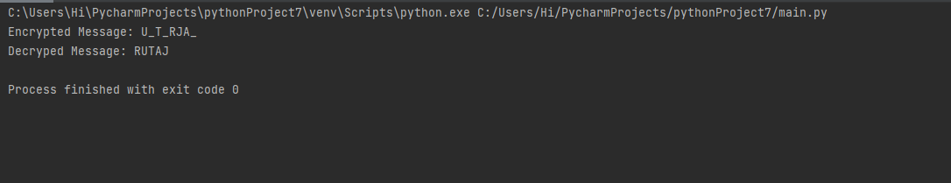

**CAESAR CIPHER**

**Program:**

def encypt_func(txt, s):  
 result = ""  
  
 # transverse the plain txt  
 for i in range(len(txt)):  
 char = txt[i]  
 # encypt_func uppercase characters in plain txt  
  
 if (char.isupper()):  
 result += chr((ord(char) + s - 64) % 26 + 65)  
 # encypt_func lowercase characters in plain txt  
 else:  
 result += chr((ord(char) + s - 96) % 26 + 97)  
 return result  
  
  
# check the above function  
txt = "CEASER CIPHER"  
s = 4  
  
print("Plain txt : " + txt)  
print("Shift pattern : " + str(s))  
print("Cipher: " + encypt_func(txt, s))

**Output:**

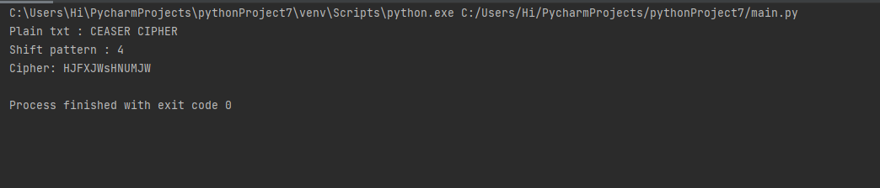

**HILL CIPHER**

**Plaintext:**

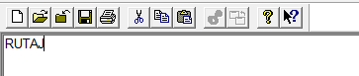

**Encryption:**

Key: CIPHERING

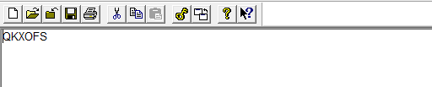

**Decryption:**

Key: CIPHERING

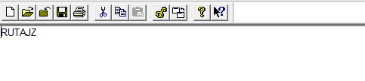

**PLAYFAIR CIPHER**

**Plaintext:**

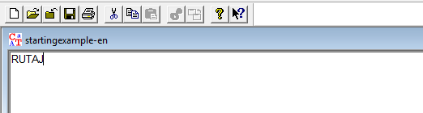

**Encryption:**

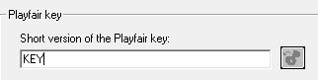

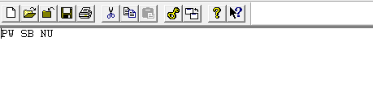

**Decryption:**



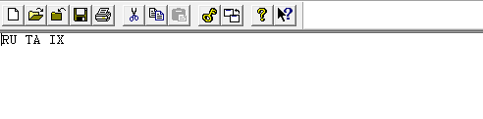

**CONCLUSION:** We successfully implemented Caesar Cipher & Columnar Transposition Cipher using python, Hill Cipher, Playfair Cipher using Cryptool.