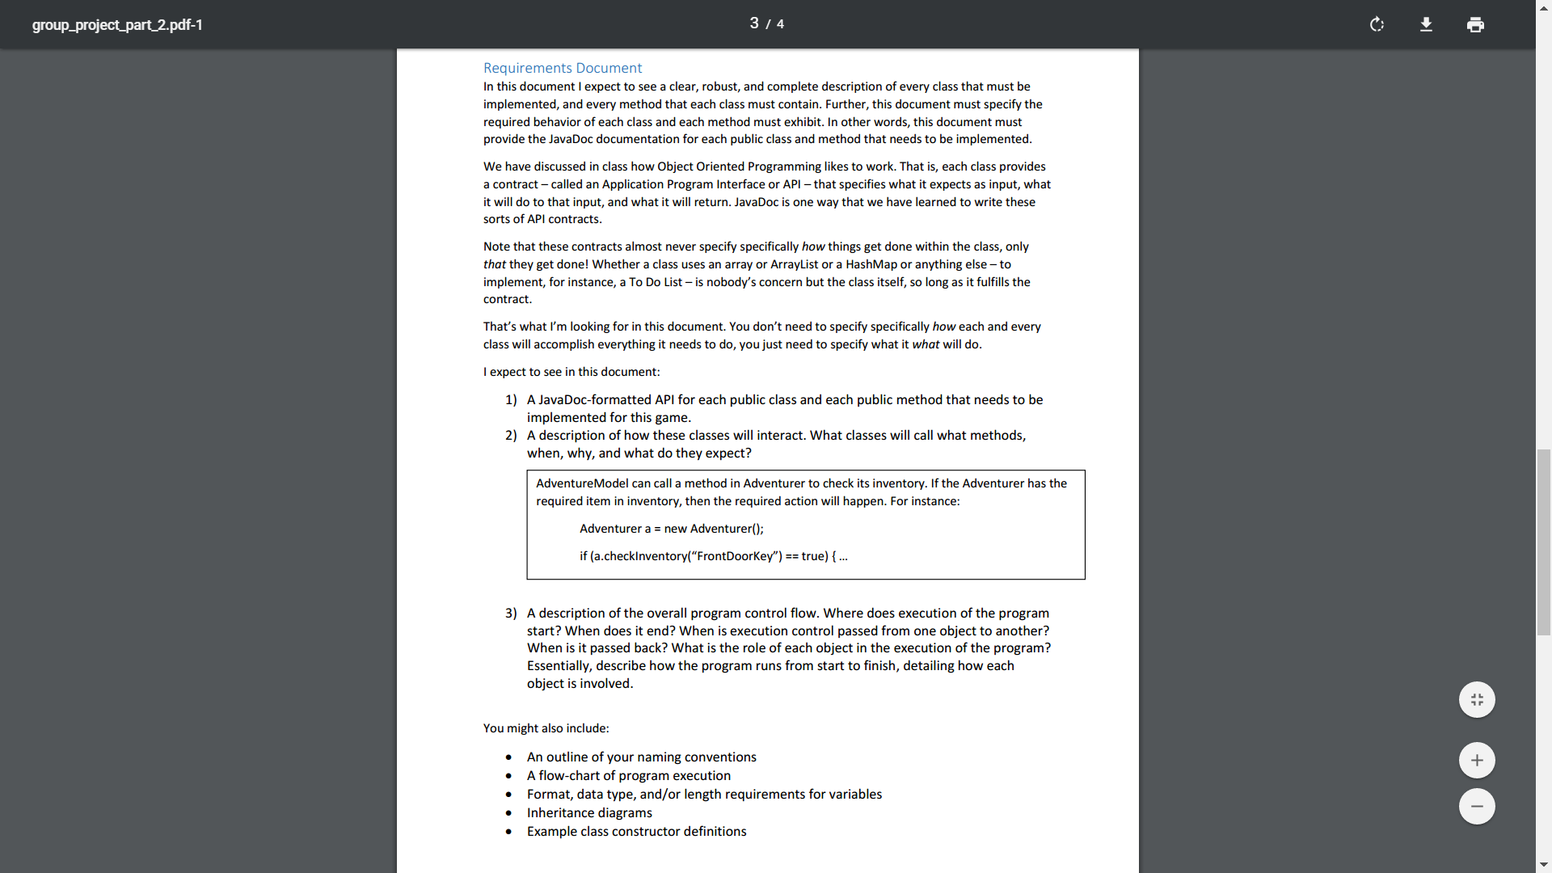

1. **API document for methods:**

/**

* @author Hackers

*

* @version 1.0

*

* @param none

* @return none

*

* @description:

*

* -The class Aron is created to keep track of all the inventory items there are in the * game *how many the player actually collects. Initially the items will be initialized to false, when * the *player obtains the items then the boolean variable will change to true.

*

*/

public class Aron {

private boolean handCuff = true;

private boolean key = false;

private boolean bookBag = false:

private boolean jewel = false;

private boolean dragonTooth = false;

private boolean torch = false;

private boolean goldCoins = false;

private boolean mummyHeadPiece = false;

private boolean shield= false;

private boolean USB = false;

private boolean universalKey = false;

private boolean medallion = false;

private boolean throwingStar = false;

private boolean treasureChest = false;

private boolean eyePatch = false;

private boolean parrot = false;

private boolean paperClip = false;

private boolean prisionerClothes = false;

private boolean suitCase = false;

private boolean dragonTooth = false;

public Aron () {

}

/**

/**

*In the same class there will be getter and setter methods that will set the boolean item

*variables *to true or false based on what the user inputs. Examples of some are listed below.

*

*This program contains the following getter and setter methods:

*

* sethandCuff

* @param boolean handCuff

* @return void

* @description catch information that is sent and save to specific THIS item

*

* gethandCuff

* @param void

* @return handCuff

* @description Returns the handCuff when called.

*

*/

public void sethandCuff(boolean handCuff) {  
 this.handCuff=!this.handCuff;  
 }  
 public boolean gethandCuff() {  
 return handCuff;  
 }

public void setkey(boolean key) {  
 this.key=!this.key;  
 }  
 public boolean getkey() {  
 return key;  
 }

}

//The methods for the main character to get the items are listed below.

Aron.gethandCuff;

Aron.getkey;

Aron.getbookBag:

Aron.getjewel;

Aron.getdragonTooth;

Aron.gettorch;

Aron.getgoldCoins;

Aron.getmummyHeadPiece;

Aron.getshield;

Aron.getUSB;

Aron.getuniversalKey;

Aron.getmedallion;

Aron.getthrowingStar;

Aron.gettreasureChest;

Aron.geteyePatch;

Aron.getparrot;

Aron.getpaperClip;

Aron.getprisionerClothes;

Aron.getsuitCase;

Aron.getdragonTooth;

**2. How the classes will interact with each other.**

The escapeRoom class is where all the user interaction and the storyline of the game will be kept. The escapeRoom class can call methods from Aron when the character takes an item and puts in his book bag or trades it in for another item.

System.out.println(“There is bookbag that you can use to store the items collected on the way,”

+ “would you like to retrieve the book bag”);

if (answer.equalsIgnoreCase(“yes”) {

Aron.getbookBag;

}

The main class escapeRoom will call the method Alex to see if the user has the item the that he will need to trade in too exit some room or open locks.

if (Aron.getuniversalKey == true) { ....

}

We will use a lot of if statements in the main class (escapeRoom) for simplicity. To make the program concise and to reduce the amount of if statements we will also utilize switch statements in the main class. Switch statements will also make it possible for us to navigate the player to room of their choice. Try and catch will be implemented in the main class as well to catch invalid inputs.

**3. Overall Program Flow:**

The player will initially be presented with the scenario/ storyline of the game. After reading the scenario, the player will choose whether to pursue playing the game or to exit by answering “yes” or “no” to the question “would you like to help Aron escape.” If the player enters “yes” then the game will begin and if the layer enters “no” then the game will end. The player will win if he or she is able to successfully escape the series of rooms that the character (Aron) is held captive in. Aron wakes up on an unfamiliar bed in an unfamiliar room. He is in **handcuffs** and doesn’t remember what happened last night. As he looks around the room he sees a dressing table in front of him with instructions. The instructions tell him to find a **key** to take off the handcuffs and find a **book bag** which is located somewhere in the room. On each of the four walls that surround him there is a sign that reveals the type of adventure he will have in that specific room and the mission he has to complete before leaving the room. On the wall facing his left there is a warning stating “Caution: Fire Breathing dragons.” If Aron decides to go into the room then his mission (which will be revealed once he enters the room) will be to obtain a **jewel**, **dragon tooth**, and **torch**. Aron will need these items later on in the game. There is no particular order to travel between the rooms, but in order for Aron to escape he needs certain find and take items to unlock the code. The second room is egyptian themed. This room has a giant sphinx in the center which, Aron has to go into obtain the mission objects which are **gold coins** and the **mummy’s head piece** and put them in his book bag for later in the game. Also, since it is dark in the tomb, Aron will need to use his **torch** to light the way. If he was unable to obtain the torch then he will have to trade in an object to get night vision glasses.

In this same pattern, Aron will travel to the tech world, ninjatown, and pirate ship rooms and complete the missions in those rooms. In ninjatown Aron’s mission is to retrieve a **medallion** and a **throwing star**. Aron must use a shield to protect himself from ninjas and if he has not yet obtained a shield from tech world then he must trade in a gold coin or jewel for protection. Tech world is a room of the future, with flying cars, robots, talking computers, and much more. Aron’s mission here is to find and get the **USB**, **shield**, and **universal key**. Again, the order of which room Aron visits first does not particularly matter, however if he visits the sequence of rooms in the order we planned, he will have an easier time. Once Aron is on the pirate ship, he has a passage to another “world” which will reveal to him another set of rooms he has to accomplish the missions to before he can escape to freedom. In order for Aron to get passage to this other dimension, he will need to find the **treasure box** on the pirate ship and open it to find a code. Once Aron finds the code he will have to find a trap door on the ship that will need the passcode that Aron discovered inside the treasure box to open. The trap door will lead Aron to a prison cell. In the cell Aron is surrounded by bars, a bed, and some items around the room. The note pinned to the bars of the cell will reveal to Aron what his mission is in that room and how to escape the cell. Depending on how Aron decides to escape the room, he will end up in a botanical garden or a large pool. In both of these rooms, Aron has a distinct mission that he must accomplish before proceeding to the next room. In the botanical garden, Aron must release the **pet parrot** he rescued from the pirate ship and put and put an **eye patch** on to keep his hurt right eye safe from the poison of the tropical plants. If Aron does not have an eye patch he must trade in gold coins, jewel, or a **paper clip** in for glasses. In the large pool room Aron’s mission is to retrieve an extremely important **suitcase** at the bottom of the pool, then change out of his wet clothes into the dry **prisoner’s clothes** that he took from the prison. Once Aron escapes both the botanical garden and large pool, he will be led to his final room which is the ancient library. In the ancient library is the final piece of the puzzle Aron must solve to escape to freedom. The ancient library has ginormous book cases with dust and cobwebs everywhere. The suitcase found in the large pool room will reveal a scrambled book name and Aron has to pick that book out of the book cases in the ancient library. Once Aron deciphers the book name and picks it out of the shelf, the entire book case will move to reveal a door. The room requires a **USB** that was obtained by Aron in tech world to open. Once Aron inputs the USB the door snaps open and Aron is free to go. The player will see the sign, “Congratulations! You did it! Thank you for helping Aron escape!” appear on the screen.