Room Walkthrough:

Room 1(lounge area):

You are an FBI agent working in the city of Gotham. You have entered an apartment complex in the worst part of the city

*Items in room are: Journal and Magazine*

*Options:*  ***Leave room, look, take journal*** *(****read journal*** *“display journal entry 1”****, take magazine*** *(****Read magazine*** *“display message about Gotham city”)*

Room 2(Leave room) - Lobby

You enter the apartment complex lobby. Half the lights are broken, and you hear eerie sounds echoing throughout the building. To the North is an elevator lobby, East is a janitor’s office, West is the security office, and south is the lounge area

*Items in room: none*

*Options:* ***go north, go east, go west, go south***

Room 3a(North)- elevator lobby

There are four elevators, three seem to be stuck shut but one’s door is slightly open.

*Items in room:* *trash bin (ammo clip inside)*

*Options:* ***enter elevator****,* ***go south****,* ***open trash bin*** *(reveal ammo clip and allow user to* ***take the ammo clip****)*

Room 3b (enter elevator):

// if power is not on

The elevator seems fine but there is no power running to it right now.

// once power is turned on:

The elevator is operational which floor would you like to go to, there are 3 floors?

*Items in room: none*

*Options:* ***leave elevator****,* ***use elevator*** *(when power is turned on),* ***floor 1,******floor 2, floor 3***

Room 4 (West)- Security Office

You have entered the security office, it is a mess and seems like someone left in a rush. There is a desk with a computer on it.

*Options:* ***look in desk*** *(find gun and allow user to* ***take******the gun****),* ***use computer*** *(Display message “Confidential security files accessed: Michael Jones, apartment: 3rd floor east hallway. Michael has been seen committing several felonies and should be considered armed and dangerous he is the leader of his gang and always wears a red bandana on his head.”),* ***leave room***

*Items in room: gun, computer*

Room 5 (East) – Janitors office:

You have entered the janitor’s office, it smells awful and there is not much useful stuff in the here but it might be worth it to look around.

*Items in room: breaker box*

*Options:* ***flip breaker******switch*** *(output message: “you hear a hum and you see some lights go back on” // this also activates the elevator),* ***leave room***

Room 6 (floor 2 lobby):

You are in the second floor lobby, there is a hallway with a couple of apartments to the east and to the west. It is quiet….. too quiet.

*Items in room: none*

*Options:* ***go west, go east, enter elevator, look*** *(display:* You are on the second floor, there is a hallway with a couple of apartments to the east and to the west. It is quiet….. too quiet.)

Room 7 (2nd floor west hallway):

You walk down the west hallway and see nothing but locked apartments. There is a man sitting at the end of the hallway he seems to be homeless and sketchy looking.

*Items in room: homeless man*

*Options:* ***go east, talk to homeless man*** *(display message “the homeless man ignores you and asks for spare change”)*

Room 8 – (2nd floor east hallway):

You walk down the east hallway and you see a door to an apartment slightly open and you hear the sound of a crying child coming from the room.

*Items in room: none*

*Options:* ***enter apartment, go west***

Room 9 (apartment):

You enter the apartment, there is broken glass and stuff thrown all around the apartment. On the floor you see a dead woman and a child crying next to her.

*Items in room: note, knife, couch(key)*

*Options:* ***Look*** *(display: you see a note on a table and a knife on the floor under the couch),* ***pick up note*** *(allow user to* ***read note*** *display message: “Sorry I put you in this situation but i owe mike over $1,000 and he isn't too happy about it. If anything happens to me just know he’s the guy with the scar under his left eye. I also put his apartment key under the couch cushion so you can have access to his apartment if you ever need to”),* ***pick up knife, search couch (take key)****.*

Room 10 (third floor lobby):

You are in the third floor lobby, there is a hallway with a couple of apartments to the east and to the west. There are a couple of people in the hallways and the atmosphere seems tense.

*Options:* ***go west, go east, enter elevator, look*** *(display: You are in the third floor lobby , there is a hallway with a couple of apartments to the east and to the west. There are a couple of people in the hallways and the atmosphere seems tense.*

*Items in room: none*

Room: 11 (3rd floor east hallway):

You see an old man standing in towards the back of the hallway. All of the apartments are locked.

*Items in room: man*

*Options:* ***talk to old man*** *(message displays: if you want to stay safe don’t go to the west hallway, there are some bad people that live over there.)* ***go west***

Room 12 (3rd floor west hallway):

There is loud music playing and you can hear people partying in a couple of apartments. You can knock on their doors but they won’t hear you over the music. You would need a key to get into the apartment.

*Items in room: none*

*Options:* ***go east, use key*** *(user must have key in inventory in order to use it)*

Room 13 – (drug lord apartment):

You slowly walk into the apartment; no one notices you yet. You see three males drinking and watching television. Now’s the perfect time to make the arrest. The man on the left is wearing a red bandana and has a teardrop tattoo under his left eye, the man in the middle has a red shirt on and has a baseball hat on, and the man on the right has a red bandana on and a scar under his left eye.

//user must choose who to arrest, the correct choice would be known based on description in the note found in the woman’s apartment. If user arrests correct man, display congratulatory message and end the game, if the user arrests wrong man, display good job but wrong person was detained.

*Items in room: man on the left, man in the middle, man on the right*

*Options:* ***arrest man on the left, arrest man in the middle, arrest man on the right, leave room.***

**Expanded Game Map with Requirements**

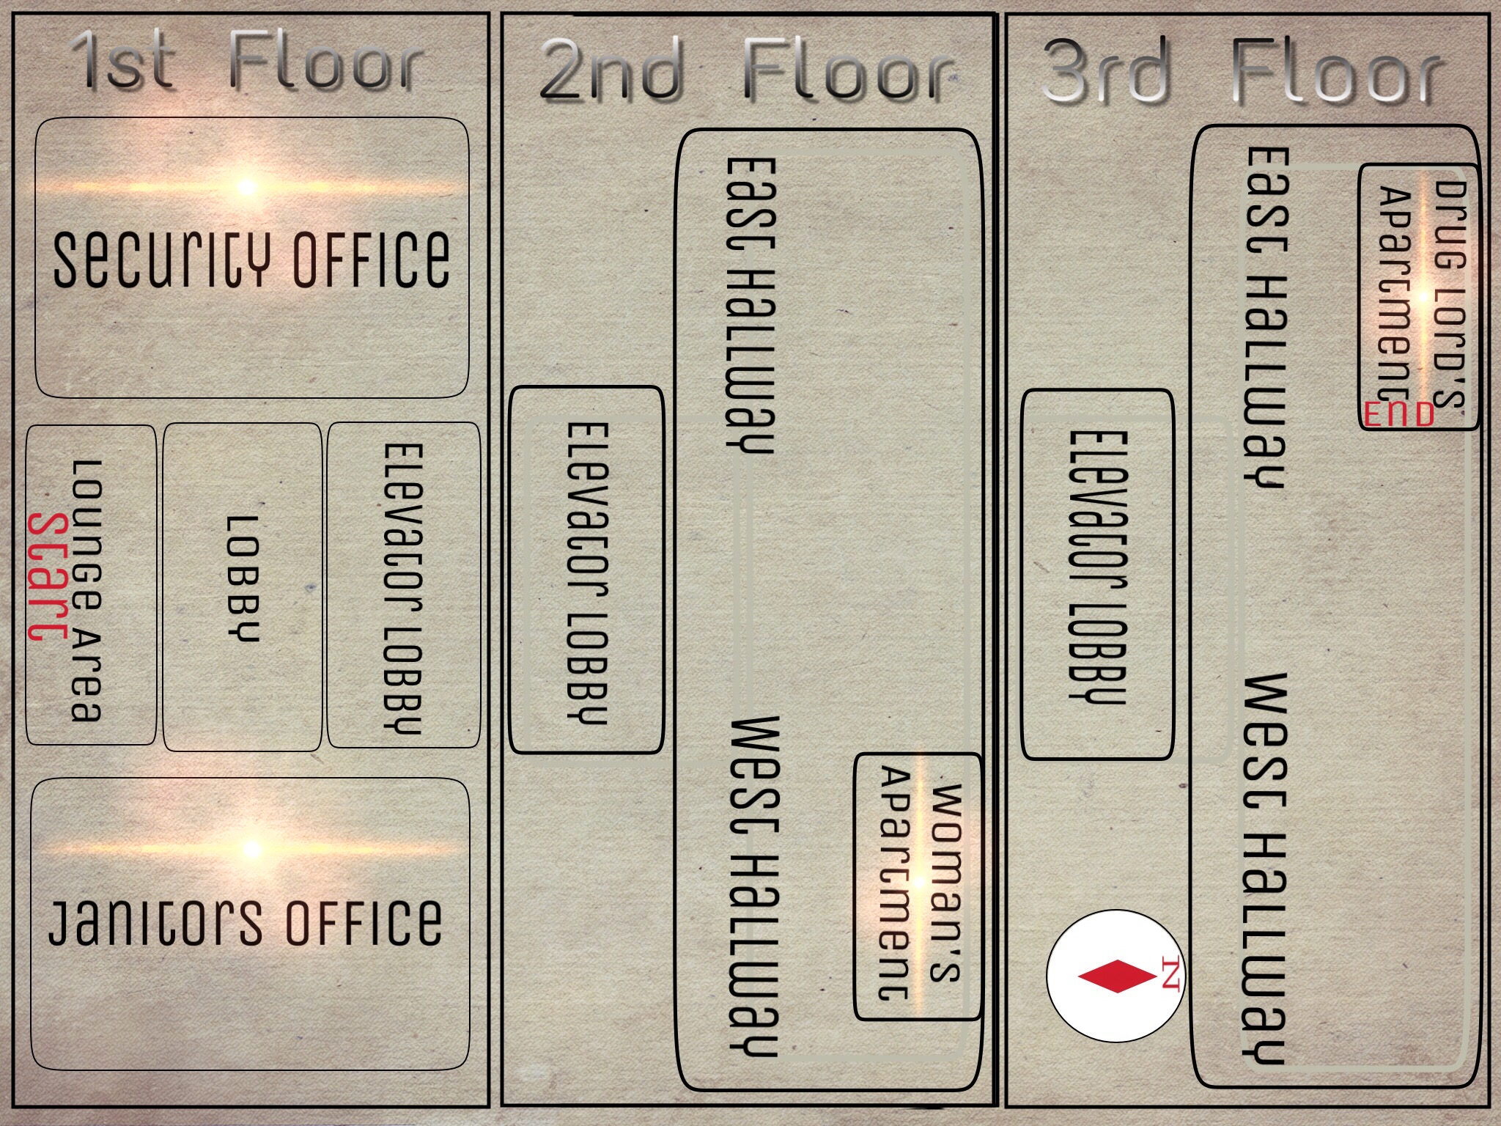

This is the full map of the apartment complex, it shows the start and end points as well as all of the rooms you will be able to go into throughout the building. The rooms that are the most important and must be entered, in order to successfully complete the game, are highlighted.

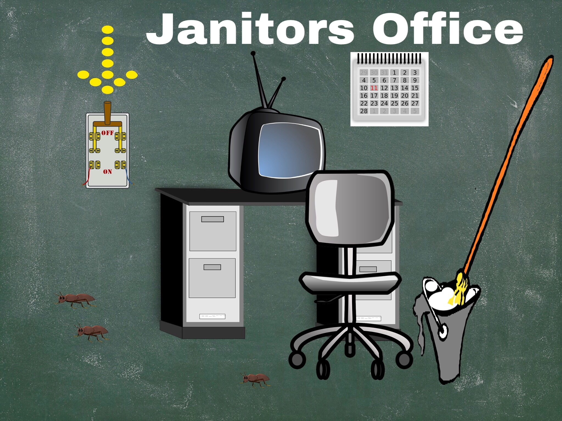

The Janitor’s office is the first of the rooms Samuel must enter in order to complete the game. The Janitor’s office is important because it is where the player must turn on the power by flipping the circuit breaker. This must be done in order to use the elevator which they need to do in order to find the drug lords apartment on the upper floor.

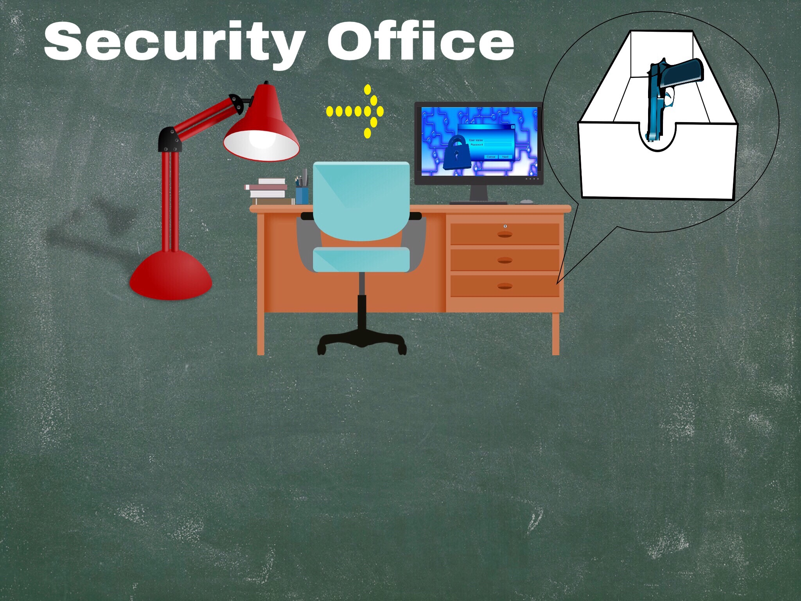

The second room of importance is the security office. This is where Samuel finds his first weapon, the gun. The gun is found by searching the security guard's desk. This is also where you can access the computer in order to gain intel on the drug lord that he is trying to catch.

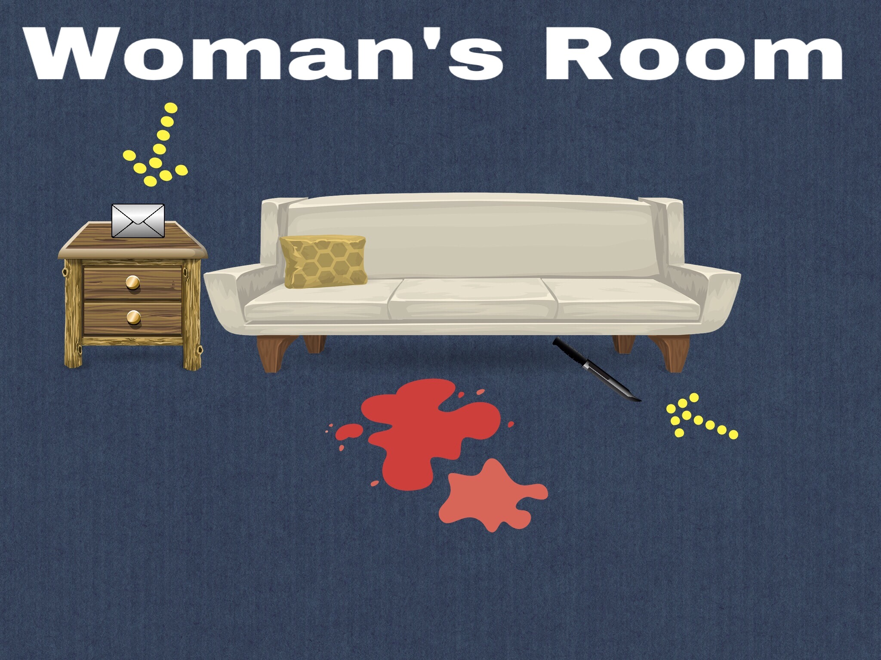

The Woman’s room is the first room you go to once you make it off the first floor. This is where Samuel finds key evidence of the drug lords crimes. There is a note on the table that describes the murderer which is imperative in being able to pick the right person to arrest later on in the game. There is also a knife which is the murder weapon the player can take as evidence or to use as a weapon. Lastly and most importantly this is where Samuel finds the key that is used to unlock the drug lord’s apartment door.

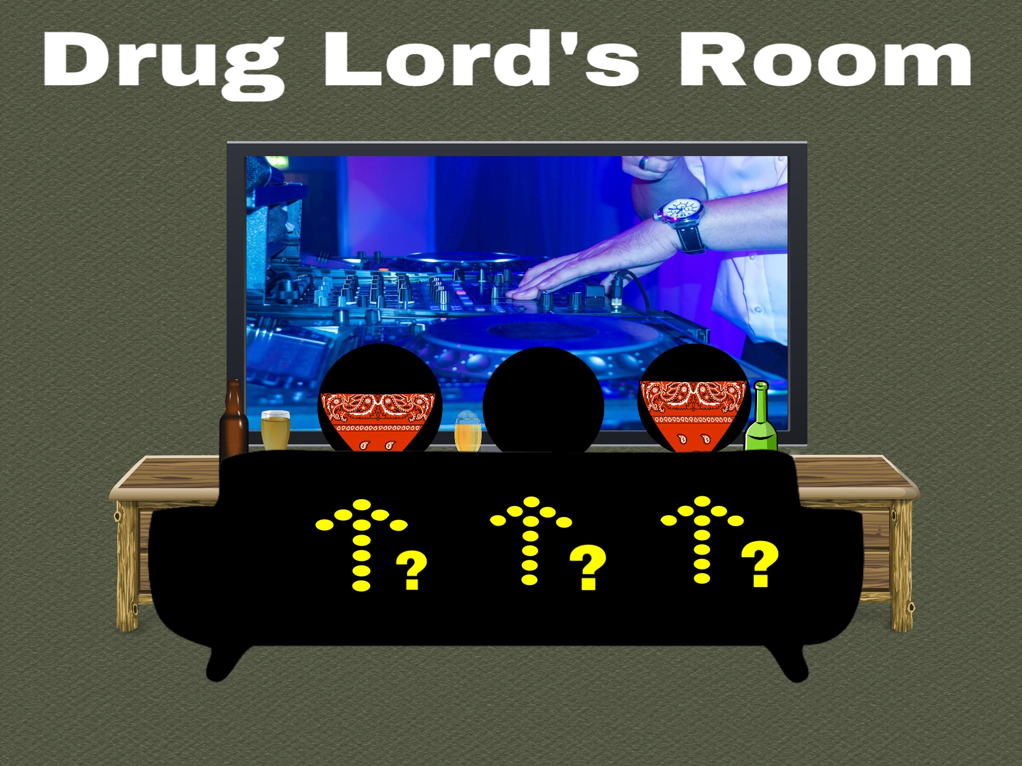

This is the final room and the end of the game. Once Samuel enters the room he must use the knowledge he gained throughout his investigation to arrest the correct gang member. Just make sure you get the details about the drug lord from the computer in the security office and the note in the woman’s room.

**Other in-game items:**

Ammunition - Found by searching in the trash bin by the elevators on the first floor.

Journal - Found in the Lounge Area (starting room).

Magazine - Found in the Lounge Area (starting room).