User Guide : Reservation.

After the Customer Signs in, when he clicks on “Reserve A spot” on the homepage.

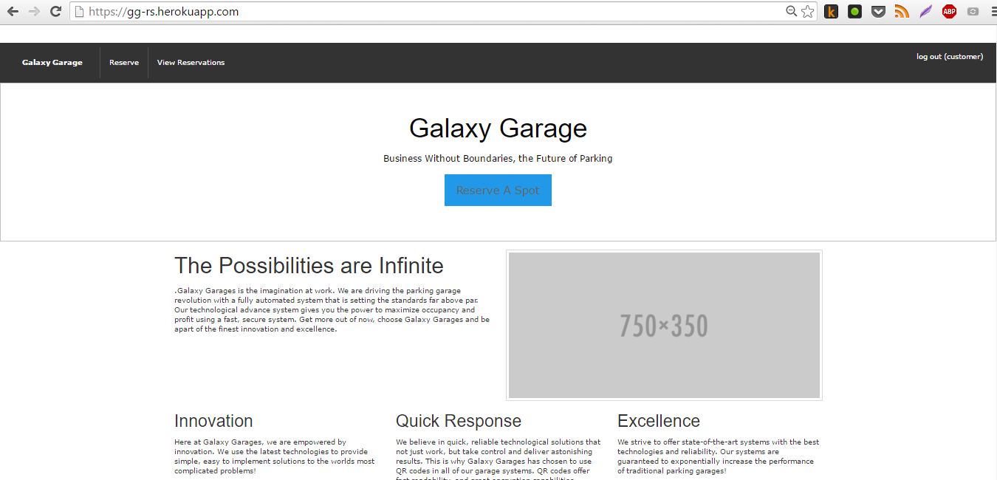

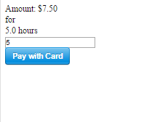The user is then redirected to this page. And the start time, finish time are then inputted.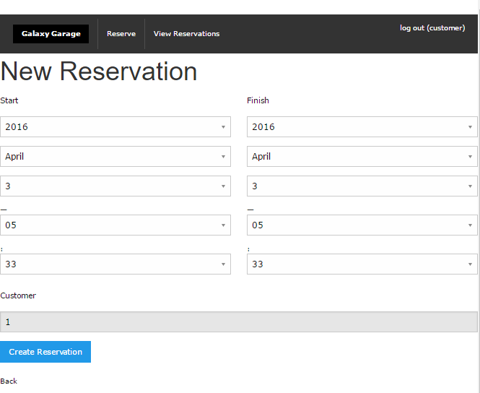The curstomer is then redirected to the payment screen.

The customer then proceeds to pay by entering his card information.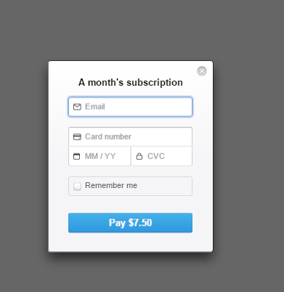

After payment the customers is redirected; to his/her list of active reservations.