**LAB01**

**Lab Summary**

#This Lab was about creating users and groups, assigning users to groups, creating a resource group, and deleting the resource group.

#Users in azure are created in the Azure active directory (Azure AD)

#There are 3 ways to create users, groups, and resource groups on Azure. Using Azure AD GUI, PowerShell, and CLI/Bash

**GUI**

After logging into through the azure portal, users can choose the Azure AD Icon welcome page (1) or search for it in the search resources bar (2).

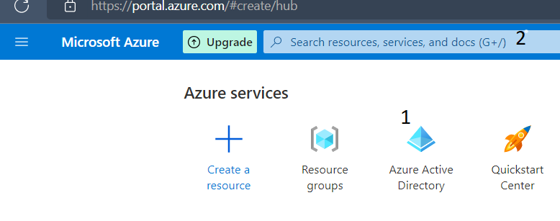

Users are redirected to the Azure AD home page with a list of activities on the left. To create a user, we either choose from the left tab (1) or by clicking the add sign (2).

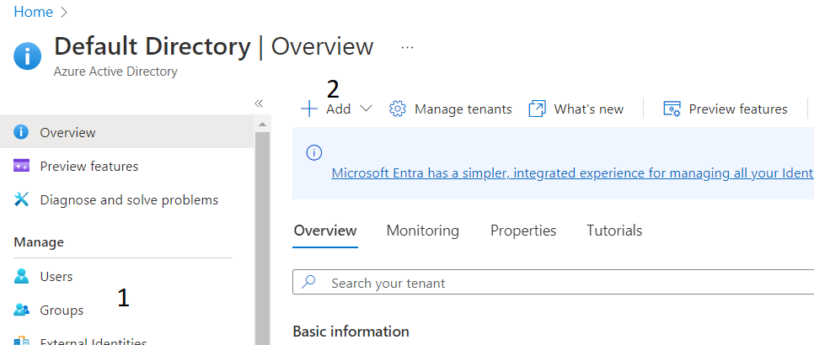

Either option chosen, the users are presented with an option to either create a new user or add a user and a form to fill. For this lab, we are creating a new user, so we go ahead to fill in the details we want. Username (1) for the user, name (2) and a password (3) which we could auto generate or create ourselves.

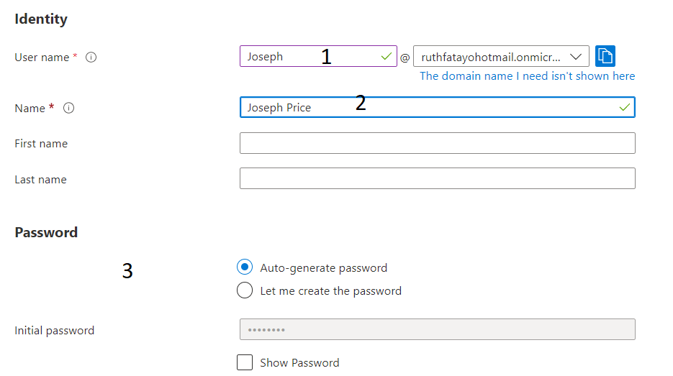

After creating the new user, users are taken back to the Azure AD home page. Next, we create a new group. As usual, you either use (1) or (2)

On getting to the group creation page, users are presented with a form to fill. (1) for the group name and users that have been created can be added as owners and/or members.

Fill in the required dteails and create a group.

This was how I created the user and group.

As earlier said, users can use the PowerShell or Bash to create users and groups. The process will not be addressed in this file, but steps for users to get to the power shell or bash will be discussed.

From anywhere on the azure page, on the top-right side of the page, the option for the console (1) can be found.

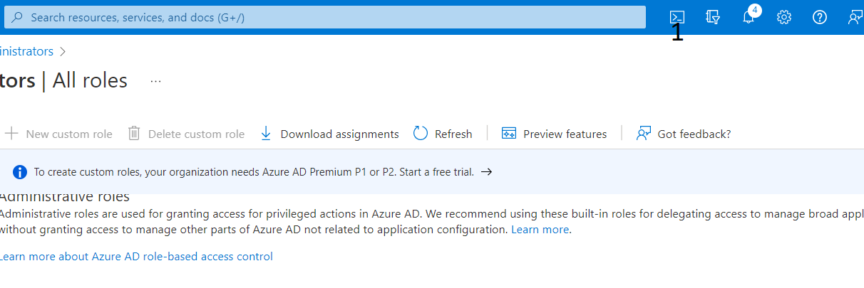

The console will pop up at the bottom of the screen, where users get to choose (1) if they want to use PowerShell or Bash.

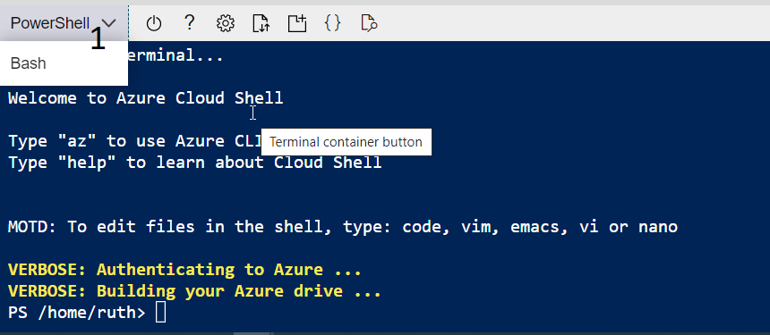

**RESOURCE GROUP**

**STEP1:**

**STEP 2:**

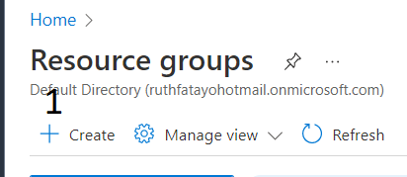

**STEP 3:**

**STEP 4:**

**STEP 5:**

**STEP 5:**

Like creating and deleting users on the PowerShell and CLI, resource groups can be deleted on PowerShell with the command

**Remove-AzResourceGroup -Name “AZ500LAB1” -Force -AsJob**

The -Force allows you delete files with system attributes or even hidden files.

The -AsJob is used to create a PowerShell job which then operates at the background until completed.