**LAB02**

**Lab Summary**

-Create a resource group, which could be done by using the GUI on the Azure Portal or the PowerShell

-Create a policy for allowed locations for resources in our resource group.

-Checking if the policy has been created.

* **Creating a resource group using PowerShell**

**Step 1:**

Navigate to the Cloud Shell.

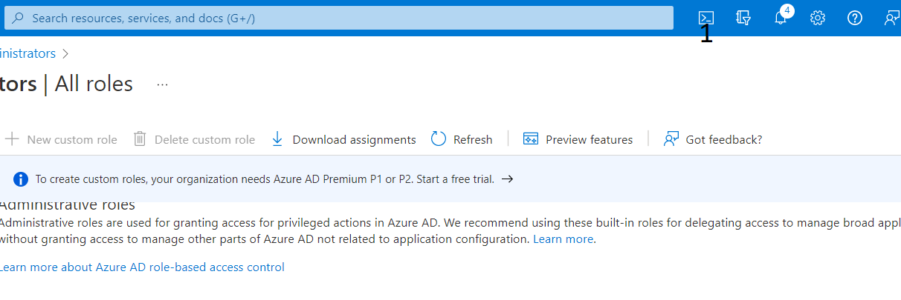

**Step 2:**

The syntax used to create a new resource group.

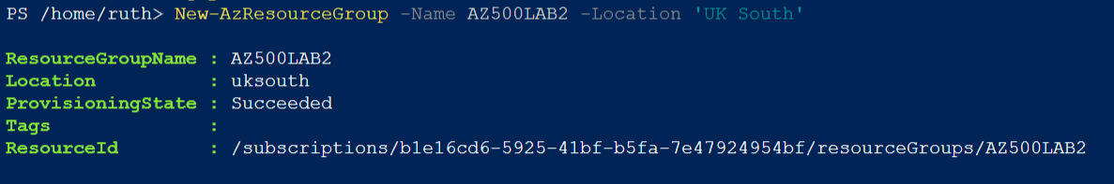

To get a list of resource groups and to also make sure your resource group has been created.

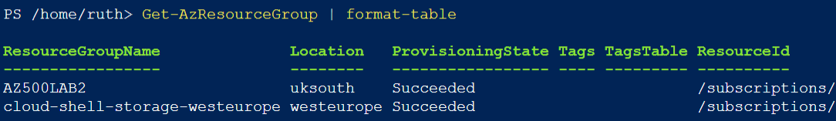

* **Create a location policy for resources that will be created in our resource group.**

This policy enables you to restrict the locations your organization can specify when deploying resources. Used to enforce your geo-compliance requirements. Case in point: User data that is restricted to Europe must be stored in an European region.

**Step 1:**

The policy function is searched for in the search bar if it has not been used before or recently.

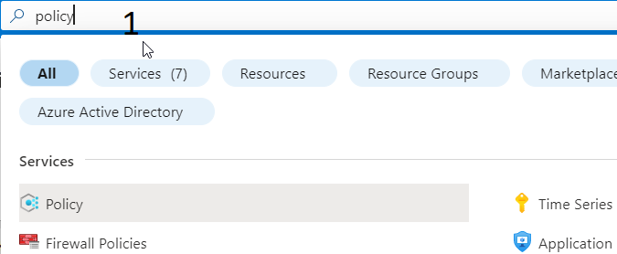

**Step 2:**

The definitions option is chosen on the policy menu blade.

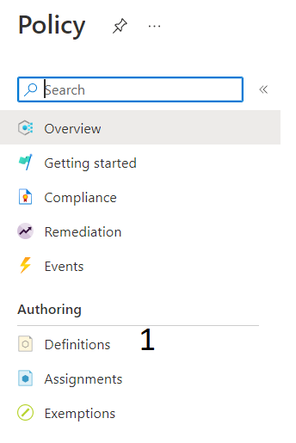

Step 3:

Use the search bar(1) for search for the policy(2).

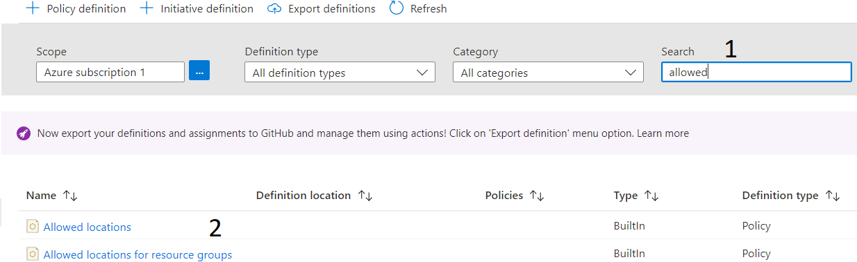

Step 4:

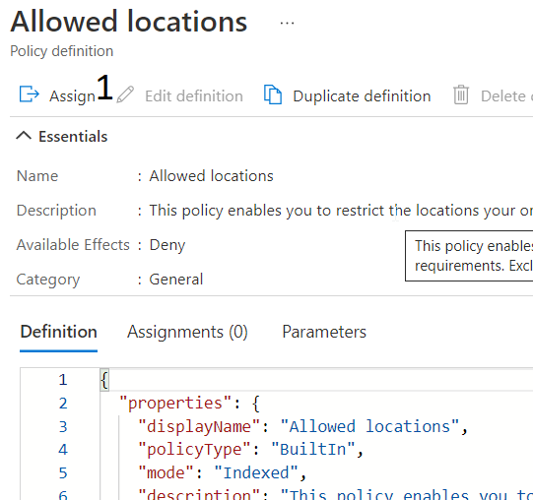

Step 5: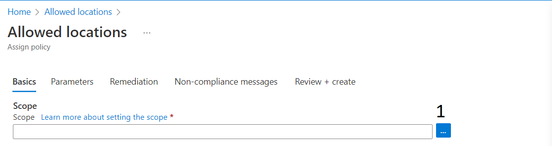

Step 6:

The subscription type and resource group for this policy is selected for the scope

Step 7:

Multiple locations can be chosen on the parameters page.

Step 8:

Review policy settings and click Create.

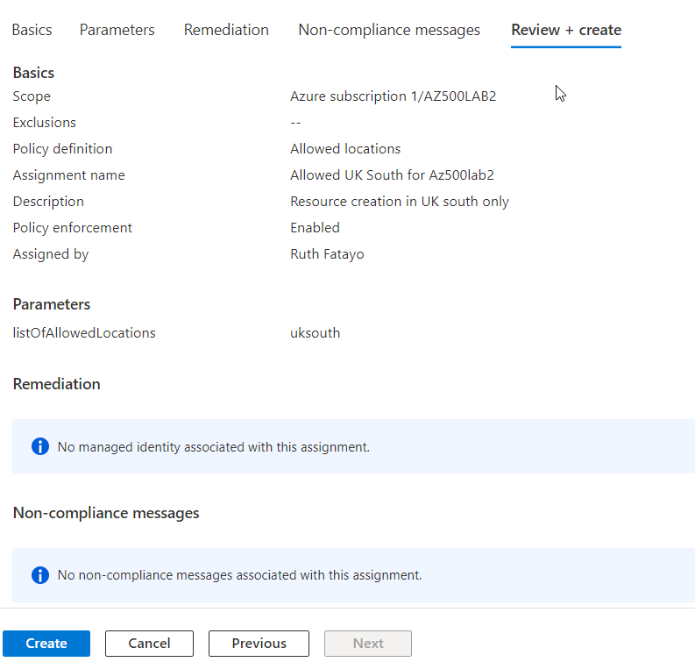

* Check!

Step 1: We will try to create a virtual network.

Step 2: We get a form to fill. To check, we input the wrong location.

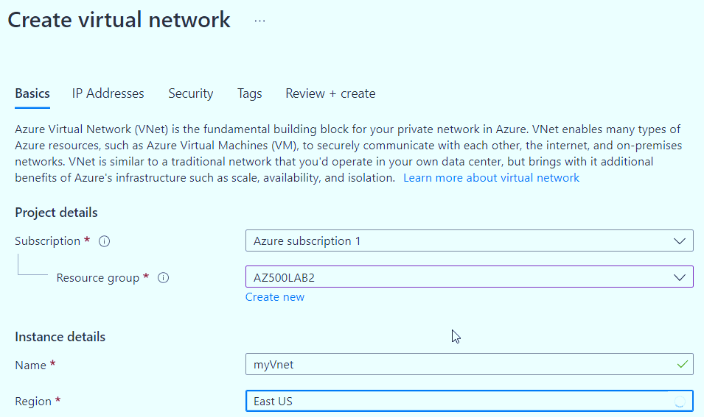

We get an error message that gives a link to the policy that was created.

Choosing the right location doesn’t give an error message and the virtual network can be created.

