**UtibuHealth Application Documentation**

1. Introduction

UtibuHealth is a mobile application designed to provide users with convenient access to medication ordering, statement checking, and healthcare updates. This documentation outlines the features and functionality of the UtibuHealth application.

2. Welcome Page

- Upon launching the UtibuHealth application, users are greeted with a welcome page.

- The welcome page includes an "About" section that introduces users to the app's features, such as medication ordering, statement checking, and healthcare updates.

- Users can click the "Get Started" button to proceed to the registration page.

- If users are already registered, they have the option to navigate to the login page.

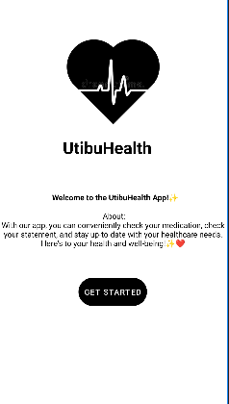

3. Registration and Login

- The registration page prompts users to enter their full name, email address, password, and re-enter password for confirmation.

- After successful registration, users are directed to the home page.

- Returning users can log in using their email address and password.

4. Home Page

- The home page serves as the central navigation hub for the UtibuHealth application.

- Users can access their profile, view available products, log in, or log out from the home page.

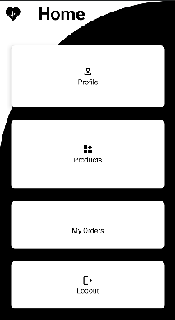

5. Profile Page

- The profile page displays the logged-in user's name and email address.

- Users have the option to change their password by clicking the "Change Password" button, which redirects them to the change password page.

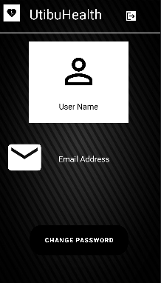

6. Products Page

- The products page showcases different medications available in the app, such as HIV-ARVs, Diabetes medication, and Hypertension medication.

- Clicking on each medication card directs users to its respective checkout page.

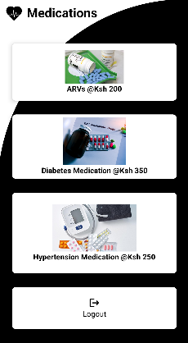

7. Checkout Page

- Each medication's checkout page allows users to enter their email address, quantity, and view the total price.

- Upon confirming the order, the app updates the order table in the database with relevant information, including order ID, item name, customer email, quantity, and price.

8. My Orders Page

- The My Orders page displays a list of orders made by the user.

- Each order entry includes details such as item name, customer email, order ID, price, and status.

- The status of each order is determined by comparing the quantity input by the customer during ordering with the quantity available in the stock table. If the quantity is less, the status is marked as approved; otherwise, it is marked as declined.

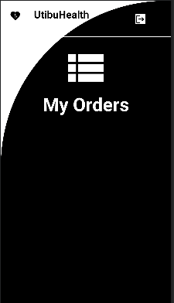

9. Database Connection

- The UtibuHealth application is connected to a SQL Server database for storing user information, product data, and order details.

- The SQL Server instance is configured to allow remote connections on port 1433.

- The connection to the database is established within the app using dependencies in the build.gradle file, updates in the AndroidManifest.xml file, and a SqlConnection class to manage database connectivity.

***Conclusion***

The UtibuHealth application provides users with a seamless experience for medication ordering, statement checking, and healthcare updates. With its user-friendly interface and robust database connectivity, UtibuHealth aims to enhance the accessibility and efficiency of healthcare services for users.