# **System Component Diagram**

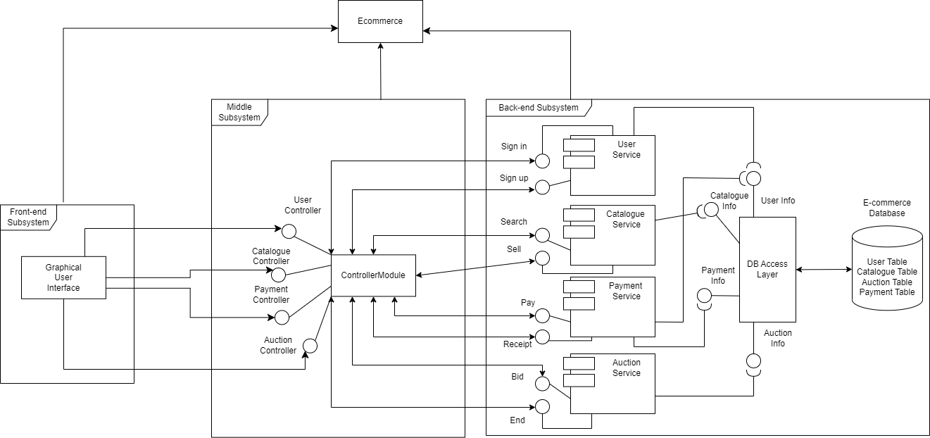

# **Sequence Diagrams**

|  |  | |
| --- | --- | --- |
| *UC1.1 Sign up & UC1.2 Sign in* | *UC5 Payment* | |

|  |  |  |
| --- | --- | --- |
| *UC4 Auction Ended* | *UC6 Receipt Page and Shipment details* | *UC7 Sell* |

# **Activity Diagrams**

|  |  |
| --- | --- |
| *UC1.1 Sign up* | *UC1.2 Sign in* |
|  |  |
| *UC2.1 Search* | *UC2.2 Display Auctioned Items* |
|  |  |
| *UC2.3 Item Selection* | *UC3.1 Forward Auction* |
|  |  |
| *UC3.2 Dutch Auction* | *UC4 Auction Ended* |