

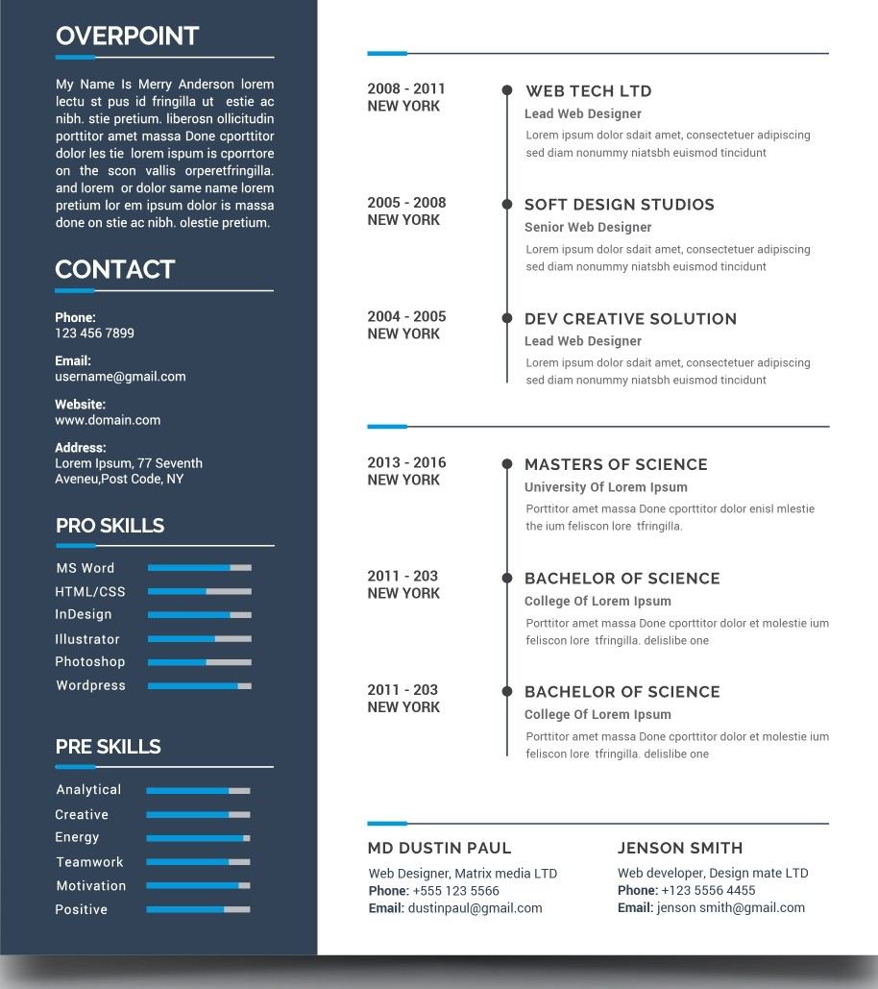

EXPERIENCE

EDUCATION

REFERENCE