DSH RSE Code Evaluation Task – Dec 2025.
You are required to develop a solution. This is a demanding task, so to ensure you can return your solution to the DSH assessment team on time, you are expected to use code-assistance capabilities powered by one or more LLMs.
We want to evaluate your knowledge of software architecture, software engineering, good coding practices, the use of patterns, and clean architecture. Therefore, we are not interested in evaluating only a completed solution; we are interested in evaluating its evolution. As the software engineer, you should be able to ask the right questions of the code assistant, evaluate its results, and refine the generated code.
For this coding task, we require the following:
- You must use your GitHub account, or create one, for the duration of the coding task. If you prefer not to create an account, you may still submit your solution as a zip file, but it will be much more difficult for evaluators to follow the progress of your work.
- You must create a GitHub repository named dsh-etl-search-ai-2025.
- You have two options for your repository:
3.1. Make the repository publicly accessible so we can see the progress of your commits.
3.2. Make the repository private. If you choose this option, you must invite the following DSH team members to access your repository:
a. GitHub account: gisvlasta (https://github.com/gisvlasta) — Vasileios Vlastaras, DSH Geospatial Software Architect
b. GitHub account: gisdarcon (https://github.com/gisdarcon) — Konstantinos Daras, DSH Product Owner
- You must use one or more LLMs to support development of the solution. You may use a combination of locally running LLMs, LLMs as a service (ChatGPT, Google Gemini, Google AI Search, etc.), or agentic code assistants (Visual Studio Copilot with agentic features, or similar). We prefer that you use an LLM that supports sharing the entire conversation with us (for example, ChatGPT or Claude provide a “share” button that can share the full conversation).
4.1. If you use such services, you must send one or more emails with the shared URLs of your conversations to:
a. vasileios.vlastaras@manchester.ac.uk
b. konstantinos.daras@manchester.ac.uk
4.2. If you prefer not to share the conversations via URLs, you must carefully copy your questions and the assistant’s answers into a document (markdown, docx, or pdf) and send it to us.
4.3. If you use an IDE with a Copilot/code assistant, you must ensure the full conversation (questions and answers) is copied carefully into a document (markdown, docx, or pdf).
- Important — You will be evaluated not based on the code you submit, but on the questions you ask the LLM/code assistant. Therefore, if you only submit code, we will treat this as a failure. We want to see how well you:
5.1. Ask system architecture questions.
5.2. Ask code architecture questions.
5.3. Ask software engineering questions.
5.4. Ask the code assistant to generate Object Oriented code using best practices that result in clean architectures.
5.5. Ask the code assistant to improve/refactor the code based on your architecture and software engineering needs (not the other way around).
5.6. Ask the code assistant to correct mistakes.

Software Development Task Instructions
You must demonstrate that you can create a dataset search and discovery solution using semantic and conversational capabilities. The task includes:
- Extraction of the datasets and their metadata. (ETL)
- Development of a semantic search database using vector embeddings.
- Development of a web app capable of searching the database using semantic and conversational capabilities.

Details
1. ETL Subsystem
Create an ETL subsystem capable of extracting metadata, data, and supporting document resources from the CEH Catalogue Service.
The CEH Catalogue Service can be accessed at:
https://catalogue.ceh.ac.uk/eidc/documents
The CEH Catalogue Service exposes the following WAF:
https://catalogue.ceh.ac.uk/documents/gemini/waf/
It also provides the following sitemap:
https://catalogue.ceh.ac.uk/eidc/sitemap.txt

You may need to create a CEH account to access the resources. You need to access only the resources with the file-identifiers attached to the coding task’s e-mail (metadata-file-identifiers.txt).
Each dataset is described by machine-readable metadata documents in different formats:
  - ISO Geographic Metadata 19115 – Well defined industry standard.
  - JSON – Expanded document modelling relationships between metadata documents
  - Schema.org (JSON-LD)
  - RDF (Turtle)
You need to demonstrate that you are capable to create object-oriented code to support the ETL processes that will extract the documents and add them in a SQLite database. You need to store the entire document in a field in the database and you need to use the Code Assistant’s knowledge of the ISO 19115 standard to extract the most important information from each document so that you can store it in tables in the SQLite database.
Your extraction class hierarchy should demonstrate capability to abstract the resources you extract (ie: remote files, API results, database records).

Below are screenshots showing you the resources you need to extract. Please find their URL patterns and automate the process.

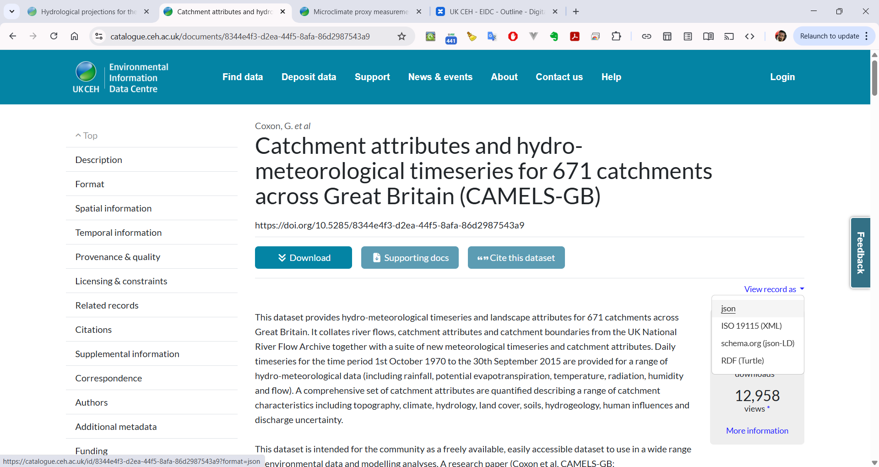
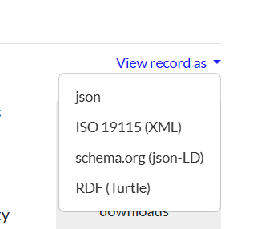

Make sure you read the JSON documents so that you will be able to model the relationship between metadata documents in your SQLite database. Read from JSON or XML documents to extract important information and add it in related tables in your SQLite database.
Each dataset includes download links in its JSON and XML metadata documents. Datasets can be accessed using the download option. These datasets are usually provided as zip files, so your ETL library must be able to extract the zip file and then extract its contents. Other datasets can be accessed using the fileAccess option. These datasets are typically available through a web-accessible folder and require different handling.

All datasets have supporting documents. Datasets packaged as zip files (via the download option in the metadata) include their supporting documents. Datasets accessed through the fileAccess option do not include their supporting documents.

All datasets also have an individual URL that allows downloading only the supporting documents. Make sure you discover the URL pattern for all supporting documents, so your application can download them.

All datasets contain one or more data files; therefore, each dataset has a one-to-many relationship with its data files.
You are required to download all of the metadata files from the list of file-identifiers attached to the coding task e-mail. You do not need to download all of the related supporting documents, although it will be beneficial. You do not need to download all of the datasets although it will be beneficial. However, your ETL library and app should be capable to download all of these resources if needed.

Semantic Database
Each metadata document includes a title and an abstract that describe the dataset. You are required to demonstrate that you can extract the title and abstract into the relevant tables in an SQLite database. You must then use these fields to create vector embeddings that capture the semantic meaning of the titles and abstracts. You need to store this semantic information in a vector store of your choice to support semantic search.
You also need to use a number of supporting document files to demonstrate that you can extract semantic meaning from these files and store it in a vector database to support RAG (retrieval augmented generation). We understand this may not be feasible for a large number of files, but you are required to develop code that can perform this task if needed and you need to test the generated embeddings for a handful of documents. You are free to use local models to generate the required vector embeddings.

Search and Discovery Frontend
You are required to develop a web app that supports the search and discovery of datasets. The web app must be built using Svelte and shadcn-ui or Vue. We are interested in how you structure your code to ensure best software engineering practices are followed. You must support dataset search and discovery using semantic search and natural language queries, based on the semantic information stored in the vector database (title, abstract, and supporting documents).
Bonus: You may attempt to add a basic conversational capability to the web app, where an agent can help users discover datasets.

Guidelines

This is a demanding task, but the time required to develop the code can be reduced dramatically with the right use of coding assistants. You do not need to complete the task. We are happy to evaluate incomplete submissions, as long as they demonstrate a candidate’s ability to architect and engineer code in a professional manner, according to the rules mentioned earlier in this document. You are required to use one or more of the following programming languages:
- C# (preferable for backend development)
- Python
- TypeScript/JavaScript

The deadline for submitting the task is 9 January 2026 at 22:00 GMT.
We prefer that you share the link to your GitHub repository early (or add us to the repository, as described earlier in the document), and that you also share your conversations with the code assistants where possible, ideally before the deadline and as you progress with the task.
If that is not possible, you must use a file-uploading service to upload:
- a zipped file containing your code, and
- all documents containing the code assistant conversations.
Your questions must be clear and must follow the guidelines described earlier in the document. We require you to use a file-uploading service to avoid our email server blocking code attachments.
We expect to evaluate your Code Assistant questions and the way you guide the assistant to generate quality code. Code only submissions will be treated as failure.

If your submission is considered successful we will send you an e-mail to participate in an interview on Monday 19th January 2026.

If you have any questions about the task, or if you need more time to submit, you must email the DSH Geospatial Software Architect:
Vasileios Vlastaras — vasileios.vlastaras@manchester.ac.uk
And CC:
- richard.kingston@manchester.ac.uk
- konstantinos.daras@manchester.ac.uk
- hala.jundi@manchester.ac.uk

