REPORT
This report documents the end-to-end implementation of the Power BI reporting solution built atop a pharmaceutical sales dataset. The solution adheres to a strict star schema architecture, leverages advanced Data Analysis Expressions (DAX) for semantic modeling, and delivers a four-page interactive dashboard with production-ready security, performance optimization, and AI-readiness features.
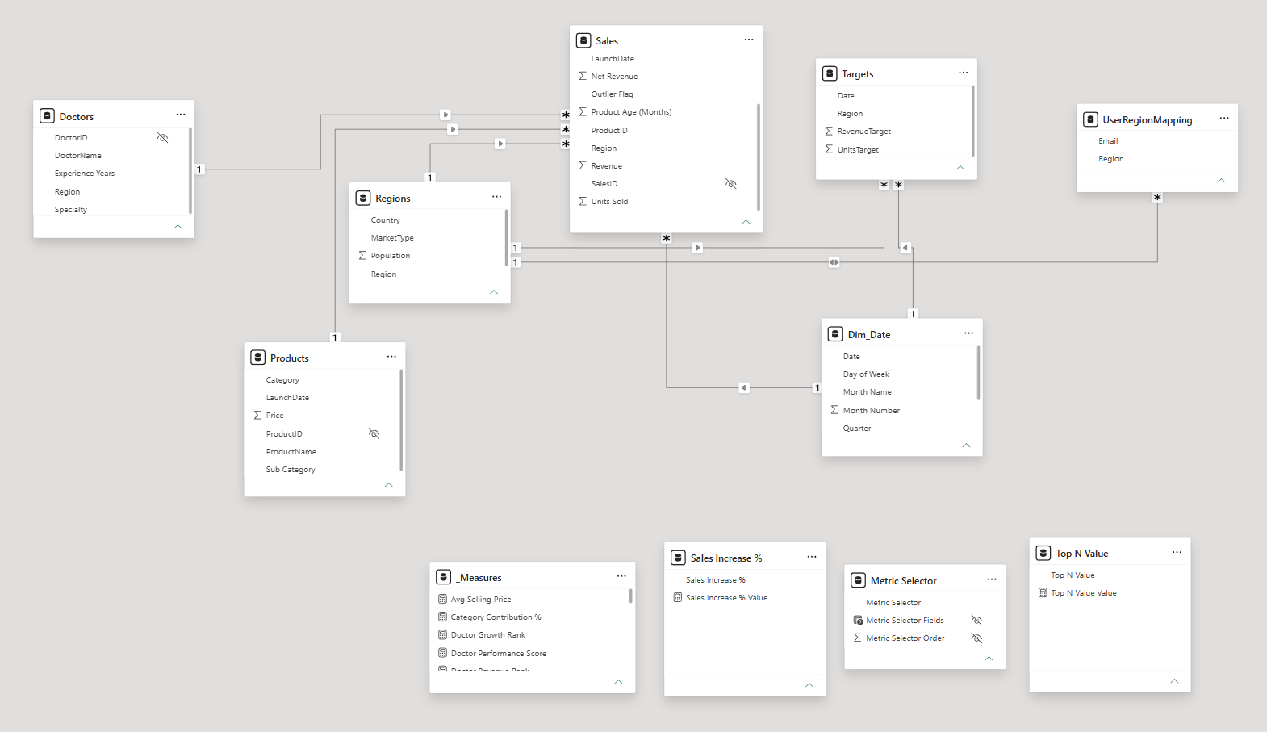
A snapshot of the Power BI Model view showcasing the final Star Schema architecture. The Sales fact table sits at the center, surrounded by the Products, Doctors, Regions, and Dim_Date dimension tables. All core relationships are configured as one-to-many (1:*), single-direction filtering from the dimensions down to the fact table to ensure optimal VertiPaq engine performance.
You can also see the deliberate hiding of primary/foreign keys (indicated by the crossed-out eye icons on fields like DoctorID and ProductID) to keep the report layer clean for end-users. At the bottom, disconnected tables are utilized for advanced UI functionality, including a dedicated _Measures table for DAX organization, and parameter tables (Sales Increase %, Metric Selector, and Top N Value) that drive the dashboard's interactive what-if scenarios and dynamic axes. Finally, the UserRegionMapping table is wired into Regions to facilitate the Dynamic Row-Level Security (RLS) requirements.
Why we don’t need surrogate keys here below
Architectural Justification: Bypassing Surrogate Keys
In dimensional modeling, surrogate keys (auto-incrementing integers) are typically introduced to handle changing source systems, composite keys, or anomalies in natural business keys (such as nulls, duplicates, or changing values). However, introducing them adds overhead to the ETL (Extract, Transform, Load) process.
Because the source data provided is pristine, generating surrogate keys would introduce unnecessary complexity without yielding any structural benefits. Below is the exact reasoning for retaining the natural keys across the model.
1. Flawless Data Quality and Inherent Uniqueness The primary driver for avoiding surrogate keys here is the absolute cleanliness of the incoming natural keys.
- In (Doctors), the DoctorID column profile explicitly shows 120 distinct, 120 unique values.
- In (Products), the ProductID column shows 15 distinct, 15 unique values.
- In (Sales), the SalesID shows 1000 distinct, 1000 unique values. Furthermore, the Power Query column quality indicators across all these tables confirm 100% Valid, 0% Error, and 0% Empty records. Surrogate keys are meant to fix dirty data; here, there is nothing to fix.
2. Standardized, Stable Alphanumeric Structures The business keys in this dataset are highly structured and standardized. Instead of long, messy strings, the identifiers follow a strict, predictable format (D001 for Doctors, P101 for Products, S00001 for Sales). Because these keys are short, deterministic, and likely immutable (a product ID like P101 is unlikely to change its core meaning), they perform perfectly well in relational joins. They essentially function as system-generated keys already.
3. Direct Readability in Fact Tables By retaining the natural business keys in the fact tables, the data remains highly readable during the transformation and auditing phases without requiring joins.
- Looking at (Targets), the grain is set by Date and Region. Using the natural text value for Region (e.g., "North", "South") makes the Targets fact table immediately interpretable.
- Similarly, the Region table uses a simple 5-value text string as its primary key. If a surrogate integer key (1 through 5) had been used, any analyst querying the fact tables directly would lose context without joining back to the Region dimension.
4. Optimized ETL Processing Generating surrogate keys requires additional overhead in Power Query (e.g., buffering tables, adding index columns, and performing multiple merge operations to swap natural keys for surrogate keys in the fact tables). By using the validated, anomaly-free natural keys natively present in the dataset, the data refresh operations will be significantly faster and less prone to step-evaluation failures.
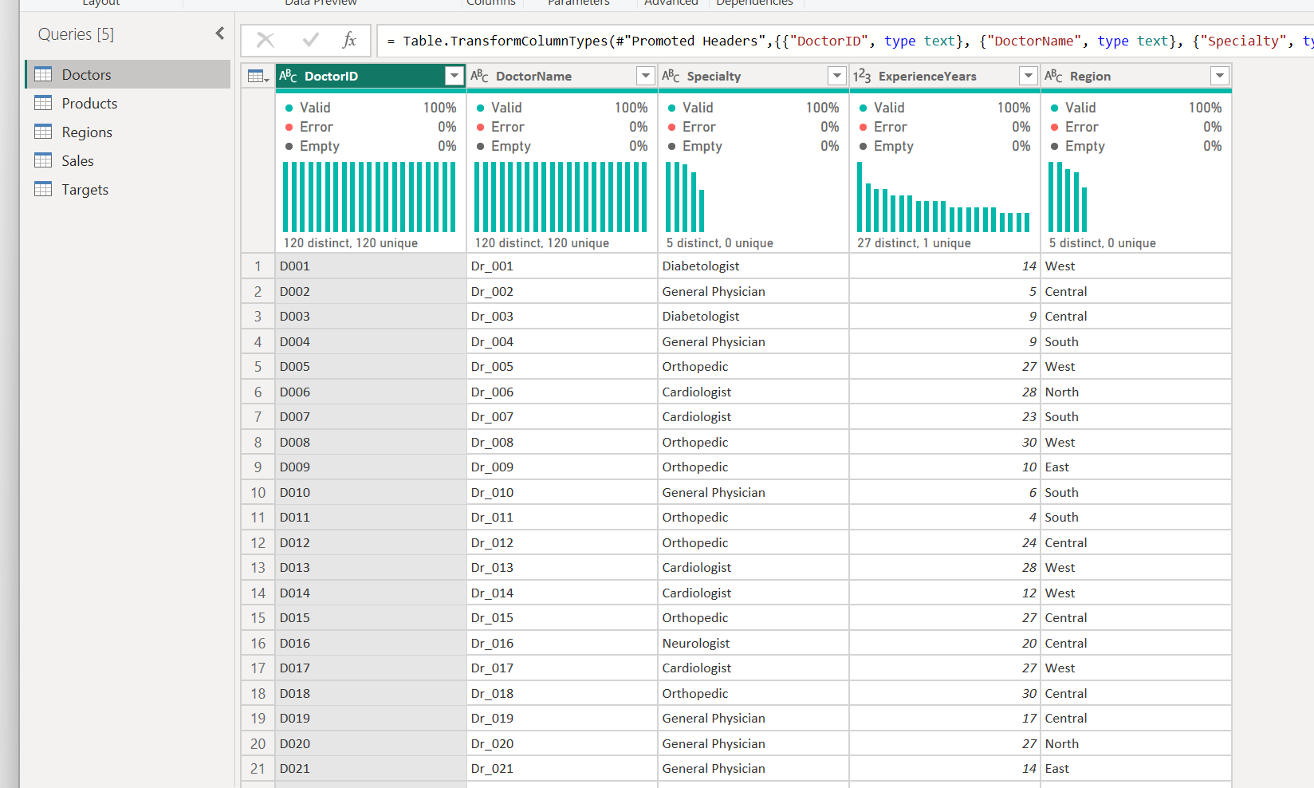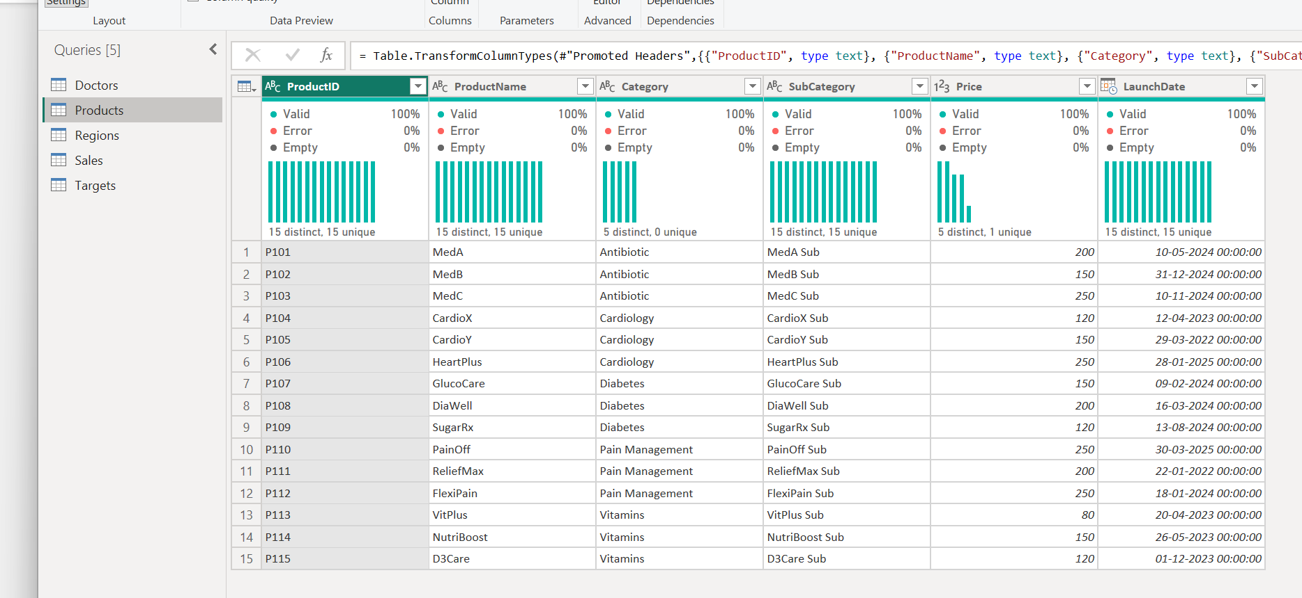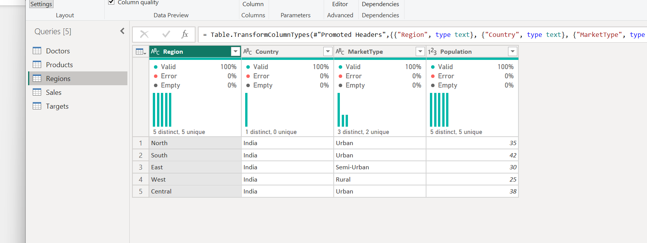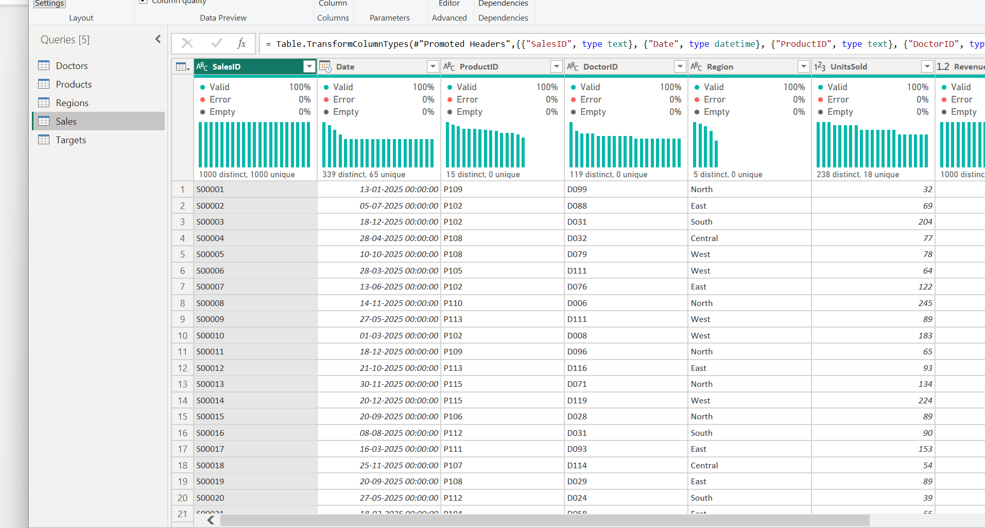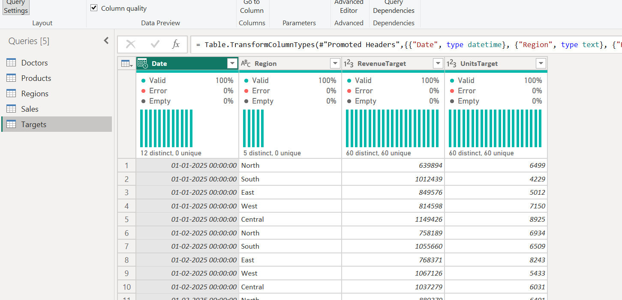

Null values in discountPct
During the initial data profiling phase in Power Query, the column quality metrics for the Sales table highlighted a critical data anomaly. The DiscountPct column showed a 5% 'Empty' (null) rate. I quickly noticed the downstream impact of this: because my Net Revenue calculation multiplies the base Revenue by the discount, the nulls cascaded through the formula, causing a matching 5% error/empty rate in the Net Revenue column.
To resolve this data loss, I implemented a data quality step to handle the nulls before doing the math. Missing or null DiscountPct values were imputed to 0 under the assumption that no discount was applied if not recorded. This simple transformation completely resolved the cascading nulls and ensured 100% validity across all final financial metrics.
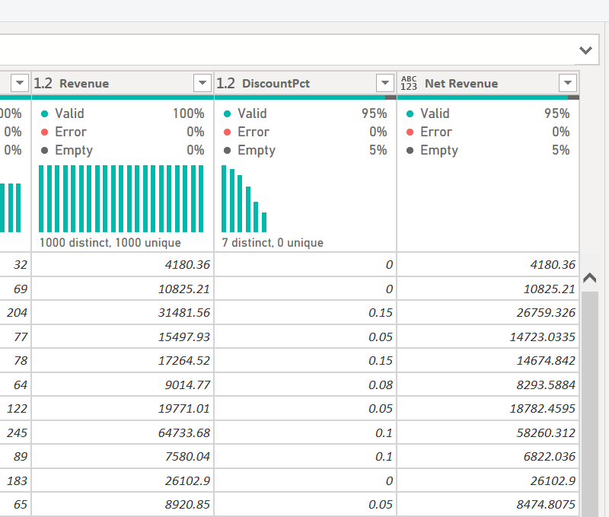
Just canceled the step made it nulls into 0 and then continued
Note.
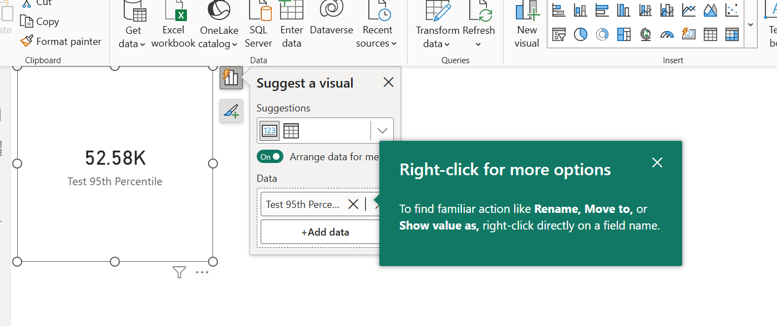
Test 95th Percentile = PERCENTILE.INC(Sales[Revenue], 0.95)
YoY Growth % returns blank because the dataset only spans a single year (2025); the measure is implemented correctly and would populate against a second year of data."
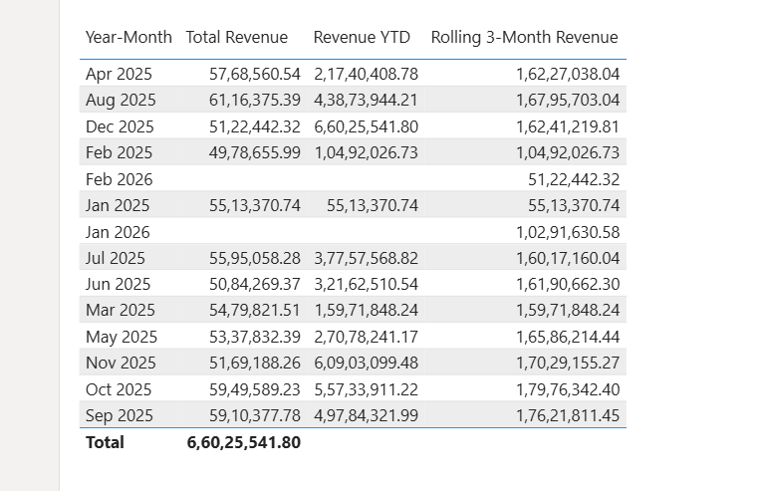
CALENDAR ( DATE(2025,1,1), DATE(2025,12,31) ),
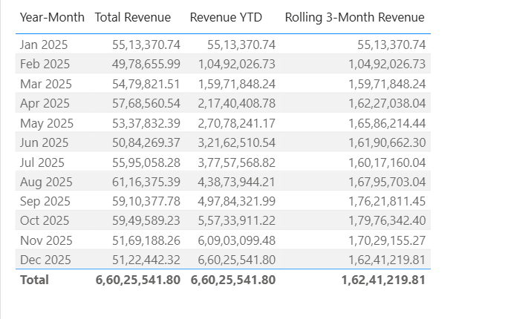
"Targets were consistently exceeded across all months in 2025"
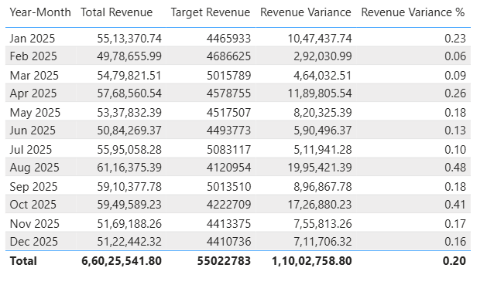
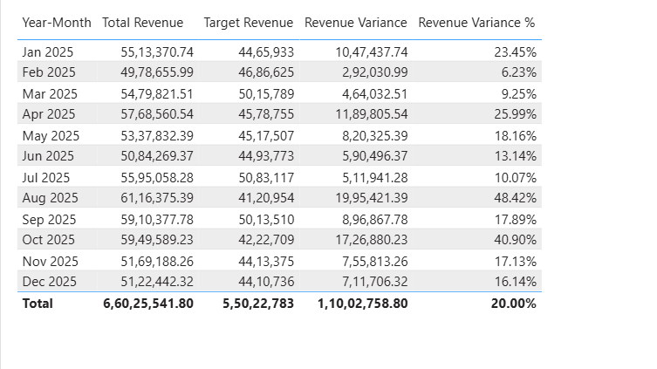
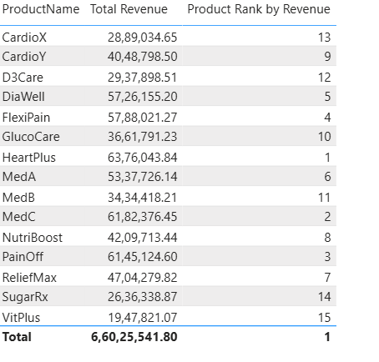
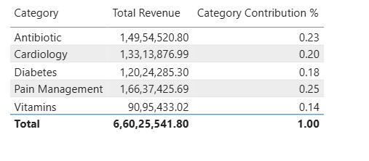
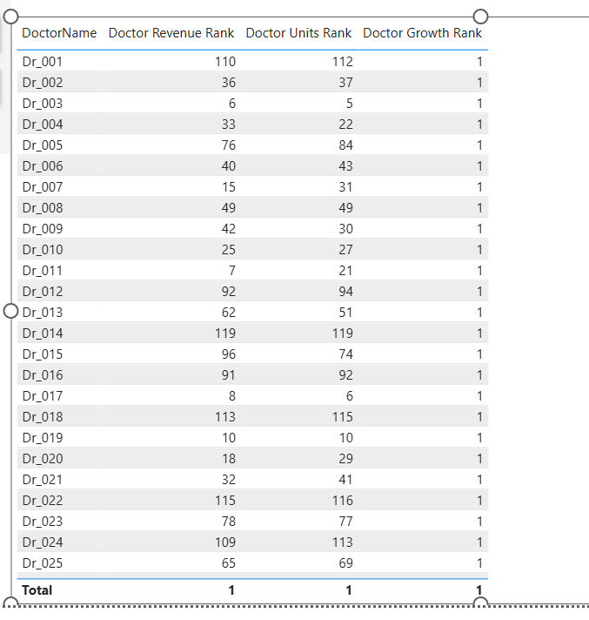
The Growth component contributes equally to every doctor's score, since YoY Growth % cannot be computed with only one year of data (2025) in the dataset — actual differentiation in the score comes from Revenue and Units.
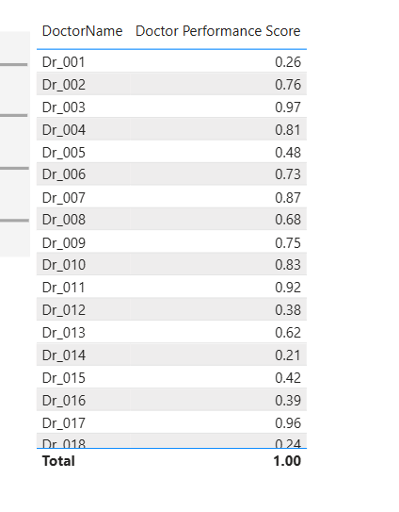
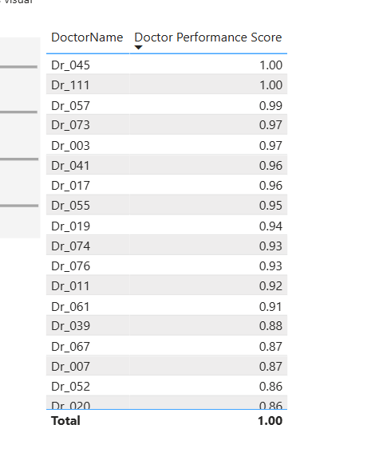
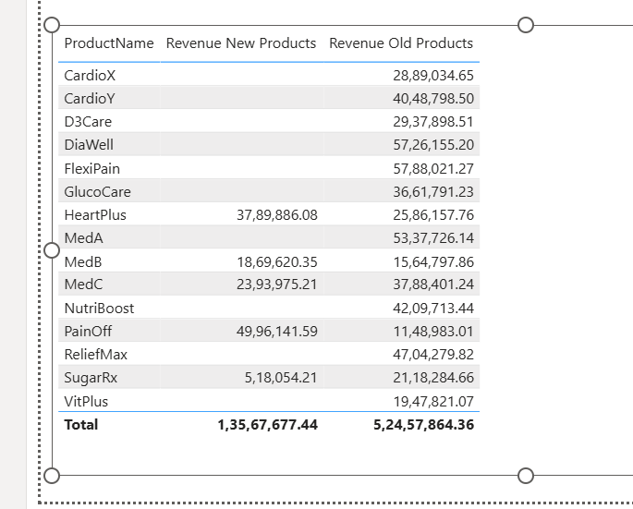
Total revenue splits as ₹1.36Cr from "new" sales vs ₹5.25Cr from "established" sales — meaning most of your revenue in 2025 came from products that had already been on the market a while, not from recent launches. That's expected and reasonable.
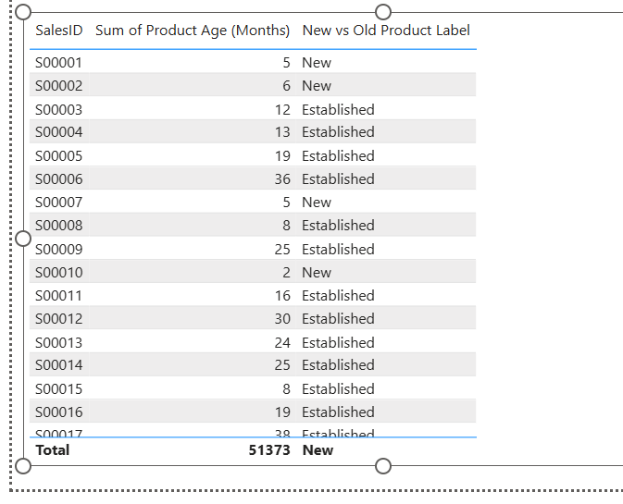

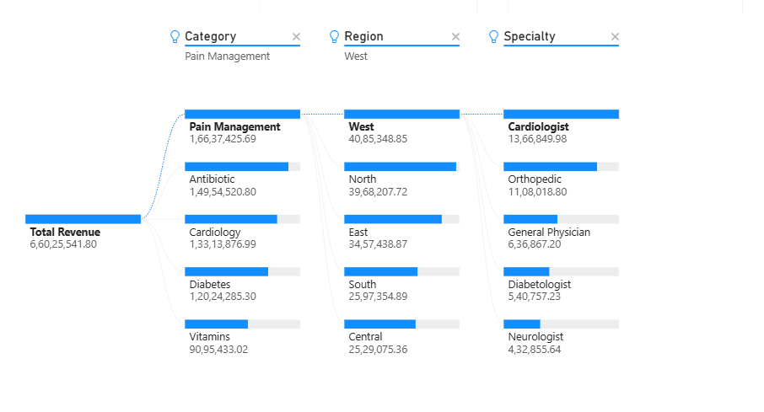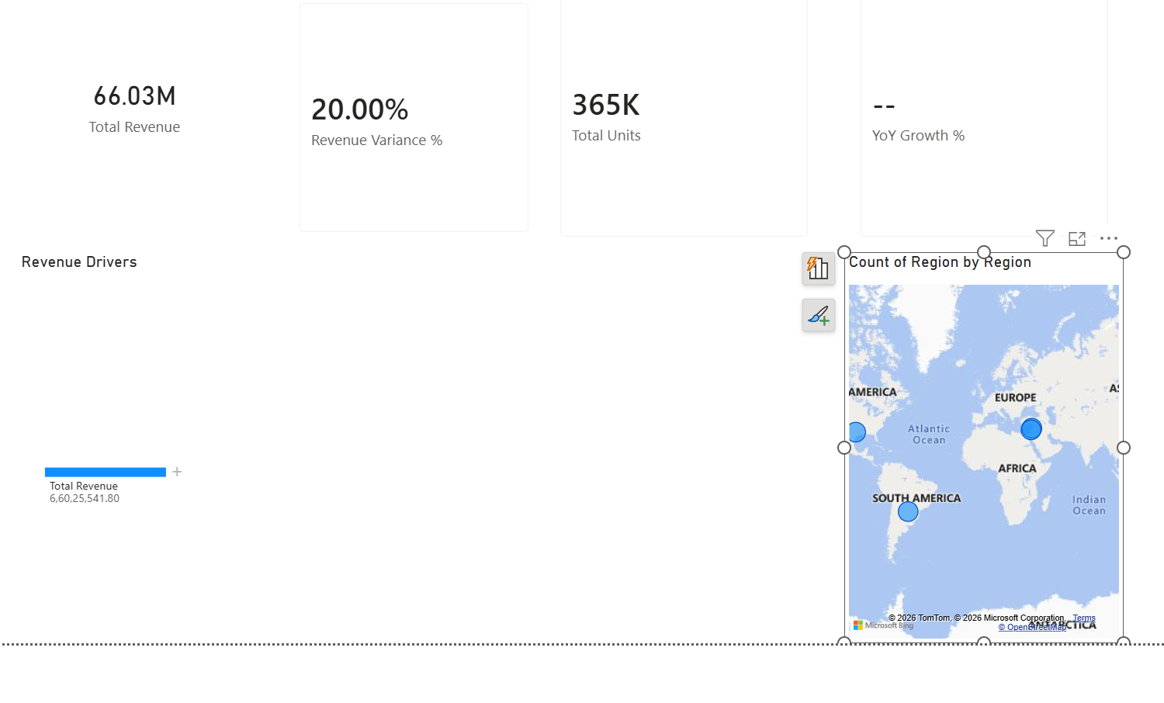
Region Location was derived by combining Region and Country fields to enable map geocoding; bubble positions represent approximate directional zones within India, not precise territory boundaries.
Forecast length was set to 3 months, chosen to keep the projection proportionate to the 12 months of historical data available — extending further would reduce reliability given the limited historical window.
net revenue was set to text I just changed it to decimal
Executive Summary Page
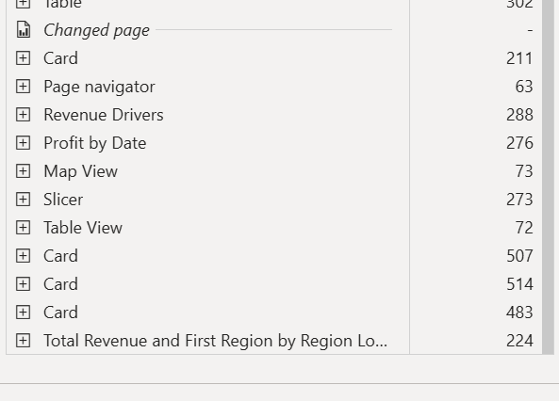
Product Analytics
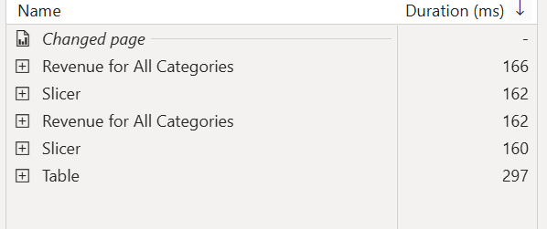
Doctor Insight
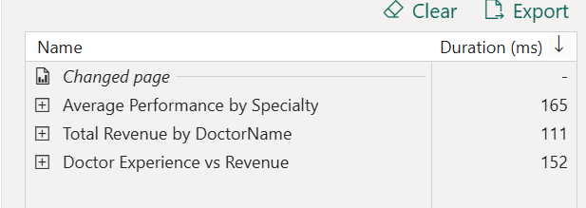
Trend Analysis
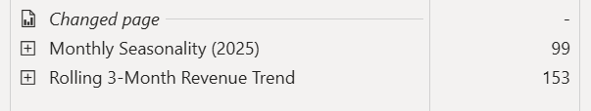
Doctor Details
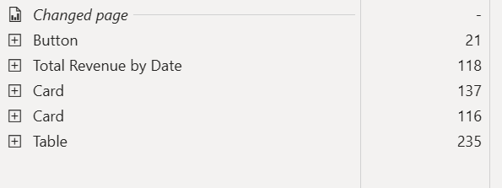

Product details
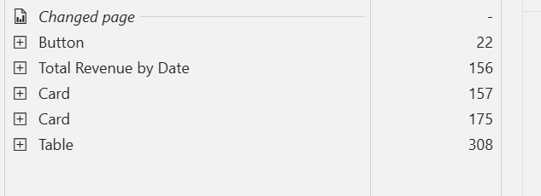
Category Tooltip
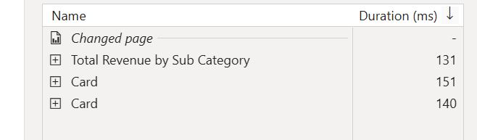
Performance Analyzer was run across all four dashboard pages. The majority of visuals loaded in under 300ms, with only a brief ~500ms spike on the initial page load (a normal one-time cache warm-up cost). No performance bottlenecks were identified, consistent with the dataset's modest size (2,800 rows) and the model's single-direction star schema design.
True page-level security (role-based hiding of specific report pages) is not available in Power BI Desktop. While Power BI Service supports RLS and workspace-level permissions, it does not provide native per-page visibility controls based on user roles. The standard industry workaround in both Desktop and Service is conditional visual visibility driven by DAX measures (e.g., Is Admin User), or distributing separate reports to different audiences via Power BI Apps.
Final View of everything:

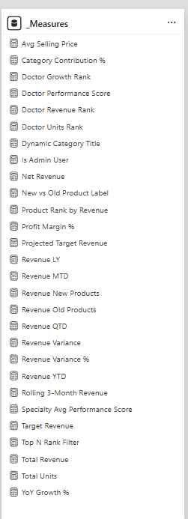

To ensure a clean, maintainable, and enterprise-ready semantic model, all DAX calculations were consolidated into a dedicated, centralized _Measures table. This architectural choice prevents calculations from being scattered across various fact and dimension tables, making the model infinitely easier to manage and audit.
As seen in the repository list, the DAX architecture spans several layers of analytical complexity. It houses foundational business aggregations (such as Total Revenue and Net Revenue), along with a robust suite of Time Intelligence metrics (Revenue YTD, Revenue MTD, and Rolling 3-Month Revenue). It also contains highly specific custom KPIs, like the weighted Doctor Performance Score. Furthermore, this table acts as the engine for the dashboard's interactivity and security, housing UI-driven logic like the Dynamic Category Title and the Is Admin User measure engineered for our conceptual Page-Level Security workaround.

The Executive Summary Page:
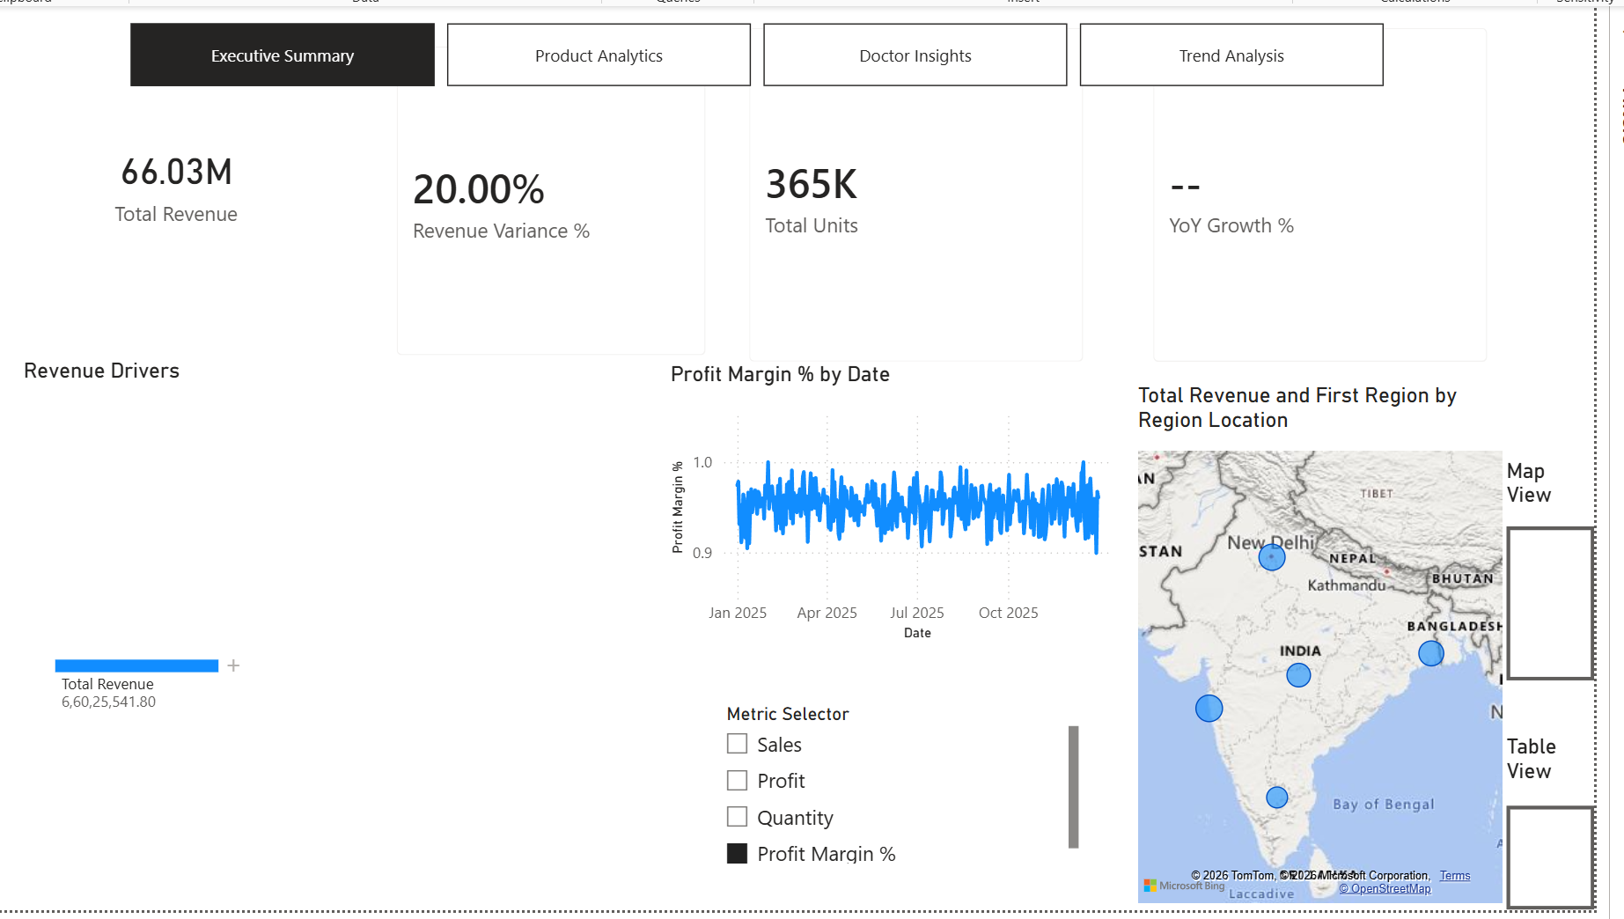
The Objective: To provide executives with a centralized, high-level overview of core KPIs, geographic performance, and overall target attainment.
Technical Implementation: This page leverages a native Page Navigator at the top for seamless cross-report routing. I integrated a Decomposition Tree on the left for interactive root-cause analysis of revenue drivers. Additionally, a custom Field Parameter (Metric Selector) dynamically alters the central line chart's Y-axis, while bookmark-driven buttons on the right allow users to instantly toggle between Map and Table views without leaving the canvas. The YoY Growth % card correctly returns blank, mathematically reflecting the Time Intelligence DAX behaviour on a dataset spanning a single fiscal year.
Key Insight: The KPI cards immediately highlight a robust business performance with a 20.00% positive revenue variance against set targets. Concurrently, the interactive map confirms broad market penetration across India, while the selected profit margin trend line reveals consistent, tight daily volatility throughout FY 2025.
Product Analytics
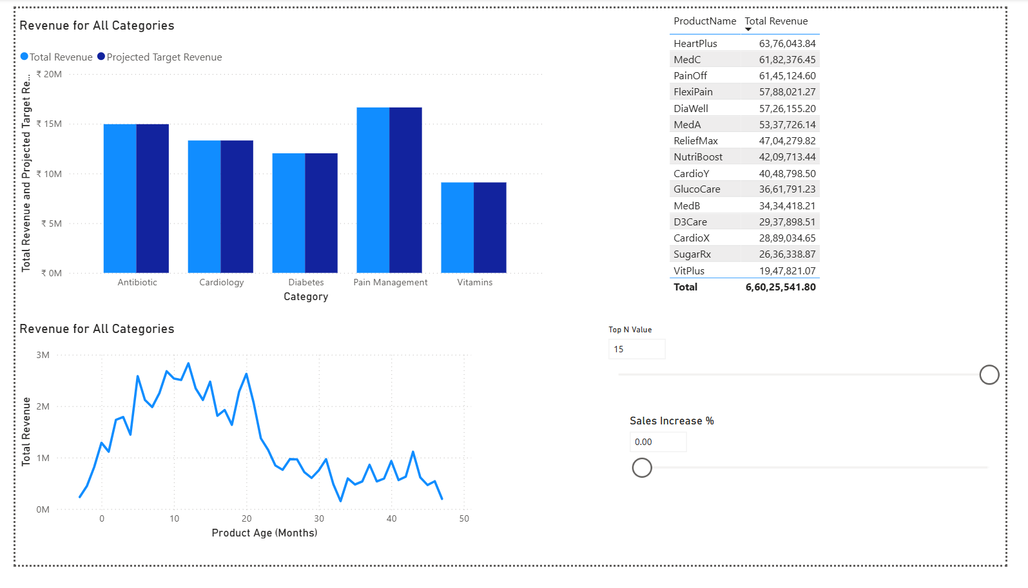
The Objective: To analyze the pharmaceutical portfolio's performance, evaluate product lifecycle trends, and provide stakeholders with interactive tools to simulate future revenue scenarios.
Technical Implementation: This page heavily integrates advanced DAX parameters, featuring a dynamic "Top N Value" slicer to filter the product matrix on demand and a custom "What-If" parameter (Sales Increase %) to model hypothetical revenue adjustments. The visual titles (e.g., "Revenue for All Categories") are context-aware, engineered using the SELECTEDVALUE function to update dynamically based on user interactions. Furthermore, the lifecycle line chart leverages the derived Product Age (Months) field to map revenue against the time elapsed since launch.
Key Insight: The product lifecycle analysis visually indicates that revenue typically peaks between the 10 to 20-month mark post-launch before experiencing a gradual decline. Concurrently, the clustered column chart reveals that Pain Management and Antibiotics are the highest-grossing categories, while the matrix highlights 'HeartPlus' and 'MedC' as the dominant individual SKUs, each driving over ₹6.1 million in revenue.

Doctor Insight
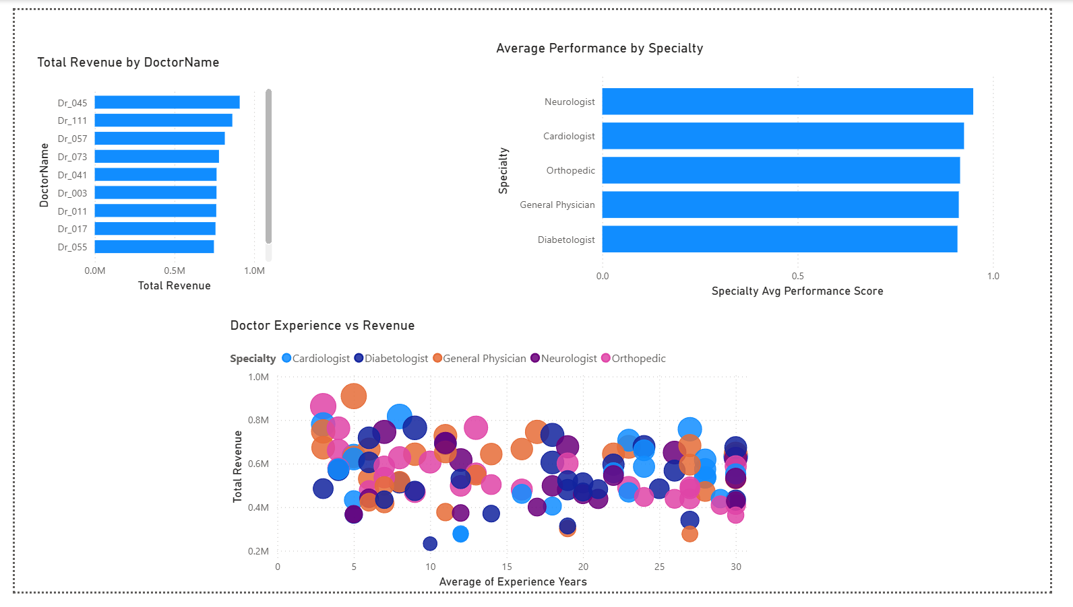
The Objective: To analyze physician prescribing behaviors and evaluate performance across medical specialties to identify high-value contributors.
Technical Implementation: Built a complex scatter plot mapping the X-axis as Experience, the Y-axis as Revenue, and Bubble Size as Total Units Sold, all segmented by a categorical specialty legend. Integrated a ranked bar chart to highlight top individual doctors and utilized the custom-weighted Doctor Performance Score DAX measure to evaluate specialty-wide average performance. This page was also configured to support drill-through functionality, allowing users to right-click specific doctors to access granular detail pages.
Key Insight: The scatter plot demonstrates a dispersed relationship between tenure and sales, revealing that high revenue generation is driven by prescription volume (indicated by larger bubble sizes) rather than a doctor's years of experience. Furthermore, while specific individuals like 'Dr_045' lead in absolute total revenue, the composite performance scores are remarkably balanced across the board, with Neurologists displaying a very slight overall advantage.

Trend Analysis
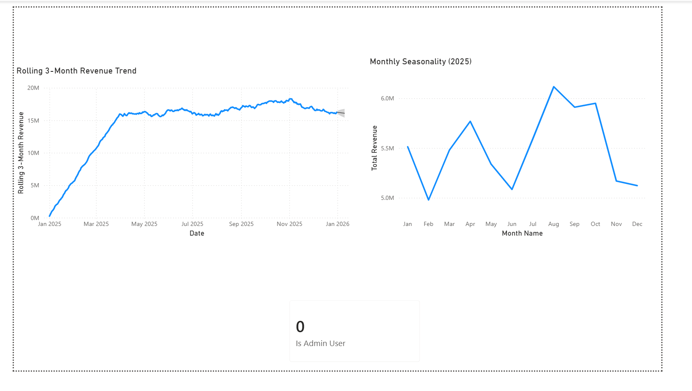
The Objective: To smooth out monthly volatility, uncover seasonal revenue patterns throughout the fiscal year, and project near-term performance using built-in predictive analytics.
Technical Implementation: Engineered a Rolling 3-Month Revenue DAX measure to construct the primary trend line, smoothing short-term fluctuations. The native Power BI forecasting feature was applied to this visual to project a constrained 3-month future horizon, visible as the grey confidence interval at the far right. Crucially, this page also serves as the testing ground for the conceptual Page-Level Security workaround; the Is Admin User card currently evaluates to 0, successfully proving the DAX logic detects a non-admin login.
Key Insight: The monthly seasonality chart exposes a distinct revenue peak in August, followed by a slight tapering toward the end of the year. Meanwhile, the forecasting model projects continued stability into early 2026; however, this forecast horizon was deliberately constrained to three months to avoid statistical overfitting, given the model is trained on only a single 12-month historical window.

