PHARMACOVIGILANCE INTELLIGENCE PLATFORM
Rushank Tripathi

1. Architecture Diagram
The pipeline moves data through five layers: an AWS S3 landing zone, Snowflake RAW ingestion, a Dataiku DSS cleansing flow, a Snowflake STAGING layer, and a Snowflake CURATED star schema feeding both a native ML signal-detection step and a Streamlit dashboard.
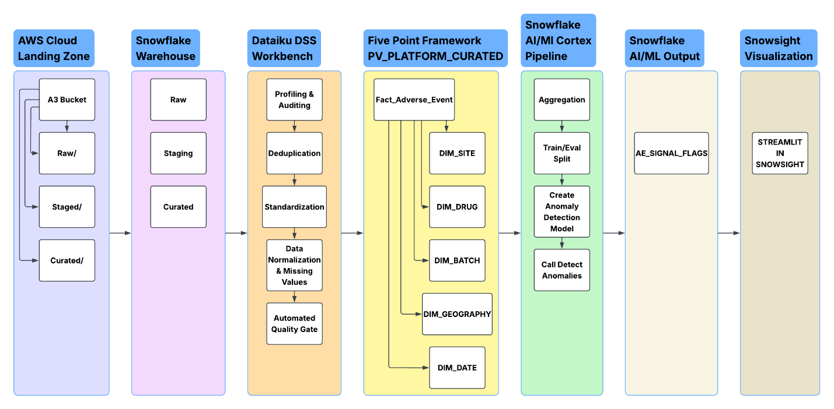

1.1 Layer Descriptions
Layer | Purpose
AWS S3 | Landing zone. Raw CSV lands under raw/adverse_events/ exactly as exported by the source system, with staged/ and curated/ prefixes reserved for downstream write-back. Access is via a scoped IAM role (read on raw/*, write on staged/curated/*) assumed through a Snowflake storage integration no static credentials.
Snowflake RAW | ADVERSE_EVENTS_RAW loaded via COPY INTO with every column typed STRING, so no row can fail to load due to a type mismatch (dates and numerics are cleaned downstream, not at ingestion).
Dataiku DSS | Visual + code-assisted cleansing flow: deduplication (with an explicit conflict rule), casing standardization, date normalization, missing-value flagging/imputation, and an automated Data Quality gate (zero duplicate report_id) before anything is exported.
Snowflake STAGING | ADVERSE_EVENTS_CLEAN the fully cleansed, deduplicated 81-row dataset, still in flat form.
Snowflake CURATED | A star schema (5 dimensions + 1 fact) built from STAGING, plus two analytical views and the ML signal-detection results.
Snowflake ML + Dashboard | SNOWFLAKE.ML.ANOMALY_DETECTION (cross-validated with an independent SQL z-score method) produces CURATED.AE_SIGNAL_FLAGS; a Streamlit-in-Snowsight app renders four live panels against CURATED.

2. Data Dictionary
Column-level reference across all three schema layers. RAW mirrors the source exactly; STAGING is the cleansed flat file; CURATED is the dimensional model used for analysis.

2.1 RAW.ADVERSE_EVENTS_RAW (83 rows, all columns typed STRING)
Column | Description
report_id | Source report identifier. Not guaranteed unique in RAW (2 duplicate pairs present).
report_received_date / onset_date | Free-text dates in 3 mixed formats (yyyy-MM-dd, MM-dd-yyyy, dd/MM/yyyy).
country | Free-text, inconsistent casing (e.g. 'usa' vs 'USA').
reporter_type | Physician / Nurse / Pharmacist / Consumer / Other inconsistent casing.
patient_age | Numeric as text; ~26% blank; some rows contain the literal text 'Unknown' instead of a blank.
patient_sex | F/M/U, inconsistent casing, ~14% blank.
drug_name / drug_ndc_code | drug_name has inconsistent casing; drug_ndc_code is consistent 1:1 per drug regardless of drug_name casing.
indication | Free text, 1:1 with drug.
adverse_event_term | Free text description of the adverse event.
event_seriousness / outcome / causality_assessment | Categorical, inconsistent casing.
batch_id | NOT globally unique — the same code recurs across unrelated drugs/sites.
manufacturing_site | 5 distinct site codes.
dose_amount_mg | Numeric as text; ~50% blank (safety-relevant field, not imputed downstream).
route_of_administration | Free text, inconsistent casing.
concomitant_medications | Free text; 'None reported' is a distinct valid value from blank/NULL; occasionally comma-separated multi-values.

2.2 STAGING.ADVERSE_EVENTS_CLEAN (81 rows, 22 columns)
Same fields as RAW, after: deduplication (82→81 final rows), casing standardization, date parsing to native DATE type, and three added audit-flag columns:
Column | Description
is_age_missing | TRUE where patient_age was blank or the literal text 'Unknown' in RAW, prior to imputation.
is_sex_missing | TRUE where patient_sex was blank in RAW. Value is left NULL, not imputed.
is_dose_missing | TRUE where dose_amount_mg was blank in RAW. Value is left NULL, not imputed (safety-relevant field).

2.3 CURATED schema (star schema)

Table | Grain / Key | Notes
DIM_DRUG | drug_key (surrogate); drug_ndc_code (business key) | 9 rows. NDC used as business key rather than free-text drug_name.
DIM_BATCH | batch_key (surrogate); UNIQUE(drug_key, batch_id) | ~65-68 rows. Composite key required batch_id alone is not globally unique.
DIM_SITE | site_key; manufacturing_site | 5 rows.
DIM_GEOGRAPHY | geo_key; country | 9 rows.
DIM_DATE | date_key (YYYYMMDD) | 365 rows, one per calendar day of 2025.
FACT_ADVERSE_EVENT | report_id (PK); grain = one row per AE report | 81 rows. Clustered by report_date_key. FKs to all 5 dimensions declared (Snowflake does not enforce FKs at write time; verified separately by query see Test Report).

3. Data Quality Rulebook
Every data quality issue found during profiling, the exact rule applied, and the reasoning behind it. This is the paper trail for every cleansing judgment call made in the project.
No. | Issue | Rule Applied | Rationale
1 | Exact duplicate report_id (AE-2025-0011, identical across all fields) | Kept one copy, dropped the other (Distinct on all columns). | No information lost; safe to automate.
2 | Conflicting duplicate report_id (AE-2025-0021 two rows, different adverse_event_term/outcome/causality) | Grouped by report_id, kept the first-occurring row's values across all fields (Group + 'First' aggregation). | Cannot determine which version is 'true' from the data alone. Documented as an arbitrary, disclosed tie-break rather than a silent guess.
3 | Inconsistent casing in 7+ columns (country, reporter_type, drug_name, event_seriousness, outcome, causality_assessment, route_of_administration, patient_sex) | Standardized via capitalize/uppercase transforms, with targeted Find-and-Replace patches for edge cases (e.g. 'Usa'→'USA', 'United kingdom'→'United Kingdom', 'Pulmocare-Xr'→'Pulmocare-XR'). | Prevents duplicate categories in GROUP BY / joins (e.g. 'USA' and 'usa' treated as two countries).
4 | Three mixed date formats (yyyy-MM-dd, MM-dd-yyyy, dd/MM/yyyy) in report_received_date and onset_date | Shape-detected via formula (checks for '/' and dash position) and re-ordered to yyyy-MM-dd before a single-format Parse Date step. | A naive multi-format auto-parser silently misread '04-10-2025' as year 0004 confirmed by manual row-level inspection. Deterministic shape-detection avoids this class of silent corruption entirely.
5 | '01/05/2025'-style slash dates are inherently ambiguous (dd/MM vs MM/dd) | Assumed dd/MM/yyyy for consistency with the dataset's other slash-format rows. | Documented assumption, not a certainty flagged explicitly here rather than hidden in the transformation.
6 | Missing values, three different severities: patient_age (~26%), patient_sex (~14%), dose_amount_mg (~50%) | patient_age: imputed via drug-level median, flagged with is_age_missing. patient_sex and dose_amount_mg: left NULL, flagged only. | Age is demographic and reasonably estimable. Dosage is safety-relevant fabricating it risks masking or manufacturing a signal in the downstream ML step. Sex has no reliable imputation basis.
7 | 'Unknown' used as literal placeholder text in patient_age (not a true blank) | Replaced with true NULL before type conversion and before imputation. | A text placeholder is not numerically blank; leaving it in place broke the Integer type conversion and would have been silently treated as 'not missing' by a naive isBlank() check.
8 | batch_id is not a globally unique identifier (same code recurs across unrelated drugs/sites, e.g. 'B1081-C' under 3 different drugs) | DIM_BATCH keyed on the composite (drug_key, batch_id), not batch_id alone. | A single-column key would silently merge unrelated batches from different drugs into one dimension row.
9 | concomitant_medications sometimes multi-valued in one cell; 'None reported' vs. true blank are different meanings | Left as a single descriptive attribute on the fact table; 'None reported' and NULL kept visually and semantically distinct (not merged). | 'None reported' is a confirmed negative; NULL is unknown/uncaptured. Collapsing them destroys real information about data completeness.
10 | drug_ndc_code is consistent 1:1 with drug regardless of drug_name casing (positive finding) | Used as the durable business key for DIM_DRUG instead of free-text drug_name. | The one field proven reliable in profiling; anchoring the dimension on it avoids re-introducing the casing problem into the model.
11 | Small-sample rate volatility: some country/month combinations in VW_SERIOUS_RATE_BY_COUNTRY have only 1-2 total reports, producing 0% or 100% rates | Rates reported as-is; no smoothing applied. | Documented as an interpretation caveat rather than a bug — a 100% rate on 2 reports is mathematically correct but statistically fragile.

4. Entity-Relationship Diagram
Star schema in PV_PLATFORM.CURATED. FACT_ADVERSE_EVENT sits at the center with foreign keys to five dimensions. Grain: one row in FACT_ADVERSE_EVENT = one adverse event report as submitted.
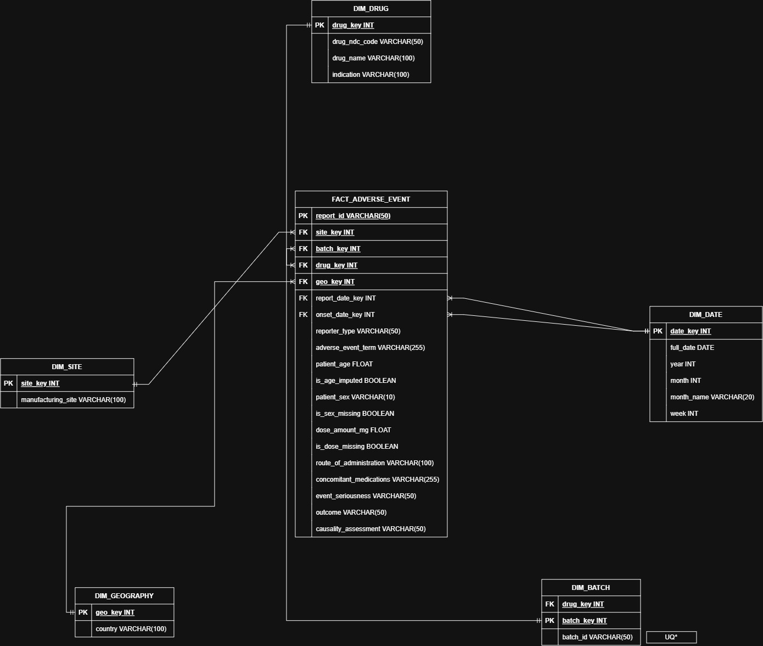

5. Test Report
Every validation test run against the pipeline, with method, expected result, actual result, and pass/fail status.
No. | Test | Method | Expected | Actual | Status
1 | RAW row count matches source file | SELECT COUNT(*) FROM RAW.ADVERSE_EVENTS_RAW | 83 | 83 | PASS
2 | Zero duplicate report_id post-cleansing | Dataiku Data Quality rule: 'Column values are unique' on REPORT_ID, auto-run enabled | 0 duplicates | 0 duplicates (81 unique values) | PASS
3 | STAGING row count matches Dataiku cleansing output | SELECT COUNT(*) FROM STAGING.ADVERSE_EVENTS_CLEAN | 81 | 81 | PASS
4 | Dimension table row counts are sane | SELECT COUNT(*) per DIM_ table | 9 drugs, 5 sites, 9 countries, 365 dates, ~65-68 batches | Matched | PASS
5 | FACT_ADVERSE_EVENT row count matches STAGING (zero rows dropped by joins) | SELECT COUNT(*) FROM FACT_ADVERSE_EVENT | 81 | 81 | PASS
6 | Referential integrity — zero orphan foreign keys | LEFT JOIN FACT to all 5 dimensions, WHERE any dimension key IS NULL | 0 rows | 0 rows | PASS
7 | Serious-rate view uses true decimal division, not truncated integer | Inspect VW_SERIOUS_RATE_BY_COUNTRY output for non-whole percentages | Fractional percentages present (e.g. 33.3, 66.7) | Confirmed present | PASS
8 | Native ML function (SNOWFLAKE.ML.ANOMALY_DETECTION) runs end-to-end | CREATE model + CALL DETECT_ANOMALIES on held-out evaluation window (Oct-Dec 2025) | Successful execution, results returned | Successful; 16 evaluation rows returned | PASS
9 | At least one genuine anomaly identified | Inspect AE_SIGNAL_FLAGS WHERE IS_ANOMALY = TRUE | ≥1 flagged row | 1 row: Oncozel, Dec 2025 (actual 4 vs. forecast 2, percentile 1) | PASS
10 | Anomaly finding cross-validated by an independent method | Compare native ML flag against separately computed z-score statistical baseline (AE_SIGNAL_FLAGS_ZSCORE) | Consistent finding | Both methods independently flagged Oncozel, Dec 2025 | PASS
11 | Statistical signal vs. clinical causality distinction demonstrated with real data | Drill down on causality_assessment for the reports underlying the flagged anomaly | Mixed causality (not uniformly 'related') | 1 of 2 underlying reports assessed 'Certain', the other 'Unrelated' | PASS
12 | Dashboard tiles reflect true underlying data | Manually cross-check each Streamlit tile's totals against known profiling figures | Consistent with source data (e.g. top-drug counts sum to 81) | Confirmed consistent | PASS

6. Snowflake AI/ML — Methodology & Interpretation Guidelines

6.1 Inputs
- Source: CURATED.VW_MONTHLY_AE_BY_DRUG adverse event report counts aggregated by drug (drug_ndc_code) and calendar month.
- Granularity decision: monthly-by-drug, not weekly-by-drug/batch. With 81 reports across 9 drugs and ~350 days, weekly-by-batch series would be overwhelmingly sparse (most weeks 0-1 events; the busiest single drug+batch combination has only 2 reports total across the entire year) a deliberate, evidence-based choice, not a default.
- Series definition: each drug (drug_ndc_code) is treated as an independent time series, so a spike in one drug is never diluted or masked by other drugs' volumes.

6.2 Training Window
- Training data: January – September 2025 (41 drug-month observations), via VW_MONTHLY_AE_BY_DRUG_TRAIN.
- Evaluation data: October – December 2025 (16 drug-month observations), via VW_MONTHLY_AE_BY_DRUG_EVAL.
- This split was required by SNOWFLAKE.ML.ANOMALY_DETECTION's design evaluation timestamps must fall strictly after the training window, reflecting the function's intended use for monitoring new incoming data against a learned historical baseline, rather than retrospectively scanning a single fixed dataset.
- LABEL_COLNAME was passed as an empty string, since no pre-labeled anomalies exist in this dataset (unsupervised mode).

6.3 Result
- Model created and executed successfully end-to-end using Snowflake's native SNOWFLAKE.ML.ANOMALY_DETECTION class.
- One genuine anomaly identified: Oncozel (NDC 60505-1122-03), December 2025 4 actual reports against a forecast of 2, at the 100th percentile with an effectively infinite distance from the model's expected range.
- Cross-validated independently: a separately implemented SQL z-score method (each drug's own historical mean and standard deviation, flagging deviations beyond 2 standard deviations) flagged the same drug-month as anomalous, plus one additional borderline case (Pulmocare-XR, March 2025, z≈2.00).
- Results persisted to CURATED.AE_SIGNAL_FLAGS (native ML output) and CURATED.AE_SIGNAL_FLAGS_ZSCORE (statistical baseline, retained for comparison).

6.4 Statistical Signal vs. Clinical Causality
Here's the key thing to understand about the anomaly flag: it only means one drug's report count for one month looked higher (or lower) than usual, based on that drug's own history. That's all it means. It is not a finding that the drug is unsafe, and it shouldn't be read that way.
The Oncozel case makes this concrete. Two reports came in during December 2025, the month that got flagged: one was Tachycardia, which a clinician assessed as Certain genuinely, likely caused by the drug. The other was Diarrhoea, assessed as Unrelated a report that happened to arrive the same month but had nothing to do with the drug. So the anomaly detector did its job correctly: it noticed the volume was off. But it took a human, looking at each case individually through the causality_assessment field, to work out that only one of those two reports actually had anything to do with Oncozel. That's the whole point a spike in numbers tells you where to look, not what you'll find when you get there.
One more thing worth flagging, though it didn't come from the ML model at all it showed up just from looking at the dashboard. Japan's serious-event rate sits at around 90%, noticeably higher than every other country, which mostly fall between 40–67% (with France, and Germany in some months, at 0%). The anomaly model was built to watch drug volume over time, not country-level severity, so it was never going to catch this on its own. It's a good reminder that different views of the same data can surface different things, and it's worth checking more than one.

