PERCEPTION

* CONSUMER PERCEPTION ON DIGITAL PAYMENT
* CONSUMER PERCEPTION ON FOOD APPS

The Indian online food industry is expected to grow up to $12.3 billion by 2023. The global growth is 9.01%, the online food delivery market in India is growing at a rate of 15%. Swiggy has sales of $1.5 billion, whereas Zomato is at sales of $800 million. Jointly both the companies have delivered 96 million orders from April 2017 to March 2018. (Visakhapatnam News, 2020)

**OBJECTIVES** of this research is to examine the consumer perception on food apps and to analyse the factors that influences consumer perception towards food apps.

**CONSUMERS PERCEPTION ON FOOD APPS**

***Survey taken in 2020 by “143 respondents”***

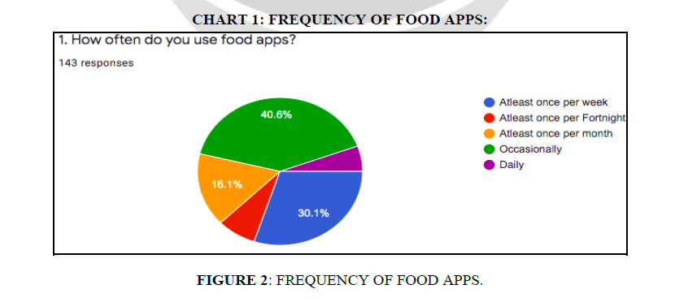

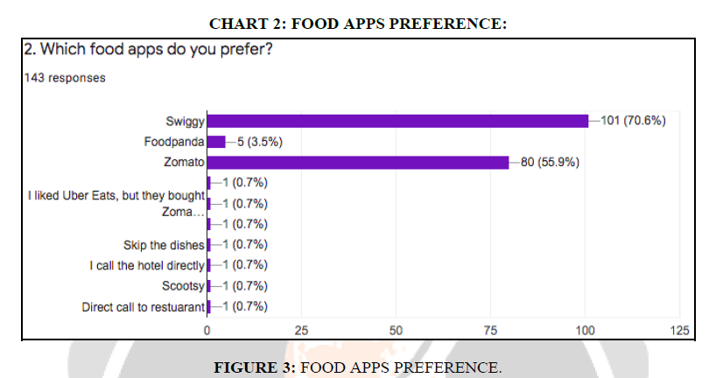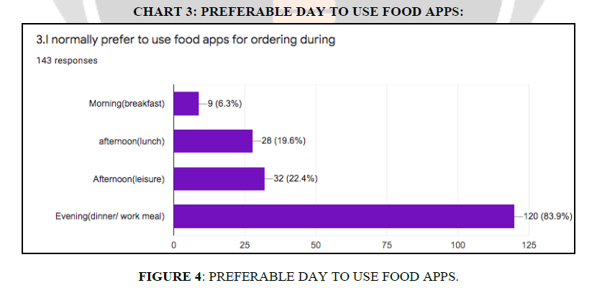

**FACTORS AFFECTING PREFERENCE**

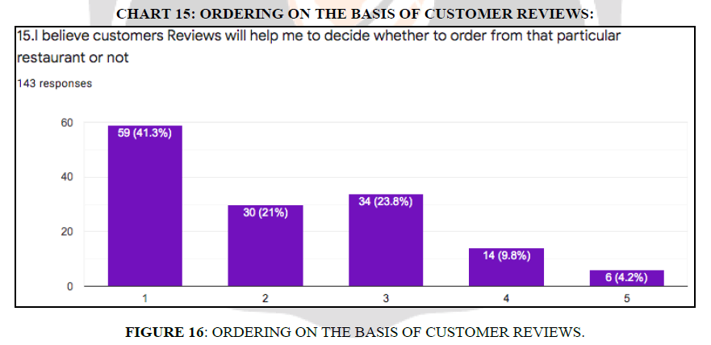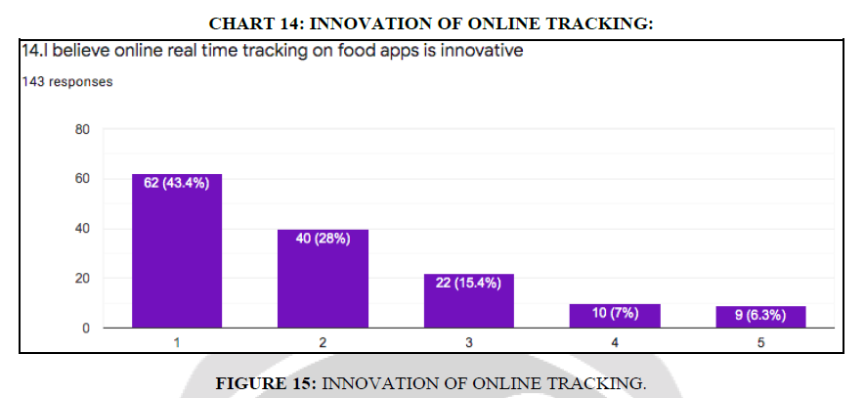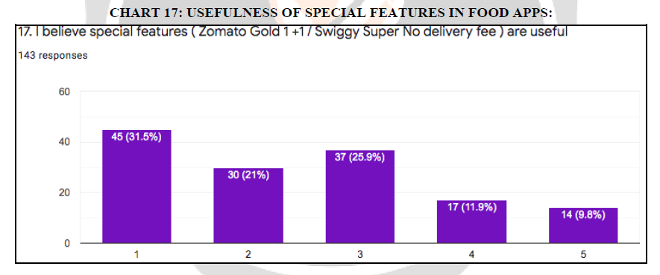

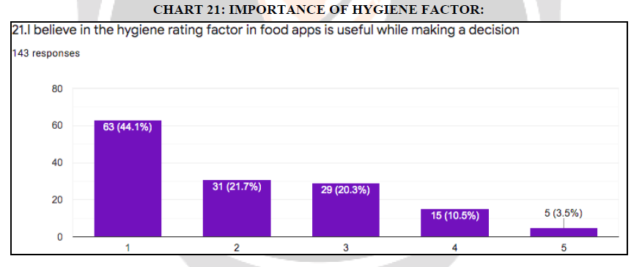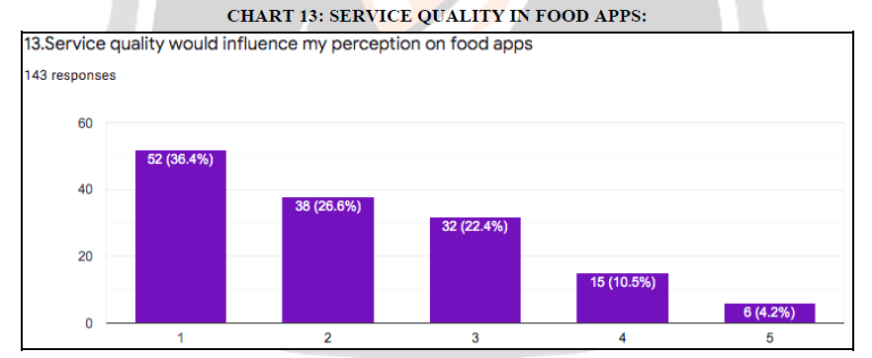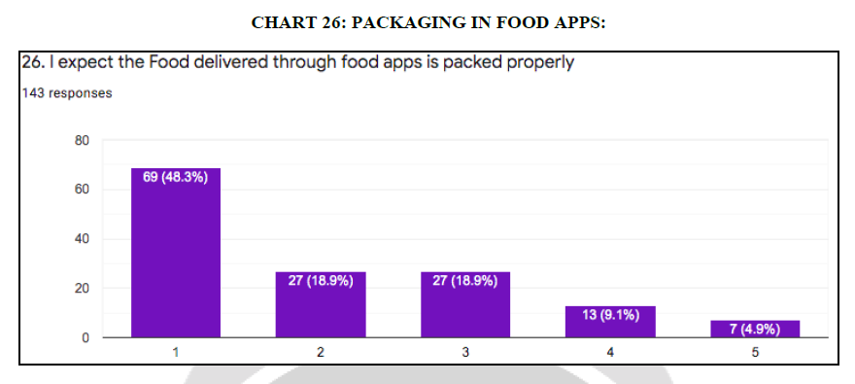

HYGIENE

PAYMENT MODE

