Alliance School of Advanced Computing

Course Name: GRAPH ANALYTICS
Course Code: E1ITC 302
Assignment No: 2

Name of the Student: Annagiri Ruthika sai Priya

Registration Number:2411021060257

A. Title of The Problem:
[HackerRank] Snakes and Ladders: The Quickest Way Up

B. Problem Statement in details:
Snakes and Ladders: The Quickest Way Up
This is a classic graph / BFS (Breadth-First Search) problem. It is commonly solved using BFS because every dice roll has the same cost: 1 move.
Problem idea
You are given a Snakes and Ladders board with cells numbered from 1 to N.
- You start at cell 1.
- Your goal is to reach cell N.
- On each move, you roll a standard 6-sided die.
- Therefore, from cell x, you can normally move to:
x + 1
x + 2
x + 3
x + 4
x + 5
x + 6
provided the resulting cell does not exceed N.
However, some cells contain:
- Ladders → they take you up to another cell.
- Snakes → they take you down to another cell.
For example:
Cell 3 → Ladder → Cell 22
Cell 27 → Snake → Cell 5
If you land on cell 3, you immediately move to 22.
If you land on cell 27, you immediately move to 5.
The question is:

What is the minimum number of dice rolls needed to reach the final cell?
If it is impossible to reach the final cell, return -1.
C. HackerRank/Leetcode Link of the problem (If applicable):
Snakes and Ladders: The Quickest Way Up | HackerRank
D. Student’s Github link of report and code upload, along with the readme file:
Hacker-rank-problems/Assignment-2 at main · Ruthika013/Hacker-rank-problems
E. Solution Steps/Algorithm:
- Read the number of test cases and the size of the Snakes and Ladders board.
- Store all ladders and snakes in an array or map.
- Start the game from cell 1.
- Use Breadth-First Search (BFS) to explore all possible positions.
- From the current cell, consider all possible dice values from 1 to 6.
- Calculate the next cell using:
next = current + dice.
- If the next cell contains a snake or ladder, move directly to its destination.
- If the destination cell has not been visited, mark it as visited.
- Store the number of dice rolls required to reach the new cell.
- Continue BFS until the final cell is reached.
- Return the minimum number of dice rolls.
12.f the final cell cannot be reached, return -1.
F. Code developed: from collections import deque

def quickestWayUp(ladders, snakes):
jump = {i: i for i in range(1, 101)}
for a, b in ladders:
jump[a] = b
for a, b in snakes:
jump[a] = b

q=deque([(1, 0)])
visited = {1}
while q:
pos, rolls = q.popleft()
if pos == 100:
return rolls
for dice in range(1, 7):
nxt = pos + dice
if nxt <= 100:
nxt = jump[nxt]
if nxt not in visited:
visited.add(nxt)
q.append((nxt, rolls + 1))
return -1
G. HackerRank test case passed Screenshot or Output screenshot (Mandatory): 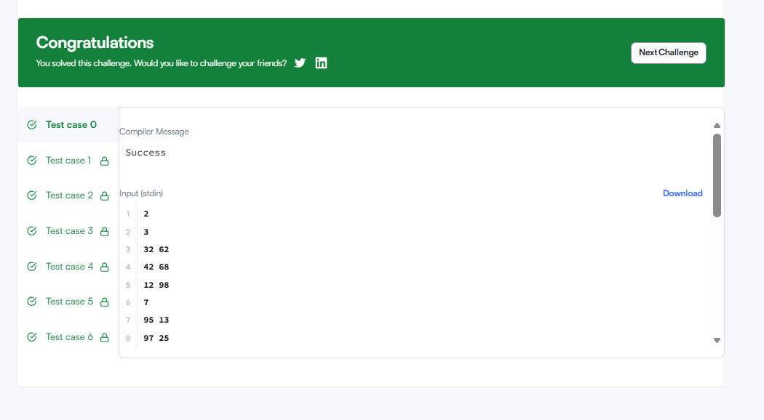

H. Observation:
The Snakes and Ladders board can be treated as a graph.
BFS is used to find the minimum number of dice rolls.
Each dice roll allows movement of 1 to 6 cells.
Snakes move the player down, while ladders move the player up.
The visited set prevents repeated processing of the same cell.
The algorithm returns the minimum number of rolls needed to reach cell 100.
If cell 100 cannot be reached, it returns -1.

