Alliance School of Advanced Computing

Course Name: GRAPH ANALYTICS
Course Code: E1ITC 302
Assignment No: 5

Name of the Student: Annagiri Ruthika sai Priya

Registration Number:2411021060257

A. Title of The Problem:
University Course Registration System Using Neo4j
B. Problem Statement in details:
Problem Statement: University Course Registration System Using Neo4j
A university needs an efficient system to manage students, faculty members, courses, and academic departments. Managing the relationships among these entities can become complex as the number of students and courses increases.
This project uses Neo4j, a graph database, to represent students, faculty members, courses, and departments as nodes and their connections as relationships. Students can register for courses, faculty members can teach courses, and courses can belong to specific departments.
Using the Cypher query language, the system retrieves information such as courses registered for by students, faculty members teaching particular courses, and courses offered by each department.
The main objective is to demonstrate how graph databases simplify relationship management, efficiently retrieve connected information, and support university academic administration.
C. HackerRank/Leetcode Link of the problem (If applicable):
D. Student’s Github link of report and code upload, along with the readme file:
Ruthika013/Neo4j: University Course Registration System Using Neo4j
E. Solution Steps/Algorithm:
- Open Neo4j AuraDB and create a database instance.
- Create nodes for Student, Faculty, Course, and Department with their respective properties.
- Establish relationships such as ENROLLED_IN, TEACHES, BELONGS_TO, and WORKS_IN.
- Insert sample data using Cypher queries.
- Execute queries to retrieve student registrations, faculty assignments, and department-wise courses.
- Verify the relationships and results using the Neo4j Browser visualization.
- Save the Cypher queries and their outputs for documentation.
- Continue BFS until the final cell is reached.
- Return the minimum number of dice rolls.
12.f the final cell cannot be reached, return -1.

F. Code developed: from collections import deque

// 1. Create Student, Faculty, Course and Department nodes
CREATE
(s1:Student {student_id: 1, name: 'Rahul Sharma', semester: 5}),
(s2:Student {student_id: 2, name: 'Priya Reddy', semester: 5}),
(s3:Student {student_id: 3, name: 'Arjun Kumar', semester: 5}),
(s4:Student {student_id: 4, name: 'Sneha Rao', semester: 6}),
(s5:Student {student_id: 5, name: 'Vikram Das', semester: 4}),

(f1:Faculty {faculty_id: 101, name: 'Dr. Meera Sen'}),
(f2:Faculty {faculty_id: 102, name: 'Dr. Ravi Kumar'}),
(f3:Faculty {faculty_id: 103, name: 'Dr. Ananya Rao'}),

(c1:Course {course_id: 201, course_name: 'Graph Analytics', credits: 4}),
(c2:Course {course_id: 202, course_name: 'NoSQL Databases', credits: 3}),
(c3:Course {course_id: 203, course_name: 'Database Systems', credits: 3}),
(c4:Course {course_id: 204, course_name: 'Machine Learning', credits: 4}),

(d1:Department {department_id: 301, name: 'Computer Science'}),
(d2:Department {department_id: 302, name: 'Information Technology'});
// 2. Create relationships with appropriate directions
MATCH (s1:Student {student_id: 1}),
(s2:Student {student_id: 2}),
(s3:Student {student_id: 3}),
(s4:Student {student_id: 4}),
(s5:Student {student_id: 5}),
(f1:Faculty {faculty_id: 101}),
(f2:Faculty {faculty_id: 102}),
(f3:Faculty {faculty_id: 103}),
(c1:Course {course_id: 201}),
(c2:Course {course_id: 202}),
(c3:Course {course_id: 203}),
(c4:Course {course_id: 204}),
(d1:Department {department_id: 301}),
(d2:Department {department_id: 302})
CREATE
(s1)-[:ENROLLED_IN {semester: 5, grade: 'A'}]->(c1),
(s1)-[:ENROLLED_IN {semester: 5, grade: 'A'}]->(c2),
(s2)-[:ENROLLED_IN {semester: 5, grade: 'B+'}]->(c1),
(s2)-[:ENROLLED_IN {semester: 5, grade: 'A'}]->(c3),
(s3)-[:ENROLLED_IN {semester: 5, grade: 'B+'}]->(c1),
(s3)-[:ENROLLED_IN {semester: 5, grade: 'B'}]->(c2),
(s4)-[:ENROLLED_IN {semester: 6, grade: 'A'}]->(c3),
(s5)-[:ENROLLED_IN {semester: 4, grade: 'B'}]->(c4),
(f1)-[:TEACHES {academic_year: '2026-2027'}]->(c1),
(f1)-[:TEACHES {academic_year: '2026-2027'}]->(c2),
(f2)-[:TEACHES {academic_year: '2026-2027'}]->(c3),
(f3)-[:TEACHES {academic_year: '2026-2027'}]->(c4),

(s1)-[:BELONGS_TO]->(d1),
(s2)-[:BELONGS_TO]->(d1),
(s3)-[:BELONGS_TO]->(d2),
(s4)-[:BELONGS_TO]->(d1),
(s5)-[:BELONGS_TO]->(d2),
(f1)-[:WORKS_IN]->(d1),
(f2)-[:WORKS_IN]->(d1),
(f3)-[:WORKS_IN]->(d2),
(c1)-[:BELONGS_TO]->(d1),
(c2)-[:BELONGS_TO]->(d2),
(c3)-[:BELONGS_TO]->(d2),
(c4)-[:BELONGS_TO]->(d1);
// 3. Relationship properties are assigned above.
// 4. Display the complete graph
MATCH (n)-[r]->(m)
RETURN n, r, m;
// 5. Count nodes belonging to each label
MATCH (n)
RETURN labels(n) AS Label, count(n) AS TotalNodes
ORDER BY Label;

// 6. Display all relationship types and directions
MATCH (a)-[r]->(b)
RETURN DISTINCT
labels(a) AS SourceLabel,
type(r) AS RelationshipType,
labels(b) AS TargetLabel;
// 7. Retrieve all students studying in Semester 5
MATCH (s:Student)
WHERE s.semester = 5
RETURN s.name AS StudentName, s.semester AS Semester;
// 8. Find all courses with more than 3 credits
MATCH (c:Course)
WHERE c.credits > 3
RETURN c.course_name AS CourseName, c.credits AS Credits;
// 9. Retrieve courses taught by Dr. Meera Sen
MATCH (f:Faculty {name: 'Dr. Meera Sen'})-[:TEACHES]->(c:Course)
RETURN c.course_name AS CourseName;
// 10. Find all students enrolled in Graph Analytics
MATCH (s:Student)-[:ENROLLED_IN]->(c:Course {course_name: 'Graph Analytics'})
RETURN s.name AS StudentName;
// 11. Find students belonging to Computer Science
MATCH (s:Student)-[:BELONGS_TO]->(d:Department {name: 'Computer Science'})
RETURN s.name AS StudentName;
// 12. Find courses offered by Information Technology
MATCH (c:Course)-[:BELONGS_TO]->(d:Department {name: 'Information Technology'})
RETURN c.course_name AS CourseName;
// 13. Students enrolled in NoSQL Databases with semester and grade
MATCH (s:Student)-[r:ENROLLED_IN]->(c:Course {course_name: 'NoSQL Databases'})
RETURN s.name AS StudentName,
r.semester AS Semester,
r.grade AS Grade;
// 14. Students enrolled in Graph Analytics and at least one other course
MATCH (s:Student)-[:ENROLLED_IN]->(c1:Course {course_name: 'Graph Analytics'}),
(s)-[:ENROLLED_IN]->(c2:Course)
WHERE c1 <> c2
RETURN s.name AS StudentName,
collect(DISTINCT c1.course_name) +
collect(DISTINCT c2.course_name) AS Courses;

G. Output screenshot (Mandatory): 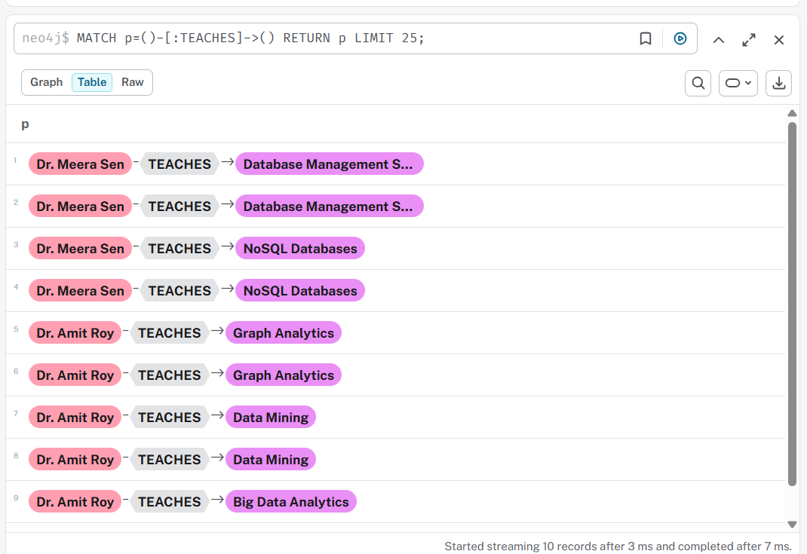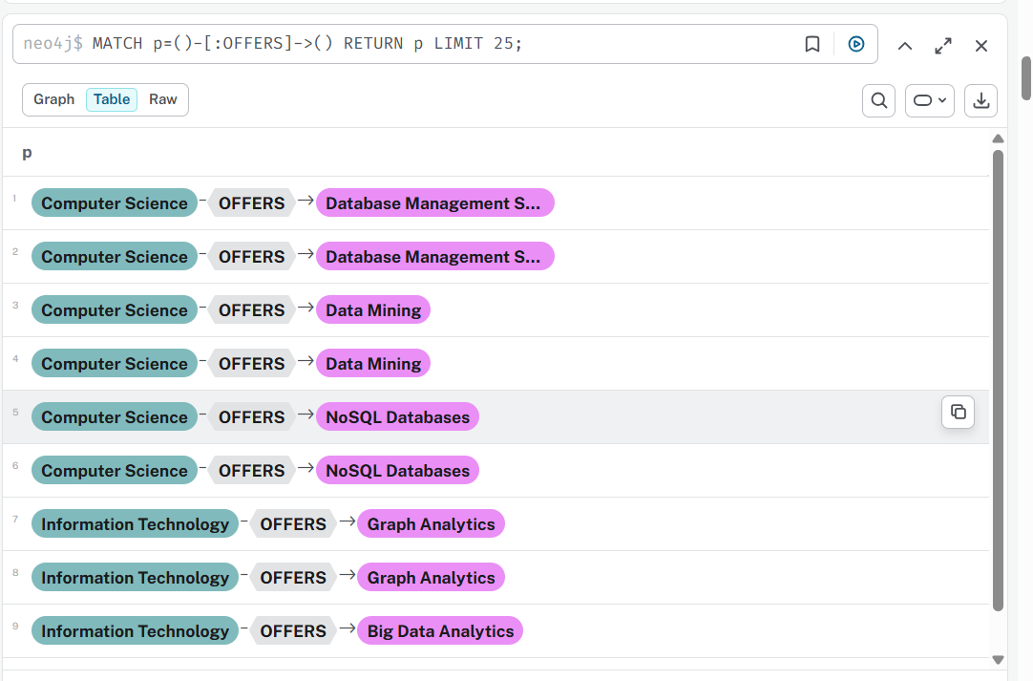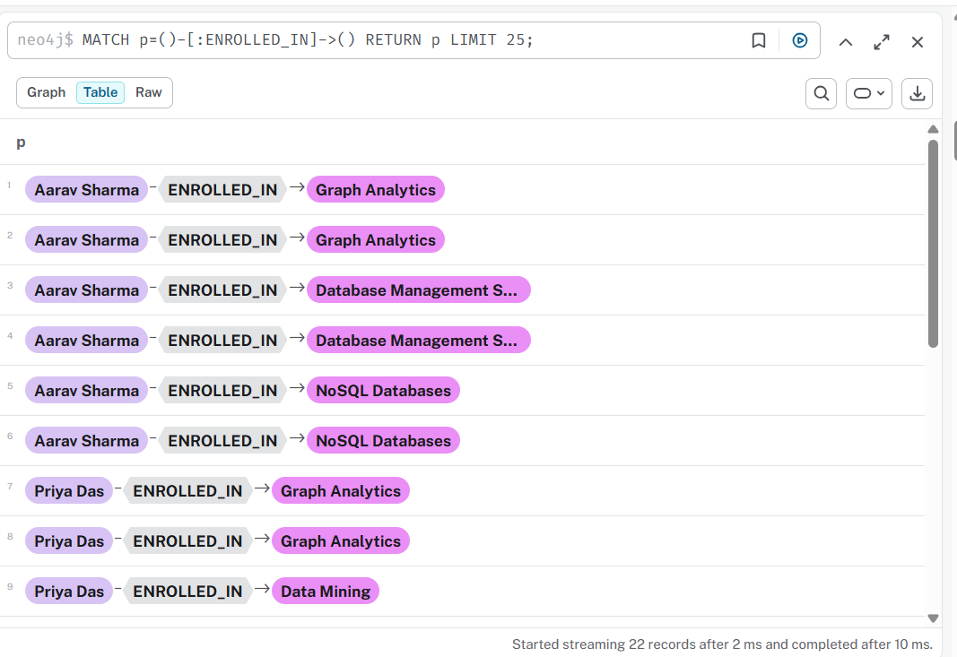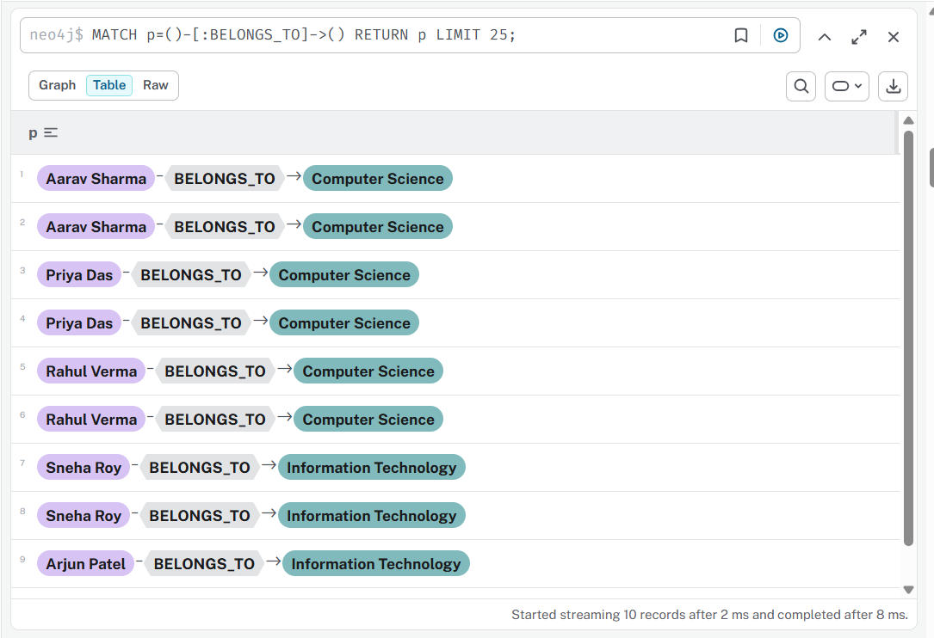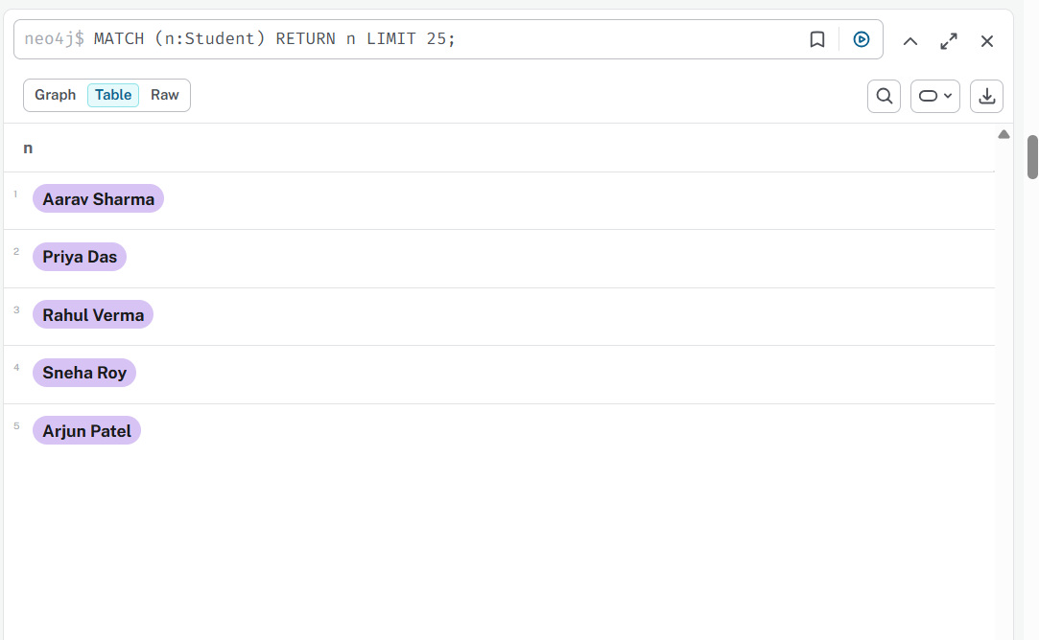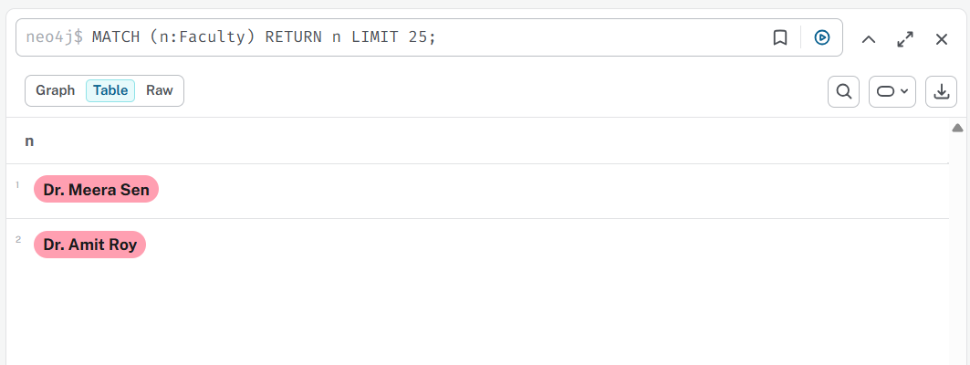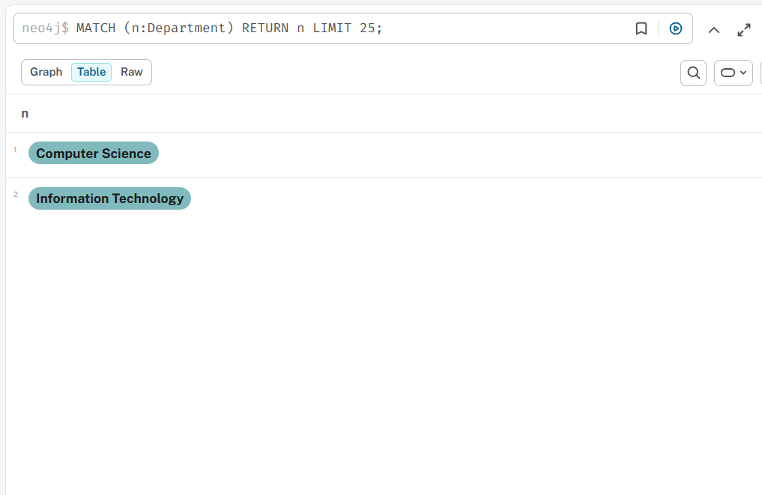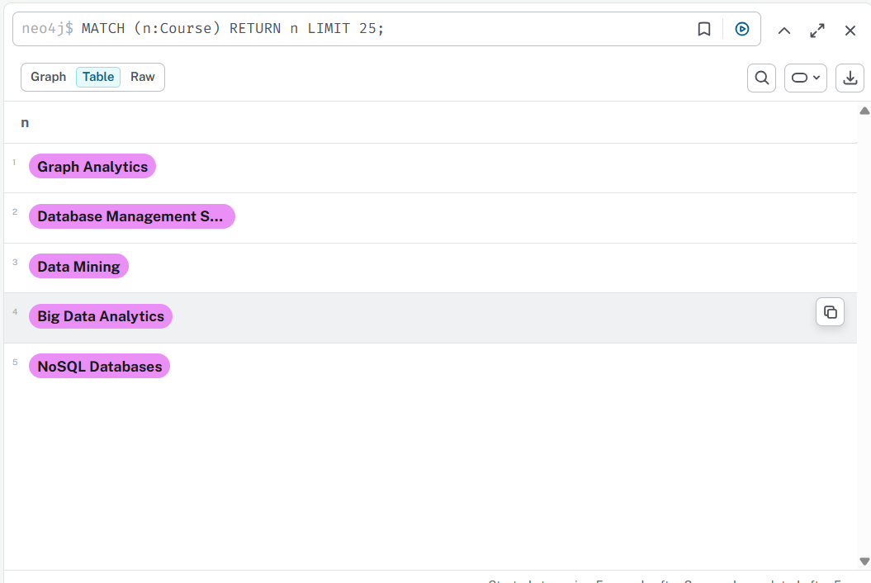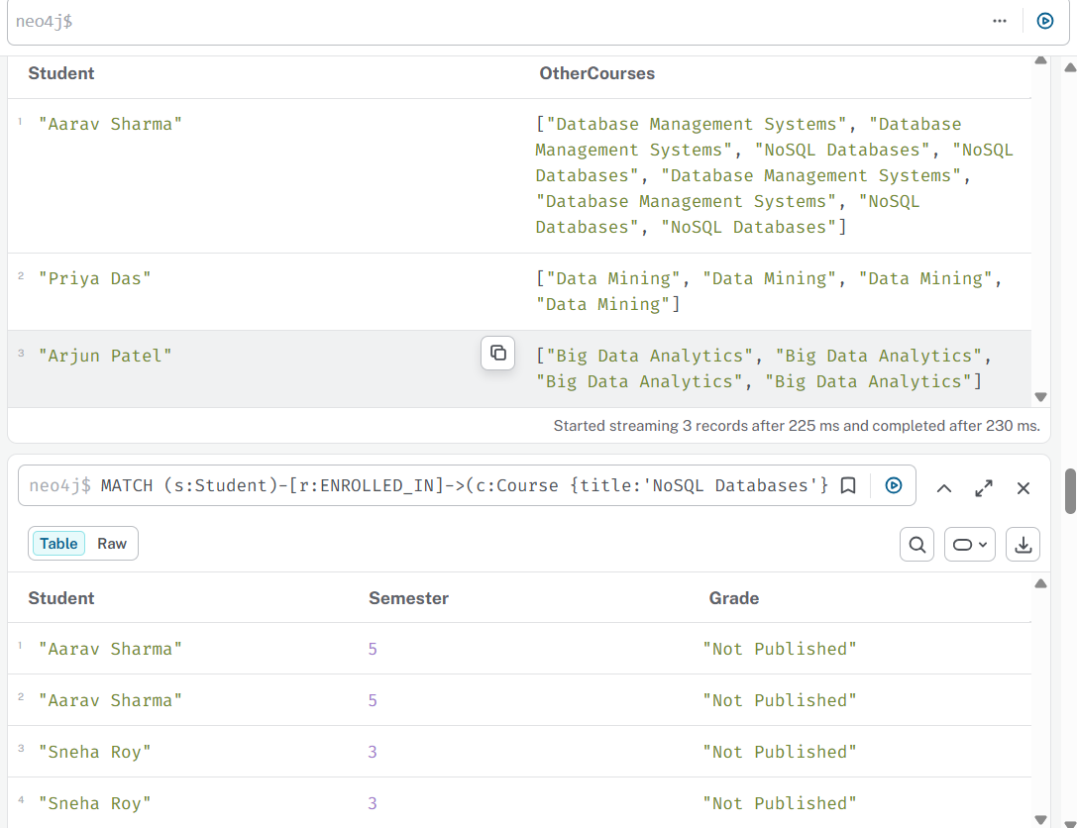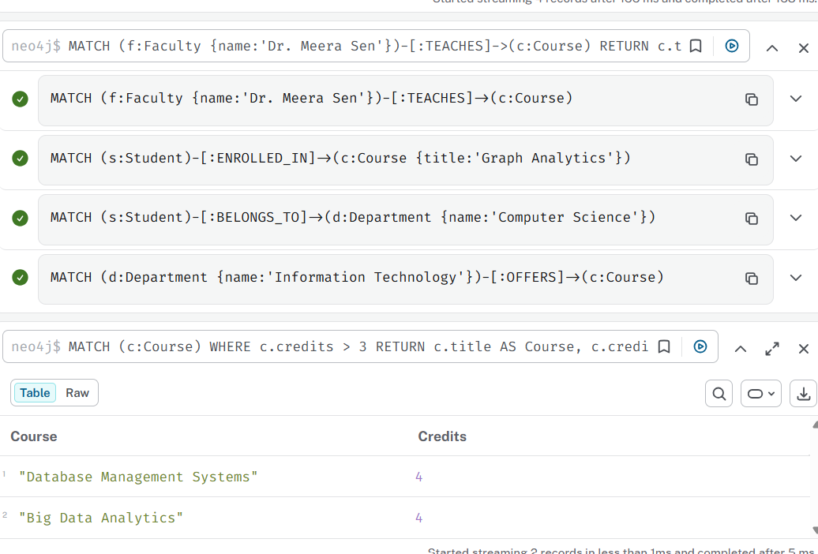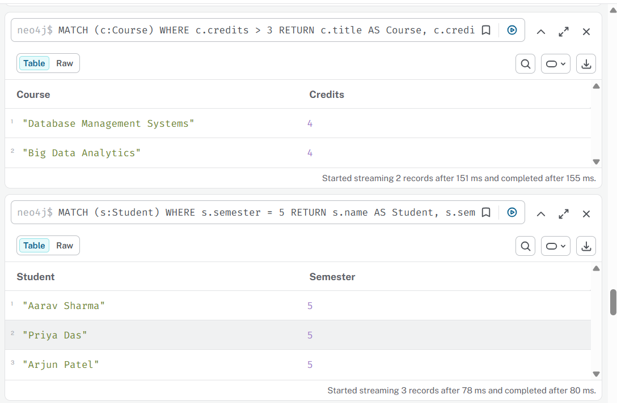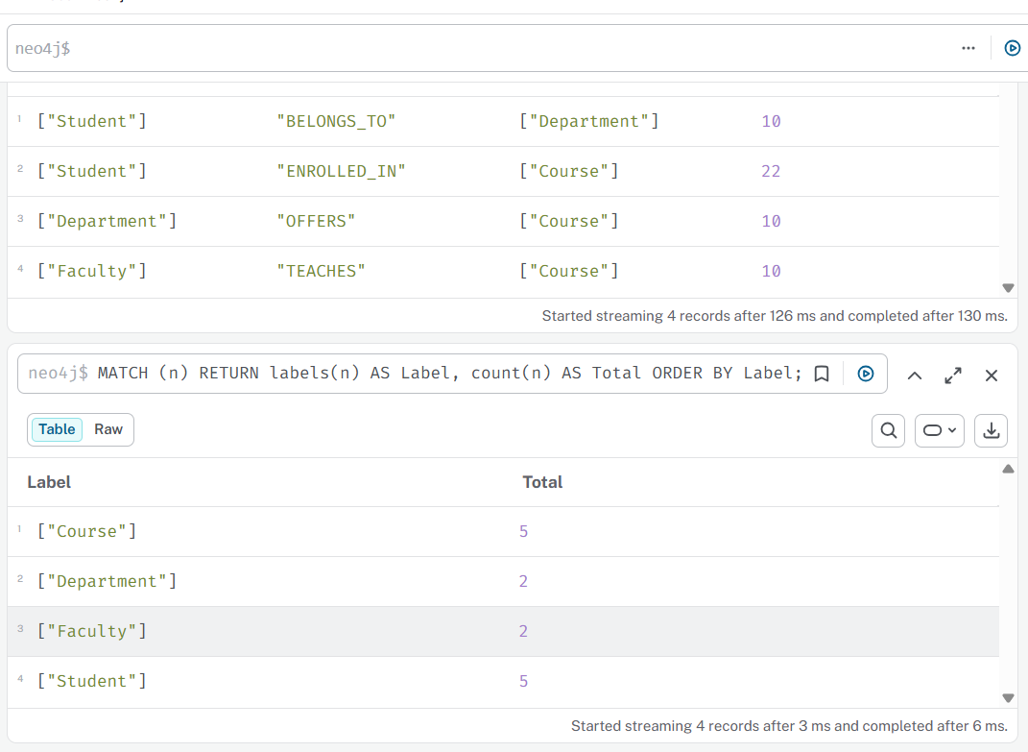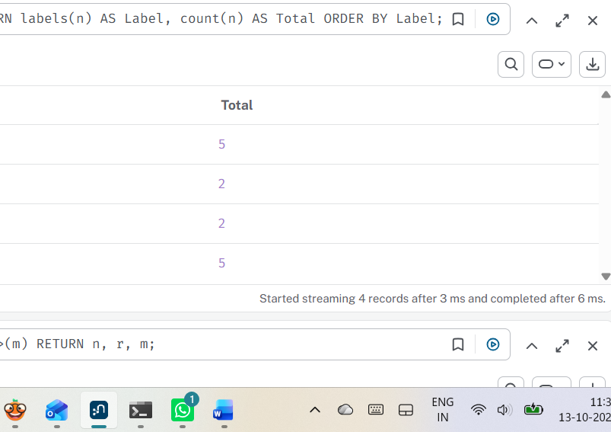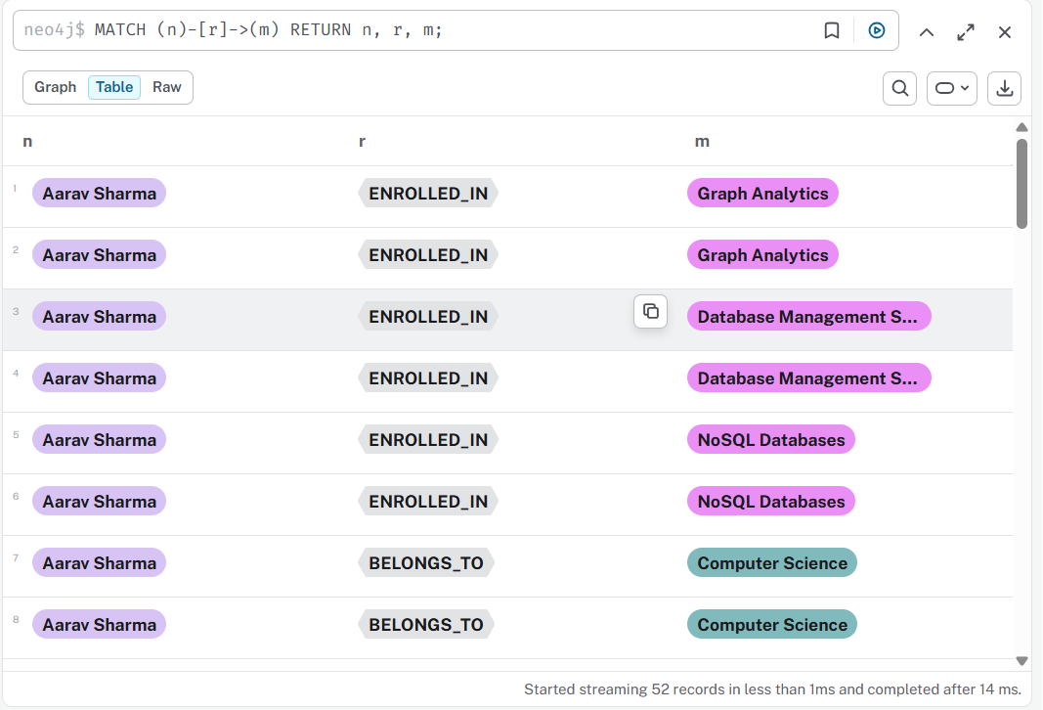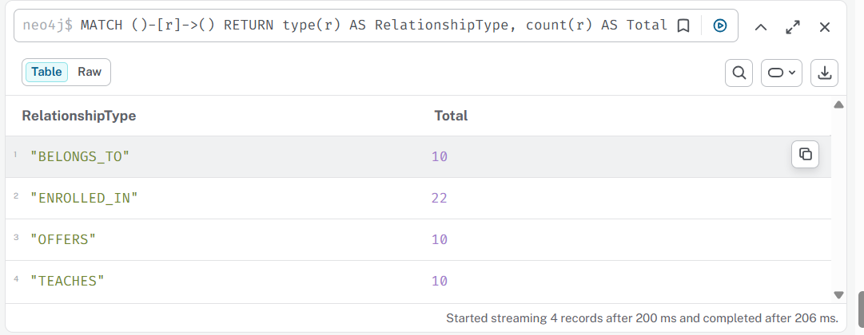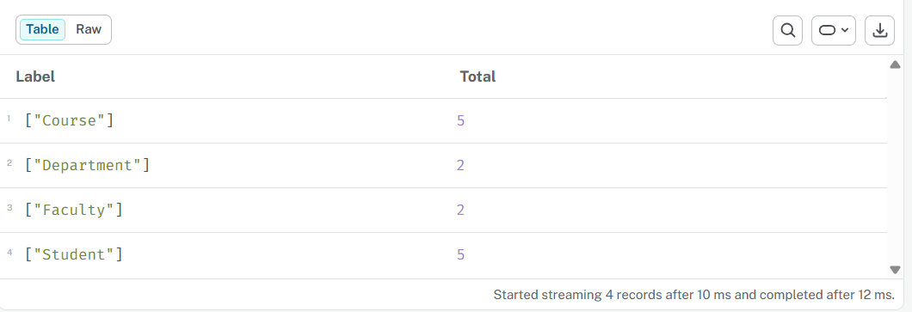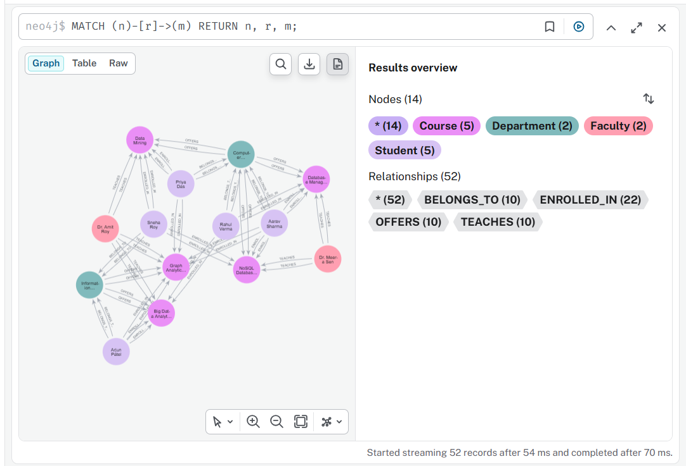

H. Observation:
The University Course Registration System was successfully implemented using Neo4j and the Cypher query language. Student, Faculty, Course, and Department nodes were created, and relationships such as ENROLLED_IN, TEACHES, BELONGS_TO, and WORKS_IN were established. The graph database successfully represents the connections between university entities and allows efficient retrieval of course registration and faculty information.

