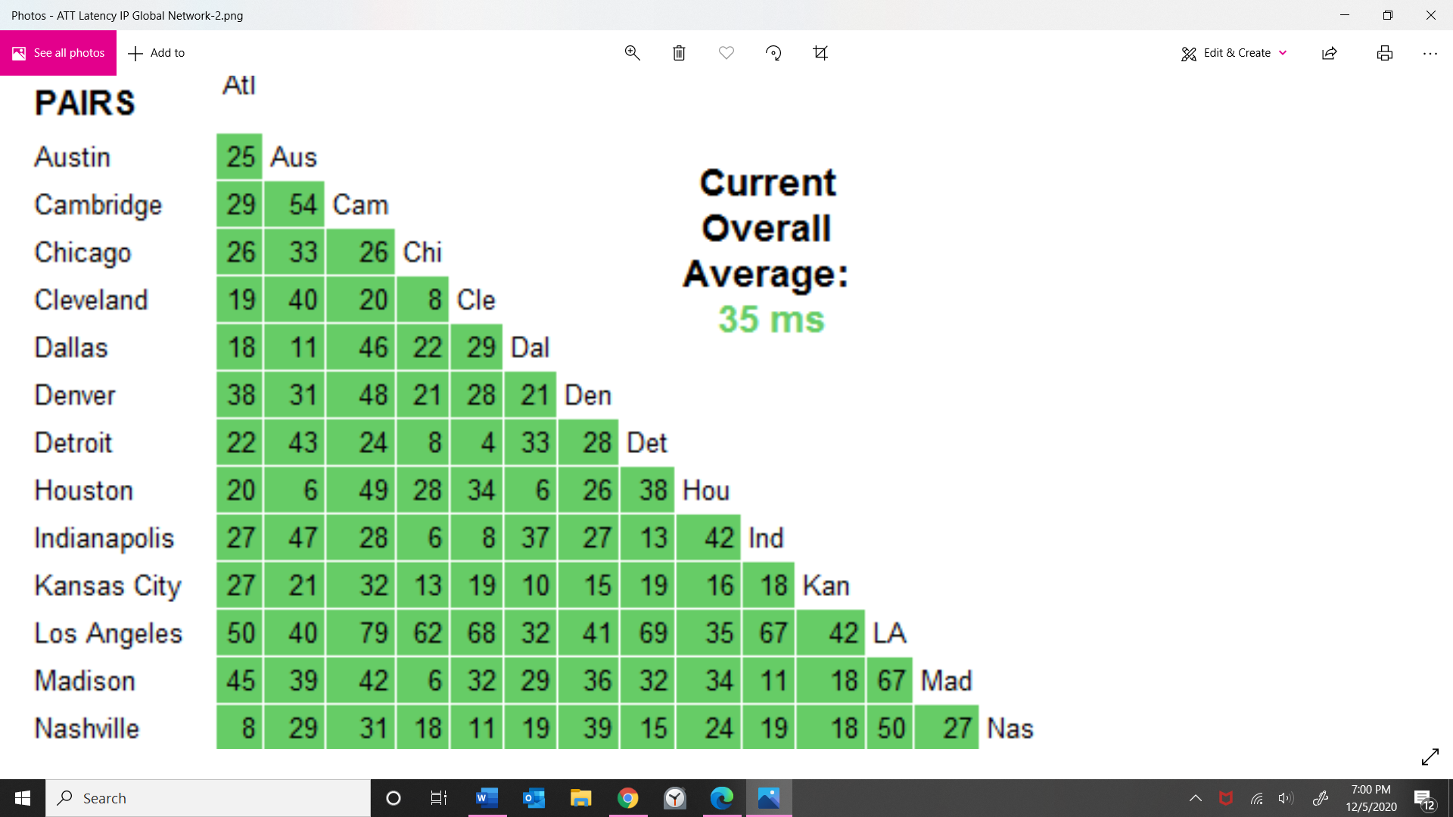

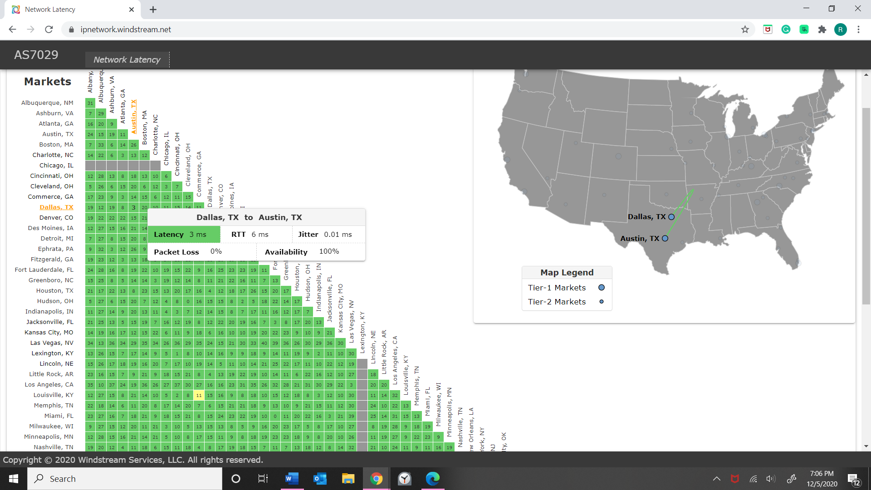

1. #Austin and Dallas.

Latency 3ms

Packet loss= 0%

1. Phoenix and NY

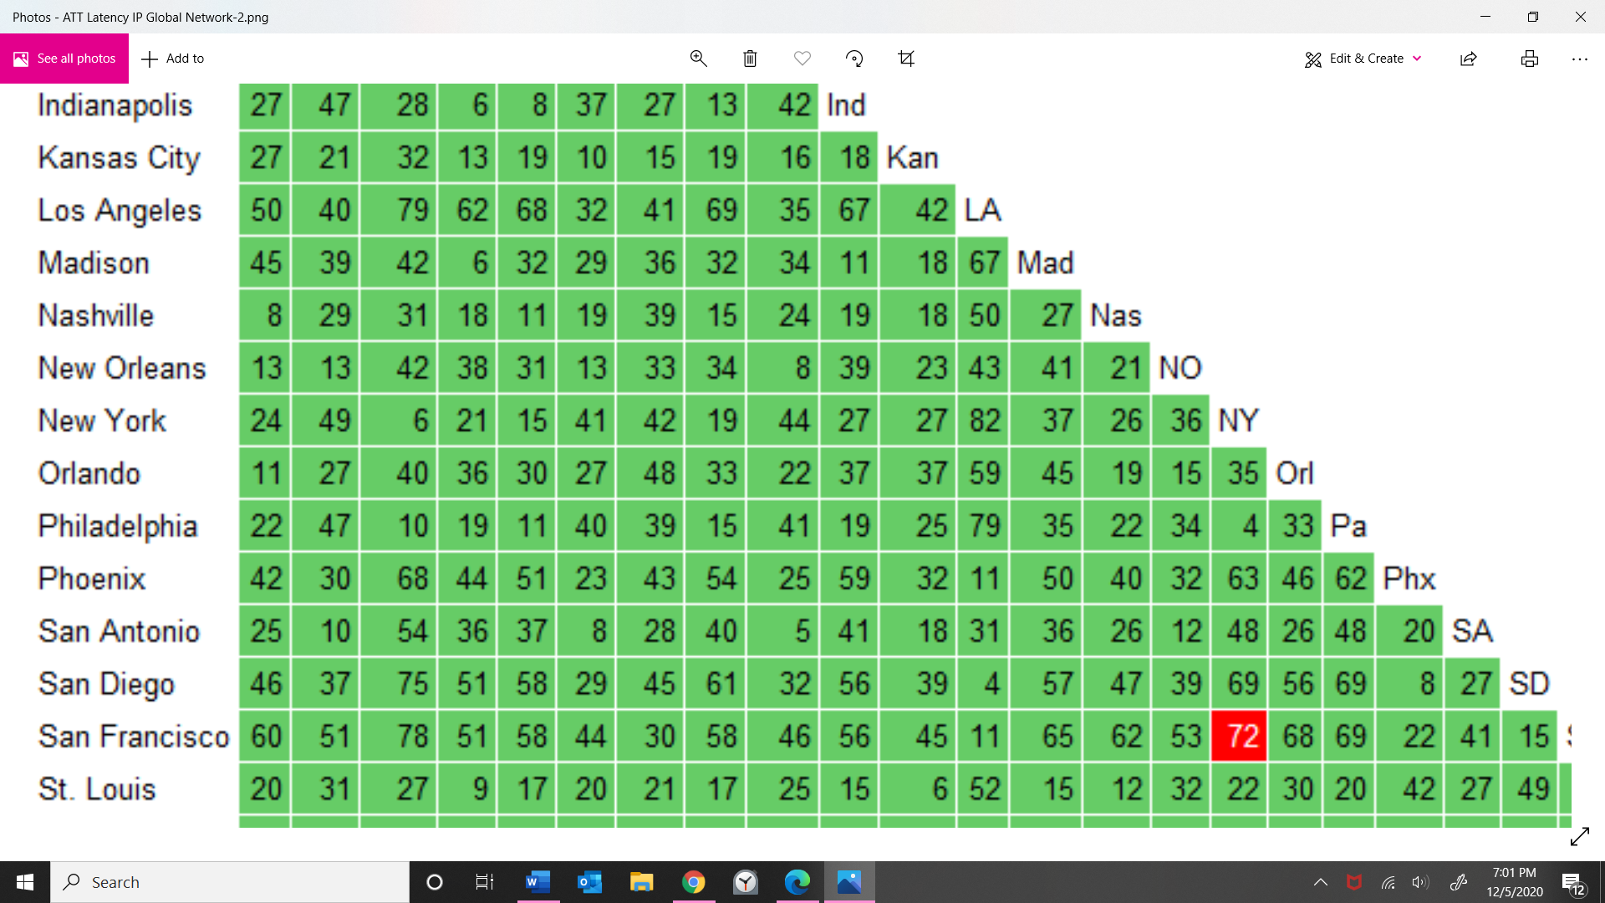

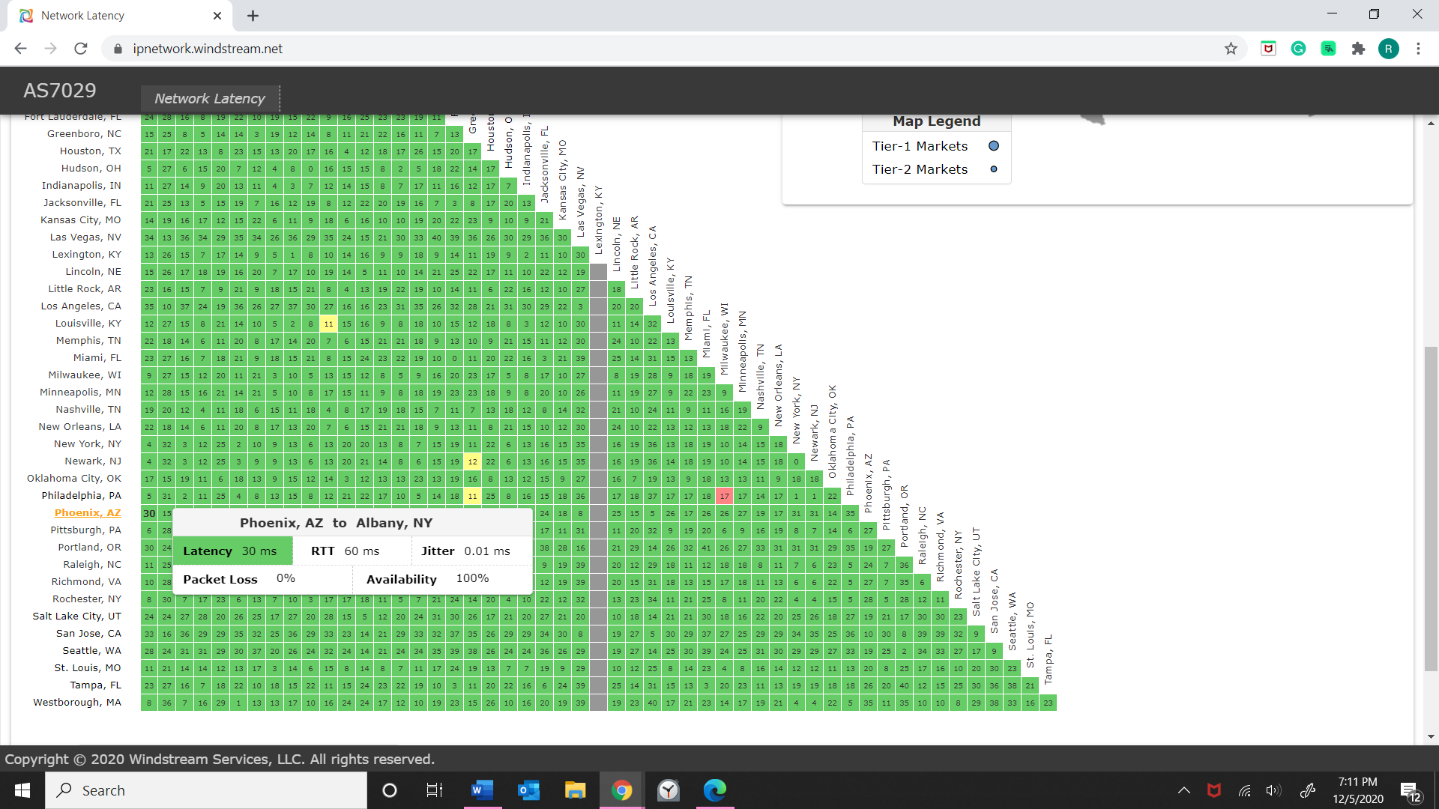

Latency=30ms

Packet Loss:0%

1. The poorest 12-month response is Europe (14.11).