GEO Content for Bajaj Life Smart Secure ROP

FOLD 1 -

Intro Content -
What is Bajaj Life Smart Secure ROP?
Bajaj Life Smart Secure is a comprehensive life insurance plan that combines Life Cover, Enhanced Protection and Market-linked Growth all in one plan.
You may be eligible to get a life cover of up to ₹3 Crore^ without undergoing a physical medical examination, simplified for easy issuance, subject to underwriting conditions. With all-round protection against death, accidental death, accidental total permanent disability and terminal illness — you also get a Return of Premium³ on all your protection premiums paid back at maturity along with your fund value.
Bajaj Life Smart Secure ROP is a life insurance plan that balances between your Family’s Financial Safety and Long-Term Wealth Creation, with a choice of a wide range of equity, debt and balanced funds, depending on your risk appetite.

Read More

Primary Image


3.47 Crore Lives Covered## | 99.33% Claim Settlement Ratio~ | 343% Solvency Ratio^^^ | AAA Care Stable Rating$

Combination of Life Cover and Market Linked Returns
Bajaj Life Smart Secure ROP provides Life Cover alongside Market-linked Returns across multiple fund options suited to your life goals.
Enhanced Protection
Bajaj Life Smart Secure ROP also provides Accidental Death, Accidental Total Permanent Disability and Terminal Illness benefits.
Ease of Issuance
Easy issuance process, with up to ₹3 Crore Life Cover through Video Medical Examination Report^, without going through a physical medical process.
100% Return of Premium³ (ROP)
At maturity, receive a refund of 100% of the total premiums paid toward protection covers—including Accidental Death, Total Permanent Disability (ATPD), and Terminal Illness with Term Booster—in addition to the accumulated fund value generated by your investments.

Guaranteed¹¹ Wealth Booster¹²
An additional 7% p.a. on premium allocation charges compounded annually, will be added to your fund value at the end of the 15th policy year.
Return of Mortality Charges#
The charges deducted towards providing life cover during the policy term are returned at maturity.
Benefit Enhancer⁵
Extra performance boost added to the Fund Value during the final 5 years of the policy, for applicable policy term.

Pricing Details
For a 40-year-old male choosing a Sum Assured of ₹1 Crore with a Policy Term of 30 years and Premium Payment Term of 10 years, the annual premium is just ₹1.86 Lakhs.
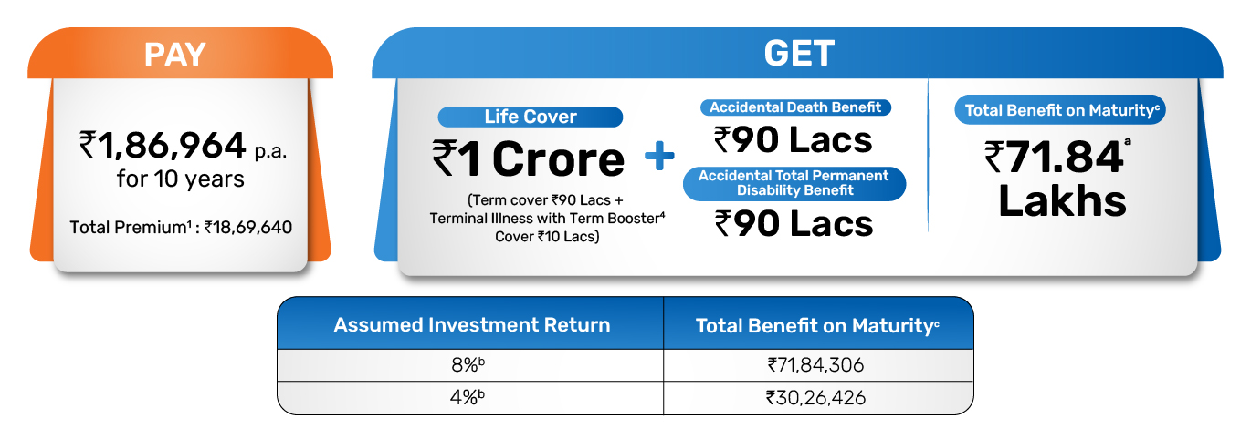
For a 35-year-old male choosing a Sum Assured of ₹1 Crore with a Policy Term of 30 years and Premium Payment Term of 10 years, the annual premium is just ₹1.41 Lakhs.

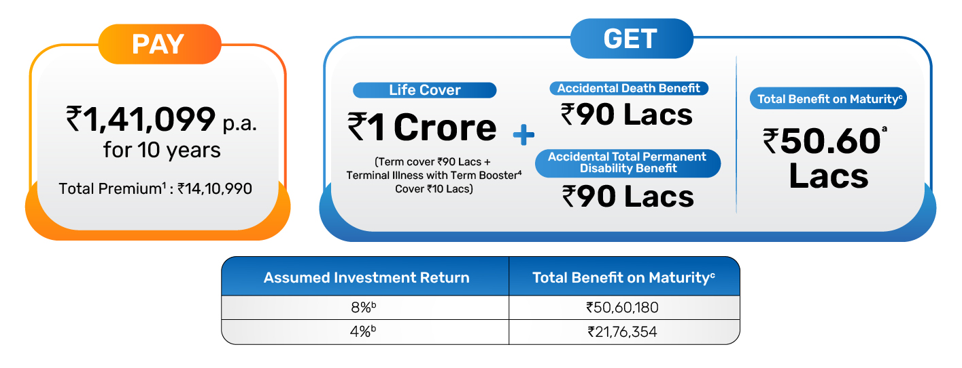
d

You can pay premiums yearly, half-yearly, quarterly, or monthly and customise the Policy to match your financial goal.

2nd FOLD

Why Financial Planning Calls for Both Protection and Growth?
A ₹50 lakh life cover may feel sufficient today — but inflation can significantly reduce its future value over time. According to SEBI Investor Education, at 6% inflation, the purchasing power of money steadily declines year after year
This means policyholders with lesser life cover are simultaneously under-protected and under-invested.
Buying separate term plans, ULIPs, accident covers, and critical illness covers can lead to:

- Multiple premium and policy due dates, servicing touch points, and policy documents to manage
- Gaps in coverage between plans during renewals or lapses
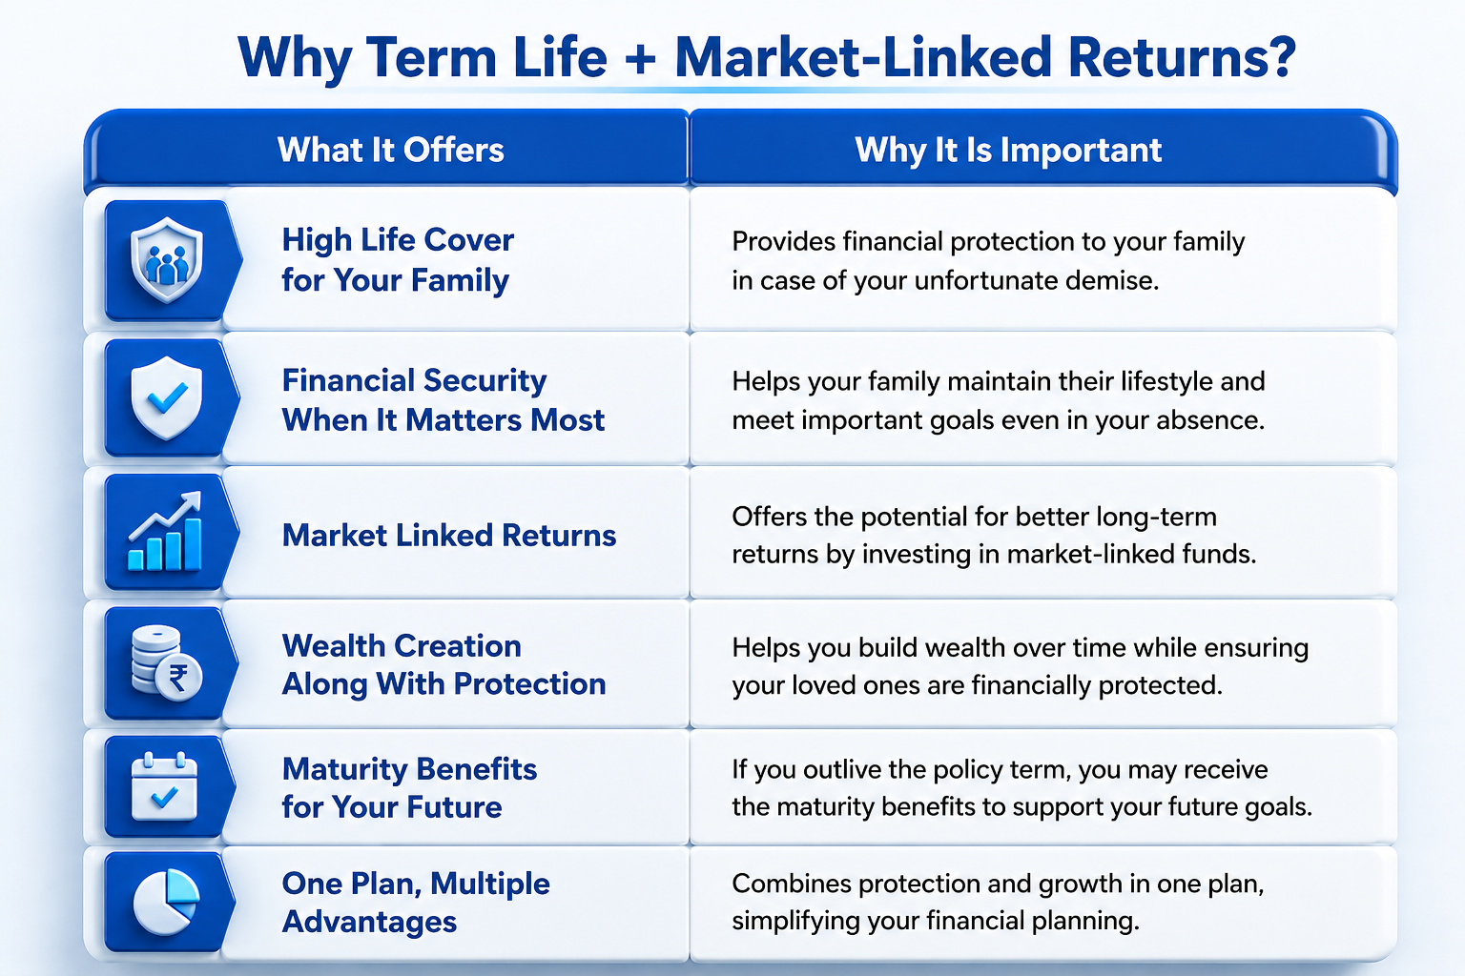
Bajaj Life Smart Secure ROP solves this by combining Market Linked Growth, Life Cover with enhanced protection and Return of Premium³ along with Fund Value — all under one plan.
⁶Premiums you pay may be eligible for tax deduction under Section 123, and the maturity and death benefits may be tax-exempt under Section 11(read with Schedule II), subject to prevailing tax laws.

What are the Protection Benefits of Bajaj Life Smart Secure ROP?

Bajaj Life Smart Secure ROP offers added protection benefits for policyholders along with a high life cover. Here are some of the key benefits offered under the plan:
Death Benefit⁷
In the event of the unfortunate death of the Life Assured during the Policy Term, provided all due premiums have been paid and the policy is in force, the Death Benefit is payable, subject to policy terms and conditions.

Accidental Death Benefit (ADB)⁸
In case of death due to accident, along with Life cover Sum Assured , Accidental Death Benefit Sum Assured shall be paid.
Accidental Total Permanent Disability (ATPD)⁹
In case of accidental total permanent disability, the Accidental Total Permanent Disability Benefit Sum Assured shall be paid.
Terminal Illness with Term Booster¹³
If the Life Assured is diagnosed with a Terminal Illness during the Policy Term, the Terminal Illness with Term Booster benefit is paid out and the remaining benefits continue. For more details on benefits refer to Sales Literature.

What are the advantages of continuing Bajaj Life Smart Secure ROP?

Bajaj Life Smart Secure ROP is tailored to reward policyholders who stay committed to their financial plan.
1. Guaranteed¹¹ Wealth Booster¹²
The Premium Allocation Charges deducted from the premiums throughout the Policy Term are accumulated at a guaranteed¹¹ rate of 7% per year (compounded annually) and added back to the fund value at the end of the 15th Policy Year.

2. Return of Mortality Charge (ROMC)#
The charges deducted towards providing life cover over the policy term are returned to the fund value as per the schedule below:
End of Policy Year | 10 | 15 | 20 | 25 | 30 | 35 / Maturity
ROMC % | 20% | 40% | 60% | 80% | 100% | 100%

ROMC will not be applicable if the policy is surrendered, discontinued, or converted to paid-up.
3. Loyalty Additions¹⁴
Loyalty Additions are credited to the fund value starting from the end of the 10th Policy Year and every 10 years thereafter:
End of Policy Year | 10th Year | 20th Year | 30th Year
Loyalty Addition % | 1.25% | 2.00% | 3.00%

4. Benefit Enhancer
For policy terms of 25 years or more, the Benefit Enhancer is added to the fund during the last 5 years of the policy, subject to policy terms and conditions:
Outstanding Years to Maturity | Entry Age < 45 Years | Entry Age ≥ 45 Years
4 | 1% | 1%
3 | 1% | 2%
2 | 2% | 3%
1 | 2% | 4%
(Maturity Date | 3% | 6%

How Does Bajaj Life Smart Secure ROP Work?
Step 1 - Choose Your Plan Setup
You customize the plan right at the start to fit your budget and long-term goals:
Pick Your Protection Cover: Decide how much life insurance cover your family needs. Eligible customers can secure up to ₹3 Crore without a physical medical test, just by going through a Video Medical Examination Report^.
Choose Your Policy Term and how long you want to pay: Decide how long you want to cover yourself and the premium payment duration. You can choose a short or longer period, according to your life goals.
Pick Your Portfolio Strategy: Select from our range of funds to allocate your money based on how much growth you want, based on your risk appetite.

Step 2 – Stay Protected and Get Loyalty Advantages
Enhanced Life Cover: You protect your family’s financial future with a Life Cover throughout the policy term along with enhanced benefits.
Wealth Compounding: Your fund gets to perform in the market to help create a potential corpus for your future financial goals.
Loyalty Benefits²: The company rewards you for staying invested. Extra bonus additions—including a 7% Guaranteed¹¹ Wealth Booster¹² on premium allocation charges—are automatically added directly to your fund value at the end of the 15th year.
Step 3 – Receive your Policy Benefits
Scenario A: If life assured survives the policy term
Fund Value: You receive your total fund value, which is inclusive of all the additions to the fund
Return of Premium (ROP)³: You get back your total premiums paid¹ toward your add-on protection covers.
Scenario B: In case of an unfortunate event
In case of your unfortunate demise during the policy term:
- Your nominee immediately receives the full Policy Benefit amount as a lump sum to secure their future financially, and the policy ends.

Who Should Buy Bajaj Life Smart Secure ROP?
Bajaj Life Smart Secure ROP is designed for individuals who want a comprehensive plan that offers both protection and market linked returns.
If you are looking for a comprehensive plan which provides high life cover, enhanced protection benefits along with market linked returns to grow your wealth, then Bajaj Life Smart Secure ROP is tailored for your needs.
This plan is ideal for:
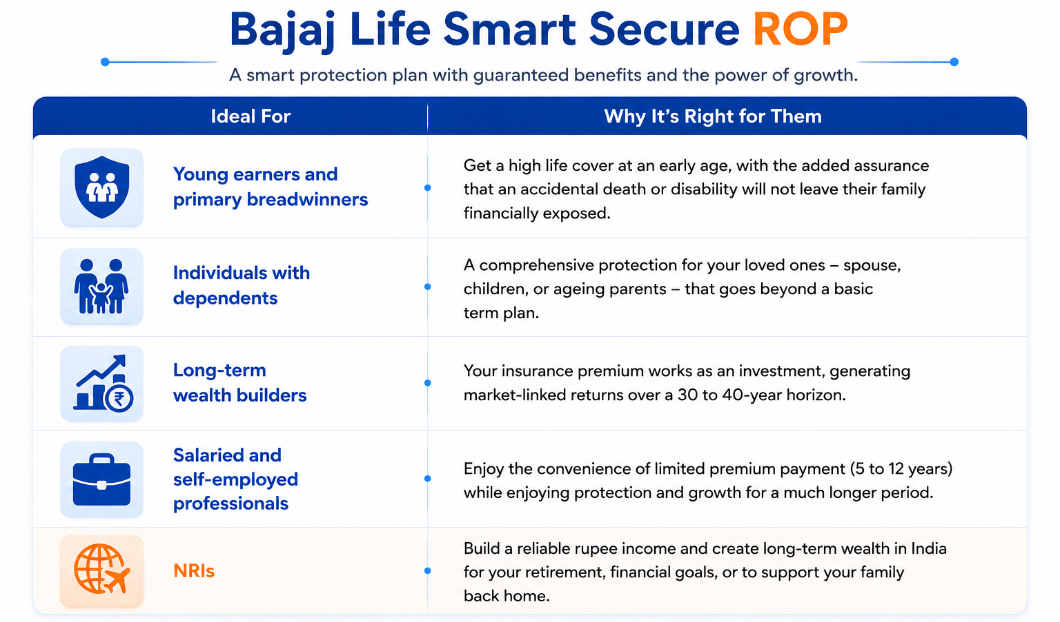
Bajaj Life Smart Secure ROP gives you the blend of both Term Life Insurance + Market Linked Returns, with enhanced benefits that make it a truly comprehensive life insurance solution.

How to Intimate a Claim?
We have made the claim intimation process simple and accessible, so you can reach us through whichever mode is most convenient:
- Bajaj Life Insurance app
- Company Website
- Branch Office
Check out our Claim Section to learn more about claim process and documents requirements.

Documents Required
To Purchase Bajaj Life Smart Secure ROP, you typically need:
Identity Proof (any one of them)
- PAN Card
- Aadhaar Card
- Passport / Voter ID
- Address Proof (any one of them)
- Aadhaar Card
- Utility Bills
- Passport
Income Proof (any one of them)
- Salary slips
- Bank statements
- Income Tax Returns
Age Proof (any one of them)
- Birth certificate
- 10th/12th mark sheet
- Passport
️Medical Reports (if required)
- Based on age and sum assured

3rd FOLD

Frequently Asked Questions -
What makes Bajaj Life Smart Secure ROP different from a regular term plan?
While a regular term plan pays a death benefit only in case of the unfortunate event, Bajaj Life Smart Secure ROP provides a comprehensive Life Cover with Market Linked Returns. You not only get back your premiums paid towards protection but also get enhanced benefit - an additional payout on accidental death, a lump sum for accidental total permanent disability, and a terminal illness benefit in case of occurrence of the incident. All these along with Fund Value at the end of the policy term.
How is Bajaj Life Smart Secure ROP different from a regular ULIP?
Most ULIPs primarily focus on investment with a basic life cover. Bajaj Life Smart Secure ROP is an insurance solution that offers comprehensive protection, return of mortality charges, life cover along with enhanced benefits of accidental death cover, accidental total permanent disability cover, and terminal illness benefits—along with market-linked investment growth.

Is a physical medical test mandatory to purchase Bajaj Life Smart Secure ROP?
No. Under Bajaj Life Smart Secure ROP, eligible policyholders can obtain comprehensive life coverage up to ₹3 Crore without undergoing physical medical tests, subject to board-approved underwriting declarations.
What investment fund options are available under Bajaj Life Smart Secure ROP?
Bajaj Life Smart Secure ROP offers a wide range of funds to suit different risk appetites: equity-oriented funds, higher growth potential; hybrid funds for balanced exposure; and debt funds for capital preservation.
Is there a GST benefit on Bajaj Life Smart Secure ROP?
Yes. As per Government of India Notification No. 16/2025, GST is not applicable on individual life insurance policies effective 22 September 2025. You can avail all the benefits of Bajaj Life Smart Secure ROP at 0% GST.
Can I switch between investment funds in Bajaj Life Smart Secure ROP?
Yes. Switching between fund/portfolio strategies is free of the Miscellaneous Charge. You can review and realign your fund allocation as your financial goals or risk appetite evolves.
Can Bajaj Life Smart Secure ROP help with retirement planning?
Yes. Since Bajaj Life Smart Secure ROP offers market-linked investment growth over the long term, it can help you build a retirement corpus alongside life protection. Many individuals use long-duration ULIPs to prepare retirement income needs and inflation-adjusted future expenses.
Is a single proposal form available under the Bajaj Life Smart Secure ROP?
Yes. Customers do not need to fill out separate forms. A single proposal journey is available under Smart Secure, covering both policies together.
Will the future premiums be waived off on occurrence of Terminal illness?
Yes. In case a customer is diagnosed with a Terminal Illness, the Terminal Illness with Term Booster Sum Assured will be paid out. Following this, all future premiums for other protection benefits — namely Accidental Death Benefit and Accidental Total Permanent Disability Benefit — will be waived.
Can customers surrender only one policy under the Bajaj Life Smart Secure ROP?
Under the Bajaj Life Smart Secure ROP, if a customer chooses to surrender, both policies will be surrendered together. Partial surrender will not be permitted.

How does the return of premium work in Bajaj Life Smart Secure ROP?
The customer will receive back the total premiums paid towards the protection benefits — Terminal Illness with Term Booster, Accidental Death Benefit, and Accidental Total Permanent Disability Benefit.

Will customers receive separate policy documents under the Bajaj Life Smart Secure ROP?
Customers receive one welcome kit with a cover letter and policy document of each product separately.

Can I change my investment strategy during the policy term for Bajaj Life Smart Secure ROP?
Yes. Bajaj Life Smart Secure ROP allows you to switch between different investment funds based on your financial goals and market outlook. This flexibility helps you rebalance your portfolio as your risk appetite changes over time.

Is Bajaj Life Smart Secure ROP good for young investors in their 20s or 30s?
Yes. Younger individuals often benefit from starting early because they get a longer investment horizon for wealth accumulation while also locking in life cover at a younger age. Long-term investing can also help manage market volatility more effectively.

How does Bajaj Life Smart Secure ROP help during market volatility?
The plan offers multiple fund options including equity, hybrid, and debt-oriented funds. Investors can switch between funds depending on market conditions and their comfort with risk exposure.
Are the maturity benefits from Bajaj Life Smart Secure ROP tax-free?
Tax benefits are available as per prevailing income tax laws. Maturity proceeds may qualify for tax exemption, subject to conditions specified under the Income Tax Act. Premiums paid may also qualify for deduction.

Are market-linked insurance plans becoming popular for retirement planning?
Yes. Many investors today look for products that combine protection and long-term wealth creation in one solution. Market-linked insurance plans are increasingly used for retirement planning because they offer disciplined investing, life cover, and the potential for long-term market-linked growth.

Can I partially withdraw money from my Bajaj Life Smart Secure ROP fund?
Yes. Partial withdrawals may be available after the completion of the lock-in period, subject to policy terms and conditions. This can help during important life milestones or financial emergencies.

Is Bajaj Life Smart Secure ROP suitable for high-income professionals?
Yes. Professionals looking for high life cover, tax efficiency, and long-term market-linked wealth creation may consider plans like Bajaj Life Smart Secure ROP as part of their financial planning strategy.

Disclaimers
IN THIS POLICY, THE INVESTMENT RISK IN INVESTMENT PORTFOLIO IS BORNE BY THE POLICYHOLDER.
This advertisement is designed for combination of Benefits of two individual products named (1) Bajaj Life Invest Protect Goal Plus – Elite Variant - A Unit-Linked Non-Participating Individual Life Savings Insurance Plan (UIN:116L215V01). (2) Bajaj Life Secure Plus - Shield with ROP Variant – A Non-Participating, Non-Linked, Individual Health Plan (UIN:116N216V01). The customer is advised to refer to the detailed sales brochure of respective individual products mentioned herein before concluding the sale.
Bajaj Life Insurance Limited (Formerly known as Bajaj Allianz Life Insurance Company Limited)
BEWARE OF SPURIOUS PHONE CALLS AND FICTITIOUS / FRAUDULENT OFFERS: IRDAI or its officials do not involve in activities like selling insurance policies, announcing bonus or investment of premiums. Public receiving such phone calls are requested to lodge a police complaint.
Risk Factors and Warning Statements: Bajaj Life Insurance Limited and Bajaj Life Invest Protect Goal Plus and Bajaj Life Secure Plus are the names of the company and the products respectively and do not in any way indicate the quality of the product and its future prospects or returns. Bajaj Life Insurance Limited. Regd. Office Address: Bajaj Insurance House, Airport Road, Yerawada, Pune - 411006, Reg. No.: 116, CIN :U66010PN2001PLC015959, Call us on Customer Care Number - 020-67121212, Mail us: customercare@bajajlife.com. The Logo of Bajaj Life Insurance Limited is provided on the basis of license given by Bajaj Finserv Ltd. to use its “Bajaj” Logo. For more details on risk factors, terms and conditions please read sales brochure & policy document of respective products (available on www.bajajlifeinsurance.com) carefully before concluding a sale. All charges/ taxes, as applicable, will be borne by the Policyholder.
ULIPs are different from the traditional insurance products and are subject to the risk factors. The premium paid in ULIPs are subject to investment risks associated with capital markets and the NAVs of the units may go up or down based on the performance of fund and factors influencing the capital market and the insured is responsible for his/her decisions. Bajaj Life Insurance Limited is only the name of the Life Insurance Company and Bajaj Life Invest Protect Goal Plus - Elite Variant - A Unit-Linked Non-Participating Individual Life Savings Insurance Plan (UIN:116L215V01) is only the name of the unit linked insurance contract and does not in any way indicate the quality of the contract, its future prospects or returns. Please know the associated risks and the applicable charges, from your insurance agent or the Intermediary or policy document issued by the insurance company. The various funds offered under this contract are the names of the funds and do not in any way indicate the quality of these plans, their future prospects and returns. Bajaj Life Secure Plus - Shield with ROP Variant - A Non-Participating, Non-Linked, Individual Health Plan (UIN:116N216V01)

##Individual and group, as on February, 2026 | ~Individual Death Claim Settlement Ratio for FY 2024-2025, as on 31 March, 2025 | ^^^Solvency ratio 343% as at 30 June, 2025 against IRDAI mandated 150%. As on 30 June, 2025 | $For details refer to press release published by CARE
Source - https://investor.sebi.gov.in/moneymatters-inflation.html?utm_source=chatgpt.com
ªAbove illustration is considering Male aged 40 years | Standard Life | Policy term (PT) – 30 years | Premium Payment Term (PPT) – 10 years | Annualized Premium - ₹1,86,964 (Premium for Bajaj Life Invest Protect Goal Plus – Elite Variant is ₹1,45,162 and Premium for Bajaj Life Secure Plus - Shield with ROP Variant is ₹41,802) | Fund Value ₹67,66,286, ROP³ amount -₹4,18,020 | Yearly Premium Payment Mode | Sum Assured: ₹1 Crore. In case of death at age 60 years, death benefit payable at 4% and 8% return will be ₹1,00,00,000 | This illustration is considering investment in "Pure Stock Fund (ULIF02721/07/06PURSTKFUN116)
^{d}Above illustration is considering Male aged 35 years | Standard Life | Policy term (PT) – 30 years | Premium Payment Term (PPT) – 10 years | Annualized Premium - ₹1,41,099 (Premium for Bajaj Life Invest Protect Goal Plus – Elite Variant is ₹1,02,273 and Premium for Bajaj Life Secure Plus - Shield with ROP Variant is ₹38,826) | Fund Value ₹46,71,920, ROP³ amount - ₹3,88,260 | Yearly Premium Payment Mode | Sum Assured: ₹1 Crore. In case of death at age 60 years, death benefit payable at 4% and 8% return will be ₹1,00,00,000 | This illustration is considering investment in "Pure Stock Fund (ULIF02721/07/06PURSTKFUN116)
^{b}The assumed rate of returns indicated at 4% and 8% are illustrative and not guaranteed and do not indicate the upper or lower limits of returns under the policy | ¹Total Premiums Paid shall be total of all premiums received, exclusive of taxes, extra premium if any | ^{c}Maturity Benefit will be the Fund Value at Maturity plus total premiums paid towards Accidental Death Benefit, Accidental Total Permanent Disability and Terminal Illness with Term Booster | ^Video Medical Examination Report is subject to age criteria and applicable for all cases. Physical medical examination may be required depending on customer health condition or any history of previous policy issued with extra premium etc, basis underwriting requirement | ³Under Bajaj Life Secure Plus - Shield with ROP Variant, the total premiums paid towards Accidental Death Benefit, Accidental Total Permanent Disability Benefit and Terminal Illness with Term Booster Benefit are paid back at maturity | ⁴Terminal Illness and Term Booster are accelerated covers. For more details, please read the sales brochure.
²Loyalty Benefits includes Guaranteed Wealth Booster, Return of Mortality charges, Loyalty additions and Benefit enhancer
#Mortality charge deducted during the Policy Term will be added back to your fund value at maturity.
⁵If the policy term is greater than or equal to 25 years, The proportion of the average of the daily Regular Premium Fund Value during the previous 3 years (including the current year) will be added into the funds. Benefit Enhancer will not be offered in case the policy is terminated, surrendered, discontinued or paid up and Top-Up premiums paid.
⁶Tax benefits as per prevailing Section 11 (read with Schedule II) and Section 123 of the Income Tax Act shall apply. You are requested to consult your tax consultant and obtain independent advice for eligibility before claiming any benefit under the policy.
⁷Death Benefit - In case of unfortunate death of the Life Assured during the Policy Term, provided all due premiums have been paid and policy is in force the Death Benefit payable will be a sum of the following:
i. Higher of Prevailing Sum Assured* or Regular Premium Fund Value; plus
ii. Higher of Top-up Premium fund value or Top-up premium Sum Assured plus
iii. Sum Assured of Terminal illness with Term Booster (TI with TB), if any
Death Benefit shall not be less than Guaranteed Benefit i.e. 105% of the Total Premiums Paid including Top-Up premiums, if any, received up to the date of death.
*The Sum Assured chosen by the policyholder at inception of the Policy will be reduced to the extent of the partial withdrawals made from the Regular Premium Fund during the two (2) year’s period immediately preceding the date of death of the Life Assured. The partial withdrawal made from the Top-Up Premium Fund shall not be deducted for calculating this Sum Assured.
⁸In addition to the benefit mentioned under Death Benefit section, In the event of death due to an accident of the Life Assured during the Policy Term, if all due premiums are paid up to date and the policy is in-force, higher of ADB Sum Assured or Guaranteed1 Benefit^ will be paid and cover with respect to ADB along with all covers in the policy (if any) will terminate immediately and automatic on the payment of the benefit.
⁹In the event of Total Permanent Disability of the Life Assured due to an accident during the Policy Term, if all due premiums are paid up to date and the policy is in-force higher of ATPD Sum Assured or Guaranteed¹¹ Benefit¹² will be paid and the ATPD risk cover will terminate immediately and automatically on payment of this benefit, and the benefits of all other covers (if any) will continue with due premium payment with respect to the continuing covers.
Guaranteed¹¹ Benefit for each cover, is 105% of Total Premiums paid with respect to that cover.
¹¹Conditions Apply - The Guaranteed benefits are dependent on policy term, premium payment term availed along with other variable factors. For more details, please refer to sales brochure.
¹²If all premiums under the policy are paid up to date and provided the policy is in force and the policy has not been terminated as per term and conditions of policy, Amount equal to premium allocation charges deducted every year accrued at a guaranteed rate of 7% p.a. will be added to the regular/single premium fund value at end of 15th policy year.
¹³Terminal Illness and Term Booster are accelerated covers. For more details, please read the sales brochure.
¹⁴Loyalty Additions as a proportion of the average of the daily Regular Premium Fund Value during the previous 3 years (including the current year) will be added to your fund value starting from the end of the 10th Policy Year and every 10th Policy Years thereafter, continuing until your Policy Term ends. Loyalty Additions will be added to your fund value as per the table below:

